**Unit 4 Chemistry SAC**: **AOS1 – Chemical pathways and instrumental analysis**

The composition of a 4.600 g sample of an organic compound is listed below.

(You have to calculate the mass of carbon yourself)

***Assume all questions relate to this substance unless the question specifies otherwise.***

|  |  |
| --- | --- |
| **element** | **mass g** |
| carbon |  |
| hydrogen | 0.622 |
| oxygen | 0.995 |

**1. a**. Determine the mass of carbon in the sample and add it to the table. __________________ 1 mark

**b**. Determine the empirical formula of the substance. 2 marks

_____________________________________________________________________________________

_____________________________________________________________________________________

______________________________________________________________________________________

**2**. The molar mass of the substance is 74 g mol-1.

**a**. What is the molecular formula of the substance? _______________________________ 1 mark

**b**. Draw and name three possible isomers with this molecular formula. 6 marks

**3**. The IR spectrum of this substance is shown below.

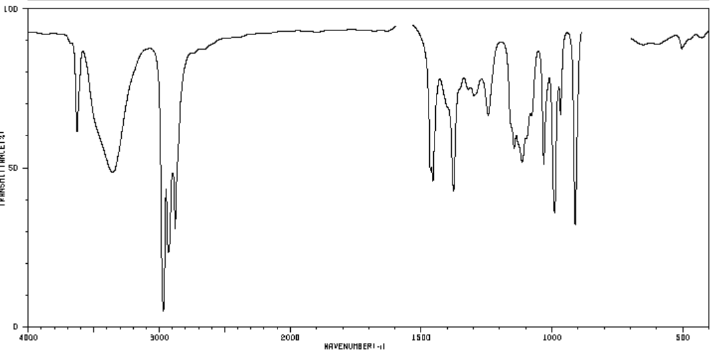

1. Explain in detail how this IR relates to the structures you drew in question 2. 3 marks

_____________________________________________________________________________________

_____________________________________________________________________________________

______________________________________________________________________________________

1. The molecule shown on right does exist but it contains a functional group

that you do not study. Explain why the IR spectrum does not match

this molecule. 1 mark

_____________________________________________________________________________________

_____________________________________________________________________________________

**4**. The C-NMR for the substance being analysed is shown below

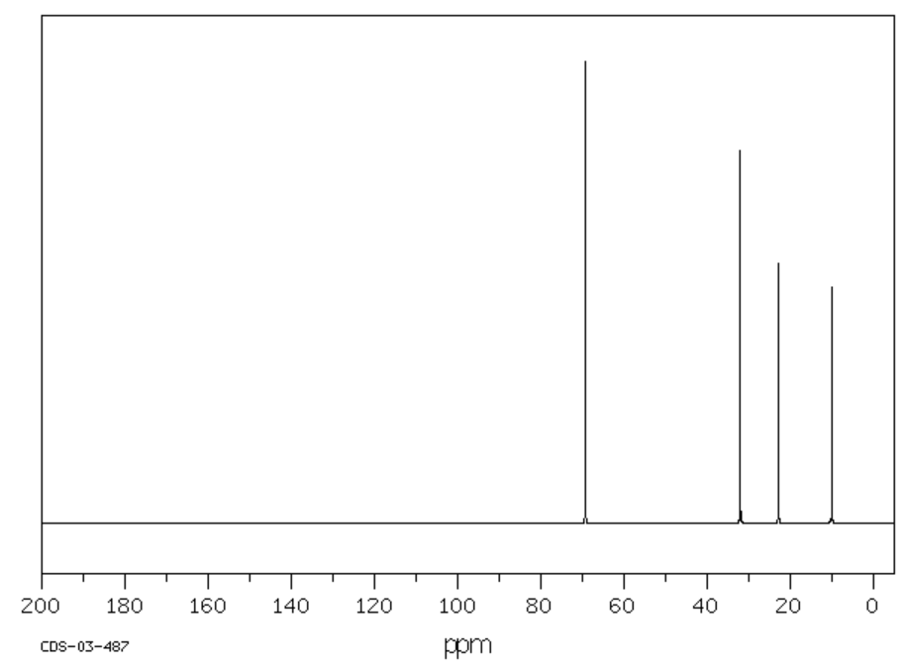

**a**. How many carbon environments does the substance have? _________ 1 mark

**b**. Can you use this information to rule out any or all of the three isomers you drew in question 2?

Explain your answer. 2 marks

_____________________________________________________________________________________

_____________________________________________________________________________________

______________________________________________________________________________________

5. The H-NMR is shown below.

The splitting is not easy to read, nor is it symmetrical, so it is supplied.

|  |  |
| --- | --- |
| **shift** | **splitting** |
| 3.8 | sextet (6) |
| 2.4 | singlet |
| 1.5 | quintet |
| 1.3 | doublet |
| 1.1 | triplet |

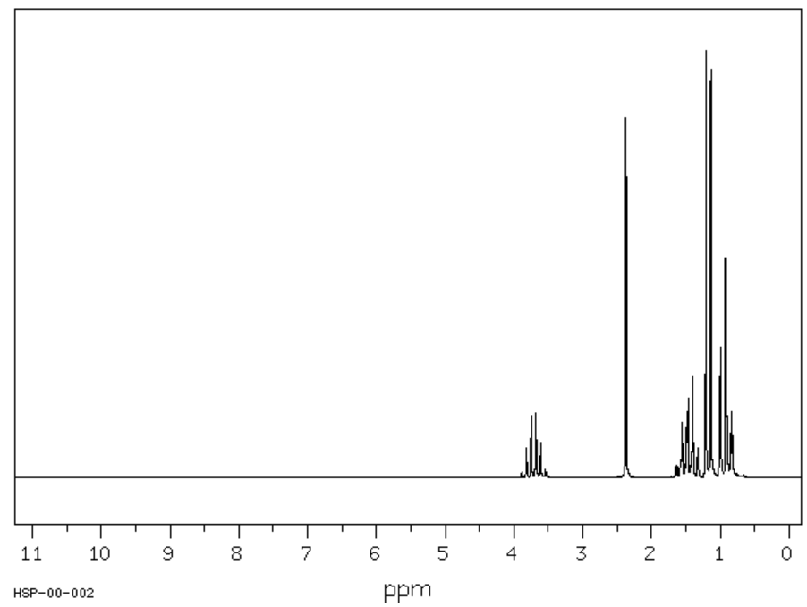

The H-NMR should enable you to confirm the identity of the substance.

Name the substance and justify your selection. 4 marks

_____________________________________________________________________________________

_____________________________________________________________________________________

______________________________________________________________________________________

_____________________________________________________________________________________

_____________________________________________________________________________________

**6**. The substance under investigation can be made from an alkene.

Name the alkene required and show the reaction occurring. 3 marks

______________________________________________________________________________________

_____________________________________________________________________________________

_____________________________________________________________________________________

**7**. The substance in question can be oxidised.

Draw the product formed and the reagents required. 2 marks

The final questions no longer relate to the substance analysed.

8. Will IR spectroscopy distinguish propan-1-ol from propan-2-ol? Discuss your answer. 2 marks

______________________________________________________________________________________

_____________________________________________________________________________________

9. Give an example of a molecule that has a different number of C-NMR peaks from H-NMR peaks. 2 marks

______________________________________________________________________________________