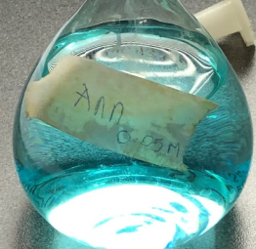
Note: There is a video with data to accompany this sheet.

SAC Unit 2: Concentration of copper sulfate using UV spectroscopy determination

Aim: To use UV spectroscopy to determine the concentration of a CuSO₄ solution

Background: UV spectroscopy.
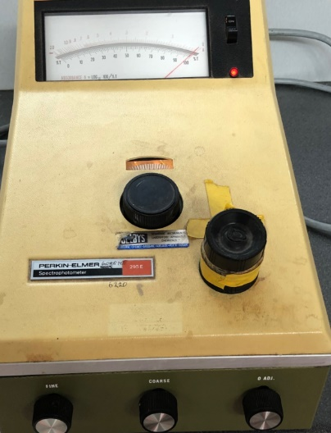
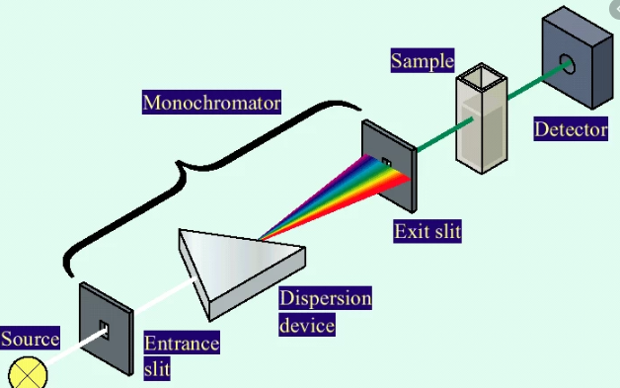

Oxalic acid: a diprotic acid

Light of a particular wavelength is directed at a solution. The more concentrated the solution the greater the absorbance of light by the solution.
The wavelength of the light used should be complementary of the colour of the light.
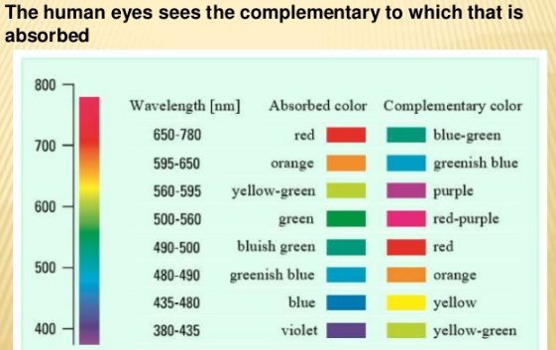

Standard solutions
To test the absorption of CuSO₄, a series of standard solutions is made and tested for absorption.
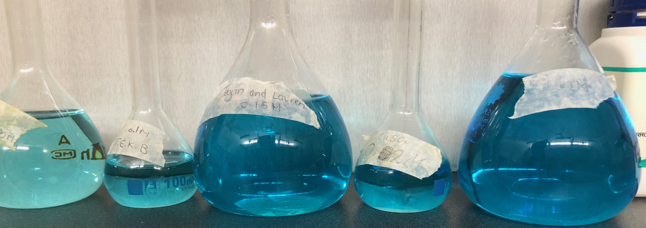

1.5 g of the mixture above was made up to the mark in a 100 mL volumetric flask.

This was added to a burette and titrated against 20.00 mL aliquots of 0.200 M NaOH.

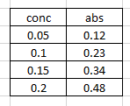

The absorption of the solution of unknown concentration is then tested.

Questions
1. Explain how the wavelength of light for this analysis is chosen. 3 marks

2. How does a UV spectrometer recognise that one solution might be twice as concentrated as another? 2 marks

3. Why was water tested in the instrument and the machine set to zero with water as the sample? 2 marks

4. Draw a calibration curve for the 4 standard solutions. 4 marks

5. What is the concentration of the unknown solution in
- M

- g L⁻¹? 3 marks

6. Could the same calibration curve be used for –
-further copper sulfate solutions the next day?
- analysis of green nickel sulfate solutions? 4 marks

7. Will UV spectroscopy work for all solutions? Explain your answer. 2 marks

8. If I take 5 mL of one of the standards and add de-inoised water to make it up to 20 mL, what will happen to the
absorption of the solution? 2 marks

9. If I measure the absorption of a solution and then test it again in a test tube that is twice the width of the
previous one, what do you think will happen to the level of absorption? 2 marks

10. Suggest an alternative method for determining the concentration of a CuSO₄ solution.

