2017 SAC tasks

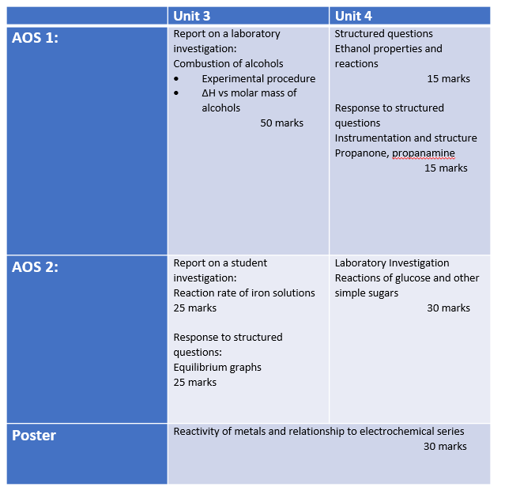

**Outcome 1 Unit 3 Prac report**

**Heats of combustion**

**Hypothesis**: The heat of combustion of alcohols will increase with molar mass.

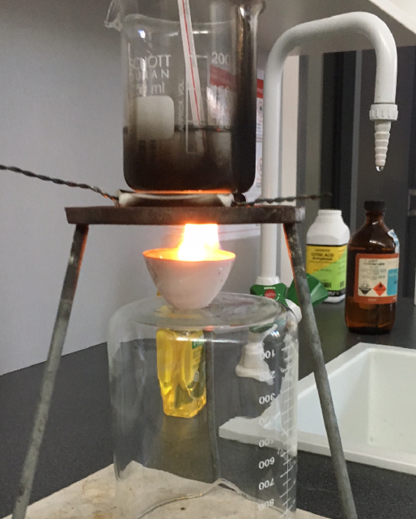**Aim**: To refine the procedure for determining the heat of combustion of fuels and to use this procedure to compare the heat of combustion of common alcohols.

**Procedure**

Use the photo to set up a sample of ethanol to burn

Under a beaker of water.

Use a Bunsen mat rather than a pipe clay triangle.

Add a sample of ethanol to the crucible, weigh the

crucible and light the sample.

Allow the ethanol to burn for 1.0 minute and measure

the temperature change.

Reweigh the crucible

Ask students to use their results to determine the

molar heat of combustion for ethanol.

**Discussion**

The value obtained will be very low. Discuss ways of improving the energy transfer.

Ask each student group to identify one aspect of the experiment design to investigate.

(Possibilities – lid, pipe clay triangle, wind shield, metal can, alcohol burner)

Students conduct an experiment to test their design modification.

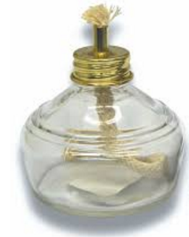**Design improvements**

Students to pool results of their experimentation.

Class to repeat experiment with ethanol using an alcohol burner.

Compare the class results to see if precision has improved.

Compare the mean value to that of the Data Book to calculate the efficiency

of combustion in your experiment.

**Part B**

Heats of combustion of various alcohols

Use any design improvements to determine the heat of combustion of methanol, ethanol. propan-1-ol and pentan-1-ol.

Graph results for heat of combustion per gram vs molar mass.

**SAC Report**

As a result of your experimenting you should have

1. Part A: Experimental data 1 mark
2. Calculations of ∆H g-1 and mol-1 3 marks
3. Part B: Data 2 marks
4. Calculations of ∆H g-1 and mol-1 5 marks
5. Graph of molar mass vs ∆H 4 marks

**Questions**

1. The results from part A will be well below accepted values.

a. Give reasons why the results from part A are poor.

b. Explain how you attempted to modify the experiment design in part B to improve results.

(2 + 2 =4 marks)

2. a. What conclusions can you draw from the graph?

b. Can you suggest reasons for the trends evident in your graph?

(2 + 2 = 4 marks)

3. For this experiment, identify

a. the independent variable

b. the dependent variable

c. any controlled variable(s) (1 + 1 + 1 = 3 marks)

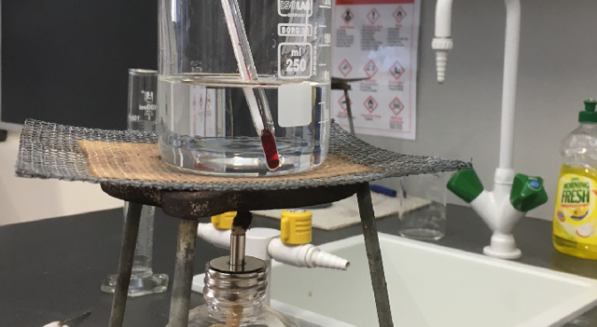

4. One group used a mat in place of a pipe clay triangle,

as shown in the diagram. What impact do you think

this would have on

1. The ∆H values obtained
2. The graph drawn? (1 + 2 = 3 marks)

5. a. Explain the difference in structure between propan-1-ol and propan-2-ol.

b. How would you expect their ∆H values to compare? Explain your answer.

(2 + 2 = 4 marks)

6. Write a balanced equation for

a. the complete combustion of butan-1-ol

b. the incomplete combustion of butan-1-ol (2 + 2 = 4 marks)

7. Ethanol can be obtained from biomolecules.

a. Name the process used to produce bioethanol

b. Write a balanced equation for the reaction occurring. (1 + 1 = 2 marks)

8. a. Does the combustion of bioethanol solve problems associated with fuel combustion?

Explain your answer.

b. Are the emissions produced by the combustion of ethanol the same as those of pentan-1-ol?

Explain

(2 + 2 = 4 marks)

9. List two safety precautions taken during this experiment. 2 marks

10. The combustion of 1 mole of ethanol should produce 1364 kJ of energy. Knowing this figure, calculate the percentage energy loss occurring when you burnt ethanol

If you were to now test hexan-1-ol, how could you use the result of part a of this question to improve your estimate of ∆H?

(3 + 2 = 5 marks)

**Commentary**

Must use proper alcohol burners: expected results

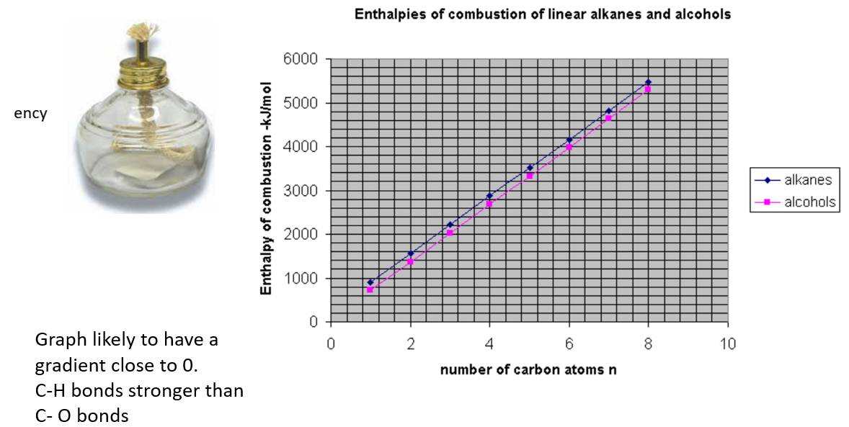

**Reaction rates with iron solutions**

**Aim**: To investigate variables that influence the rate of a chemical reaction.

**Background**

Iron (III) nitrate solution is brown in colour. When it is mixed with sodium thiosulfate, the Fe3+ is reduced to clear Fe2+.

The rate of this reaction can be determined by drawing a cross and sitting the reaction flask on top of this cross. The time can be measured until the cross becomes visible.

*Observe cross from above*

*Flask sits on a cross drawn on paper*

**Apparatus**

100 mL measuring cylinder

0.2 M Fe(NO3)3

0.1 M Fe(NO3)3

0.2 M Na2S2O3

0.1 M Na2S2O3

0.1 M CuSO4

0.1 M NiSO4

Stopwatch

100 mL beaker

Thermometer

Hotplate

**Part A:** Rate and temperature

Draw a cross on a piece of paper and sit a 100 mL beaker on the cross

1. Add 30 mL of 0.1 M Na2S2O3 solution to the beaker. Record the temperature

2. Add 30 mL of 0.1 M Fe(NO3)3 solution to the beaker and start timer

3. Stop the timer as soon as the cross is visible through the liquid in the flask

4. Repeat the procedure with both liquids at 40 0C

5. Repeat the procedure with both liquids at 60 0C

**Part B**: Rate vs Concentration

1. Repeat the procedure at room temperature but using a 0.2 M solution of Na2S2O3

2. Repeat the procedure at room temperature but using 0.2 M solutions of both liquids

3. Repeat the procedure at room temperature but using 0.05 M solutions of both liquids

**Part C**: Rate vs Catalyst

1. Repeat the procedure at room temperature using solutions of concentration 0.1 M but this

time add 1 drop of 0.1 M CuSO4 to the Fe(NO3)3 before the two liquids are mixed.

2. Repeat the procedure at room temperature using solutions of concentration 0.1 M but this

time add 1 drop of 0.1 M NiSO4 to the Fe(NO3)3 before the two liquids are mixed.

Appropriate recording of measurements 8 marks consisting of;

Labelling of data 2 marks

Use of tables 4

Units 2

**Questions**

**1**. The reaction is between Na2S2O3 and Fe(NO3)3. It is a redox reaction.

**a**. Write a balanced half equation for the reduction of Fe3+

________________________________________________________________________________

**b**. Write a balanced half equation for the reaction of S2O32-  to S4O62-

________________________________________________________________________________

**c**. Write a balanced overall equation for this reaction.

________________________________________________________________________________

**d**. Explain why the solution loses colour.

________________________________________________________________________________

1 + 1 + 1 + 1 = 4 marks

**Part A**

2. Graph the results of time for cross to disappear against temperature.

3 marks

**3. a**. How should the rate of reaction be changing with temperature?

________________________________________________________________________________

**b**. Is your graph showing this?

________________________________________________________________________________

2 + 1 = 3 marks

**4.** Calculate the reciprocal of each value of time taken for the cross to disappear in part A

Draw a graph of the reciprocal against temperature.

3 marks

**5**. Explain how this graph is a better representation of the impact of temperature upon

reaction rate.

________________________________________________________________________________

________________________________________________________________________________

________________________________________________________________________________

2 marks

**6**. Should this graph pass through the origin? Explain your answer.

________________________________________________________________________________

________________________________________________________________________________

________________________________________________________________________________

3 marks

**7**. Explain why the rate of reaction changes with temperature

________________________________________________________________________________

________________________________________________________________________________

________________________________________________________________________________

2 marks

**8**. List two examples you can think of where temperature is used to change the rate of a

reaction.

________________________________________________________________________________

________________________________________________________________________________

2 marks

**Part B**

**9**. How does the rate of reaction change with concentration?

________________________________________________________________________________

________________________________________________________________________________

2 marks

**10**. Explain why concentration impacts the rate of reaction.

________________________________________________________________________________

________________________________________________________________________________

1 mark

**11. a**. When you double the concentration of the 30 mL of Na2S2O3, does this mean the

concentration of the Na2S2O3 is double when the reaction occurs? Explain your

answer using a calculation

________________________________________________________________________________

________________________________________________________________________________

________________________________________________________________________________

**b**. Explain clearly why it is more difficult to study the impact of concentration changes

than it is to study the impact of temperature changes

________________________________________________________________________________

________________________________________________________________________________

3 + 3 = 6 marks

**12**. List two examples you can think of where concentration changes are used to affect the

rate of a reaction.

________________________________________________________________________________

________________________________________________________________________________

2 marks

**Part C**

**13. a**. What was the impact of adding the CuSO4?

________________________________________________________________________________

**b**. What was the impact of adding the NiSO4?

________________________________________________________________________________

1 + 1 = 2 marks

**14**. a. Explain what has happened

________________________________________________________________________________

**b**. Is the impact of each solution chosen the same?

________________________________________________________________________________

1 + 1 = 2 marks

**15**. List two examples that you can think of where a catalyst is used to affect the rate of a

reaction.

________________________________________________________________________________

________________________________________________________________________________

2 marks

**16**. Discuss safety and chemical disposal aspects of this experiment.

________________________________________________________________________________

________________________________________________________________________________

________________________________________________________________________________

3 marks

**AOS 2: Equilibrium structured questions**

**Experiment 1: The equilibrium law**

Theory says that for each reversible reaction there is an equilibrium law. When applied, this law leads to an equilibrium constant. The reaction between hydrogen and iodine gases is an example of a reversible reaction.

H2(g) + I2(g) ⬄ 2HI(g)

Three different mixtures of hydrogen and iodine gases are added to three different reactors at 731 °C. Some of the concentrations at equilibrium are shown in the table below.

|  |  |  |  |
| --- | --- | --- | --- |
| **Experiment** | [H2] | [I2] | **[HI]** |
| **1** | 0.0114 | 0.0120 | 0.0252 |
| **2** |  | 0.0200 | 0.0296 |
| **3** | 0.0770 | 0.0310 |  |
|  |  |  |  |

**Experiment 2: Simulation**

The reaction between nitrogen and hydrogen gases to form ammonia is a reversible one;



**Reactor 1**. A reactor is shown below. Samples of nitrogen and hydrogen are added to the reactor and allowed to react. Assume that each molecule shown stands for 1 mole of the gas.

N2 H2 H2 H2 H2

H2 H2

N2 H2 H2 N2

N2 N2 H2 H2 H2

→

t = 0

**Reactor 2**. A second reactor has a sample of ammonia gas added to it.

NH3 NH3  NH3

NH3 NH3

NH3 NH3

→

**Experiment 3: Graphs of K**

The graph shown is for a reversible reaction.

*% product*

Each line shows the yield of the reaction and how

it changes with an increase in temperature**.**

The other two lines show how an increase in pressure

impacts upon yield.

500 atm

300 atm

100 atm

*temperature*

**Experiment 4: Graphing**

Carbon monoxide and hydrogen can react to form methanol

CO(g) + 2H2(g) ⬄ CH3OH(g)

A sample of carbon monoxide and hydrogen is added to an empty reactor and allowed to react. Their concentrations are shown on the graph below

0.8

0.6

0.4

0.2

M

time

1 2 3 4 5 mins

**Questions**

**Experiment 1**

**1**. Write an expression for K for this reaction.

___________________________________________________________________

1 mark

**2**. Determine the values of the two measurements missing from the table.

___________________________________________________________________

___________________________________________________________________

1 mark

**3**. Perhaps other expressions also lead to constants i.e. perhaps [H2][I2] is also constant

[HI]

Use the data provided to check whether this does in fact lead to a constant.

___________________________________________________________________

___________________________________________________________________

2 marks

**Experiment 2: Simulation**

**Reactor 1**.

N2 H2 H2 H2 H2

H2 H2

N2 H2 H2 N2

N2 N2 H2 H2 H2

→

t = 0

**4. a**. The molecules in the reactor react and equilibrium is reached. Assuming whole

numbers, draw in the blank box some combination of the concentrations that is

stoichiometrically correct.

**b**. Is there more than one possible answer? Explain your answer.

___________________________________________________________________

___________________________________________________________________

2 + 2 = 4 marks

**Reactor 2**. A second reactor has a sample of ammonia gas added to it.

NH3 NH3  NH3

NH3 NH3

NH3 NH3

→

**5. a.** Assuming whole numbers, draw in the blank box some combination of the

concentrations that is stoichiometrically correct.

**b**. How many possible answers are there? Explain your answer.

___________________________________________________________________

___________________________________________________________________

2 + 2 = 4 marks

**Experiment 3: Graphs of K**

*% product*

Each line shows the yield of the reaction and how

it changes with an increase in temperature**.**

The other two lines show how an increase in pressure

impacts upon yield.

500 atm

300 atm

100 atm

*temperature*

**6**. **a**. Is this reaction exothermic or endothermic? Explain your answer.

___________________________________________________________________

___________________________________________________________________

**b**. Would it be wise to run this reaction at very low temperatures to maximise the

yield?

___________________________________________________________________

___________________________________________________________________

1 + 1 = 2 marks

**7. a**. Does the yield increase or decrease when the pressure is increased?

___________________________________________________________________

___________________________________________________________________

**b**. What does this tell you about the reaction occurring?

___________________________________________________________________

___________________________________________________________________

**c**. Explain why high pressure is not always desirable?

___________________________________________________________________

___________________________________________________________________

2 + 2 + 1 = 5 marks

**Experiment 4: Graphing**

A sample of carbon monoxide and hydrogen is added to an empty reactor and allowed to react. Their concentrations are shown on the graph below

0.8

0.6

0.4

0.2

M

time

1 2 3 4 5 mins

**8. a**. Identify which line is the carbon monoxide and which is the hydrogen.

**b**. Draw in the graph for the methanol

**c**. Calculate a value for K

___________________________________________________________________

___________________________________________________________________

1 + 1 + 1 = 3 marks

**9**. The volume of the container is halved at the 6 minute mark. Extend the 3 lines to show

the likely response of the system

3 marks

**Chemistry: Outcome 3: Research project (Poster)**

**Outcome 3**

Design and undertake a practical investigation related to energy and/or food and present methodologies, findings and conclusion in a scientific poster.

**Other VCAA requirements**

* 7-10 hours of class time
* Logbook to be used to record progress, results and design
* Poster to be submitted (not exceeding 1000 words)
* Correct citation of resources used
* Risk assessment conducted
* Hypothesis must be tested
* Students can conduct experiments in pairs but must submit individual posters.

**Further details**

Unit 3 investigations have to relate to energy. I have restricted your investigation further to investigate some aspect of galvanic cells.

The investigation requires the student to

* identify an aim, develop a question, formulate a hypothesis and plan a course of action to answer the question and that complies with safety and ethical requirements.
* undertake an experiment that involves the collection of primary quantitative data
* analyse and evaluate the data
* identify limitations of data and methods
* link experimental results to theory
* reach a conclusion in response to the question and suggests further investigations
* communicate findings in a scientific poster
* maintain a logbook

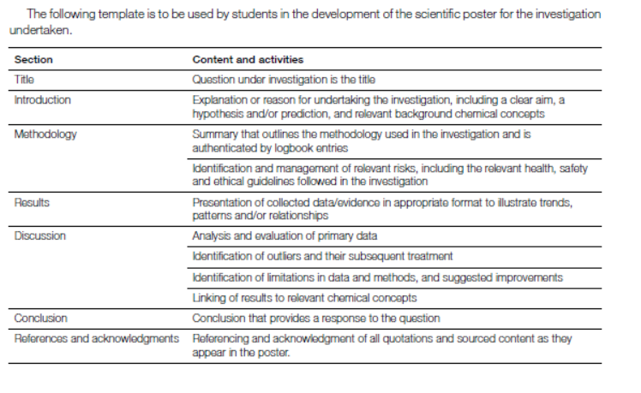

**Background**

What society calls batteries, chemists call galvanic cells. Galvanic cells convert chemical potential energy directly to electrical energy. They are used to power the wide range of portable devices that we rely on so heavily.

In a competitive market place, the performance and the efficiency of the cell needs to be maximised. In this task you will select one aspect of cell design to investigate. You will propose a hypothesis and design an experiment to test your hypothesis. The data you obtain will form the basis of your conclusion. Your findings are presented as a poster.

It is assumed you have a sound understanding of galvanic cell theory before commencing this task.

**Introductory experiment 1**: **Reactivity of metals and the electrochemical series**

**Aim**: To compare the chemical reactivity of metals with their position on the electrochemical series.

**Materials**

Samples of the following metals

* zinc, magnesium, iron (nails), copper, lead

0.5 M HCl

3.0 M HCl

Test-tubes

**Procedure**

Add a sample of copper to 0.5 M HCl in a test-tube

Repeat in a separate test-tube for each metal

Compare the rate of reaction for each metal.

For the metals that were difficult to discern, repeat the procedure with 3.0 M HCl.

Rank the metals tested in order of reactivity.

**Introductory experiment 2 (Teacher demonstration)**: Making a galvanic cell

Your teacher will demonstrate the construction of a basic galvanic cell using a copper half-cell and a zinc half-cell.

This design of this cell will be deliberately poor.

Record the voltage.

Compare the voltage and polarity obtained with theoretical values.

**Student investigation**

Select an aspect (a variable) of galvanic cells to investigate.

Possible variables include

* impact of solution concentration
* impact of solution temperature
* salt bridge concentration
* electrode separation
* electrode surface area
* measuring current instead of voltage
* choice of salt bridge solution
* performance of cell over time

**Designing and planning your task**

You need to show me evidence that you have a valid hypothesis and plan for testing the hypothesis.

|  |  |
| --- | --- |
| Topic |  |
| State the aspect you are studying |  |
| Why is this a relevant topic? |  |
| What is your hypothesis? |  |
| Outline the procedure you will follow | __________________________________________________________  __________________________________________________________  __________________________________________________________  __________________________________________________________  __________________________________________________________  __________________________________________________________ |
|  |  |

**Experimentation**

Use the headings below to outline the experiment you will conduct and your requirements.

Description of your experiment

__________________________________________________________________________________

_________________________________________________________________________________

__________________________________________________________________________________

__________________________________________________________________________________

__________________________________________________________________________________

__________________________________________________________________________________

Materials required

__________________________________________________________________________________

__________________________________________________________________________________

Risk assessment

__________________________________________________________________________________

__________________________________________________________________________________

__________________________________________________________________________________

Variables

__________________________________________________________________________________

__________________________________________________________________________________

__________________________________________________________________________________

**Results and analysis**

During your experiment you collected data. Outline this data and analyse it.

**Results**

**Graphing of data**

**Conclusions**

__________________________________________________________________________________

__________________________________________________________________________________

__________________________________________________________________________________

__________________________________________________________________________________

__________________________________________________________________________________

__________________________________________________________________________________

**Final experiment**: Forming an electrochemical series

Your class has investigated different aspects of galvanic cells. Combine the conclusions of the class to set guidelines for obtaining accurate values for a range of galvanic cells. Combinations to try should be –

* magnesium, zinc, iron and lead to all be tested against copper.

Compare your data to the position and voltage of the electrochemical series.

**Question**: Has the quality of your data obtained improved?

__________________________________________________________________________________

__________________________________________________________________________________

__________________________________________________________________________________

__________________________________________________________________________________

__________________________________________________________________________________

**POSTER**

You have 1 hour in class under exam conditions to construct a poster summarising your investigation.

You will be supplied with an A3 sheet of paper for your poster.

You may bring results table, resource citations and graphs already prepared to this session.

**Galvanic cell experiment feedback**

Group 1: Testing the impact of temperature.

Group set-up a zn/cu cell on a hot plate and monitored the voltage with temperature.

Obtained a linear graph with a gentle rise in temperature. This is consistent with the Nernst equation.

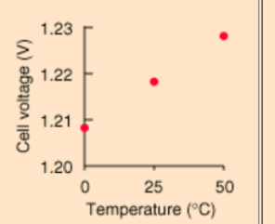

Group 2: Effect of concentration of KNO3 on the salt bridge

Group set up a zn/cu cell and soaked a salt bridge in 0.1 M KNO3. Record voltage. Move to a salt bridge of higher concentration and repeat this procedure.

They found a rapid increase in voltage with concentration until the concentration reached around 2.0 M then it started to plateau out. Limit to how low the resistance can go.

Group 3: Solution concentrations

Group set up a zn/cu cell using solutions that were 0.1 M. Increased the concentrations incrementally. Voltage increased a linear fashion with concentration

Group 4: electrode separation

This cannot be done with a salt bridge. Use a beaker with CuSO4 and dip the zn and cu electrodes in very briefly to this beaker. Adjust the separation each time. Using a voltmeter will give no variation. Using an ammeter will. The separation affects the current but not the voltage.

For 4 and 5, the electrode needs to always be at the same depth in the solution for good results. Same volume of solution should be used each time

Group 5: electrode surface area

Same set up as group 4 but using a range of electrode sizes. Again current increases with surface area but not voltage.

**SAC: Outcome 1 Unit 4: Experiment - Properties of ethanol**

**Preliminary discussion**

Ethanol can be produced naturally from the fermentation of sugar. There are not many countries in the world that do not have an alcohol industry. Ethanol, however, is a very useful chemical in its own right. It is a popular solvent and it is the starting point for the manufacture of other chemicals.

**Part A: Fractional distillation**

**Aim**: To obtain samples of ethanol using fractional distillation.

**Materials**

Quickfit apparatus as shown below – a measuring cylinder can be used instead of a receiving flask

Bottle of port or similar alcohol of content around 18% alcohol and red in colour

3 x 100 mL measuring cylinders

**Method**:

1**.** Measure 50 mL of wine and add it to the boiling flask

2. Add a few boiling chips

3. Have your teacher check your apparatus before heating

4. Heat gently

5. The first distillate should be obtained at a temperature around 78 0C. Catch a sample of

this in a 100 mL measuring cylinder.

8**.** Once the temperature reaches 90 0C, stop heating.



**Part B: Testing your fraction**

**Aim**: To test the properties of the fraction

**Materials**

Watchglasses

1 mL pipette

Balance

**Procedure**

**Determine the density of the alcohol fraction using the formula density = mass/volume**

**1.** Weigh a watchglass

**2.** Add 2 mL of the first alcohol fraction (measured accurately) to the watchglass and reweigh it.

**3.** Calculate the density of each sample

**Flammability**

Leave a small sample of the fraction on the watchglass

Try to set each fraction alight using a match.

Record whether the sample will burn or not.

**Solvent**

Use a large filter paper and draw any symbols on it using a series of dark biros.

Drop some of the fraction onto the symbols and observe the impact of the ethanol on the ink

**Solubility in water: Class demonstration**

Add 50 mL of water to a measuring cylinder.

Add 50 mL of ethanol (methylated spirits is a cheaper option) to another measuring cylinder.

Pour the ethanol into the water.

Observe the volume of the final solution

**Part C: Chemical reaction of ethanol**

**Aim**: To investigate the reaction of ethanol with potassium dichromate

**Materials:**

1 M sulfuric acid

0.5 M K2Cr2O7 solution

Test tube

**Procedure**

Add to a test tube – 5 drops of ethanol, 10 drops of 1M sulfuric acid and 5 drops of potassium dichromate solution.

Heat in a beaker of hot water until a colour change occurs. Record your observations.

**Questions**

Appropriate set out of results and observations 8 marks

*To include measurements and calculation of density and observations from each section*.

**Part A**

Ethanol boils at 78.5 0C and water at 100 0C. Fractional distillation should see the ethanol vaporise first and it can be collected before the water boils. Simple fractional distillation, however, does not lead to 100% separation of both components.

1. Draw a structural diagram of ethanol.

1 mark

1. Explain clearly why water has a higher boiling point than ethanol

_______________________________________________________________________  
  
_______________________________________________________________________

_______________________________________________________________________

_______________________________________________________________________

3 marks

1. What did you notice about the colour of the fractions compared to the original alcohol?

________________________________________________________________________

_______________________________________________________________________

2 marks

**4**. What safety precautions should be taken during distillation and why?

_______________________________________________________________________

_______________________________________________________________________

3 marks

**Part B**: Testing the ethanol

**5, a**. What was the density value you obtained from your sample?

___________________________________

**b**. The density of pure ethanol is listed as 0.78 g mL-1. What conclusion can you draw about the purity of your ethanol sample?

______________________________________________________________________________

______________________________________________________________________________  
 1 + 2 = 3 marks

**6**. Write a balanced equation for the complete combustion of ethanol.

________________________________________________________________________

2 marks

**7. a**. Describe the effect of dripping ethanol onto dark biro.

_______________________________________________________________________

_______________________________________________________________________

**b**. What property of ethanol is this highlighting?

_______________________________________________________________________

2 + 1 = 3 marks

**Part C**: **Reactions of ethanol**

**8. a**. Write a balanced half equation for the reaction of ethanol to ethanoic acid.

________________________________________________________________________

**b**. Write a balanced half equation for the reaction of dichromate ions to Cr3+ ions.

________________________________________________________________________

**c**. Identify the oxidant and the reductant in this reaction.

________________________________________________________________________

**d**. Write a balanced overall equation for the reaction.

________________________________________________________________________

**e**. How do you know when all the ethanol has reacted?

________________________________________________________________________

1 + 1 + 2 + 1 + 1 = 6 marks

**9. a**. What was the final volume when you added the 50 mL of water to 50 mL of water?

________________________________________________________________________

**b**. Suggest reasons why the volume is not 100 mL. Use your knowledge of bonding in

your answer.

________________________________________________________________________

________________________________________________________________________

________________________________________________________________________

1 + 2 = 3 marks

**Part D:**

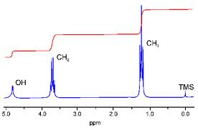**10.** An NMR spectrum for ethanol is shown below.

Explain each feature of this NMR

________________________________________________________________________

________________________________________________________________________

________________________________________________________________________

________________________________________________________________________

5 marks

**11.** An infrared spectrum of ethanol is shown.

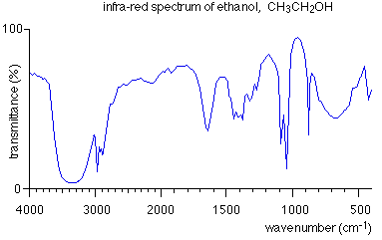

Explain what information can be ascertained from this spectrum.

________________________________________________________________________

________________________________________________________________________

________________________________________________________________________

3 marks

**12**. There are several possible pathways for the production of ethanol.

**a**. **i**. Write a balanced equation for the production of ethanol from fermentation of glucose.

________________________________________________________________________

**ii**. Can ethanol produced this way be referred to as bioethanol? Explain your answer.

________________________________________________________________________

_________________________________________________________________________

1 + 2 = 3 marks

**b. i**. Write a balanced equation for the production of ethanol from an alkene.

_________________________________________________________________________

**ii**. What category of a reaction is this? ___________________________________

2 + 1 = 3 marks

**c**. Write balanced equations for the production of ethanol from an alkane in two steps.

____________________________________________________________________________

2 marks

**Unit 4 Outcome 2**

**SECTION A – Response to stimulus material**

**Instructions for Section A**

A particular molecule is under investigation. The data provided should enable you to deduce the structure of this molecule.

Read the data and answer the questions set.

This task is open book.

Students should not communicate during this task.

Students must answer questions independently

**Aim**: To use the data provided to deduce the formula and structure of a molecule

**Data**

A 2.840 g sample of an organic molecule is found to contain 60.0 % carbon by mass and 26.7 % oxygen.

**1**. Complete the table provided to show the mass of each element present

|  |  |
| --- | --- |
| **element** | **mass present** |
| carbon |  |
| hydrogen |  |
| oxygen |  |

1 mark

**2**. Find the empirical formula of the mystery molecule.

________________________________________________________________

________________________________________________________________

2 marks

The mass spectrum of the molecule is shown below

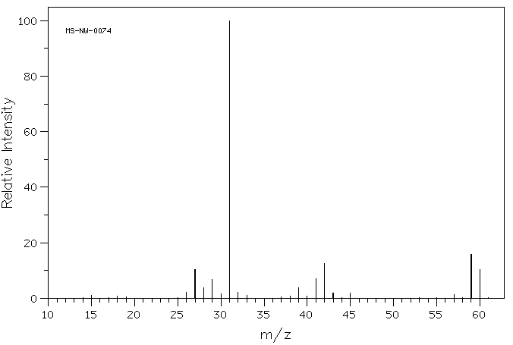

**3. i**. What is the mass of the parent molecular ion? _____________

**ii**. What is the molecular formula of the molecule?

___________________________________________________

**iii**. What is the mass of the base peak? ___________

3 marks

The infrared spectrum of the mystery molecule is shown below

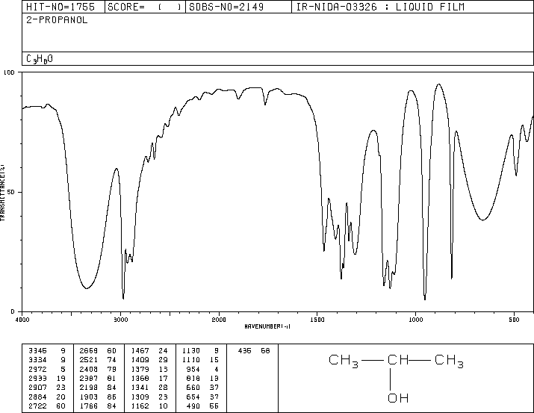

**4. i.** Referring to the infrared spectrum, do you think this is an alcohol molecule?

Explain your answer.

**___________________________________________________________**

**ii.** Does the molecule contain a C = O bond?

___________________________________________________________

2 marks

Two proposed structures for the mystery molecule are shown below.



Structure A Structure B

**5**. Give reasons from the evidence supplied so far for each of these molecules not to be the

mystery molecule we are investigating.

Molecule A ___________________________________________________________

___________________________________________________________

Molecule B ___________________________________________________________

___________________________________________________________

2 marks

**6**. The mystery molecule is an alcohol.

Draw two possible isomers of this alcohol. Name both isomers.

2 marks

**7**. A sample of each isomer is heated with sulfuric acid and potassium dichromate, K2Cr2O7,

on a water bath.

**i**. How could this help discern which isomer is the mystery molecule?

**_________ ___________________________________________________________**

**____________________________________________________________________**

**ii**. Draw and name the products formed from each reaction.

4 marks

The high resolution proton NMR of the molecule is shown below

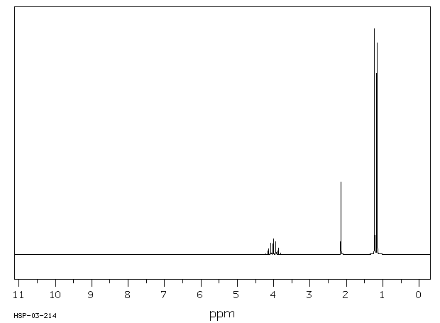

**8**. **i**. How many different hydrogen environments does this molecule have? ______

**ii**. Which isomer is the mystery molecule?

Explain your answer by explaining each feature of the NMR carefully

**___________________________________________________________**

**___________________________________________________________**

**iii**. How will the areas of each set of peaks compare if the NMR spectrum above is

integrated?

_______________________________________________________________

5 marks

**9**. The mystery molecule could be formed from an alkene.

**i**. Draw the pathway for this, listing any reagents required.

**ii**. What steps would be required to ensure that a pure product was obtained?

_______________________________________________________________

______________________________________________________________

4 marks

**10.** Howmany peaks will the 13C NMR of this molecule have?

____________________________________________________________________

1 mark

**11. a.** Will this molecule be soluble in water? Explain your answer.

____________________________________________________________________

____________________________________________________________________

2 marks

b. Write a balanced equation for the complete combustion of this molecule.

_____________________________________________________________________

2 marks

**Titration SAC task: Outcome 1 Unit 4**

**Aim**: To design a titration to determine the oxalic acid content of an impure sample.

**Materials**

Burette

Pipette

* 1. M NaOH

Balance

Oxalic acid

Sodium chloride

100 mL volumetric flask

**Sample preparation**: to be done with the whole class.

* Sit a 250 mL beaker on a balance.
* Tare the balance
* Add around 5 g of oxalic acid dihydrate but do not record the actual mass
* Add sodium chloride until the mass is around 6.0 g. Record the exact mass.
* Add 100 mL of distilled water and stir to dissolve solids.

Your task is to perform a titration to determine the %oxalic acid in the solids you added to the beaker. To do this you have to conduct a titration with 0.100 M NaOH solution.

Use a pipette and volumetric flask to dilute your sample by a factor of 10 before titrating.

You have to design the titration yourself, choosing the aliquot size and the indicator to use.

Conduct the titration to obtain concordant results.

**Experiment design**

1. Describe your titration procedure in point form 4 marks

**Results**

2. Record your volume measurements and mean titre 4 marks

**Report**

3. Write a balanced equation for the reaction (oxalic acid is C2H2O4). 2 marks

4. a. Calculate the number of mole of NaOH.

b. Calculate the number of mole of oxalic acid in your diluted sample.

c. Calculate the number of mole of oxalic acid in the original sample.

d. Determine the %mass of oxalic acid in the original sample (do not include the dihydrate in

the %mass oxalic acid.) (1 + 1 + 1 + 3 = 6 marks)

5. Explain your choice of indicator for this experiment. 3 marks

6. List what you used to rinse

* burette
* pipette
* volumetric flask
* conical flask 4 marks

7. Write equations to show the two stage ionisation of oxalic acid in water. 2 marks

8. List possible errors in this titration. 3 marks

9. What design modifications would you use to improve the procedure you used? 2 marks

10. Obtain results from other groups in the class. Comment on the precision of these results.

2 marks

11. If the NaOH was really 0.090 M in concentration, explain carefully how your results would have

differed.

2 marks

12. Explain the consequences of using methyl red as an indicator. 2 marks

13. Sodium hydroxide can be used as a secondary standard but not as a primary standard. Explain

using a chemical equation why it is not suitable as a primary standard. 2 marks

14. a. A solution is diluted by adding 20 mL of solution to a 250 mL volumetric flask, then adding

230 mL of distilled water. Why is this poor practice?

b. 10 mL of 2.0 M HCl is added to a 250 mL volumetric flask and it is made up to the mark with

distilled water.

What is the concentration of the diluted solution?

1 + 1 = 2 marks

Total 40marks

**SAC: Practical investigation: Sucrose Experiment**

**Background**

Sucrose is a disaccharide produced in many plants. We are familiar with it as a natural sweetener but keep in mind that it is an organic chemical with chemical properties that can be tested.

**Aim**: To investigate the properties of sugars.

**Part A**: Properties of sucrose

**Materials**

Ignition tubes

Bunsen burner

Hand lens or microscope

Power supply

Ammeter

Carbon electrodes

Tongs

Sugar

**Procedure**

***This experiment is best set up as a workstations – one task at each station means less equipment is required***

**Crystal structure**

Use a hand lens to inspect sugar crystals.

Do they have a predominant shape?

**Solubility and conductivity**

1. Stir a spatula of salt into 50 mL of water in a beaker. Describe the solubility of salt.

2. Use a simple circuit with power supply, ammeter and two carbon electrodes to test the

electrical conductivity of the salt solution.

3. Repeat for table sugar

**Flammability (Teacher demo limits mess)**

1. Use tongs and a fume cupboard to see if you can get a sugar cube to burn. Hold it in a

Bunsen flame and then withdraw it if it seems to be burning.

2. Coat another sugar cube in a layer of fine ash (charcoal or activated charcoal) and try again.

Do you notice a difference?

**Heat resistance**

1. Fill one third of an ignition tube bulb with sucrose.

2. Heat it slowly and carefully in a Bunsen, observing each change in the sugar. Stop

heating before large amounts of gas evolve.

3. Allow the ignition tube to cool to re-examine it. Record your observations.

**Part B**: Reactions of sucrose

**Materials**

Sulfuric acid 8.0M

Benedict’s solution

Test tubes

Bunsen burner

Tripod

Gauze mat

250 ml beaker

Sucrose

Dried yeast

Limewater

5% sucrose solution

5% glucose solution

**Sucrose and sulfuric acid**

1. Fill one third of an ignition tube with sugar.

2. **CAREFULLY** cover the sugar in a layer of concentrated sulfuric acid.

3. Watch the test tube over the next hour and record any changes.

**Sucrose and yeast**

1. Add two spoons of sugar to a flask of warm water.

2. Add some dried yeast to the flask.

3. Stopper the flask and run a tube from the flask through a beaker containing lime water.

4. Sit the apparatus on the window sill in a warm environment for a few days.

5. Record your observations.

**Sugars and Benedict’s Solution**

1. Add about 200 mL of water to a 250 mL beaker and heat on a tripod over a bunsen. This

is your water bath.

2. Add 10 mL of glucose solution to a test tube.

3. Add 5 mL of Benedict’s solution to the test tube.

4. Sit the test tube in the beaker of hot water and boil gently for 10 minutes.

5. Prepare a second test tube using Benedict’s solution and 10 mL of sucrose.

6. Add this test tube to the water bath to boil gently with the other test tube.

7. Compare the colour changes occurring in the test tubes.

8. Record your observations

Clear record of all experimental results 10 marks

**Questions**

**1**. List three properties of sucrose.

__________________________________________________________________

__________________________________________________________________

3 marks

**2**. Draw a molecule of glucose and a molecule of fructose showing all bonds.

Circle and label all functional groups.

Draw the products formed when the molecules react.

6 marks

**3.** **a**. What type of reaction is this?

_____________________________________________________________________

**b**. Is mass conserved during this reaction? Explain your answer.

_____________________________________________________________________

_____________________________________________________________________

3 marks

**4**. Explain the solubility of sucrose.

_____________________________________________________________________

_____________________________________________________________________

2 marks

**5**. Explain the conductivity of sugar.

_____________________________________________________________________

_____________________________________________________________________

2 marks

**6**. What is the role of the ash when burning the sugar?

_____________________________________________________________________

_____________________________________________________________________

2 marks

**7. a**. What changes occurred when the sugar was heated?

_____________________________________________________________________

_____________________________________________________________________

**b**. How did the bonding change during the heating process?

_____________________________________________________________________

_____________________________________________________________________

**c**. Is the change permanent? _______________________________________________________________________

_______________________________________________________________________

**d**. Write a possible equation for the reaction occurring.

______________________________________________________________________

_______________________________________________________________________

7 marks

**8**. What are the likely products of combustion of sucrose?

_____________________________________________________________________

1 mark

**9**. Write a balanced equation for the combustion of sucrose.

_____________________________________________________________________

1 mark

**10**. Write a balanced equation for the reaction occurring when sucrose is reacted with

sulfuric acid.

_____________________________________________________________________

1 mark

**11. a**. How did the reactions of glucose and sucrose compare with Benedict’s solution?

_______________________________________________________________________

_______________________________________________________________________

1. What is the significance of this reaction?

_______________________________________________________________________

_______________________________________________________________________

4 marks

**12**. What are the products of fermentation?

_____________________________________________________________________

2 marks

**13.** **a**. Write an equation for the reaction occurring in the limewater.

_____________________________________________________________________

**b**. Write an equation for the fermentation reaction.

_____________________________________________________________________

**c.** The fermentation reaction features glucose, not sucrose. Describe one function

of the yeast in the fermentation reaction.

_______________________________________________________________________

_______________________________________________________________________

4 marks

**14**. Explain some safety precautions you have taken during this experiment.

_______________________________________________________________________

_______________________________________________________________________

2 marks

**Chemistry Unit 4** Outcome 2

Food SAC Experiment

**Title**: Invertase in action.

**Aim**: To investigate the behaviour of the enzyme invertase

**Background**

Invertase (sucrase) is an enzyme that catalyses the hydrolysis of sucrose into fructose and glucose.

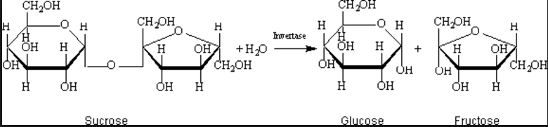

The progress of this reaction can be monitored through the use of the Benedict’s reagent. Benedict’s reagent produces a brownish colour in the presence of reducing sugar. Sucrose is not a reducing sugar but glucose and fructose are. Therefore a sucrose solution produces no colour change but a glucose or fructose solution will.

**Materials**

Yeast sachet

Water baths

Test tubes

* 1. M sucrose solution ( 9 g of table sugar to 250 mL tap water)

Benedict’s reagent

1. 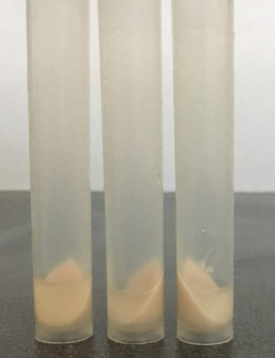M NaOH

Buffer solutions: pH 1, pH 5, pH 7, pH 9, pH 11

**Invertase preparation**

Add a sachet of yeast to 175 mL of tap water in a flask.

Place in a 40 0C water bath for 30 minutes.

Centrifuge for 10 minutes.

Pipette off the supernatant liquid – this is the enzyme stock

**Part A: Enzyme functionality and pH**

Aim: To investigate the effect of pH on the activity of invertase

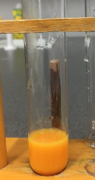

**Method**

A hot water bath set to 70 0C should be set up for the latter steps.

Add 2mL of each buffer to 5 separate test tubes. Label each test tube

Add 2 mL of sucrose and 2 mL of invertase to each tube. Leave for approximately 5 minutes.

Add 10 drops of 1.0 M NaOH solution to each test tube to establish an alkaline environment.

Add 2 mL of Benedict’s reagent to each test tube and add each test tube to the water bath

Time how long it takes for each test tube to reach a particular intensity of brown solution.

**Part B: Enzyme functionality and temperature**

**Aim**: To investigate the effect of temperature on the activity of invertase

**Method**

Set water baths at temperatures of 20 0C, 30 0C, 40 0C, 50 0C and 60 0C.

Place 2 mL of buffer 5 into each test tube and 2 mL of invertase.

Place one test tube in each water bath and leave 25 mins.

Add 2 mL of sucrose to each test tube.

Place back in the water bath in each test tube.

Take each test tube out and cool in an iced water bath (about 4 mins)

Add 2 mL of Benedict’s solution to each test tube.

Return the test tubes to the 70 0C water bath and time how long it takes for the brown colour to form.

**Results**

Appropriate presentation of results 4 marks

**Graphs**

For Part A draw a graph of time for brown formation vs pH of buffer.

For Part B draw a graph of time for brown formation vs temperature. 6 marks

**Questions**

**Part A**

1. Put into your own words how Part A is designed to work. 3 marks

2. Identify the independent variable, the dependent variable and any controlled variables. 4 marks

3. What conclusion can you draw from your graph about the performance of invertase? 2 marks

4. Explain what is happening to invertase at a pH of 13. 2 marks

5. The equations below show the reactions occurring when Benedict’s reagent is added.

a. What type of reaction is this?

b. What is happening to the copper ions during this reaction?

c. Why is there a colour change?

d. Refer to the equations to explain why NaOH was added to the mixture. 5 marks

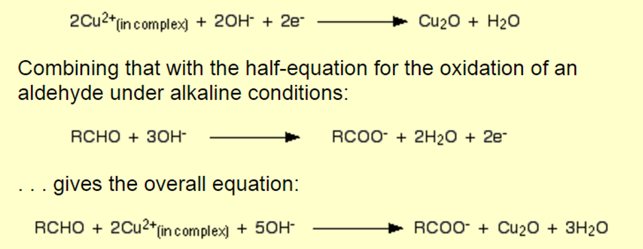

6. Glucose is a reducing sugar, sucrose is not. Glucose can form an open chain molecule with an aldehyde group. Sucose does not.

Explain what Benedict’s reagent is showing. 3 marks

**Part B**

7. Identify the independent variable, the dependent variable and any controlled variables. 4 marks

8. Discuss what your graph is showing about the impact of temperature on enzyme activity. 3 marks

9. a. Explain why the reaction rate increases from 20 0C to 40 0C.

b. Explain why the reaction rate decreases from 40 0C to 60 0C. 4 marks

Teacher notes

The preparation of invertase is simple and a fresh batch leads to better results.

There is an assumption that the action of invertase stops when the NaOH is added to the test tubes.