2021 Unit 2 Chemistry trial exam

Name: ____________________ Total: ______/83

Section A: Multiple Choice section

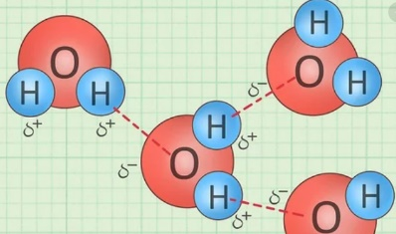
Question 1

The dashed bonds shown in the diagram are examples of
A. dispersion forces.
B. intramolecular forces.
C. hydrogen bonds.
D. covalent bonds.

Question 2
Which of the following will require the most energy?
A. heating 60 g of water from 60 ºC to 80 ºC
B. heating 20 g of water by 60 ºC
C. heating 80 g of olive oil by 22 ºC
D. heating 80 g of water by 22 ºC

Question 3
All of the following substances are soluble in water. Which one dissolves through dissociation?
A. ethanol
B. NaCl
C. HCl
D. NH₃

Question 4
Select the correct statement about the properties of water.
A. Energy is released when steam condenses to water.
B. The density of water will increase as it turns to ice.
C. Water will always boil at exactly 100 ºC.
D. All ionic solids will dissolve in water.

Question 5
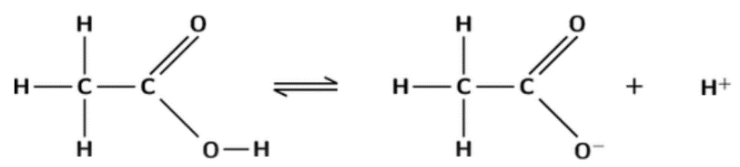

The diagram above can be used to explain
A. that ethanoic acid is a strong acid.
B. that ethanoic acid is a weak acid.
C. that hydrogen bonds can form when ethanoic acid is added to water.
D. that ethanoic acid dissociates in water.
Question 6
This substance is a molecular compound. It
- is soluble in water
- will have a low pH in water
- will react with magnesium to produce magnesium sulfate as one of the products.
The substance is
A. NaCl
B. NaOH
C. HCl
D. H₂SO₄

Question 7
Which of the following will have a pH of 13?
A. 0.1 M HCl
B. 0.1 M H₂SO₄
C. 0.1 M NaOH
D. 1.0 M KOH

Question 8
The products of a reaction are potassium chloride and water. The reactants were
A. KOH and HCl
B. K₂CO₃ and HCl
C. K and HCl
D. KOH and H₂SO₄

Question 9
In which of the following is the oxidation number of sulfur highest?
A. S₈
B. H₂SO₄
C. SO₂
D. H₂S

Question 10
Which alternative is a correctly balanced half-equation?
A. O₂ + 2e⁻ O²⁻
B. MnO₄⁻ + 2H₂ + 2e⁻ Mn²⁺ + 4OH⁻
C. 2FeCl₂ + Cl₂ 2FeCl₃
D. ClO₃⁻ + 6H⁺ + 6e⁻ Cl⁻ + 3H₂O

Question 11
The oxidising agent in a redox reaction
A. will lose electrons as it is reduced.
B. will gain electrons as it is oxidised.
C. will gain electrons as it is reduced.
D. will always be a non-metal atom as it will gain electrons.

Use the following solubility curves to answer questions 12 to 14.

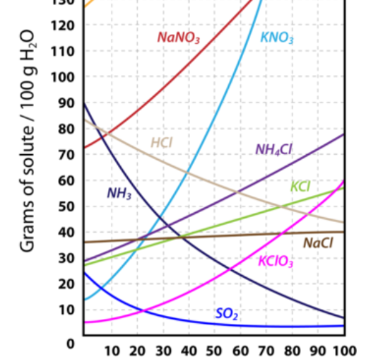 temperature

Question 12
Which of these substances is the least impacted by temperature?
A. NaNO₃
B. KCl
C. KClO₃
D. NaCl

Question 13
Which of the following is most likely to be a gas?
A. NH₃
B. KCl
C. NaCl
D. KNO₃

Question 14
The mass of NH₄Cl that can be dissolved in 500 g of water at 70 ºC is closest to
A. 62 g
B. 100 g
C. 310 g
D. 372 g

Use the following information to answer questions 15 and 16.

The equation for the reaction between butane and oxygen is

2C₄H₁₀(g) + 13O₂(g) 8CO₂(g) + 10H₂O(l)

Question 15
The number of mole of CO₂ that can be formed from 52 mole of oxygen is
A. 32
B. 52
C. 64
D. 85

Question 16
The mass of water that can be formed from 116 g of butane is, in g,
A. 10
B. 180
C. 240
D. 360

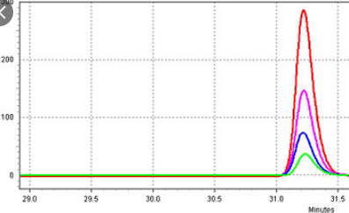
Question 17
This HPLC diagram shown can be used to explain
A. how the retention time changes with concentration.
B. how the peak area changes with concentration.
C. how the peak area changes with temperature.
D. how the choice of stationary phase impacts retention time.

Question 18
The chromatogram below was produced when a sample of ink was spotted onto the base of a sample of chromatography paper.
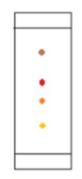
D
A
Select the statement below that can be made with the most certainty.
A. The ink contains four components only.
B. Substance A will be more soluble than substance D in all solvents.
C. Substance D spends more time on the stationary phase than substance A.
D. Substance A contains smaller molecules than substance D.

Question 19
A student uses gravimetric analysis to determine the concentration of a 100 mL solution of MgCl₂. She takes a 10 mL sample from the solution and adds excess AgNO₃ solution to it. The number of mole of precipitate formed is 0.02 mol. The number of mole of MgCl₂ in the original solution is
A. 0.01
B. 0.02
C. 0.1
D. 0.2

Question 20
A 0.20 M NaOH solution is used in a titration to determine the concentration of a sulfuric acid solution. 20.0 mL aliquots of NaOH are used and the mean titre of sulfuric acid is 15.0 mL. The concentration of the sulfuric acid solution is, in M,
A. 0.13
B. 0.15
C. 0.20
D. 0.26

Section B: Short answer questions

Question 1 (12 marks)
a. What is the oxidation number of the element in bold? 4 marks

i. N₂O₄ ________ ii. NH₃ _________ iii. BrO₃⁻ _________ iv. SO₃²⁻ _____________

b. Complete the following half-equations and label each as oxidation or reduction. 4 marks

i. Fe²⁺ Fe³⁺ Oxidation or reduction? _________________

ii. Br⁻ Br₂ Oxidation or reduction? _________________

iii. MnO₄⁻ + H⁺ Mn²⁺ Oxidation or reduction? _________________

c. i. Which one of the following reactions will occur spontaneously? 1 mark

Ca + ZnCl₂

Zn + CaCl₂

ii. Explain how you arrived at your decision. 1 mark

_____________________________________________________________________________________

____________________________________________________________________________________

iii. For the reaction that occurs write the half-equations. 2 marks

_____________________________________________

_____________________________________________

Question 2 (11 marks)
a. Categorise the following as acid, base or neutral.

LiOH ________ HNO₃ ___________ CH₃CH₂OH __________ 3 marks

b. Calculate the pH of the following solutions: 3 marks

i. 0.001 M HNO₃ ______________________ ii. 0.25 M HCl _____________________

iii. 0.01 M NaOH __________________________________________________________________

c. Use examples to explain the difference between a weak acid and a dilute acid. 2 marks

_______________________________________________________________________________

________________________________________________________________________________

d. Write balanced equations for the reactions below: 3 marks

i. zinc + hydrochloric acid ___________________________________________________

ii. sulfuric acid (H₂SO₄) + calcium carbonate ______________________________________________

iii. nitric acid (HNO₃) + magnesium hydroxide _____________________________________________

Question 3 (9 marks)
a. One of potassium nitrate and zinc carbonate is soluble in water and the other is not.

i. Which one will be soluble? _____________________________ 1 mark

ii. Draw how the particles are arrangement when it dissolves in water. 2 marks

b. Nitric acid, HNO₃, is soluble in water.
Write an equation to show the reaction between nitric acid and water. 1 mark

__________________________________________________________________________________

c. Methanol is soluble (or miscible) in water.
Draw the bonding that occurs between methanol molecules and water molecules. 2 marks

d. Calculate the energy required to heat 650 g of water from 18.4º C to 85.0 ºC. 1 mark

___________________________________________________________________________________

e. The volume of 2.0 g of an ice sample is calculated and then the ice is allowed to thaw. How will the volume of
the ice, once thawed, compare to what is was before thawing? Justify your answer. 2 marks

_________________________________________________________________________________________

_________________________________________________________________________________________

Question 4 (10 marks)
The equation for the reaction between ethane and oxygen is:

2C₂H₆(g) + 7O₂(g) 4CO₂(g) + 6H₂O(g)

a. Given a sample of 10 mol of ethane, calculate the number of mol of 3 marks

i. oxygen required for the reaction _____________________________

ii. CO₂ formed _____________________ iii. H₂O formed ___________________

b. Given a sample of 64.0 g of O₂, calculate the mass of CO₂ that can be formed. 2 marks

__________________________________________________________________________________

___________________________________________________________________________________

c. The concentration of a copper sulfate, CuSO₄, solution can be analysed using gravimetric analysis.

i. Write a balanced equation to show the precipitate that will form if NaOH is added to CuSO₄. 1 mark

________________________________________________________________________________

ii. Write a balanced equation to show the precipitate that will form if Ba(NO₃)₂ is added to CuSO₄. 1 mark

_________________________________________________________________________________

iii. Given a 50 mL solution of CuSO₄, outline a procedure you would follow to gravimetrically determine the
concentration of the CuSO₄. 3 marks

__________________________________________________________________________________

___________________________________________________________________________________

__________________________________________________________________________________

___________________________________________________________________________________

Question 5 (10 marks)
a. 20.0 g of sodium carbonate is dissolved in water to make a 400 mL solution.
Calculate the concentration of the NaCl 3 marks

i. in molarity _____________________________________________________

ii. in g L⁻¹ _____________________________________________________

iii. as a %(m/V) _____________________________________________________

b. i. A student is able to dissolve 520 g of CuSO₄ in 2.0 litres of water at 12 ºC. Calculate the solubility in g/100 g of
solution for the CuSO₄ at that temperature. (assume 1 mL = 1 g for the solution) 2 marks

__________________________________________________________________________________

___________________________________________________________________________________

ii. Explain how the student could make a supersaturated solution of CuSO₄. 2 marks

__________________________________________________________________________________

___________________________________________________________________________________

c. A student uses a titration to determine the concentration of a sulfuric acid solution. A 20.0 mL aliquot of sulfuric
acid requires a titre of 24.6 mL of 0.105 M NaOH for neutralisation.
Use a balanced equation for the reaction to determine the concentration of the acid. 3 marks

__________________________________________________________________________________

___________________________________________________________________________________

__________________________________________________________________________________

___________________________________________________________________________________

Question 6 (11 marks)
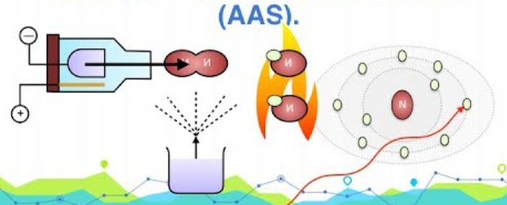

The diagram above shows an outline of the procedure involved in atomic absorption spectroscopy.
a. i. What type of substances is AAS best suited to? 1 mark

_____________________________________________________________________________

ii. Explain clearly why some atoms will absorb radiation? 1 mark

_____________________________________________________________________________

iii. Do sodium and calcium absorb the same radiation? Explain your answer. 2 marks

_____________________________________________________________________________

_____________________________________________________________________________

iv. How will the machine respond differently to a 0.1 M solution of LiCl compared to a 0.5 M solution of LiCl? 1 mark

_____________________________________________________________________________

b. A calibration curve is shown below for lead solutions. (ppm can be assumed to be mg L⁻¹)
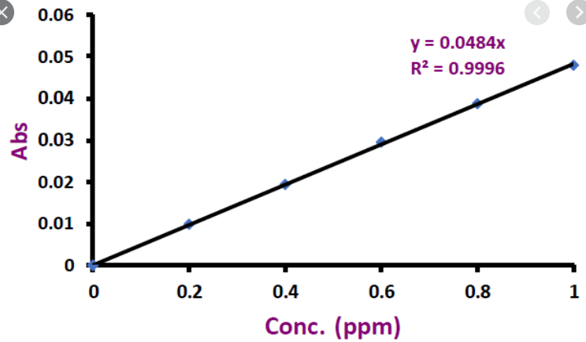
i. How was this curve produced? 1 mark

______________________________________________________________________________________

ii. A lead sample is diluted by making 1 mL up to 10 mL. The absorbance of the diluted solution is 0.025.
Determine the mass of lead in the sample. 2 marks

_____________________________________________________________________________

_____________________________________________________________________________

c. A HPLC chromatogram for a solution is shown below.
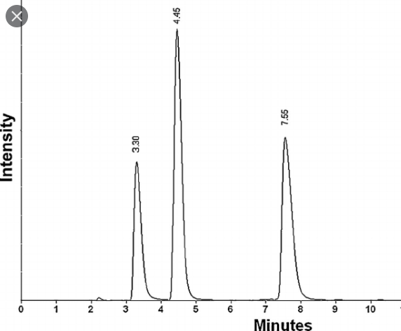

Explain what you can deduce from this chromatogram. 3 marks

_____________________________________________________________________________

_____________________________________________________________________________

_____________________________________________________________________________

End of exam

Section A: 20 marks
Section B: 63 marks

