2021 Unit 3 Chemistry trial exam

Name: ____________________ Total: ______/82

Section A: Multiple Choice section

Use the following information to answer Questions 1 and 2.
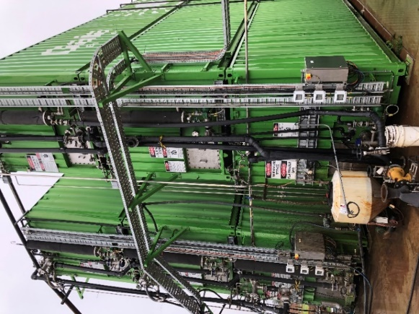
The effluent from the barn below is connected to the biodigestor
shown. The biodigestor in turn is connected to a gas generator.

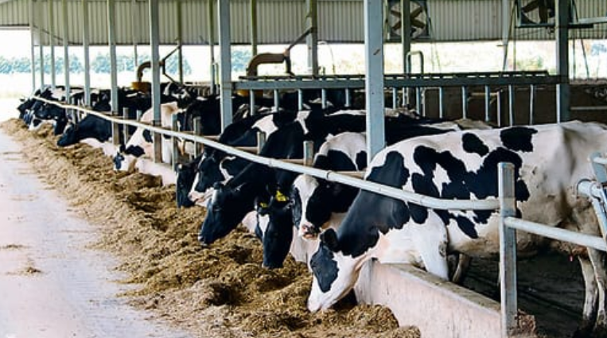

Question 1
Select the alternative that describes the processes occurring.
A. The biodigestor will convert the carbohydrates in effluent to bioethanol that can then form electricity.
B. The effluent is burnt to produce electrical energy.
C. The biodigestor will produce a gas mixture that is burnt to produce electrical energy.
D. The biodigestor will produce bioethanol which can be used with triglycerides to form biodiesel.

Question 2
The best description of the sustainability of this process is:
A. The process is non-renewable as the volume of fuel is limited by the small number of cows.
B. This process is renewable and it does not produce any greenhouse emissions.
C. This process is renewable but it releases significant amounts of methane to the atmosphere.
D. This process is renewable but it will still produce greenhouse emissions.

Question 3
Which of the following will release the most CO₂ from complete combustion?
A. 3.8 mol of methane.
B. 2 mol of ethane.
C. 0.9 mol of butane.
D. 0.4 mol of octane.

Question 4
Which of the following will release the most energy?
A. 49.6 L of methane at SLC.
B. 30 g of methane.
C. 50 L of ethane at SLC.
D. 33 g of octane.

Question 5
Which of the following fatty acids will have the lowest melting point?
A. stearic acid
B. linoleic acid
C. linolenic acid
D. arachadic acid

Question 6
An energy profile diagram is shown below.
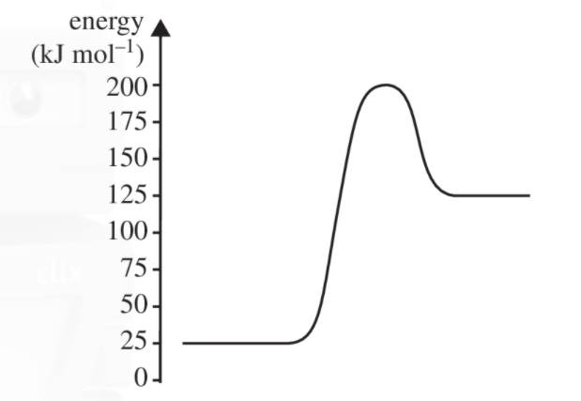

Which alternative correctly shows the activation energy and enthalpy change of the reverse reaction?
A. -75 kJ mol⁻¹ and -100 kJ mol⁻¹
B. +175 kJ mol⁻¹ and -100 kJ mol⁻¹
C. +75 kJ mol⁻¹ and -100 kJ mol⁻¹
D. +175 kJ mol⁻¹ and +100 kJ mol⁻¹

Question 7
In which of the following is the oxidation number of nitrogen +5?
A. NH₃
B. HNO₃
C. N₂O₄
D. NO₂

Question 8
The balanced half-equation for the reaction of ethanol to ethanoic acid is:
A. C₂H₆O(aq) + O₂() C₂H₄O₂(aq) + 2H₂O(l) + 4e⁻
B. C₂H₆O(aq) + H₂O(l) + 4e⁻ C₂H₄O₂(aq) + 4H⁺(aq)
C. C₂H₆O(aq) + 2OH⁻(aq) C₂H₄O₂(aq) + H₂O(l) + 2e⁻
D. C₂H₆O(aq) + H₂O(l) C₂H₄O₂(aq) + 4H⁺(aq) + 4e⁻

Question 9
The reaction at the anode in a methane fuel cell operating in acid conditions is:
A. O(g) + 4H⁺(aq) + 4e⁻ 2H₂O(l)
B. CH₄(g) + 4H⁺(aq) CO₂(g) + 4H₂O(l) + 4e⁻
C. CH₄(g) + H₂O(l) CO₂(g) + 4H⁺(aq) + 4e⁻
D. CH₄(g) + 2H₂O(l) CO₂(g) + 8H⁺(aq) + 8e⁻

Use the following information to answer questions 10 and 11
The diagram shows a cross section of a zinc, bromine flow battery. This cell can be charged to produce zinc and bromine. When power is required, the zinc and bromine can be reacted with each other.
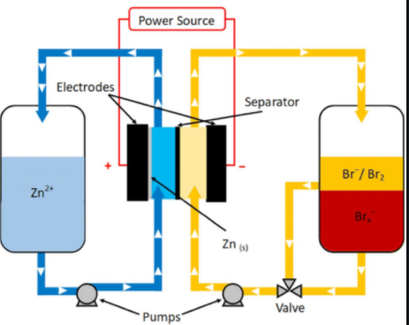

Question 10
In this cell, whether charging or discharging, the
A. zinc will always be the negative electrode.
B. bromine will always be the anode.
C. electrons will always flow from the zinc electrode to the bromine electrode.
D. zinc will always be the anode.

Question 11
The overall equation in this cell when it is charging will be
A. Zn(s) + Br₂(l) Zn²⁺(aq) + 2Br⁻(aq)
B. Zn²⁺(aq) + Br₂(l) Zn(s) + 2Br⁻(aq)
C. Zn²⁺(aq) + 2Br⁻(aq) Zn(s) + Br₂(l)
D. Zn(s) + 2Br⁻(aq) Zn ²⁺(aq) + Br₂(l)

Question 12
A copper half-cell is connected to a half-cell that has hydrogen gas pumped into a graphite electrode. In this cell
A. the copper electrode will gradually dissolve and water will be produced at the anode.
B. oxygen gas will be formed at the cathode and water at the anode.
C. copper metal will be deposited at the cathode and water at the anode.
D. copper metal will be deposited at the cathode and the pH will drop at the anode.

Question 13
When hydrochloric acid is added to sodium thiosulfate, the following reaction occurs gradually.

Na₂S₂O₃(aq) + 2HCl(aq) 2S(s) + SO₂(g) + 2NaCl(aq) + H₂O(l)

The rate of this reaction can be monitored by placing the beaker the reaction is taking place in on top of a cross. As the reaction proceeds, the solution becomes cloudier and the cross obscured.
Which of the following lists contains only changes that will lower the reaction time of the reaction?
A. Decreased temperature, decreased HCl concentration and addition of a catalyst.
B. Decreased temperature, increased HCl concentration and addition of a catalyst.
C. Increased temperature, decreased HCl concentration and addition of further water.
D. Increased temperature, addition of a catalyst and increasing of the HCl concentration.

Question 14
The reaction between nitrogen monoxide and chlorine gas is

2NO(g) + Cl₂(g) ⇄ 2NOCl(g)

2.0 mole of NOCl is added to an empty reactor. At equilibrium 1.4 mole remains. The number of mole of gas in the reactor is
A. 1.5
B. 2.3
C. 3.5
D. unable to be determined.

Use the following diagram to answer Questions 15 and 16
The equation for the formation of ammonia is:

N₂(g) + 3H₂(g) ⇄ 2NH₃(g) ∆H = -92 kJ mol⁻¹ K_{c} = 729 M⁻² at 100 ºC.

Question 15
The magnitude of K_{c} for the equation

N₂(g) + H₂(g) ⇄ NH₃(g) at 100 ºC will be:

A. 0.0014
B. 9
C. 27
D. 729

Question 16
The volume of an equilibrium mixture of the above gases is halved. When equilibrium is re-established, compared to the first point of equilibrium, the
A. concentration of hydrogen will be lower and the amount will be lower.
B. concentrations of nitrogen and hydrogen gases will be lower.
C. position of equilibrium is unchanged because the temperature is unchanged.
D. concentration of hydrogen will be higher but the amount will be lower.

Question 17
A current is passed through a 0.1 M solution of Fe(NO₃)₂ using iron electrodes. The products at the anode and cathode respectively will be
A. oxygen gas and hydrogen gas.
B. iron ions and iron metal.
C. oxygen gas and iron metal.
D. iron ions and hydrogen gas.

Question 18
2000 C of charge is passed through each of the following cells. Which cell will see the deposition of the highest mass of metal?
A. 0.1 M Sn(NO₃)₄
B. 0.1 M Sn(NO₃)₂
C. 0.1 M AgNO₃
D. 0.1 M Ca(NO₃)₂

Question 19
A beaker contains a mixture of 0.1 M Pb(NO₃)₂, 0.1 M Al(NO₃)₃ and 0.1 M Ca(NO₃)₂. Graphite electrodes are added to the circuit and a current is passed through it until metals stop depositing on the cathode. The order in which the metals deposit will be
A. lead only.
B. lead then aluminium only.
C. lead then calcium only.
D. lead, then aluminium, then calcium.

Question 20
A student constructs a galvanic cell from standard zinc and copper half-cells. She sets the room temperature at 25 ⁰C. The voltage obtained is 0.72 Volts. She repeats the arrangement for four more cells and obtains further voltages of 0.71 V, 0.73 V and 0.72 V. The student’s results are an example of data that is
A. precise but the accuracy cannot be determined.
B. accurate but not precise.
C. precise but not accurate.
D. accurate and precise.

Section B: Short answer questions

Question 1 (9 marks)
The diagram below is of the process used to form biodiesel. The labels have been removed from the diagram.
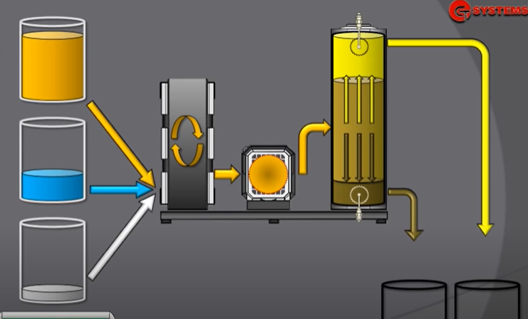

______________

______________
_______________

_____________ _______________

a. Use the lines provided on the diagram to
i. name the two reactants and the reagent required for this process. 2 marks

ii. name the two products from the process. 2 marks

b. i. Give an example of a common source in Australia of raw material for this process. 1 mark

_________________________________________________________________________________

ii. Explain why the two products are relatively easy to separate. 1 mark

___________________________________________________________________________________

iii. How is this product used in Australia? 1 mark

____________________________________________________________________________________

c. Draw the structure of an example of a biodiesel molecule. (Semi-structural diagram acceptable.) 2 marks

Question 2 (9 marks)
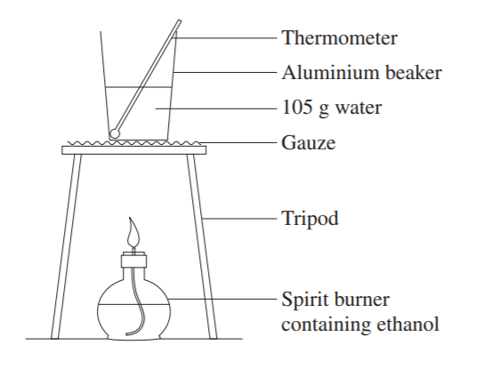
A student’s apparatus used to measure the enthalpy of combustion
of ethanol is drawn on the right.

a. Write a balanced equation for the reaction occurring. 1 mark

________________________________________________

b. If the mass change of ethanol is 0.740 g, what is the theoretical
temperature change? 2 marks

____________________________________________________________________________________

____________________________________________________________________________________

____________________________________________________________________________________

c. i. Are the student’s results likely to be higher or lower than theoretical predictions? Explain your answer.
2 marks
______________________________________________________________________________________

______________________________________________________________________________________

ii. Suggest two modifications that could be made to this procedure to improve the results obtained. 2 marks

______________________________________________________________________________________

______________________________________________________________________________________

d. Olive oil is used to replace the water in the beaker. Discuss the likely impact of this change and whether valid
results could still be obtained for the heat of combustion of ethanol. 2 marks

______________________________________________________________________________________

______________________________________________________________________________________

Question 3 (8 marks)
One form of lithium cell being trialled uses a grid of lithium in graphite and a grid of lithium in iron (III) phosphate.
The cell is rechargeable and the diagram below shows the cell being discharged.
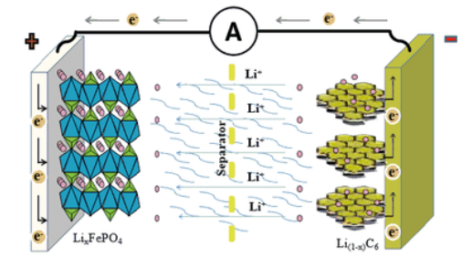

__________ _____________

_ _ _ _ _ _ _ - - - - - - - - - -

The half-equations occurring in the discharging cell are:
LiC₆ Li⁺ + C₆ + e⁻
FePO₄ + Li⁺ + e⁻ LiFePO₄
a. i. Use the boxes and lines provided to show the polarity of the electrodes during discharge. 1 mark

ii. Use the solid lines to indicate the anode and cathode during discharge. 1 mark

iii. Use the dashed lines to indicate the anode and cathode during recharge. 1 mark

b. Use the headings below to write overall equations for

i. Discharge: ______________________________________________________________ 1 mark

ii. Recharge: ______________________________________________________________ 1 mark

c. What is the oxidation number change occurring in the half-equation FePO₄ + Li⁺ + e⁻ LiFePO₄? 1 mark

_______________________________________________

d. Give two reasons why lithium is so popular in newer technology cells. 2 marks

___________________________________________________________________________________

____________________________________________________________________________________

Question 4 (11 marks)
The diagram below is of an electrolytic cell where the electrolyte is brine, concentrated NaCl solution.
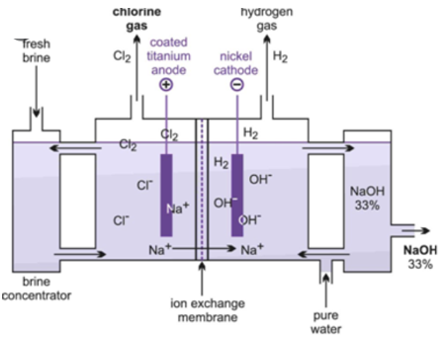

a. i. Sodium metal is not formed in this cell. Explain why? 1 mark

______________________________________________________________________________________

ii. Oxygen gas is not formed in this cell. Explain why. 2 marks

______________________________________________________________________________________

_______________________________________________________________________________________

b. Use the headings below to write the half-equations and overall equations for the reactions in this cell. 3 marks

Anode: ____________________________________________________________

Cathode: _____________________________________________________________

Overall: _____________________________________________________________

c. Why is this cell useful? 2 marks

_______________________________________________________________________________________

_______________________________________________________________________________________

d. The cell operates at 25 ºC and 200 kPa. Calculate the volume of gas produced when a current of 240 amps runs
for 1.00 hour. 3 marks

___________________________________________________________________________

___________________________________________________________________________

____________________________________________________________________________

Question 5 (10 marks)
Two diagrams from a textbook are shown below.
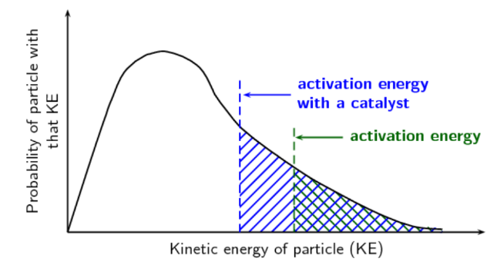
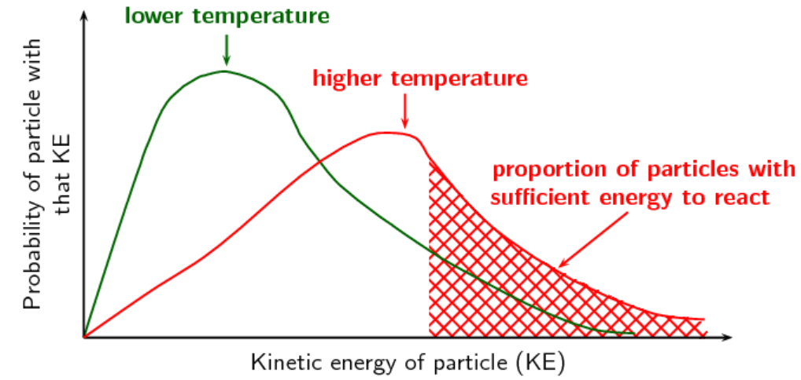
Diagram 1 Diagram 2

a. Discuss what Diagram 1 is illustrating. In your answer give an example of a reaction where the conditions can be
varied to investigate the concept involved. 3 marks

______________________________________________________________________________________

_______________________________________________________________________________________

_______________________________________________________________________________________

______________________________________________________________________________________

b. Discuss what Diagram 2 is illustrating. In your answer, draw an energy profile diagram to further explain your
answer. 3 marks

________________________________________________________________________________________

_________________________________________________________________________________________

_________________________________________________________________________________________

c. The decomposition of hydrogen peroxide, H₂O₂, is often studied as an example of a rate of reaction. A range of
catalysts can be used for this experiment, including potato, liver and manganese dioxide.
Outline an experiment you could perform to compare the effectiveness of various catalysts. Include in your
answer
- an equation for the reaction
- an experimental set-up
- what you will measure to judge rate
- how you will compare the catalysts. 4 marks

________________________________________________________________________________________

_________________________________________________________________________________________

_________________________________________________________________________________________

__________________________________________________________________________________________

Question 6 (8 marks)
The following reaction can be used to produce nitrosyl bromide:

2NO(g) + Br₂(g) ⇄ 2NOBr(g) ∆H = - 16.1 kJ mol K_{c} = 1.3 × 10⁻² M⁻¹ at 1000 K

a. What are the values of ∆H and K_{c} for the reaction 2 marks

NO(g) + ½ Br₂(g) ⇄ NOBr(g)?

∆H _____________________ and K_{c} __________________________

b. What are the values of ∆H and K_{c} for the reaction 2 marks

NOBr(g) ⇄ NO(g) + ½ Br₂(g)?

∆H _____________________ and K_{c} __________________________

c. The temperature of an equilibrium mixture of the above gases is increased. Explain the impact of this change on
i. the concentration of NOBr. 1 mark

_________________________________________________________________________________________

ii. the rate of the forward reaction. 1 mark

__________________________________________________________________________________________
d. 0.50 mol of NO and 0.50 mol of Br₂ are both added to an empty 2.0 L container at 1000 K. Calculate the
concentration of the NOBr at equilibrium. 2 marks

_________________________________________________________________________________________

_________________________________________________________________________________________

Question 7 (7 marks)
The diagram shown is for you to compare a galvanic cell with an electrolytic cell.
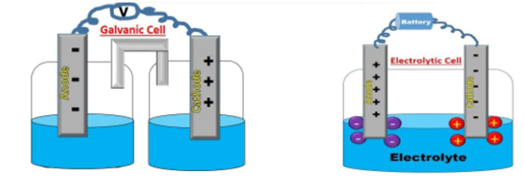

a. Complete the following sentences. 4 marks

Galvanic cell | Electrolytic cell
Oxidation at the ______________  Anode is _______________  Electrons flow from the ______ to the _______  Reaction occurs _______________ | Oxidation at the __________  Anode is ____________  Electrons flow from the _______ to the ________  Reaction is not __________________

b. Which one of the following will react spontaneously? 2 marks

Manganese metal and hydrogen gas or manganese metal and sulfur solid.

Explain how you arrived at your answer.

________________________________________________________________________________________

_________________________________________________________________________________________

c. Which one of the following electrolytes will produce oxygen gas in an electrolytic cell? 1 mark

0.1 M AlCl₃(aq) 4.0 M NaCl(aq) 4.0 M KI(aq)

________________________________________________________________________________________

End of exam

Section A: 20 marks
Section B: 62 marks

