2022 Unit 3 Chemistry trial exam

Name: ____________________

Section A: Multiple Choice section

Question 1
Select the alternative that is the best description of a biodiesel molecule.
A. A fatty acid molecule.
B. The product of hydrolysis of a triglyceride.
C. An ester formed from the reaction between a small alcohol molecule and a long alcohol molecule.
D. The product of an alcohol combining with a fatty acid.

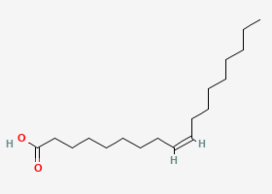
Question 2
The molecule shown here is

A. palmitoleic acid
B. stearic acid
C. oleic acid
D. linoleic acid

Question 3
A Maxwell-Boltzmann curve is drawn below.
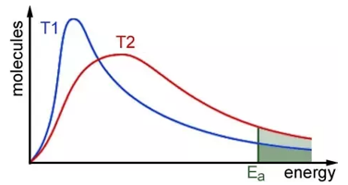
This graph can best be used to explain
A. how the introduction of a catalyst will increase the rate of a reaction.
B. how the proportion of particles that will react increases with temperature.
C. how a catalyst lowers the activation energy required for a reaction.
D. how increasing the surface area of a reactant increases the reaction rate.

Question 4
Which of the following electrolytes will produce the same products whether the electrolyte is molten or aqueous?
A. KCl
B. CuI₂
C. KNO₃
D. KI
Question 5
Which of the following will produce the greatest mass of metal at the cathode of an electrolytic cell?
A. a charge of 0.50 faraday through a cell containing 1.0 M NaCl
B. a charge of 0.20 faraday through a cell containing NaCl(l)
C. a charge of 0.30 faraday through a cell containing Al₂O₃(l)
D. a charge of 0.20 faraday through a cell containing 1.0 M AgNO₃

Use the galvanic cell drawn below to answer Questions 6 and 7
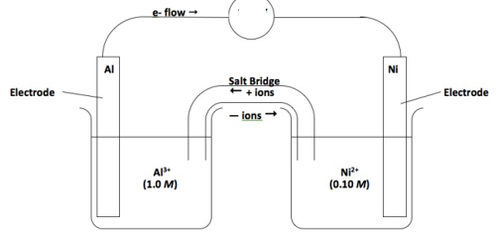
Question 6
The overall equation in the cell will be
A. Al(s) + Ni²⁺(aq) Al³⁺(aq) + Ni(s)
B. 2Al(s) + Ni²⁺(aq) 2Al³⁺(aq) + 3Ni(s)
C. 2Al³⁺(aq) + 3Ni(s) 2Al(s) + 3Ni²⁺(aq)
D. 2Al(s) + 3Ni²⁺(aq) 2Al³⁺(aq) + 3Ni(s)

Question 7
In this cell,
A. aluminium will be the negative electrode and the potential will be around 1.41 V
B. the electrons will flow from the nickel electrode to the aluminium electrode.
C. nickel metal is oxidised and aluminium ions are reduced.
D. nickel will be the positive electrode and electrons will flow to the aluminium electrode.

Question 8
The equation for the equilibrium that forms between hydrogen iodide and oxygen gases is
4HI(g) + O₂(g) ⇌ 2H₂O(g) + 2I₂(g)
The volume of an equilibrium mixture of the above gases is decreased. When equilibrium is re-established,
A. the concentration of HI will lower than it was at the first equilibrium.
B. the concentration of HI will higher than it was at the first equilibrium.
C. the amount of HI will be higher than it was at the first equilibrium.
D. the value of K_{c} will have increased as the forward reaction is favoured.

Question 9
Which of the following systems will have units of M²?
A. 2SO₂(g) + O₂(g) ⇄ 2SO₃(g)
B. N₂(g) + 3H₂(g) ⇄ 2NH₃(g)
C. H₂(g) + I₂(g) ⇄ 2HI(g)
D. CH₄(g) + H₂O(g) ⇄ CO(g) + 3H₂(g)

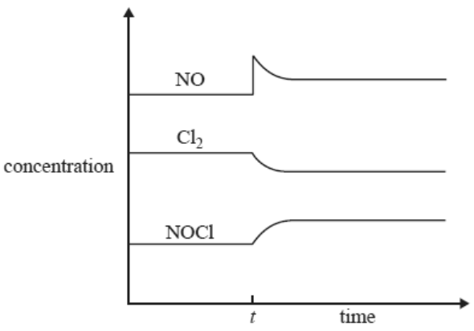
Question 10

The change made at time t in this system could be
A. an increase in temperature of the system.
B. a decrease in volume of the system.
C. the addition of more NO gas.
D. the addition of a catalyst.

Question 11
The equation for the equilibrium between hydrogen and iodine gases is

H₂(g) + I₂(g) ⇌ 2HI K_{c} = 64 at 240 ˚C.

For the reaction below, the value of K_{c} at 240 ˚C will be

HI ⇌ ½ H₂(g) + ½ I₂(g)

A. 0.01156
B. 0.125
C. 8
D. -64

Question 12

SO₄²⁻(aq) + 10H⁺(aq) + 8e⁻ H₂S(g) + 4H₂O(l)

The oxidation state change of sulfur atoms in the half-equation above is
A. +6 to +2
B. +4 to +2
C. +6 to -2
D. +4 to -2

Question 13
Aluminium metal can be produced from molten Al₂O₃ in an electrolytic cell. In this cell
A. aluminium is reduced at the cathode and 0.12 faraday of charge will produce 0.04 mole of aluminium B. aluminium is reduced at the cathode and 0.12 faraday of charge will produce 0.06 mole of aluminium
C. aluminium is oxidised at the cathode and 0.12 faraday of charge will produce 0.04 mole of aluminium
D. aluminium is reduced at the anode and 0.12 faraday of charge will produce 0.04 mole of aluminium

Use the following diagram to answer Questions 14 and 15
The cell shown uses hydrazine, N₂H₄, and hydrogen peroxide,H₂O₂ as reactants in acid conditions..
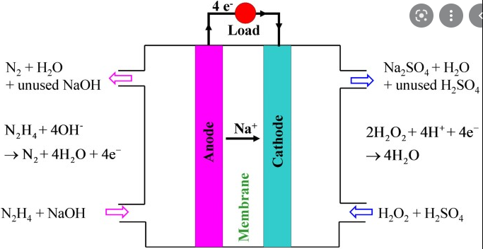
Question 14
The oxidation state change of nitrogen in anode reaction is
A. +3 to -2
B. +5 to -3
C. +2 to 0
D. +4 to -2

Question 15
The overall reaction occurring in this cell can be simplified to
A. N₂H₄ + NaOH + H₂SO₄ + 2H₂O₂ N₂ + Na₂SO₄ + H₂O
B. N₂H₄ + 2H₂O₂ N₂ + H₂O
C. N₂H₄ + 4OH⁻ + 4H⁺ + 2H₂O₂ N₂ + 8H₂O
D. N₂H₄ + 2NaOH + H₂SO₄ + 2H₂O₂ N₂ + Na₂SO₄

Question 16
Which of the following fuels has the highest melting point?
A. biodiesel
B. petrol
C. ethanol
D. petrodiesel

Question 17
Select the correct statement about coal-fired power stations.
A. The thermal energy from the coal is transformed firstly into kinetic energy.
B. The only reaction occurring is the complete combustion of carbon.
C. Chemical energy is converted directly to electrical energy but the efficiency of the process is low.
D. Coal releases electrons as it burns enabling the power station to produce electrical energy.

Question 18
Which alternative is a correct comparison of cells?
A. The anode is negative in both a primary cell and an electrolytic cell.
B. The combustion of methane can be utilised in a gas-fired plant or a fuel cell.
C. A fuel cell is the only type of cell that has a continuous supply of reactants.
D. The efficiency of a secondary cell will always be higher than that of a primary cell.

Question 19
Select the correct statement about natural gas.
A. Natural gas produces CO₂ during combustion but no other harmful emissions.
B. Natural gas is not suitable for use in fuel cells.
C. Natural gas is a renewable form of energy as it can be replenished at a sustainable rate.
D. Natural gas produces CO₂ and a range of other pollutants during combustion.

Question 20
Which of the following is an example of a systematic error?
A. A measuring cylinder is used for accurate volume measurements rather than a pipette.
B. The wick on an alcohol burner varies in height during the course of a trial.
C. A thermometer with a small air bubble causing each reading to be 1.5 ˚C above the real value.
D. The electrical power being delivered to a power supply has intermittent fluctuations.

Section B: Short answer questions
Question 1 (8 marks)
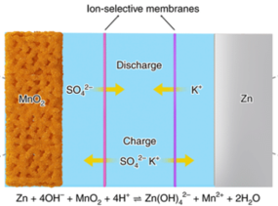
Zinc alkaline batteries have had a long existence of powering everyday toys and devices. The technology of these batteries is still viable and scientists are regularly making further improvements to their design. The diagram below shows a typical modern version and its overall reaction. The voltage produced by the cell is 1.55 V.

a. Use the circles provided to indicate the polarity of the cell. 1 mark

b. i. Use the overall equation provided to write the half-equations occurring below. Include states.

Anode: _____________________________________________________________________ 1 mark

Cathode: _____________________________________________________________________ 1 mark

ii. The diagram provided shows the direction of ion flow in the cell during discharge and recharge.
Explain why potassium ions will flow away from the zinc electrode during discharge. 1 mark

_______________________________________________________________________________

c. i. Write an equation for the reaction occurring during recharge. 1 mark

_______________________________________________________________________________

ii. What voltage would you suggest be used to ensure recharging is successful? 1 mark

_______________________________________________________________________________

iii. What is the oxidation state change occurring at the anode during recharging? 1 mark

_______________________________________________________________________________

d. An important function of the membranes shown on the cell diagram is that they do not allow the flow
of any other ions than the ones shown. This is a very important feature for this particular cell. Examine
the half-equations you have written to suggest a reason for the need for limited ion flow in the cell.

____________________________________________________________________________ 1 mark
Question 2 (9 marks)
The diagram below shows a potential CO₂ capture system based on the action of a CO₂ electrolytic cell. The cell reacts CO₂ with water to produce carbon monoxide, CO, and hydrogen gas.
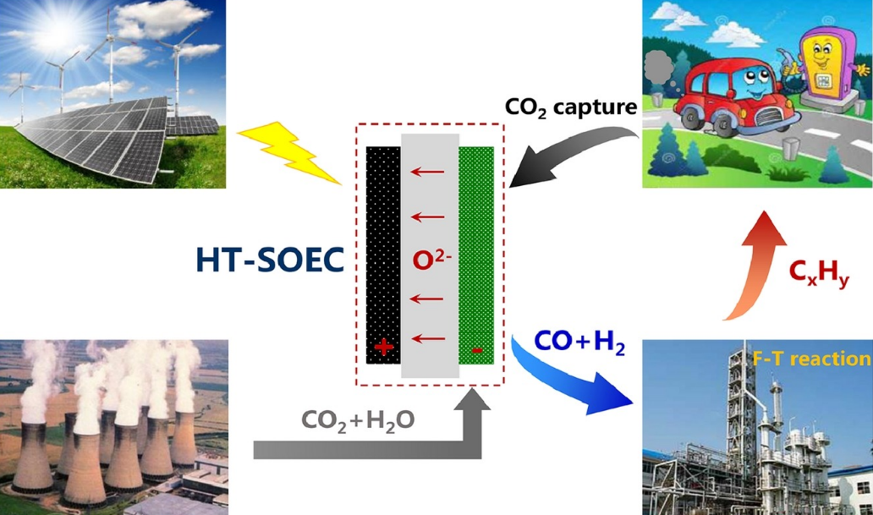

a. i. Use the diagram to explain why scientists might be interested in this cell. 1 mark

_______________________________________________________________________________

_______________________________________________________________________________

ii. Write a balanced equation to show how a car might be a source of CO₂ gas. 1 mark

_______________________________________________________________________________

iii. Write a balanced equation to show how a coal-fired power station might produce CO₂. 1 mark

_______________________________________________________________________________

b. The main products of the cell are CO, H₂ and O₂ gases.
i. Write a balanced half-equation for the production of CO and H₂ from CO₂. 1 mark

_______________________________________________________________________________

ii. Which electrode will this reaction occur at? _______________________ 1 mark

iii. Write a balanced half-equation for the reaction of water to produce O₂ gas in acid conditions.
1 mark
_______________________________________________________________________________

c. Explain why the diagram features a solar panel array. 1 mark

________________________________________________________________________________

d. i. Give one use for the hydrogen gas produced in this cell. 1 mark

_______________________________________________________________________________

ii. Write a thermochemical equation for the complete combustion of hydrogen gas. 1 mark

_______________________________________________________________________________

Question 3 (9 marks)
a. Determine the mass of ethanol that needs to undergo complete combustion to produce 1.00 MJ of
energy. 1 mark

_______________________________________________________________________________

b. Determine the mass of CO₂ formed from the complete combustion of 500 g of ethane. 3 marks

_______________________________________________________________________________

_______________________________________________________________________________

_______________________________________________________________________________

c. Determine the volume of oxygen gas required at 400 ⁰C and 220 kPa pressure for the complete
combustion of 50.0 g of butane. 3 marks

_______________________________________________________________________________

_______________________________________________________________________________

_______________________________________________________________________________

d. Assuming petrol to be pure octane and a sample of E10 fuel to have exactly 10.0 % (m/m) ethanol,
determine the energy that can be obtained from a 100 g sample of E10 fuel. 2 marks

_______________________________________________________________________________

_______________________________________________________________________________

_______________________________________________________________________________

Question 4 (10 marks)
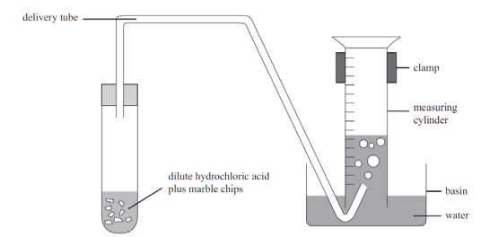
A student is investigating the rate of a
reaction using the apparatus shown
here. One of the student’s graphs is shown
under the apparatus.
The chemical formula of marble chips is
CaCO₃.

a. Write a balanced equation for
the reaction occurring. 1 mark

____________________________

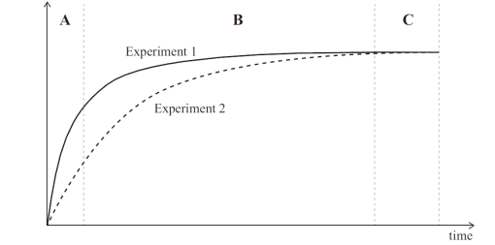
____________________________

b. Consider experiment 1 only.
i. Explain how the student is
tracking the rate of this reaction.
2 marks
____________________________

____________________________

____________________________

______________________________________________________________________________

ii. Explain why the graph is not a straight line. 1 mark

________________________________________________________________________________

________________________________________________________________________________

c. Compare the graph for experiment 2 with that of experiment 1. Could experiment 2 be a repeat of
experiment 1 but using HCl that has been diluted? Discuss the possibility of this being the change made.
3 marks
_______________________________________________________________________________

_______________________________________________________________________________

_______________________________________________________________________________

d. Give a reason why it is difficult to get precise results when investigating the impact of surface area on
reaction rate in this experiment. 1 mark

_______________________________________________________________________________

_______________________________________________________________________________

e. How will the pH change during a typical run of this experiment? Discuss. 2 marks

_______________________________________________________________________________

_______________________________________________________________________________

_______________________________________________________________________________

Question 5 (6 marks)
The diagram shows an energy profile diagram for a reaction with a catalyst and then without the catalyst.
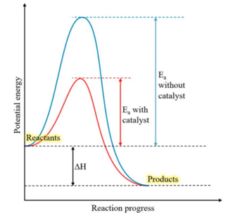

a. i. What is the impact of the catalyst on the magnitude of the activation energy? 1 mark

________________________________________________________________________________

ii. What is the impact of the catalyst on the magnitude of ∆H? 1 mark

________________________________________________________________________________

iii. How does a catalyst work? 1 mark

________________________________________________________________________________

b. If the energy profile diagram refers to the reaction of methane in a fuel cell,
i. what is the value of ∆H? ___________________________ 1 mark

ii. Will the cell produce the same amount of energy without the catalyst as it will with the catalyst?
Explain your answer. 2 marks

_______________________________________________________________________________

_______________________________________________________________________________

_______________________________________________________________________________

Question 6 (10 marks)
Sulfur dioxide can react with oxygen gas to form SO₃ gas. The equation for the reaction is

2SO₂(g) + O₂(g) ⇌ 2SO₃(g) ∆H = -ve

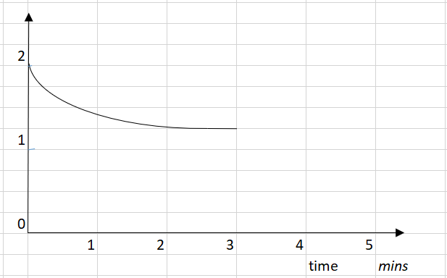
concentration

SO₂

a. Equal amounts of SO₂ and O₂ are added to a 1.00 L reactor. The SO₂ concentration is shown on the
graph above.

i. Use the graph provided to draw the concentrations of both O₂ and SO₃ up to the 3 minute
mark. 2 marks

ii. Use the graph to determine the value of K_{c} for this reaction. 3 marks

_______________________________________________________________________________

_______________________________________________________________________________

_______________________________________________________________________________

b. At the 3 minute mark, the temperature of the reactor is increased.

i. Use the graph to show the impact of the temperature change on the three gases present. 3 marks

ii. When equilibrium is re-established, how will the rate of the back reaction compare to what it was
just before the 3 minute mark? Explain your answer. 2 marks

_______________________________________________________________________________

_______________________________________________________________________________

_______________________________________________________________________________

Question 7 (6 marks)
A dilute solution of aluminium nitrate, Al(NO₃)₃ is electrolysed using graphite electrodes.

a. Write balanced half-equations for the reactions occurring. 2 marks

Anode: ____________________________________________________________

Cathode: ___________________________________________________________

b. Calculate the volume of gas that could be collected from the cell at 25 ˚C and 130 kPa pressure if a
current of 4.20 amps is passed through the cell for 3.00 hours. 4 marks

_______________________________________________________________________________

_______________________________________________________________________________

_______________________________________________________________________________

_______________________________________________________________________________

_______________________________________________________________________________

_______________________________________________________________________________

End of Exam
Mark section A: /20
Mark section B: /58
Total: /78

