2023 Unit 2 Chemistry trial exam

Name: ____________________ Total: ______/92

Section A: Multiple Choice section

Question 1
The conjugate base of NH₄⁺ is
A. NH₂⁻
B. NH₃
C. NH₃⁻
D. NH₅

Question 2
Which of the following will require the most energy?
A. heating 60 g of water from 60 ºC to 80 ºC
B. heating 20 g of water by 60 ºC
C. heating 80 g of olive oil by 22 ºC
D. heating 80 g of water by 22 ºC

Question 3
Which of the following will require the most energy?
A. converting 100 g of water at 100 ⁰C to steam
B. raising 100 g of water from 0 ⁰C t o100 ⁰C
C. converting 100 of ethanol liquid at 78 ⁰C to a gas
D. converting 100 g of ice to 100 g of water

Question 4
Select the correct statement about the properties of water.
A. Energy is released when steam condenses to water.
B. The density of water will increase as it turns to ice.
C. Water will always boil at exactly 100 ºC.
D. All ionic solids will dissolve in water.

Question 5
Which of the following solutions will have the lowest pH?
A. 5 M NaOH
B. 10 mL of 2 M HCl
C. 10 mL of 2 M H₂SO₄
D. 500 mL of 1 M ethanoic acid

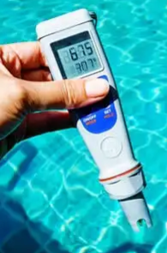
Use the following photograph to answer Questions 6 and 7
The meter shown is a portable electrical conductivity sensor.

Question 6
If salt is dissolved in a water sample being tested,
A. the electrical conductivity of the solution will be a constant and not vary with salt concentration.
B. the sample will not conduct electricity as water is not ionic.
C. the sample will conduct electricity due to the flow of electrons to both electrodes.
D. the sample will conduct electricity due to the flow of ions to both electrodes.

Question 7
Emissions from industry can impact upon the electrical conductivity of ocean water. The main reason for this is
A. the gaseous water emissions from vehicles is increasing the ocean volume.
B. the CO₂ emissions increase the self-ionisation of water.
C. the CO₂ emissions will dissolve in the ocean to form ions.
D. CO₂ is highly soluble in water and it has a high electrical conductivity.

Question 8
The products of a reaction are potassium chloride and water. The reactants were
A. KOH and HCl
B. K₂CO₃ and HCl
C. K and HCl
D. KOH and H₂SO₄

Question 9
In which of the following is the oxidation number of sulfur highest?
A. S₈
B. H₂SO₄
C. SO₂
D. H₂S

Question 10
Which alternative is a correctly balanced half-equation?
A. O₂ + 2e⁻ O²⁻
B. MnO₄⁻ + 2H₂ + 2e⁻ Mn²⁺ + 4OH⁻
C. 2FeCl₂ + Cl₂ 2FeCl₃
D. ClO₃⁻ + 6H⁺ + 6e⁻ Cl⁻ + 3H₂O

Question 11
The oxidising agent in a redox reaction
A. will lose electrons as it is reduced.
B. will gain electrons as it is oxidised.
C. will gain electrons as it is reduced.
D. will always be a non-metal atom as it will gain electrons.

Use the following solubility curves to answer questions 12 and 13.
The following metals are listed in order of most reactive to least reactive:

zinc cadmium lead copper silver

They all form ions with a charge of 2+ except silver, which forms an Ag⁺ ion.

Question 12
Which of the following will react spontaneously?
A. Ag(s) + Zn(NO₃)₂(aq)
B. Pb(s) + Zn(NO₃)₂(aq)
C. Cu(s) + Cd(NO₃)₂(aq)
D. Cd(s) + Cu(NO₃)₂(aq)

Question 13
When a cadmium half-cell is connected to a silver half-cell,
A. cadmium ions will form cadmium metal at the positive electrode.
B. cadmium ions will be the oxidising agent.
C. electrons will move from the cadmium electrode to the positive silver cathode.
D. electrons will move from the cadmium electrode to the negative silver anode.

Question 14
The following three solutions are added to the one beaker – silver nitrate, potassium chloride and sodium nitrate.
A. No precipitate will form as all solutions are soluble.
B. The only precipitate to form is sodium chloride.
C. The only precipitate to form is silver chloride.
D. Precipitates of silver chloride and potassium nitrate will form.

Use the following information to answer questions 15 and 16.

The equation for the reaction between aluminium metal and chlorine gas is

2Al(s) + 3Cl₂(g) 2AlCl₃(s)

Question 15
The mass of AlCl₃ that can be formed from 0.90 mole of chlorine gas is, in g,
A. 60.1
B. 80.1
C. 120.2
D. 133.5

Question 16
The volume of the Cl₂ at SLC needed to react completely with 8.0 mole of aluminium is, in L,
A. 102
B. 130
C. 198
D. 298

Question 17
Nickel sulfate forms a green coloured solution in water. What colour filter should a colorimeter use for the most accurate determination of the concentration of a nickel sulfate solution?
A. green
B. red
C. blue
D. yellow

Question 18
Which of the following emission releases is likely to impact the Earth’s atmosphere the most?
A. 50 litres of methane, CH₄
B. 100 litres of steam (water)
C. 100 litres of CO₂
D. 500 litres of oxygen gas

Question 19
A student uses gravimetric analysis to determine the concentration of a 100 mL solution of MgCl₂. She takes a 10 mL sample from the solution and adds excess AgNO₃ solution to it. The number of mole of precipitate formed is 0.02 mol. The number of mole of MgCl₂ in the original solution is
A. 0.01
B. 0.02
C. 0.1
D. 0.2

Question 20
A 0.20 M NaOH solution is used in a titration to determine the concentration of a sulfuric acid solution. 20.0 mL aliquots of NaOH are used and the mean titre of sulfuric acid is 15.0 mL. The concentration of the sulfuric acid solution is, in M,
A. 0.13
B. 0.15
C. 0.20
D. 0.26

Section B: Short answer questions Total 72 marks

Question 1 (10 marks)
The graph below provides information on the solubility of a range of substances in water.
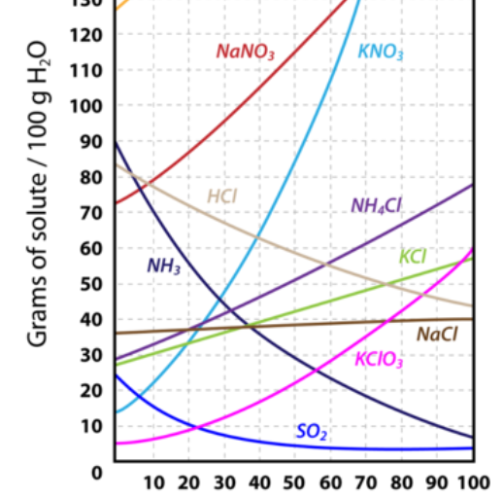

a. i. What conclusion can you draw by comparing the graph for NaNO₃ with that of NaCl? 1 mark

____________________________________________________________________________________

ii. What conclusion can you draw by comparing the graph for NaNO₃ with the graph for SO₂ gas? 2 marks

_____________________________________________________________________________________

_____________________________________________________________________________________

b. i. What is a supersaturated solution? 1 mark

_______________________________________________________________________________________

ii. Explain how you would prepare a supersaturated solution of KN0₃. Include in your response the actual masses
and volumes you would use. 3 marks

_____________________________________________________________________________________

_____________________________________________________________________________________

_____________________________________________________________________________________

_____________________________________________________________________________________

c. i. Determine the mass of KClO₃ that will dissolve in 40 g of water at 60 ⁰C. 1 mark

____________________________________________________________________________________

ii. 44 g of a substance is able to be dissolved in 50 g of water at 20 ⁰C. Identify the substance. 2 marks

_____________________________________________________________________________________

_____________________________________________________________________________________
Question 2 (5 marks)
a. H₂O and H₂S are molecules with a similar shape. The boiling point of water is significantly higher than that of H₂S
Refer to the bonding in these molecules to explain why. 3 marks

_____________________________________________________________________________________

_____________________________________________________________________________________

b. A 10 mL sample of water and a 10 mL sample of ethanol are both placed in cold storage until both liquids solidify.
How will the volume of the solid water (ice) compare to that of the solid ethanol? Explain your answer. 2 marks

_____________________________________________________________________________________

_____________________________________________________________________________________

_____________________________________________________________________________________

_____________________________________________________________________________________

Question 3 (10 marks)
a. What is the oxidation number of the element in bold? 4 marks

i. N₂O₄ ________ ii. NH₃ _________ iii. BrO₃⁻ _________ iv. SO₃²⁻ _____________

b. Complete the following half-equations and label each as oxidation or reduction. 4 marks

i. Fe²⁺ Fe³⁺ Oxidation or reduction? _________________

ii. Br⁻ Br₂ Oxidation or reduction? _________________

iii. MnO₄⁻ + H⁺ Mn²⁺ Oxidation or reduction? _________________

c. i. Which one of the following reactions will occur spontaneously? 1 mark

Ca + ZnCl₂

Zn + CaCl₂

ii. Explain how you arrived at your decision. 1 mark

_____________________________________________________________________________________

____________________________________________________________________________________

Question 4 (8 marks)
A galvanic cell can be formed when a nickel half cell (Ni²⁺/Ni) is connected to a zinc half-cell (Zn²⁺/Zn).
The nickel solution will be green in colour.

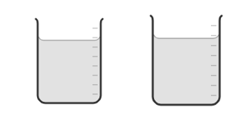
Use the template below to 8 marks
- draw this cell
- identify the anode and cathode
- show the direction of electron flow
- write the relevant half-equations
- write the overall equation
- list the observations you can
make of the changes in each
half-cell

½ equation ________________ _______________

Overall equation _________________________________________

observations nickel half-cell: ________________________________________________________

observations zinc half-cell: _________________________________________________________

Question 5 (12 marks)
a. Categorise the following as acid, base or neutral.

LiOH ________ HNO₃ ___________ CH₃CH₂OH __________ 3 marks

b. Calculate the pH of the following solutions: 3 marks

i. 0.001 M HNO₃ ______________________ ii. 0.25 M HCl _____________________

iii. 0.10 M NaOH __________________________________________________________________

c. Pure water is considered to be a neutral substance. Does this mean, it has no hydronium ions? Discuss.
Include an equation to support your response. 3 marks

_______________________________________________________________________________

________________________________________________________________________________

d. Write balanced equations for the reactions below: 3 marks

i. barium + nitric acid (HNO₃) ___________________________________________________

ii. sulfuric acid (H₂SO₄) + lithium hydroxide ______________________________________________

iii. nitric acid + calcium carbonate _____________________________________________

Question 6 (11 marks)
The photograph below shows a series of copper sulfate (CuSO₄) solutions. The concentrations of the first five beakers increases from 0.1 M to 0.5 M. The sixth beaker is a sample of unknown concentration.

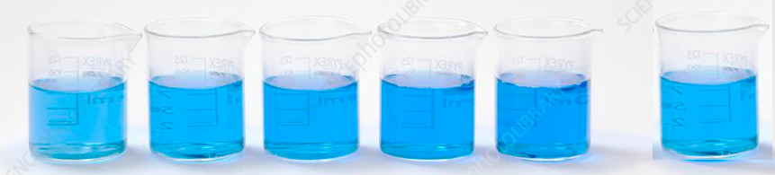
solution 1 solution 5 unknown

a. Calculate the concentration of solution 1 in units of g L⁻¹. 2 marks

_____________________________________________________________________________________

b. The solutions can be used in a UV-visible spectrophotometer to determine the concentration of the unknown
sample.
i. How does a UV-visible spectrophotometer differentiate between solutions 1 and 5? 2 marks

______________________________________________________________________________________

______________________________________________________________________________________

_______________________________________________________________________________________

ii. Explain how the concentration of the unknown sample can be determined. 3 marks

______________________________________________________________________________________

______________________________________________________________________________________

_______________________________________________________________________________________

c. The concentration of the copper sulfate sample could also be determined gravimetrically, by adding an excess of
barium nitrate solution to the copper sulfate sample.

i. Write a balanced equation for the reaction between copper sulfate and barium nitrate. 1 mark

________________________________________________________________________________________

ii. A precipitate of mass 0.860 g is obtained from a 20.0 mL solution of copper sulfate. Use this figure to
determine the concentration, in molarity, of the copper sulfate solution. 3 marks

______________________________________________________________________________________

______________________________________________________________________________________

_______________________________________________________________________________________

Question 7 (10 marks)
A 10.0 mL sample of vinegar is diluted to 100 mL. The diluted sample is added to a burette and titrated against a standardised 0.150 M NaOH solution. The acid in vinegar is the weak acid, ethanoic acid, CH₃COOH.

The aliquot size of NaOH used is 25.0 mL and the mean titre of diluted vinegar is 16.6 mL.

a. i. Write a balanced equation for the reaction. 1 mark

______________________________________________________________________________________

ii. What should the following items of glassware be rinsed with before titrating? 2 marks

Burette: __________________________ Conical flasks: ____________________________

iii. Discuss the choice of a suitable indicator for the titration. 2 marks

______________________________________________________________________________________

______________________________________________________________________________________

_______________________________________________________________________________________

b. Use the data provided to determine the concentration of the

i. diluted vinegar 2 marks

______________________________________________________________________________________

______________________________________________________________________________________

_______________________________________________________________________________________

ii. undiluted vinegar 1 mark

______________________________________________________________________________________

c. Use your results from part b. to explain what precise but not accurate results by the class would look like for
this experiment. 2 marks

______________________________________________________________________________________

______________________________________________________________________________________

_______________________________________________________________________________________

Question 8 (6 marks)

The equation for the reaction between ethane and oxygen is:

2C₂H₆(g) + 7O₂(g) 4CO₂(g) + 6H₂O(g)

a. Given a sample of 10 mol of ethane, calculate the number of mol of (assuming conditions are constant)
3 marks

i. oxygen required for the reaction _____________________________

ii. CO₂ formed _____________________ iii. H₂O formed ___________________

b. Given a sample of 64.0 g of O₂, calculate the volume of CO₂ that can be formed at 100 ⁰C and 100 kPa pressure.
3 marks

__________________________________________________________________________________

___________________________________________________________________________________

End of exam

Section A: 20 marks
Section B: 72 marks

