2024 Unit 3 Chemistry trial exam

Name: ____________________ Total: ______/83

Section A: Multiple Choice section

Question 1
One of the stages in the production of bioethanol is distillation. This step is required
A. to separate ethanol from other alcohols present in the fermented solution.
B. to increase the concentration of the ethanol in the fermented solution.
C. to break the bonds in the glucose molecules enabling the yeast to form ethanol from glucose.
D. to increase the rate of the fermentation reaction.

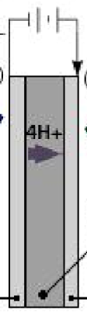
Use the following information to answer Questions 2 and 3.

Hydrogen gas can be produced in a PEM electrolyser cell. The diagram provided
Is an outline of a PEM cell with the labels removed

Question 2
In this cell, the reaction at
A. the cathode is 2H₂O(l) O₂(g) + 2H₂(g) + 4e
B. the anode is 2H₂(g) + O₂(g) 2H₂O(l)
C. the anode is 2H₂O(l) O₂(g) + 4H⁺(aq) + 4e
D. the cathode is 4OH⁻(aq) + 4e H₂(g) + H₂O(l)

Question 3
Select the alternative that is a correct description of the hydrogen gas produced.
A. This cell produces green hydrogen if it is powered by a wind turbine.
B. The hydrogen gas produced in a PEM is considered green hydrogen as the only raw material is water.
C. The use of electrodes that act as catalysts makes the energy required for this cell negligible.
D. The salt bridge in this cell should be a solution of KNO₃.

Question 4
Which of the following will release the most energy?
A. 49.6 L of methane at SLC.
B. 30 g of methane.
C. 50 L of ethane at SLC.
D. 20 g of hydrogen gas.

Use the following information to answer Questions 5 and 6

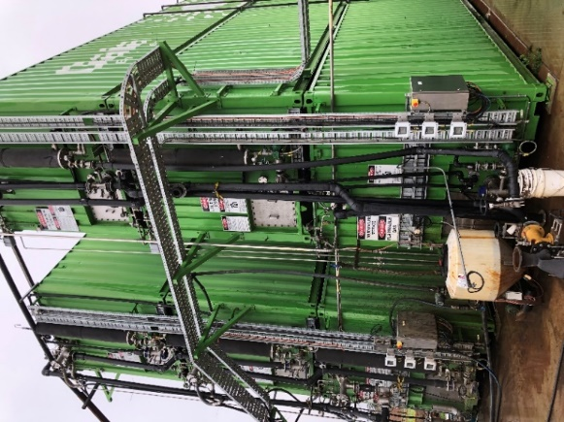
The effluent from the barn below is connected to the biodigestor
shown. The biodigestor in turn is connected to a gas generator.

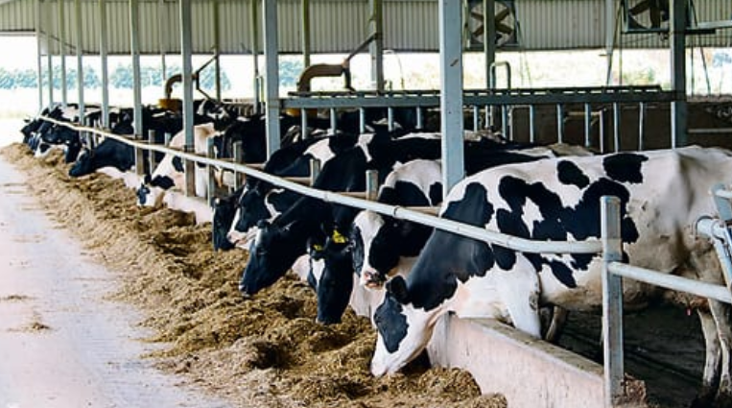

Question 5
Select the alternative that describes the processes occurring.
A. The biodigestor will convert the carbohydrates in effluent to bioethanol that can then form electricity.
B. The effluent is burnt to produce electrical energy.
C. The biodigestor will produce a gas mixture that is burnt to produce electrical energy.
D. The biodigestor will produce bioethanol which can be used with triglycerides to form biodiesel.

Question 6
The best description of the sustainability of this process is:
A. The process is non-renewable as the volume of fuel is limited by the small number of cows.
B. This process is renewable and it does not produce any greenhouse emissions.
C. This process is renewable but it releases significant amounts of methane to the atmosphere.
D. This process is renewable but it will still produce greenhouse emissions.

Question 7
Which statement about energy changes in combustion is correct?
A. Incomplete combustion of a fuel will release more energy than complete combustion.
B. The molar enthalpy of combustion is represented as a negative value while the heat of combustion is positive.
C. Less energy is released when water is formed as a liquid rather than as a gas.
D. The energy required to break the bonds in the fuel is greater than the energy released when new bonds form.

Question 8
The reaction at the anode in a methane fuel cell operating in acid conditions is:
A. O(g) + 4H⁺(aq) + 4e⁻ 2H₂O(l)
B. CH₄(g) + 4H⁺(aq) CO₂(g) + 4H₂O(l) + 4e⁻
C. CH₄(g) + H₂O(l) CO₂(g) + 4H⁺(aq) + 4e⁻
D. CH₄(g) + 2H₂O(l) CO₂(g) + 8H⁺(aq) + 8e⁻

Question 9
An energy profile diagram is shown below.
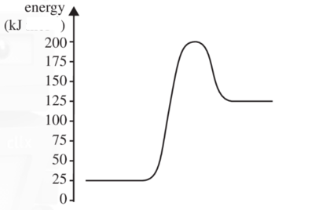

Which alternative correctly shows the activation energy and enthalpy change of the reverse reaction?
A. -75 kJ and -100 kJ
B. +175 kJ and -100 kJ
C. +75 kJ and -100 kJ
D. +175 kJ and +100 kJ

Use the galvanic cell drawn below to answer Questions 10 and 11
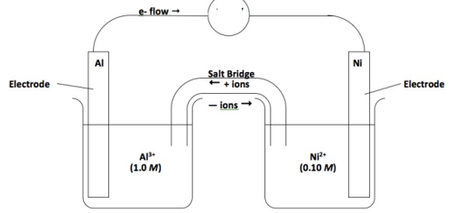
Question 10
The overall equation in the cell will be
A. Al(s) + Ni²⁺(aq) Al³⁺(aq) + Ni(s)
B. 2Al(s) + Ni²⁺(aq) 2Al³⁺(aq) + 3Ni(s)
C. 2Al³⁺(aq) + 3Ni(s) 2Al(s) + 3Ni²⁺(aq)
D. 2Al(s) + 3Ni²⁺(aq) 2Al³⁺(aq) + 3Ni(s)

Question 11
In this cell,
A. aluminium will be the negative electrode and the potential will be around 1.41 V
B. the electrons will flow from the nickel electrode to the aluminium electrode.
C. nickel metal is oxidised and aluminium ions are reduced.
D. nickel will be the positive electrode and electrons will flow to the aluminium electrode.

Question 12
A copper half-cell is connected to a half-cell that has hydrogen gas pumped into a graphite electrode. In this cell
A. the copper electrode will gradually dissolve and water will be produced at the anode.
B. oxygen gas will be formed at the cathode and water at the anode.
C. copper metal will be deposited at the cathode and water at the anode.
D. copper metal will be deposited at the cathode and the pH will drop at the anode.

Question 13
When hydrochloric acid is added to sodium thiosulfate, the following reaction occurs gradually.

Na₂S₂O₃(aq) + 2HCl(aq) 2S(s) + SO₂(g) + 2NaCl(aq) + H₂O(l)

The rate of this reaction can be monitored by placing the beaker the reaction is taking place in on top of a cross. As the reaction proceeds, the solution becomes cloudier and the cross obscured.
Which of the following lists contains only changes that will lower the reaction time of the reaction?
A. Decreased temperature, decreased HCl concentration and addition of a catalyst.
B. Decreased temperature, increased HCl concentration and addition of a catalyst.
C. Increased temperature, decreased HCl concentration and addition of further water.
D. Increased temperature, addition of a catalyst and increasing of the HCl concentration.

Question 14
The reaction between nitrogen monoxide and chlorine gas is

2NO(g) + Cl₂(g) ⇄ 2NOCl(g)

2.0 mole of NOCl is added to an empty reactor. At equilibrium 1.4 mole remains. The number of mole of gas in the reactor is
A. 1.5
B. 2.3
C. 3.5
D. unable to be determined.

Use the following diagram to answer Questions 15 and 16
The equation for the formation of ammonia is:

N₂(g) + 3H₂(g) ⇄ 2NH₃(g) ∆H = -92 kJ mol⁻¹ K = 729 M⁻² at 100 ºC.

Question 15
The magnitude of K for the equation

N₂(g) + H₂(g) ⇄ NH₃(g) at 100 ºC will be:

A. 0.0014
B. 9
C. 27
D. 729

Question 16
The volume of an equilibrium mixture of the above gases is halved. When equilibrium is re-established, compared to the first point of equilibrium, the
A. concentration of hydrogen will be lower and the amount will be lower.
B. concentrations of nitrogen and hydrogen gases will be lower.
C. position of equilibrium is unchanged because the temperature is unchanged.
D. concentration of hydrogen will be higher but the amount will be lower.

Question 17
A current is passed through a 0.1 M solution of Fe(NO₃)₂ using iron electrodes. The products at the anode and cathode respectively will be
A. oxygen gas and hydrogen gas.
B. iron ions and iron metal.
C. oxygen gas and iron metal.
D. iron ions and hydrogen gas.

Question 18
2000 C of charge is passed through each of the following cells. Which cell will see the deposition of the highest mass of metal?
A. 0.1 M Sn(NO₃)₄
B. 0.1 M Sn(NO₃)₂
C. 0.1 M AgNO₃
D. 0.1 M Ca(NO₃)₂

Question 19
A beaker contains a mixture of 0.1 M Pb(NO₃)₂, 0.1 M Al(NO₃)₃ and 0.1 M Ca(NO₃)₂. Graphite electrodes are added to the circuit and a current is passed through it until metals stop depositing on the cathode. The order in which the metals deposit will be
A. lead only.
B. lead then aluminium only.
C. lead then calcium only.
D. lead, then aluminium, then calcium.

Question 20
A student constructs a galvanic cell from standard zinc and copper half-cells. She sets the room temperature at 25 ⁰C. The voltage obtained is 0.72 Volts. She repeats the arrangement for four more cells and obtains further voltages of 0.71 V, 0.73 V and 0.72 V. The student’s results are an example of data that is
A. precise but the accuracy cannot be determined.
B. accurate but not precise.
C. precise but not accurate.
D. accurate and precise.

Section B: Short answer questions

Question 1 (9 marks)
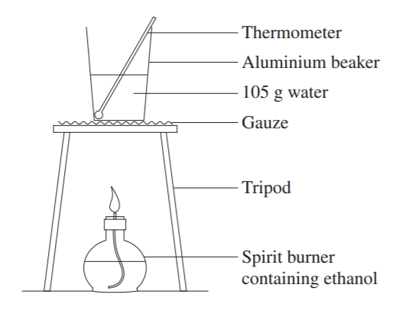
A student’s apparatus used to measure the enthalpy of combustion
of ethanol is drawn on the right.

a. Write a balanced equation for the reaction occurring. 1 mark

________________________________________________

b. If the mass change of ethanol is 0.740 g, what is the theoretical
temperature change? 2 marks

____________________________________________________________________________________

____________________________________________________________________________________

____________________________________________________________________________________

c. i. Are the student’s results likely to be higher or lower than theoretical predictions? Explain your answer.
2 marks
______________________________________________________________________________________

______________________________________________________________________________________

ii. Suggest two modifications that could be made to this procedure to improve the results obtained. 2 marks

______________________________________________________________________________________

______________________________________________________________________________________

d. Olive oil is used to replace the water in the beaker. Discuss the likely impact of this change and whether valid
results could still be obtained for the heat of combustion of ethanol. 2 marks

______________________________________________________________________________________

______________________________________________________________________________________

Question 2 (8 marks)
One form of lithium cell being trialled uses a grid of lithium in graphite and a grid of lithium in iron (III) phosphate.
The cell is rechargeable and the diagram below shows the cell being discharged.
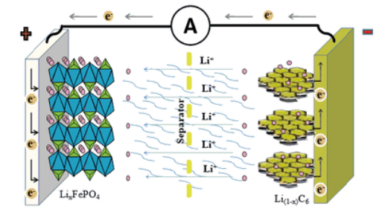

__________ _____________

_ _ _ _ _ _ _ - - - - - - - - - -

The half-equations occurring in the discharging cell are:
LiC₆ Li⁺ + C₆ + e⁻
FePO₄ + Li⁺ + e⁻ LiFePO₄
a. i. Use the boxes and lines provided to show the polarity of the electrodes during discharge. 1 mark

ii. Use the solid lines to indicate the anode and cathode during discharge. 1 mark

iii. Use the dashed lines to indicate the anode and cathode during recharge. 1 mark

b. Use the headings below to write overall equations for

i. Discharge: ______________________________________________________________ 1 mark

ii. Recharge: ______________________________________________________________ 1 mark

c. What is the oxidation number change occurring in the half-equation FePO₄ + Li⁺ + e⁻ LiFePO₄? 1 mark

_______________________________________________

d. Give two reasons why lithium is so popular in newer technology cells. 2 marks

___________________________________________________________________________________

____________________________________________________________________________________

Question 3 (10 marks)
The diagram below shows a potential CO₂ capture system based on the action of a CO₂ electrolytic cell. The cell reacts CO₂ with water to produce carbon monoxide, CO, and hydrogen gas.
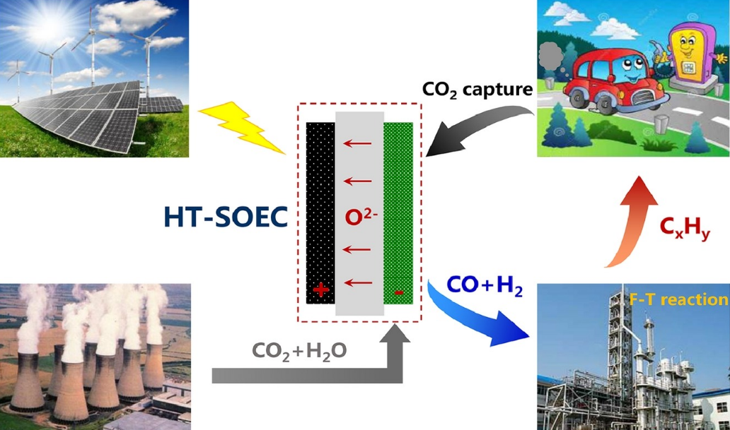

a. i. One of the components of petrol is octane. Write a balanced equation to show how petrol
produces CO₂. 1 mark

_______________________________________________________________________________

_______________________________________________________________________________

ii. Write a balanced equation to show how a coal-fired power station might produce CO₂. 1 mark

_______________________________________________________________________________

iii. Discuss the sustainability benefits offered by this cell. 3 marks

_______________________________________________________________________________

_______________________________________________________________________________

_______________________________________________________________________________

_______________________________________________________________________________

b. A simple sketch of the CO₂ electrolytic cell is shown below:
(The electrolyte is non-aqueous, therefore states not shown)

Use the information on the diagram to

i. write a balanced half-equation for the reaction occurring at the anode. 1 mark

____________________________________________________________________________

ii. write balanced half-equations for the two separate reactions occurring at the cathode. 2 marks

____________________________________________________________________________

_____________________________________________________________________________

c. i. State one use for the hydrogen gas produced in this cell. 1 mark

_______________________________________________________________________________

ii. Write a thermochemical equation for the complete combustion of hydrogen gas. 1 mark

_______________________________________________________________________________

Question 4 (11 marks)
The diagram below is of an electrolytic cell where the electrolyte is brine, concentrated NaCl solution.
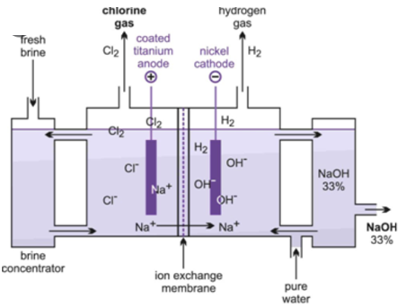

a. i. Sodium metal is not formed in this cell. Explain why? 1 mark

______________________________________________________________________________________

ii. Oxygen gas is not formed in this cell. Explain why. 2 marks

______________________________________________________________________________________

_______________________________________________________________________________________

b. Use the headings below to write the half-equations and overall equations for the reactions in this cell. 3 marks

Anode: ____________________________________________________________

Cathode: _____________________________________________________________

Overall: _____________________________________________________________

c. Why is this cell useful? 2 marks

_______________________________________________________________________________________

_______________________________________________________________________________________

d. Calculate the volume of gas produced at SLC when a current of 240 amps runs
for 1.00 hour. 3 marks

___________________________________________________________________________

___________________________________________________________________________

____________________________________________________________________________

Question 5 (5 marks)
a. Write a thermochemical equation for

i. the complete combustion of glucose. 1 mark

_______________________________________________________________________________________

ii. respiration in body cells. 1 mark

_______________________________________________________________________________________

b. i. Use the axes provided to draw an energy profile diagram for the combustion of glucose. 2 marks

kJ

ii. Mitochondria in cells contain enzymes that catalyse the combustion of glucose. Show on your graph the
action of the catalyst. 1 mark

Question 6 (8 marks)
The following reaction can be used to produce nitrosyl bromide:

2NO(g) + Br₂(g) ⇄ 2NOBr(g) ∆H = - 16.1 kJ mol K = 1.3 × 10⁻² M⁻¹ at 1000 K

a. What are the values of ∆H and K_{c} for the reaction 2 marks

NO(g) + ½ Br₂(g) ⇄ NOBr(g)?

∆H _____________________ and K __________________________

b. What are the values of ∆H and K for the reaction 2 marks

NOBr(g) ⇄ NO(g) + ½ Br₂(g)?

∆H _____________________ and K __________________________

c. The temperature of an equilibrium mixture of the above gases is increased. Explain the impact of this change on
i. the concentration of NOBr. 1 mark

_________________________________________________________________________________________

ii. the rate of the forward reaction. 1 mark

__________________________________________________________________________________________

d. 0.50 mol of NO and 0.50 mol of Br₂ are both added to an empty 2.0 L container at 1000 K. Calculate the
concentration of the NOBr at equilibrium. 2 marks

_________________________________________________________________________________________

_________________________________________________________________________________________

Question 7 (12 marks)
Hydrogen peroxide, H₂O₂, decomposes to form water and oxygen gas. Manganese dioxide can be used as a catalyst for this reaction.

A student uses the equipment shown below to investigate the impact of temperature upon the rate of this reaction.
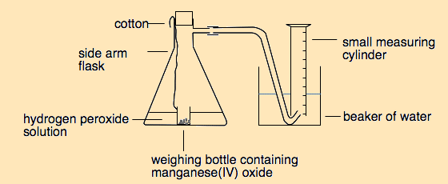

a. i. Write a balanced equation for the reaction occurring. 1 mark

______________________________________________________________________________

ii. Identify the reason for the use of string in this reaction. 1 mark
______________________________________________________________________________
______________________________________________________________________________

b. i. Write a procedure the student could follow to investigate the impact of temperature on rate of
this reaction. 3 marks

_______________________________________________________________________________

_______________________________________________________________________________

_______________________________________________________________________________

_______________________________________________________________________________

_______________________________________________________________________________

_______________________________________________________________________________

ii. identify the independent and dependent variables in your procedure. 2 marks

Independent variable: ________________________________________________________________

Dependent variable: __________________________________________________________________.

c. i. Explain why the rate changes with temperature? 2 marks
_______________________________________________________________________________

_______________________________________________________________________________

_______________________________________________________________________________

ii. Will the final volume of gas increase with temperature? Justify your answer. 2 marks
_______________________________________________________________________________

_______________________________________________________________________________

_______________________________________________________________________________

iii. Circle the one of the following that manganese dioxide impacts? 1 mark

enthalpy of the reaction the position of equilibrium the activation energy of the reaction

End of exam

Section A: 20 marks
Section B: 63 marks

