**Topic test 3: Instrumentation and analysis**

**SECTION A – Multiple-choice questions**

|  |
| --- |
| **Instructions for Section A**  Answer **all** questions.  Choose the response that is **correct** or **best answers** the question.  A correct answer scores 1, an incorrect answer scores 0.  No mark will be given if more than one answer is completed for any question.  Marks will **not** be deducted for incorrect answers. |

**Question** **1**

Select the equation that could be an ionisation equation occurring in a mass spectrometer.

**A.** CH3CH2OH + e 🡪 CH3CH2+ + OH- + 2e

**B.** CH3CH2OH + e 🡪 CH3CH2+ + OH+

**C.** CH3CH2OH + e 🡪 CH3CH2. + OH-

**D**. CH3CH2OH + e 🡪 CH3CH2OH+ + 2e

*Use the following equation to answer Questions 2 and 3*

The proton-NMR of a compound is shown below. It shows a quartet, a singlet and a triplet.

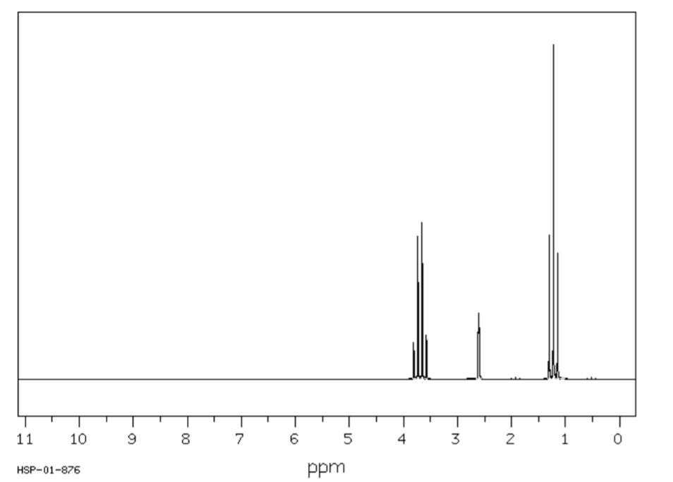

**Question 2**

Select the correct statement about proton NMR.

**A.** Splitting is the result of interactions between protons on all carbon atoms.

**B.** Splitting is the result of interactions between protons on neighbouring carbon atoms.

**C.** Splitting is the result of interactions between protons on neighbouring oxygen atoms.

**D**. Splitting is the result of interactions between protons on neighbouring atoms.

**Question 3**

The spectrum could be of

**A**. ethanol.

**B**. propan-1-ol.

**C**. propan-2-ol.

**D**. 2-chloropropane.

**Question 4**

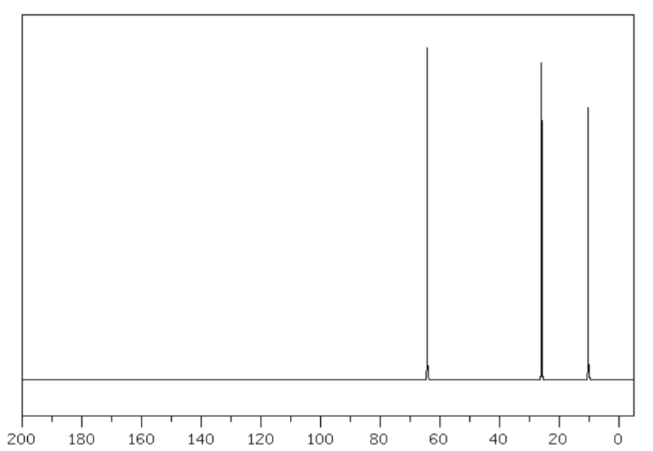

The spectrum above could be

**A**. a mass spectrum of propanoic acid.

**B**. a carbon-NMR of propan-2-ol.

**C**. a carbon-NMR of propan-1-ol.

**D**. a proton-NMR of 2-chloropropane.

**Question 5**

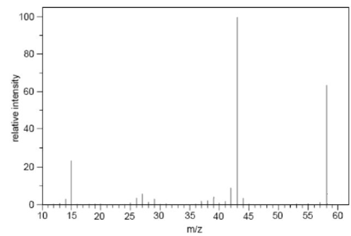

The mass spectrum shown could be of

**A**. ethanoic acid.

**B**. propan-1-ol.

**C**. propanal.

**D**. propanone.

**Question 6**

A chemist conducts an experiment to produce propanoic acid from propanol. She uses infrared spectroscopy to check if she has 100% conversion of reactant to product. To do this she should look for

**A**. the presence of an absorption between 1680-1740 cm-1.

**B**. the absence of an absorption between 1680-1740 cm-1.

**C**. the absence of a broad absorption between 3200-3600 cm-1.

**D**. the presence of an absorption between 2500-3500 cm-1.

**Question 7**

Which option is an analysis task that is suited to HPLC?

**A**. Determining the functional groups present in a new drug.

**B**. Determining the concentration of ethanol in a petrol sample.

**C**. Determining the identity of an unknown substance in a blood sample.

**D**. Determining if two molecules are optical isomers of each other.

**Question 8**

The printout below is from a HPLC test of a blood sample. A polar solvent has been used. The abbreviation Hb stands for haemoglobin.

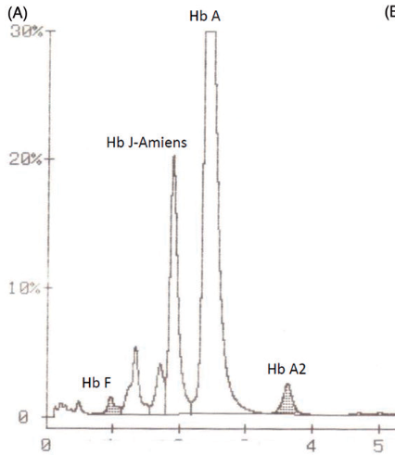

From this printout it is likely that

**A**. there are four forms of haemoglobin.

**B**. Hb F is the most polar form of haemoglobin.

**C**. Hb A2 is the most polar form of haemoglobin as the retention time is the longest.

**D**. the concentration of Hb J will be half that of Hb A.

**Question 9**

The choice of indicator for an acid-base titration is mainly dependent upon the

**A**. relative concentrations of the acids and bases used.

**B**. reactions that might occur between the indicator and the chemicals used.

**C**. pH at the endpoint.

**D**. pH at the equivalence point.

**Question 10**

In a particular titration, a 20 mL aliquot of 0.6 M NaOH is neutralized by 30 mL of acid. It is possible that the

A. acid is monoprotic with a concentration of 0.6 M.

B. acid is monoprotic with a concentration of 1.2 M.

C. acid is monoprotic with a concentration of 0.3 M.

D. acid is diprotic and has a concentration of 0.2 M.

**SECTION B- Short-answer questions**

|  |
| --- |
| **Instructions for Section B**  Questions must be answered in the spaces provided in this book. To obtain full marks for your responses you should   * Give simplified answers with an appropriate number of significant figures to all numerical questions; unsimplified answers will not be given full marks. * Show all workings in your answers to numerical questions. No credit will be given for an incorrect answer unless it is accompanied by details of the working.   Make sure chemical equations are balanced and that the formulas for individual substances include an indication of state; for example, H2(g); NaCl(s) |

**Question 1** (13 marks)

An organic molecule has an empirical formula of C3H6O2. Its mass spectrum is shown below.

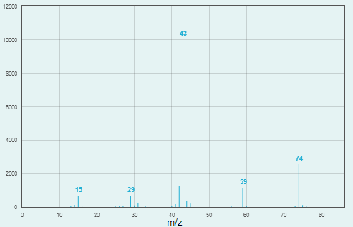

**a.**  **i**. What is the molecular formula of this compound? Justify your answer. 2 marks

_________________________________________________________________________________

**ii**. Suggest a fragment that could have produced the base peak on the spectrum. __________ 1 mark

**b**. Draw and name 3 possible structures for this molecule. 3 marks

The infrared spectrum of this molecule is shown below.

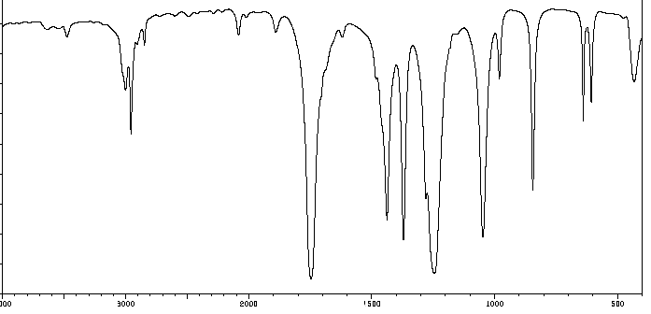

**c**. Can you now rule out any of the three structures you drew in part b? Explain your answer. 2 marks

___________________________________________________________________________________

____________________________________________________________________________________

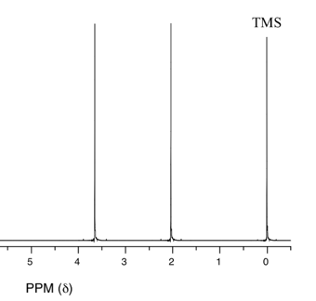**d**. The proton-NMR spectrum of the original molecule is shown below.

Use this spectrum to deduce the identity of the molecule.

Explain your reasoning. 3 marks

_____________________________________________________

_____________________________________________________

_____________________________________________________

_____________________________________________________

**e**. The molecule in question can be formed from the reaction of two smaller molecules. 2 marks

Draw both of these molecules.

C3H6O2 methyl ethanoate

**Question 2** (8 marks)

A printout from a HPLC experiment is shown below.

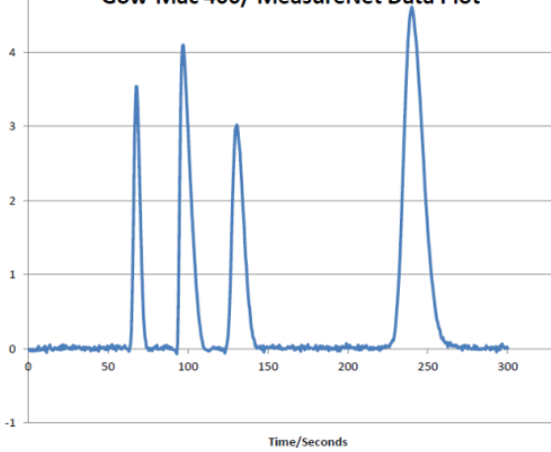

**a.** State two conclusions you can draw from this printout. 2 marks

__________________________________________________________________________________

___________________________________________________________________________________

**b.** The experiment is repeated but this time the solvent flow rate is increased. Explain how the printout will

be affected by this change. 1 mark

____________________________________________________________________________________

**c**. The solvent used in this experiment was non-polar. If a mixture of hexane and hexan-1-ol was injected into

this column, which will have the longer retention time? Explain your answer. 2 marks

____________________________________________________________________________________

_____________________________________________________________________________________

d. One of the substances in the original chromatogram was 1-chloropentane but its retention time is not

known. Explain how you could use this column and solvent to determine the concentration of a solution of

1-chloropentane. 3 marks

**______________________________________________________________________________________**

**______________________________________________________________________________________**

**______________________________________________________________________________________**

**Question 3** (9 marks)

**a**. How many different carbon environments are there in 2 marks

* cyclohexane __________________________
* cyclohexene __________________________

**b.** Describe the splitting pattern that will occur when 2 marks

 proton-NMR is conducted on the molecule shown.

**____________________________________________**

**____________________________________________**

**c.**  Suggest a molecule fragment that could produce a mass spectrum peak with m/z ratio of –

3 marks

* 29 _________________________
* 31 __________________________
* 43 _________________________

**d.** List two likely infrared absorbances of any amide molecule. 2 marks

________________________________________________________________________________

**Question 4** (total 10 marks)

The concentration of a solution of ethanamine is to be determined by titration against a 0.150 M HCl solution.

20.00 mL aliquots of ethanamine are used and the titres obtained are listed below.

|  |  |  |  |  |
| --- | --- | --- | --- | --- |
| Run | 1 | 2 | 3 | 4 |
| Titre (mL) | 23.9 | 22.9 | 23.0 | 23.1 |

**a.** **i**. Write a balanced equation for the reaction between ethanamine and water. 1 mark

____________________________________________________________________________________

**ii**. Use the equation you wrote to explain why ethanamine is a base. 1 mark

____________________________________________________________________________________

**iii**. Write a balanced equation for the reaction between ethanamine and HCl. 1 mark

_____________________________________________________________________________________

**b**. Suggest a suitable indicator to use for this titration. Justify your selection. 2 marks

_____________________________________________________________________________________

______________________________________________________________________________________

**c**. Inspect the titres obtained and use sound chemical practice to determine the concentration of the

ethanamine solution. 3 marks

_____________________________________________________________________________________

______________________________________________________________________________________

______________________________________________________________________________________

**d**. What should these pieces of equipment be rinsed with before the titration? 2 marks

- the burette _________________________

- the pipette _________________________