Unit 2 Chemistry SAC task : Critique of an experiment design
Title: Critique of a titration
Background
A titration can be performed to determine the concentration of an acid or base solution. The solution in question is titrated against a standard solution. The higher the volume of standard solution required, the higher the concentration of the acid or base you are investigating.
In most chemistry classes, the teacher has thought through the procedure in advance and has selected an appropriate indicator and suitable concentrations for both the acid and the base solutions. For this experiment, the pre-planning has not been done and the results obtained are likely to lack precision. It will be your task to critique the procedure used and to make design changes. You will then test the effectiveness of your changes.
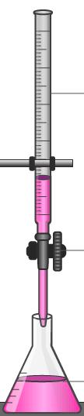
Part A: Initial titration
Materials
burette
20 mL pipette
100 mL conical flasks
methyl red indicator
commercial vinegar
0.20 M NaOH solution
Procedure
Add 20 mL of NaOH to a conical flask
Fill the burette with vinegar
Add 5 drops of methyl red indicator
Conduct a titration

Equation 1 mark
Write a balanced equation for the reaction between ethanoic acid and sodium hydroxide.

______________________________________________________________________

Measurements and calculations 2 + 3 = 5 marks

_________________________________________________________________________________________

_________________________________________________________________________________________

_________________________________________________________________________________________

_________________________________________________________________________________________

_________________________________________________________________________________________

Observations and commentary 5 marks
The procedure you followed had some limitations. Can you identify what these ‘limitations’ are?
List any relevant observations you made or issues you think this procedure might have.
_________________________________________________________________________________________

_________________________________________________________________________________________

_________________________________________________________________________________________

_________________________________________________________________________________________

Precision
Have each group in the class write the concentration they obtained for the ethanoic acid on the board.
What conclusion can you make about the precision of your class’s results? 2 marks
_________________________________________________________________________________________

_________________________________________________________________________________________

Design changes
Consider each facet of this titration Changes can be made to improve the titre obtained.
List possible changes.
For each suggested change, explain why you are anticipating a better result. 6 marks
_________________________________________________________________________________________

_________________________________________________________________________________________

_________________________________________________________________________________________

_________________________________________________________________________________________

_________________________________________________________________________________________

_________________________________________________________________________________________

Part B: Second titration
Repeat your titration, incorporating any improvements that are practical.
Measurements 2 marks

_________________________________________________________________________________________

_________________________________________________________________________________________

Report (to be completed under test conditions)
Use your titre results to determine the ethanoic acid concentration for your vinegar sample. 3 marks
_________________________________________________________________________________________

_________________________________________________________________________________________

_________________________________________________________________________________________

Each group in the class to place their result on the board. Comment on how the precision for the second titration compares to the original. 2 marks
_________________________________________________________________________________________

_________________________________________________________________________________________

_________________________________________________________________________________________

Indicator choice: Nominate an appropriate indicator to use for this experiment and explain why you have chosen this indicator. 3 marks

_________________________________________________________________________________________

_________________________________________________________________________________________

_________________________________________________________________________________________

List two other adjustments you made that you think helped your result. Explain why each improves the precision.
4 marks
Change 1: ________________________________________________________________________________

Explanation: ______________________________________________________________________________

________________________________________________________________________________________

________________________________________________________________________________________

Change 2: ________________________________________________________________________________

Explanation: ______________________________________________________________________________

________________________________________________________________________________________

________________________________________________________________________________________

Rinsing: What should you rinse each of the following with? 3 marks

Burette: __________________ Pipette: _____________________ Conical flask: ___________________

Total: 36 marks

Teacher Guide
Title: Critique of a titration
Suited to: Unit 2: Area of Study 2
Study design references

Analysis for acids and bases
- volume-volume stoichiometry (solutions only) and application of volumetric analysis, including the use of indicators, calculations related to the preparation of standard solutions, dilution of solutions, and use of acid-base titrations (excluding back titrations) to determine the concentration of an acid or a base in a water sample.

Scope of task
This task would ideally be covered over the course of two double periods, one week apart.
Week 1: Conduct the initial titration.
During the week – review the results and have students complete their design changes sheet above.
Week 2 – perform titration 2 and sit report under test conditions.

Titration 1 Limitations:
- Methyl red is not a suitable indicator to use for the titration of a weak acid and strong base. Phenolphthalein is more appropriate. The transition is prolonged and difficult to discern if methyl red is used.
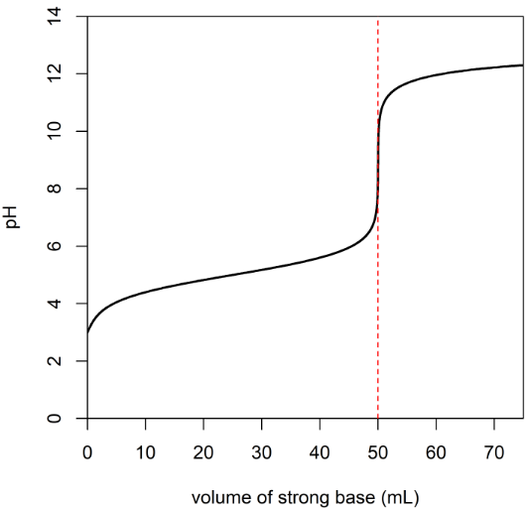

- Vinegar should be diluted. Typical commercial vinegars are 0.85 M. A better result will be obtained if a concentration closer to that of the base is used. The endpoint will occur too quickly.
- Multiple runs. A titration should be repeated until concordant results are obtained.

Rinsing:

Burette: vinegar Pipette: NaOH Conical flask: deionised water

