Unit 1-2 Chemistry SAC task: Media File
Topic: Innovations in plastic recycling
Task
You are presented with two related articles on the innovations on plastics recycling of Licella and other companies.
- Article 1: Licella’s proposal to develop the plastic recycling capacity of Timor Leste. The technology proposed is new in that it does not remould the plastic, instead it breaks it down to a synthetic oil.
- Article 2: The use of this same technology to recycle waste plastic to new, food-grade polymers.
You will have one week between receiving these articles and completing your SAC task during a class,

Comment for teachers: Articles like these should enable students to respond using the chemical concepts they are studying so the response is not just ‘opinion’. Good students should be able to explain why thlis form or recycling is very different from more common forms where a plastic is remoulded to a product with inferior properties. Students should also be able to draw the structures of propene and polypropene to further demonstrate their understanding. They can also reflect on the sustainability impact of this technology.

You need to read both articles and to respond to the information presented.
Your response should
- demonstrate an understanding of the chemistry of this new form of recycling
- show structures of relevant materials mentioned
- explain how this new process differs from conventional recycling
- discuss the sustainability impact of this technology
- incorporate a conclusion as to your opinion on the importance of this technology.

Your response might take the form of a written report or poster or slideshow or other form negotiated with the teacher.

A possible rubric that could be used to assess student responses might utilise the following five criteria:
- Clarity of communication
- Explanation of the sustainability impact
- Understanding of the chemistry of the processes
- Analyse, evaluate and communicate scientific ideas
- Construct evidence-based arguments and draw conclusions
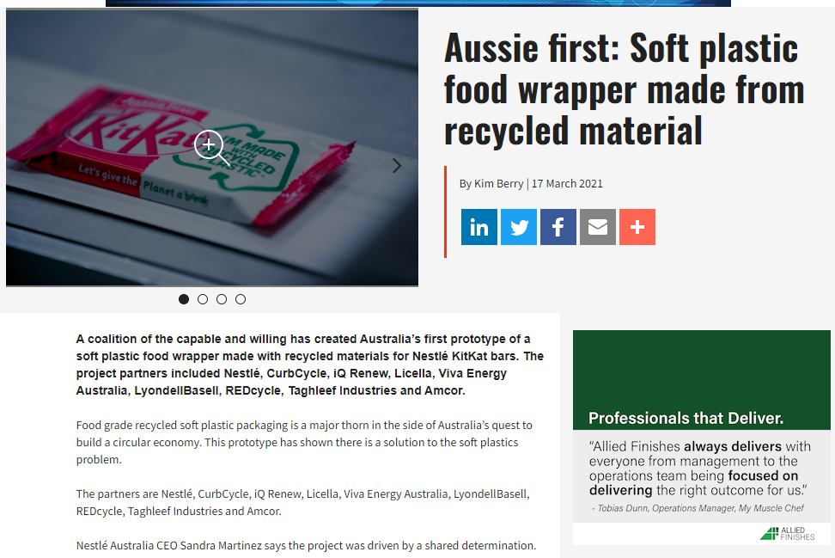
https://www.foodanddrinkbusiness.com.au/news/aussie-first-soft-plastic-food-wrapper-made-from-recycled-material
