Unit 1-2 Chemistry SAC task: Application of chemical concepts to a real-life context
Title: Green steel production
Background
Iron is the most used metal on Earth and Australia is the world’s leading exporter of iron ore, the raw material used in the production of iron and steel. In 2021 world iron production was 2.5 x 10⁹ tonnes.
Iron is found in the Earth’s crust as a variety of ores but the two most abundant ones are
- haematite, Fe₂O₃ and
- magnetite, Fe₂O₄.
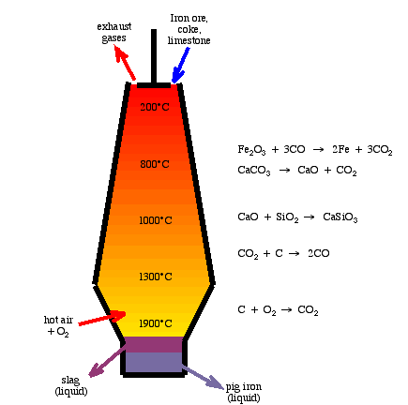
To obtain relatively pure iron, the oxygen in the ore must be removed. This is usually done by heating the ore with carbon (coal) in a blast furnace. The oxygen and the carbon combine to form CO₂. There are several problems with this technology, such as the large quantity of coal required, the greenhouse gases produced and the energy required for the process.

Blast furnace

Green steel
The steel industry is very focused on the move to ‘green steel’ production, to lower the environmental impact of steel production. There are two important areas of focus in green steel research-
- use of hydrogen gas generated by renewable energy to provide the energy needed by the steel industry.
- use of alternatives to coal as the reductant to lower CO₂ emissions and to lower the dependence of society on coal.
The focus of this task is on the latter area of research following the research of Professor Veena Sahajwalla and the University of NSW (UNSW).

Task
Your teacher will supply you with reading material on the trials UNSW is making with used car tyres as the source of carbon, rather than coal. You will have a week to read these articles and to prepare for a set of questions relating to
- the importance and uses of iron
- the structure of metal alloys (since steels are a range of alloys of iron
- the role of carbon in a blast furnace
- how tyres can replace carbon
- environmental gains offered by this process.

You may bring a double-sided set of notes to the SAC. The SAC will consist of a series of questions relating to the source material.

Possible questions

Metals
1. List the properties of most metals.

2. a. Compared to other metals,
- how do you think the durability of iron ranks?
- how do you think the strength of iron ranks?
- how do you think the melting point of iron ranks?

b. Considering your answers to part a. why do you think iron is the most used metal in the
world?

3. Why is iron not found pure in the Earth’s crust?

Blast furnace
4. Write an equation for the most important reaction taking place in a blast furnace.

5. Explain why carbon is added in large quantities to a blast furnace?

6. What gases are emitted in a blast furnace and why are emission levels so high?

University of New South Wales: Green steel
The University of New South Wales considers the use of car tyres in a blast furnace to be a very exciting innovation.

7. What are the car tyres replacing in the blast furnace?

8. What are car tyres made from?

9. Explain in detail how this innovation impacts-
a. total levels of greenhouse emissions

b. levels of landfill

c. the depletion of fossil fuel reserves

10. Car tyres burn easily, releasing significant amounts of energy.
Does this help or hinder a blast furnace?

Alloys
Steel is an alloy of iron
11. Explain what an alloy is.

12. Why add small amounts of elements such as carbon and chromium to iron?

