Unit 1-2 Chemistry SAC task: Analysis and evaluation of an innovation
Analysis and evaluation of Nullarbor fibre.
Background: Rayon (viscose) is a popular fabric for clothing. Traditionally it has been made from cotton or bamboo or forest plantations. The use of these raw materials on a large scale poses a threat to the local environment.
Australian company, Nullarbor Fabrics is trialling the use of waste biomass as the raw material. In this case study you will be provided with background on this new process and be asked to evaluate whether it offers potential sustainability improvements.
Process
You will be sent a PowerPoint presentation on Nanollose. This will outline
- what rayon is
- how it is made commercially
- the environmental impact of the sourcing of raw materials
- how Nanollose is trialling a different approach.

You will have one week to research this topic. In that time, you should
- research the chemical structure of rayon.
- analyse how the Nanollose process is different to traditional production processes
- identify two sustainability goals that the Nanollose process might address.
You will then have 1 hour in class, working under test conditions, to respond to input material by addressing a set of related questions.

Chemistry related Sustainability Goals listed in the Study Design
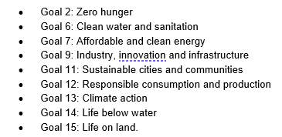

Questions
1. Rayon is made from the natural polymer, cellulose.
Draw the structure of the monomer in cellulose and outline the structure it forms in cellulose.
2. Outline how rayon production might be detrimental to the environment.
3. Explain how Nanollose production is different to traditional rayon production methods. Include
in your answer an explanation of the significant role of enzymes in this process.
4. Identify two Sustainability goals that the use of Nullarbor fibre might address. Evaluate the
likely impact on these goals of the commercial success of Nanollose.
5. Conclusion. You have researched this topic and related sustainability goals. What conclusion do
you draw from your research?

