**Modern farming – robotics and biodigesters**

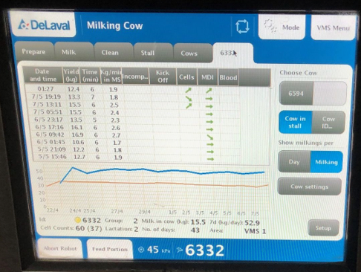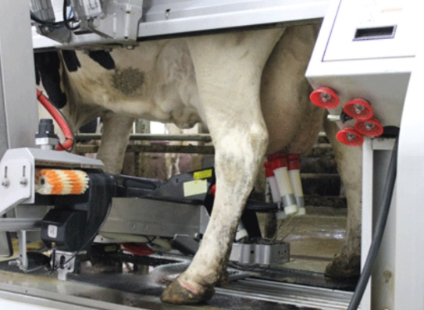

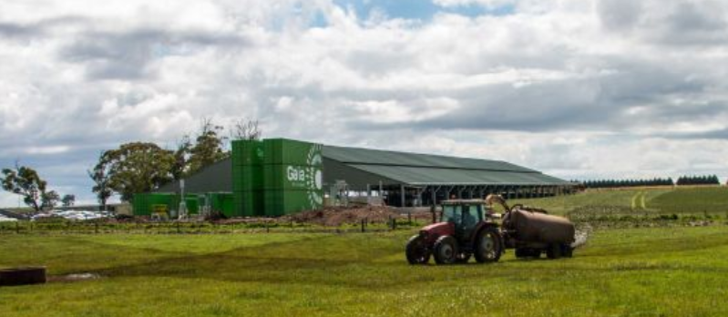

The cows are milked by robot. A computer tests the milk for fat content, volume and signs of infection.

On this farm, the cows live entirely in the barn. Their food is strictly controlled.

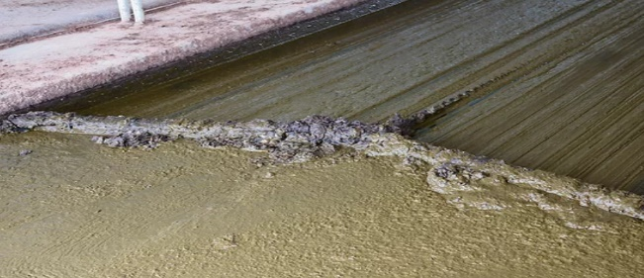

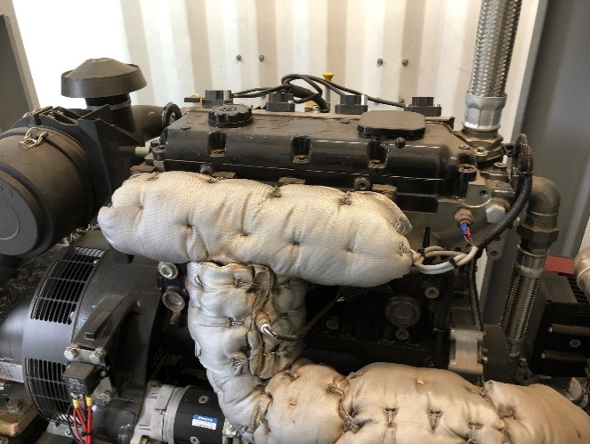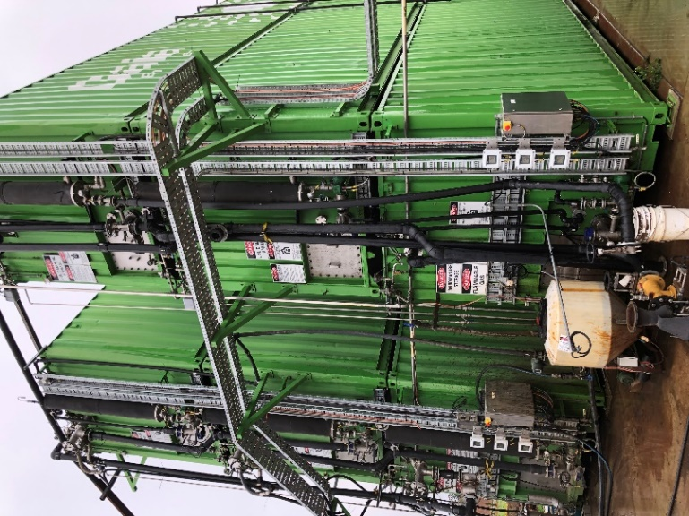 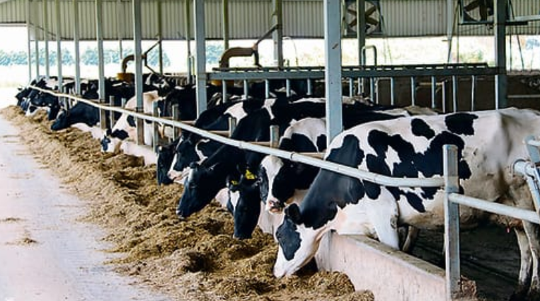

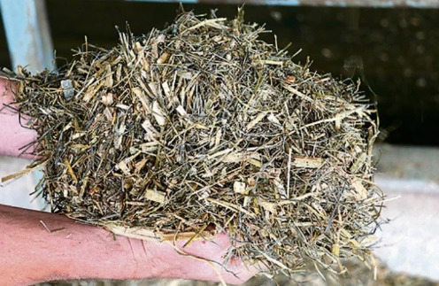

Biogas composition

Methane 60 %

CO2 25 %

Water

Hydrogen sulfide

Waste is collected, added to a digestor and the methane burnt in a generator to produce electricity.