**Topic test 4: Food molecules**

**SECTION A – Multiple-choice questions**

|  |
| --- |
| **Instructions for Section A**  Answer **all** questions.  Choose the response that is **correct** or **best answers** the question.  A correct answer scores 1, an incorrect answer scores 0.  No mark will be given if more than one answer is completed for any question.  Marks will **not** be deducted for incorrect answers. |

**Question** **1**

Which of the following molecules is not a polymer?

**A**. Casein protein.

**B**. Palmitic acid.

**C**. Glycogen.

**D**. Starch.

**Question 2**

Hydrogen bonding could occur between which pair of amino acids on a protein molecule?

**A**. leucine and valine

**B**. aspartic acid and alanine

**C**. serine and threonine

**D**. cysteine and phenylalanine

**Question 3**

Consider the following options to answer this question.

I dispersion forces

II dipole-dipole bonds

III hydrogen bonds

IV ionic bonds

V covalent bonds

Which of the above bond types can be present between one part of a protein chain and another?

**A**. I and III only.

**B**. I and II only.

**C**. I, II, III and IV only.

**D**. All options.

**Question 4**

A peptide bond is formed when

**A**. an amide group reacts with a carboxylic acid.

**B**. an amine group reacts with a carboxylic acid.

**C**. an amine group reacts with a hydroxyl group.

**D**. an amine group reacts with an amide group.

**Question 5**

A skeletal diagram of vitamin K is shown below.

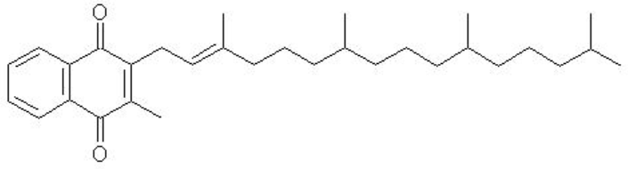

Select the option that is a correct reference to this molecule.

**A**. Vitamin K will not be fat-soluble as it contains two oxygen atoms.

**B**. Vitamin K will be soluble in water as it contains two oxygen atoms.

**C**. All vitamins are soluble in water if they contain oxygen atoms.

**D**. Vitamin K will insoluble in water due to the lack of hydroxyl groups.

**Question 6**

A polymer forms when several thousand β-glucose monomers combine. The polymer is most likely to be

**A**. glycogen.

**B**. cellulose.

**C**. glucose.

**D**. amylose.

**Question 7**

Which of the following fatty acids is likely to have the highest melting point?

**A**. arachidic acid

**B**. linoleic acid

**C**. myristic acid

**D**. lauric acid

**Question 8**

How many carbon-to-carbon double bonds will there be in a fatty acid with molecular formula C18H32O2?

**A**. 0

**B**. 1

**C**. 2

**D**. 3

**Question 9**

A polysaccharide formed from the reaction of twelve molecules of glucose will have a molar mass, in g mol-1, of

**A**. 1944

**B**. 1962

**C**. 2142

**D**. 2160

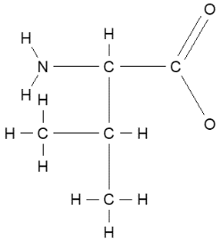**Question 10**

The molecule shown is the amino acid

**A**. valine in alkaline conditions.

**B**. valine.

**C**. leucine in acid conditions.

**D**. leucine in alkaline conditions.

**SECTION B- Short-answer questions**

|  |
| --- |
| **Instructions for Section B**  Questions must be answered in the spaces provided in this book. To obtain full marks for your responses you should   * Give simplified answers with an appropriate number of significant figures to all numerical questions; unsimplified answers will not be given full marks. * Show all workings in your answers to numerical questions. No credit will be given for an incorrect answer unless it is accompanied by details of the working.   Make sure chemical equations are balanced and that the formulas for individual substances include an indication of state; for example, H2(g); NaCl(s) |

**Question 1** (9 marks)

Use the following table to nominate a molecule to match each description.

|  |  |  |  |  |  |  |  |
| --- | --- | --- | --- | --- | --- | --- | --- |
| **A** | **B** | **C** | **D** | **E** | **F** | **G** | **H** |
| C6H12O6 | C18H34O2 | C7H12O2N | C3H8O3 | C4H9O3N | H2O | C12H22O11 | C18H36O2 |

**a**. A saturated fatty acid ______

**b**. A molecule formed when carbohydrates, proteins and triglycerides are formed _____

**c**. An amino acid with low solubility in water _______

**d**. An unsaturated molecule ________

**e**. A molecule that reacts with three fatty acid molecules __________

**f**. A molecule that can be used to form polysaccharides ___________

**g**. A very soluble amino acid ______

**h**. A molecule formed when molecule A reacts with itself ________

**i**. Draw the carbon compound formed when molecule E reacts with itself.

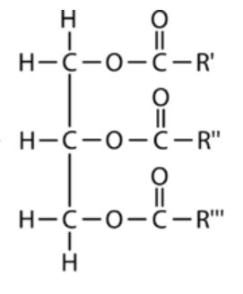**Question 2** (9 marks)

A general structure of a triglyceride is shown below.

**a**. If R’ is derived from palmitic acid and R” and R”’ from oleic acid

draw the structure of the triglyceride. 3 marks

**b. i**. How many carbon-to-carbon double bonds does the triglyceride contain? ________ 1 mark

**ii**. How many ester bonds does the molecule contain? ___________ 1 mark

**c**. Use oleic acid to explain what *cis* and *trans* geometric isomers are. 2 marks

_____________________________________________________________________________

**d**. Which of stearic acid or palmitoleic acid has the higher melting point? Explain your answer. 2 marks

__________________________________________________________________________________

___________________________________________________________________________________

**Question 3** (10 marks)

The molecule shown is a tripeptide.

**a. i**. List the three amino acids used

to form this molecule. 3 marks

_______________________________

A

B

**ii**. Which amino acid will be the least soluble in water? ____________________________ 1 mark

**iii**. Circle all peptide linkages present. 1 mark

**b**. **i**. What type of bonding is the R group marked with an A likely to form? __________ 1 mark

**ii**. What type of bonding is the R group marked with a B likely to form? ___________ 1 mark

**c**. **i**. What is the molecular formula of this molecule? _____________________ 1 mark

**ii**. A sample of this molecule is added to water. Is the solution formed likely to be acidic, neutral or

alkaline? ___________________________ 1 mark

**iii**. How many other molecules were formed when the three amino acids reacted to form the tripeptide?

__________________________________ 1 mark

**Question 4** (8 marks)

A sample of glucose reacts to form a polysaccharide. One of the intermediate products formed is shown below.

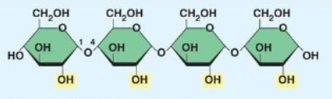

**a. i**. If thousands of these molecules react with each other, what compound is formed? _______ __ 1 mark

**ii**. What is the molar mass of the molecule shown? _______________ 2 marks

**iii**. Is the molecule shown above likely to be soluble in water? Explain your answer. 2 marks

________________________________________________________________________________

**iv**. Is the formation of the molecule drawn above likely to be an endothermic or exothermic reaction?

___________________________________ 1 mark

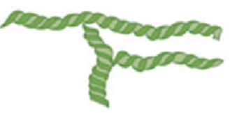**b**. The structures of two different forms of starch are represented below.

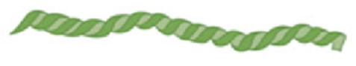

________________ ________________

Identify both structures and explain how they are different. 2 marks

____________________________________________________________________________________

____________________________________________________________________________________

**Question 5** (4 marks)

The structures of two different vitamins are shown below.

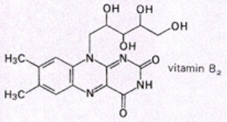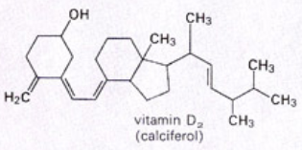

**a**. Which of these vitamins is water soluble? Explain your answer. 2 marks

______________________________________________________________________________

**b**. If a vitamin is water soluble, how does this influence the how humans should consume it? 2 marks

______________________________________________________________________________