**Biomolecules topic test solutions**

**SECTION A: Multiple-choice questions (1 mark each)**

**Question 1**

*Answer:* B

*Explanation:*

Palmitic acid is a long fatty acid but not a polymer.

**Question 2**

*Answer:* C

*Explanation:*

Hydrogen bonding can form between the hydroxyl groups on each amino acid.

**Question 3**

*Answer:* D

*Explanation:*

All listed types of bonds occur at some point along a typical protein.

**Question 4**

*Answer:* B

*Explanation:*

Peptides are an amide linkage formed from reaction of an amine with a carboxylic acid.

**Question 5**

*Answer:* D

*Explanation:*

The lack of -OH groups makes vitamin K fat-soluble.

**Question 6**

*Answer:* B

*Explanation:*

Cellulose is formed from β-glucose.

**Question 7**

*Answer:* A

*Explanation:*

Arachidic acid is the longest molecule and it is saturated.

**Question 8**

*Answer:* C

*Explanation:*

A saturated fatty acid would have 36 hydrogen atoms if it has 18 carbon atoms. If it only has 32 hydrogen atoms it must have 2 carbon-to-carbon double bonds.

**Question 9**

*Answer:* B

*Explanation:*

Glucose weighs 180 – 12 glucose will be 2160. Subtract 11 water molecules (198) gives 1962.

**Question 10**

*Answer:* A

*Explanation:*

This is valine in alkaline conditions.

**SECTION B: Short-answer questions**

**Question 1** (9 marks)

**a**. H **b**. F **c**. C **d**. B **e**. D **f**. A **g**. E **h**. G **i**.

**Question 2** (9 marks)

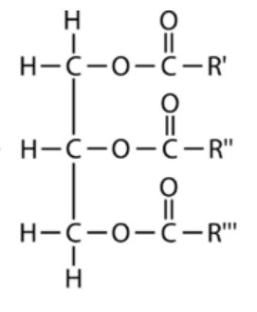

(CH2)14CH3

**a**. 3 marks

(CH2)7CH=CH(CH2)7CH3

(CH2)7CH=CH(CH2)7CH3

**b. i**. 2 1 mark **ii**. 3 1 mark

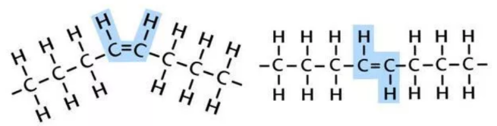**c**. . 2 marks

*cis*(Hs on same side) *trans*(Hs on opposite sides). A trans fatty acid will have a V-shape

**d**. Stearic acid will have the higher melting point. The absence of carbon-to-carbon double bonds leads to a

more linear structure that will allow the molecules to pack together more tightly. 2 marks

**Question 3** (10 marks)

**a. i**. glutamic acid, glycine, serine 3 marks

**ii**. glycine – no dipoles 1 mark

**iii**. circle the two instances of -NH- CO- 1 mark

**b**. **i**. ionic 1 mark **ii**. Hydrogen bonding 1 mark

**c**. **i**. C10H17O7N3 1 mark

**ii**. acidic as one of the R groups is a carboxyl group. 1 mark

**iii**. two water molecules. 1 mark

**Question 4** (8 marks)

**a. i**. starch 1 mark

**ii**. 4 molecules of glucose subtract 3 molecules of water : 4 x 180 – 3 x 18 = 666 g mol-1 2 marks

**iii**. this molecule will be soluble due to the large number of hydroxyl groups. 2 marks

**iv**. endothermic, as the build up of most food polymers is endothermic. 1 mark

**b**. amylose is a linear molecule with very few branches. Amylopectin is also a polymer of glucose but it

has branches after every 20 or so glucose molecules, leading to the branched structure shown. The

solubility of amylose will lower than that of amylopectin as the molecules can pack more tightly.

**Question 5** (4 marks)

**a**. Vitamin B is water-soluble due to the four hydroxyl groups it contains. 2 marks

**b**. If needs to be consumed frequently in small doses as it will not be stored in the body. The body will

dispose of it in urine. 2 marks