**Substances**

**diamond, water**

**Non-metals**

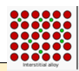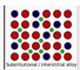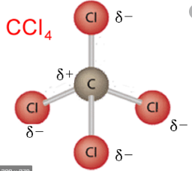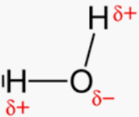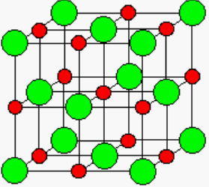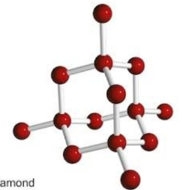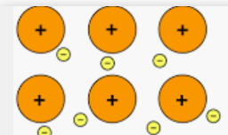

**ammonia, water**

**soluble in water**

**MPoint not so low**

**CCl4 CO2**

**oxygen methane**

**low MPoint**

***electron sharing***

**NaCl CuBr2**

**high MP**

**hard, brittle**

**+ve and -ve ions**

**Mg Na Au**

**malleable**

**conduct electricity**

**high MP**

**sea electrons**

**Polar**

**With dipoles**

**diamond, silica**

**hard, brittle, high MP**

***electron transfer***

**brass steel solder**

**malleable**

**conduct electricity**

**metal mixture –**

**properties not average**

**Ionics**

**Non-polar**

**Molecular**

**Covalent network lattices**

**Metals**

**Alloys**