Chemistry SAC Unit 4

Response to structured questions

1. State the molecular formula and sketch each of the following molecules.

|  |  |  |
| --- | --- | --- |
| Name | Molecular formula | Structural formula |
| Pentan-3-ol |  |  |
| 2,2-dichlorobutane |  |  |
| Butan-1-amide |  |  |
| Methylpropanoate |  |  |
| 3-methylbut-1-ene |  |  |
| 3-aminopentanoic acid |  |  |

12 marks

1. Name each of these molecules
2.  b.

2 marks

1. Draw and name three structural isomers with the molecular formula C3H6O2.

6 marks

1. Draw and name the products of each of the following reactions.
2. But-1-ene + Cl2 🡪
3. Butan-1-ol + K2Cr2O7(aq)/H+(aq) 🡪
4. Butan-2-ol + K2Cr2O7(aq)/H+(aq) 🡪
5. Propan-1-ol + ethanoic acid 🡪
6. Propan-1-amine + ethanoic acid 🡪
7. But-1-ene + itself many times 🡪
8. Ethane + Cl2 (UV) 🡪 14 marks
9. Draw and label the two geometric isomers of 2,3-dichlorobutene.

2 marks

1. Identify the chiral centre on the molecule below.

Draw an optical isomer of this molecule.

2 marks

1. 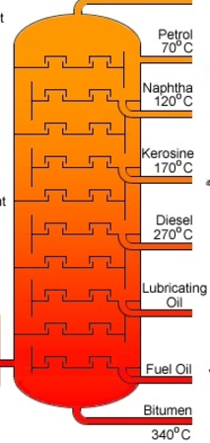A fractional distillation column is shown on the right.
2. Explain clearly what this column separates and how it works.

___________________________________________________

___________________________________________________

___________________________________________________

___________________________________________________

___________________________________________________

1. Write a balanced equation for the complete combustion of hexan-1-ol

______________________________________________________________

3 + 1 = 4 marks

1. Write a balanced half-equation for the reduction of Cr2O72- to Cr3+.

_____________________________________________________________________ 1 mark

1. Explain clearly, with the aid of diagrams, why the boiling point of propan-1-ol is higher than that of butane.

___________________________________________

____________________________________________

____________________________________________

____________________________________________

3 marks

1. Calculate the atom economy of the reaction of 1-chloropropane and KOH to form ethanol.

__________________________________________________________________________________

_________________________________________________________________________ 2 marks

1. Bromine solution is added to cyclohexane in one test-tube and to cyclohexene in another test-tube.

Describe and explain what happens.

__________________________________________________________________________________

_________________________________________________________________________ 2 marks