**Chemistry Name: ________________**

**2019 Trial exam**

**SECTION A – Multiple-choice questions**

|  |
| --- |
| **Instructions for Section A**  Answer **all** questions.  Choose the response that is **correct** or **best answers** the question.  A correct answer scores 1, an incorrect answer scores 0.  No mark will be given if more than one answer is completed for any question.  Marks will **not** be deducted for incorrect answers. |

*Use the following information to answer Questions 1 and 2*

The Australian Department of Environment and Energy monitors Australia’s energy consumption. The table below summarises the main energy sources for the years 2015-16.

(1 PJ = 1015 Joule)

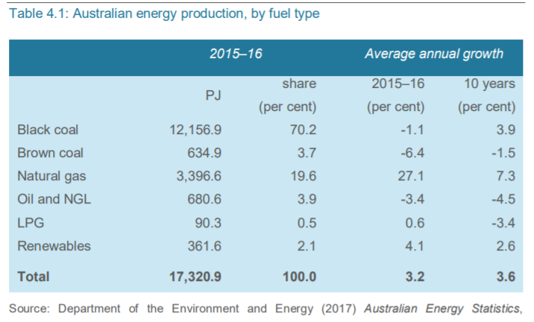

**Question 1**

The percentage of our energy sourced from fossil fuels in 2015-2016 was

**A**. 73.9

**B**. 77.8

**C**. 93.5

**D**. 97.9

**Question 2**

The mass of methane that would need to undergo complete combustion to produce the energy provided by natural gas would be, in kg,

**A**. 3.8 × 109

**B**. 6.1 × 1010

**C**. 3.8 × 1012

**D**. 6.1 × 1013

**Question 3**

The complete combustion of 3 mole of an alkane produces 149 L of CO2 at SLC. The alkane is

**A**. methane

**B**. ethane

**C**. butane

**D**. octane

**Question 4**

The main form of chemical bonding within biodiesel molecules is

**A**. dispersion forces.

**B**. hydrogen bonding.

**C**. dipole bonding.

**D**. covalent bonding.

**Question 5**

Molasses is a by-product of the sugar industry. It contains a mixture of saccharide molecules. Scientists have designed a process that enables them to produce a biofuel from molasses. The biofuel is most likely to be

**A**. natural gas

**B**. biogas

**C**. bioethanol

**D**. biodiesel.

*Use the following information to answer Questions 6 to 8*

The diagram below shows a zinc-mercury oxide button cell. This is a primary cell that produces a voltage of 1.35 volts. These cells were used extensively but have been phased out in recent years.

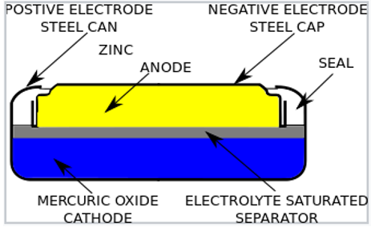

The half-equation for the reaction involving mercury in this cell is

HgO(s) + H2O(l) + 2e- 🡪 Hg(s) + 2OH-(aq)

**Question 6**

The likely half-equation for the anode reaction is

**A**. Zn(s) + 2OH-(aq) 🡪 Zn(OH)2(s) + 2e

**B**. Zn(s) + H2O(l) 🡪 Zn(OH)2(s) + OH-(aq) + e-

**C**. Zn(OH)2(s) + H2O(l) + 2e- 🡪 Zn(s) + 2OH-(aq)

**D**. Zn(s) + 2OH-(aq) + 2e- 🡪 Zn(OH)2(aq) + H2O(l)

**Question 7**

In this cell, the

**A**. pH will rise during discharge due to the production of OH- ions.

**B**. pH will fall during discharge due to the production of OH- ions.

**C**. mass of the cell will drop during discharge as zinc metal reacts.

**D**. mass and the pH will remain constant.

**Question 8**

This cell has been phased out in recent years. A likely reason for its demise is

**A**. the issues with its safe disposal.

**B**. there is little market for button batteries.

**C**. that all small batteries are now recyclable.

**D**. that zinc is now a very scarce material.

**Question 9**

Sulfate ions can be converted to peroxysulfate ions (S2O82-)in a redox reaction. A balanced half equation for this reaction is

**A**. 2SO42-(aq) 🡪 S2O82-(aq) + 2e-

**B**. SO42-(aq) + 4H2O(l) 🡪 S2O82-(aq) + 8H+(aq) + 2e-

**C**. 2SO42-(aq) + 4H2O(l) 🡪 2S2O82-(aq) + 8H+(aq) + 2e-

**D**. 2SO42-(aq) + 2e- 🡪 2S2O82-(aq)

**Question 10**

An energy profile diagram below shows the energy changes occurring when methane undergoes complete combustion.

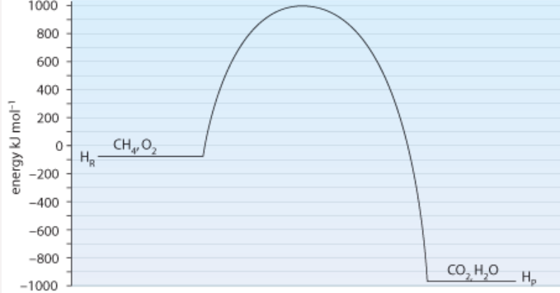

The activation energy and the enthalphy change for the **reverse** reaction will be, respectively,

**A**. -1090 kJ mol-1 and -890 kJ mol-1

**B**. +1090 kJ mol-1 and +890 kJ mol-1

**C**. +1980 kJ mol-1 and +890 kJ mol-1

**D**. +1980 kJ mol-1 and -890 kJ mol-1

**Question 11**

The decomposition of hydrogen iodide gas is a reversible reaction.

2HI(g) ⇌ H2(g) + I2(g)

3.0 mol of HI is added to an empty 2.0 L reactor and given time to reach equilibrium. The amount of H2 gas at equilibrium is 0.20 mol. The value of the equilibrium constant at this temperature is

**A**. 0.0059

**B**. 2.0

**C**. 65

**D**. 169

*Use the following information to answer Questions 12 and 13*

The reaction between Fe3+ and SCN- ions forms a complex with a deep red colour. The equation for this reaction is

Fe3+(aq) + SCN-(aq) ⇌ FeSCN2+(aq)

*deep red*

**Question 12**

Which of the following changes will not lead to an increase in the intensity of the red colour?

**A**. Evaporation of some water from the solution.

**B**. Addition of a few drops of KSCN solution.

**C**. Addition of a few drops of Fe(NO3)3 solution.

**D**. Dilution with water.

**Question 13**

A few drops of AgNO3 is added to an equilibrium mixture of the above chemicals. The Ag+ ions form an AgSCN precipitate. As a result of this addition, the

**A**. value of the equilibrium constant increases as the reverse reaction is favoured.

**B**. concentration of SCN- ions in the mixture will be lower than it was before the addition.

**C**. concentration of FeSCN2+ will increase as the forward reaction is favoured.

**D**. concentration of SCN- ions in the mixture will be higher than it was before the addition.

*Use the following information to answer Questions 14 and 15*

An electrolytic cell is shown below that produces chlorine gas and hydrogen gas.

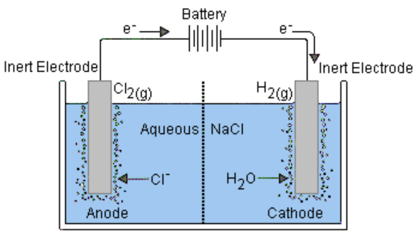

**Question 14**

The electrolyte in this cell is likely to be

**A**. 0.1 M HCl

**B**. 0.1 M NaCl

**C**. 4.0 M NaCl

**D**. NaCl(l)

**Question 15**

The cell runs with a current of 2.80 amps and a voltage of 5.20 V for 5.00 minutes. The volume of gas produced at the cathode at SLC in this time will be, in L,

**A**. 0.054

**B**. 0.108

**C**. 0.216

**D**. 108

**Question 16**

What is the systematic name of this molecule?



**A**. 3,4-dibromo-2,5-dimethylheptane

**B**. 3,4-dibromononane

**C**. 4,5-dibromo-3,6-dimethylheptane

**D**. 3,6-dimethyl-4,5-dibromoheptane

**Question 17**

Pentan-1-amine could be formed from the reaction of

**A**. pentane and ammonia.

**B**. 1-chloropentane and ammonia.

**C**. butan-1-ol and chloromethane.

**D**. pentanoic acid and ammonia.

**Question 18**

A substance with molecular formula C4H6Cl2 could have

**A**. no isomers of any type.

**B**. geometric isomers only.

**C**. geometric or structural isomers only.

**D**. structural isomers, geometric isomers or optical isomers.

**Question 19**

A HPLC printout for a substance is shown below. A polar stationary phase has been used.

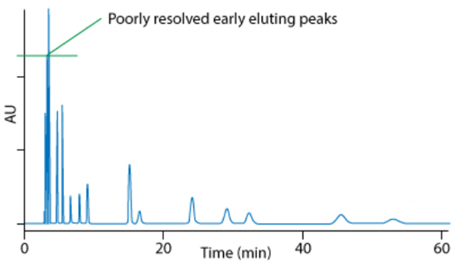

The chromatogram indicates that

**A**. the substance being tested has few impurities.

**B**. there is likely to be significant concentrations of polar components in the mixture.

**C**. there is likely to be significant concentrations of non-polar components in the mixture.

**D**. the column is not providing adequate separation of peaks.

**Question 20**

Butan-2-ol is tested in both proton-NMR and carbon-NMR. It will have

|  |  |  |
| --- | --- | --- |
|  | Hydrogen environments | Carbon environments |
| **A.** | 3 | 3 |
| **B.** | 4 | 3 |
| **C.** | 5 | 3 |
| **D.** | 5 | 4 |

**Question 21**

A carbon-NMR is shown below.

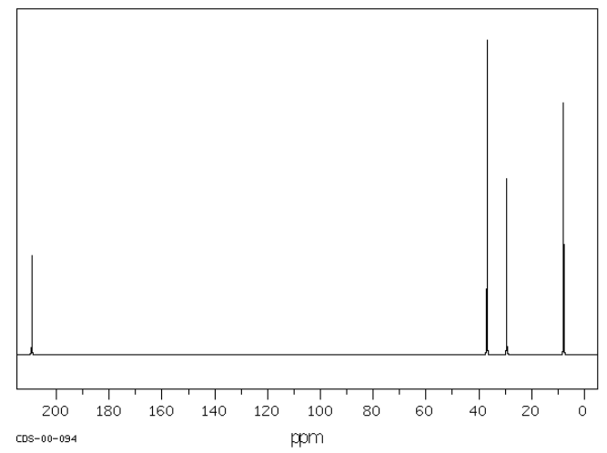

This molecule is likely to be

**A**. butane

**B**. butan-1-ol

**C**. pentanoic acid

**D**. butanone

**Question 22**

An impure sample of oxalic acid (M = 90 g mol-1) is tested through titration. A 3.00 g sample is dissolved in water. 29.4 mL of 0.25 M NaOH is required to neutralise the diprotic oxalic acid. The acid concentration, as a %m/m, is closest to

**A**. 5.5

**B**. 11

**C**. 22

**D**. 55

**Question 23**

The mass spectrum of a molecule is shown below.

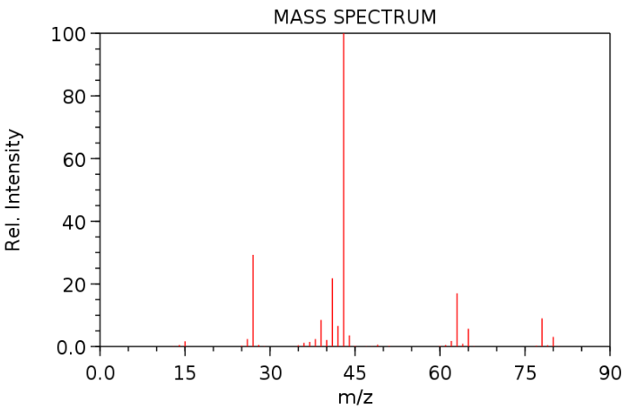

The molecule is likely to be

**A**. 2-chloropropane

**B**. propan-1-amine

**C**. pentane

**D**. propanoic acid

**Question 24**

Ethanoic acid can be formed from the oxidation of ethanol. The same reaction can be performed as a titration which can be used to determine the ethanol concentration. Dichromate ions (Cr2O72-) are often used for the oxidation. The dichromate ions are converted in acid conditions to Cr3+ ions.

In this titration the mole ratio of ethanol to dichromate ions will be

**A**. 1:1

**B**. 2:3

**C**. 3:2

**D**. 5:1

**Question 25**

Which of the following food molecules contains the highest number of hydroxyl functional groups?

**A**. glucose

**B**. glycine

**C**. glycerol

**D**. glycogen

**Question 26**

A particular fatty acid has a molecular formula of C20H32O2.

How many carbon-to-carbon double bonds does this molecule contain?

**A**. 1

**B**. 2

**C**. 3

**D**. 4

**Question 27**

The effectiveness of three different enzymes at different pH levels is illustrated in the graph below. All three enzymes play an important role in human digestion.

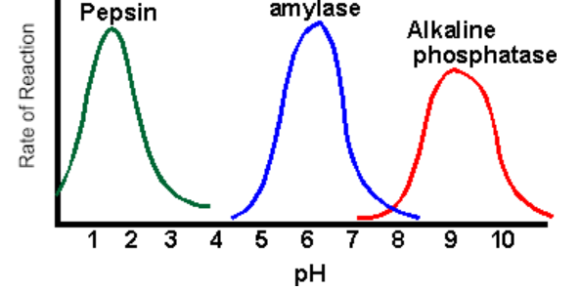

From the graph it is likely that

**A**. amylase is in saliva, pepsin in the stomach and phosphatase in the small intestine.

**B**. amylase and pepsin are found mainly in saliva and phosphatase in the stomach.

**C**. amylase is in saliva, pepsin in the small intestine and phosphatase in the stomach.

**D**. all three enzymes will operate mainly in the stomach.

**Question 28**

The molecule 2-amino-3-hydroxypropanoic acid is also known as

**A**. glycine.

**B**. serine.

**C**. threonine.

**D**. valine.

**Question 29**

A 5.0 g sample of carbohydrate is used to heat a sample of water from 17.50C to 25.50C. The same mass of fat should be able to increase the temperature of the same water sample by

**A**. 80C

**B**. 160C

**C**. 18.50C

**D**. 20.80C

**Question 30**

A student conducts a titration adding acid into a burette that was not cleaned at all after the previous experiment. She is using a standard acid solution to determine the concentration of a alkaline solution. In the previous experiment a base had been used in the burette. The impact of this poor technique is likely to be a

**A**. higher titre than expected causing the calculated concentration of the base to be high.

**B**. higher titre than expected causing the calculated concentration of the base to be low.

**C**. lower titre than expected causing the calculated concentration of the base to be high.

**D**. lower titre than expected causing the calculated concentration of the base to be low.

**Section A 30 marks ____**

**Total Section B 90 marks ____**

**Total exam 120 marks ____**

**SECTION B - Short-answer questions**

|  |
| --- |
| **Instructions for Section B**  Questions must be answered in the spaces provided in this book. To obtain full marks for your responses you should   * give simplified answers with an appropriate number of significant figures to all numerical questions; unsimplified answers will not be given full marks. * show all workings in your answers to numerical questions. No credit will be given for an incorrect answer unless it is accompanied by details of the working. * make sure chemical equations are balanced and that the formulas for individual substances include an indication of state; for example, H2(g); NaCl(s) |

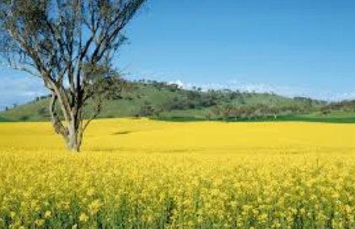**Question 1** (9 marks)

Canola crops like the one pictured below have

become a common sight around Victoria.

The oil extracted from the seeds of the crop

can be used in the transport industry or the

food industry.

Like most fats and oils, canola oil contains a

mixture of fatty acids, oleic acid being the most

common at 56%.

**a. i**. Draw the complete structure of a molecule of biodiesel that could be formed from the

reaction between oleic acid and ethanol. 2 marks

**ii**. Write a balanced equation for the complete combustion of the biodiesel molecule.

2 marks

________________________________________________________________________

**b.** **i.** What category of fatty acid does oleic acid belong to? _____________ 1 mark

**ii**. How will the melting point of oleic acid compare to that of stearic acid? Explain

your answer. 2 marks

_______________________________________________________________________

_______________________________________________________________________

**c**. There are limitations on the production of biodiesel from canola oil in Australia.

List two limitations. 2 marks

_______________________________________________________________________

_______________________________________________________________________

**Question** **2** (10 marks)

The zinc alkaline cell is a very common commercial battery with a voltage of 1.43 V. A cross-section of the cell is shown below.

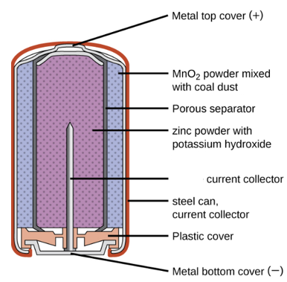

The overall equation for the reaction occurring is

Zn(s) + 2MnO2(s) + H2O(l) 🡪 Mn2O3(s) + Zn(OH)2(s)

**a**. Write balanced half-equations for the reaction occurring at the 2 marks

anode: ___________________________________________________________

cathode: ___________________________________________________________

**b**. Research shows the voltage of this zinc half-equation is listed as -1.28 V.

What will the voltage of the MnO2 half-equation be? 1 mark

_______________________________________________________________________

**c**. One of the advantages of this cell over the cheaper zinc dry cell is that the casing of the

battery does not corrode away. Use the half-equations you have written to explain why

this is the case. 2 marks

_______________________________________________________________________

_______________________________________________________________________

**d**. Methane gas can be used to produce electrical energy in a fuel cell. Write half-equations

and an overall equation for the reactions of methane in an alkaline fuel cell. 3 marks

anode: _____________________________________________________________

cathode: _____________________________________________________________

overall: _____________________________________________________________

**Question 3** (8 marks)

The amide molecule shown can be synthesised from smaller molecules in the process outlined below. Ethene is used as the starting reactant.



 HCl H3PO4/H+

**B**

**A**

NH3 H+/Cr2O72-

**D**

**C**



**a**. Use the boxes provided to draw and name the molecules A to D. 4 marks

**b.** Write a balanced equation for – 2 marks

**i**. the reaction between ethene and HCl.

______________________________________________________________________

**ii**. the reaction between molecule A and NH3.

_______________________________________________________________________

**c**. Write a balanced half-equation for the formation of molecule D. 1 mark

_____________________________________________________________________

**d**. Give an example of reaction in the above pathway that has an atom economy of 100%.

1 mark

_____________________________________________________________________

**Question 4** (11 marks)

Sulfur trioxide is an unstable gas that can decompose according to the equation:

2SO3(g) ⇌ 2SO2(g) + O2(g) Δ*H* > 0

**a**. A mixture of the thee gases is added to a gas syringe and the contents are allowed

sufficient time to reach equilibrium. The volume of the syringe is then halved and the

temperature is held constant. Explain

the impact of this volume change on

**i**. the value of the equilibrium constant. 1 mark

_______________________________________________________________________

**ii**. the concentration of SO2 gas. 2 marks

________________________________________________________________________

________________________________________________________________________

**iii**. the amount of SO2 gas. 1 mark

________________________________________________________________________

_________________________________________________________________________

**b**. A sample of sulfur trioxide gas is added to an empty reactor and its concentration is

measured over the next 3 minutes. The SO3 concentration is plotted on the graph

below.

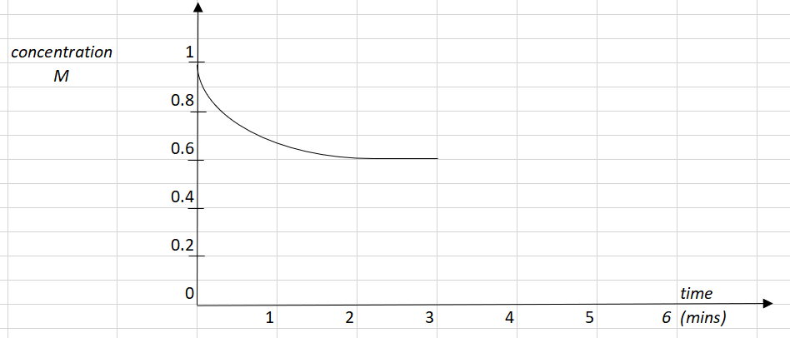

**i**. Draw on the graph provided the corresponding concentration for the sulfur dioxide

and oxygen gases during the first 3 minutes. 2 marks

**ii**. Calculate the equilibrium constant at the 3 minute mark. 2 marks

______________________________________________________________________

______________________________________________________________________

______________________________________________________________________

**iii**. At the 3 minute mark the temperature of the system is increased. Use the graph to

show the impact of this change on all 3 gases. 3 marks

**Question 5** (9 marks)

The mass spectrum of an aldehyde molecule is shown below.

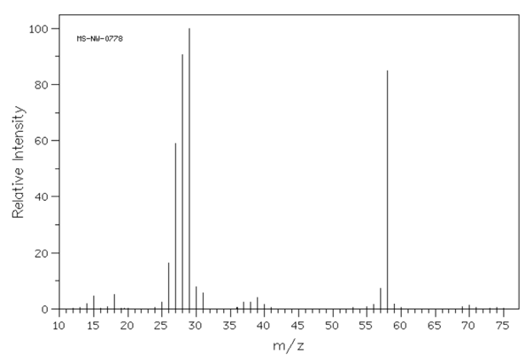

**a**. Use the mass spectrum to:

**i**. suggest a molecular formula for the molecule _____________________ 1 mark

**ii**. suggest a name for the molecule. ___________________________ 1 mark

**b**. Draw and name a molecule that could be used to manufacture this aldehyde. 2 marks

**c**. The infrared spectrum for the aldehyde molecule is shown below.

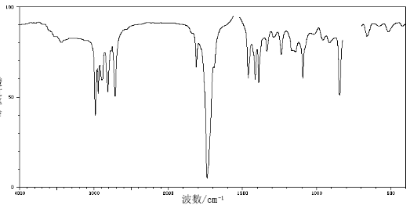

In the table below, write the bond responsible for the wave numbers given. 1 mark

|  |  |
| --- | --- |
| Wave number (cm-1) | Bond |
| 3000 |  |
| 1750 |  |

**d**. The proton-NMR spectrum for the aldehyde molecule is shown below.

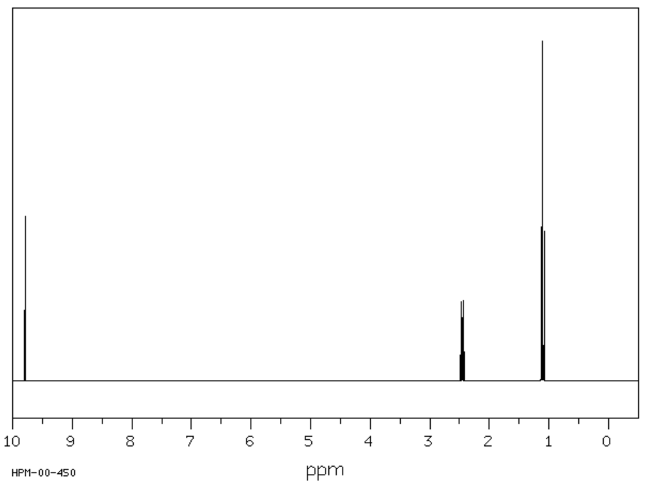

The splitting pattern is not obvious on this spectrum. In the table below, draw the part of the molecule responsible for each set of peaks and predict the likely splitting pattern. 3 marks

|  |  |  |
| --- | --- | --- |
| Shift | Likely structure | Splitting pattern |
| 1.1 |  |  |
| 2.4 |  |  |
| 9.8 |  |  |

**e**. This molecule can be produced naturally from a reaction involving one of the food

groups. Suggest a reaction that might lead to the formation of this aldehyde. 1 mark

______________________________________________________________________

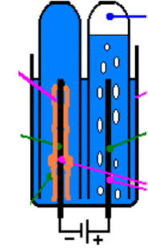**Question 6** (8 marks)

The diagram shown is a snippet from an electrolysis cell.

The products shown are a brown metal and a colourless gas.

1 mark

**a. i**. Suggest a solution that could be used to lead to these products.

_________________________________________________

**ii**. Use the template below to show the half-equations and

overall reaction occurring. 3 marks

anode: _____________________________________________

cathode: _____________________________________________

overall equation: _______________________________________

**b.** Calculate the volume of gas produced if a current of 6.60 amps runs for 2 mins 20 secs.

The temperature is 21.0 0C and the pressure 95.0 kPa. 4 marks

______________________________________________________________________

______________________________________________________________________

______________________________________________________________________

______________________________________________________________________

**Question 7** (10 marks)

Testing laboratories usually test the heat of combustion of food items in a bomb calorimeter

rather than a solution calorimeter. A diagram of a bomb calorimeter is shown below.

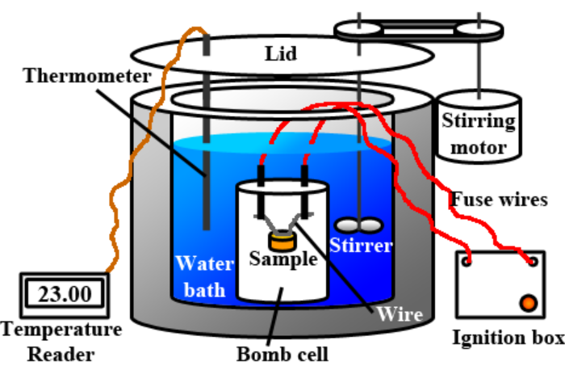

**a. i**. List two reasons why a bomb calorimeter might provide a more accurate value than

a solution calorimeter for the heat of combustion of a biscuit. 2 marks

_______________________________________________________________________

_______________________________________________________________________

_______________________________________________________________________

**ii**. Oxygen is often added to the bomb cell under pressure. Why is a high pressure used?

1 mark

_______________________________________________________________________

**iii**. What is the role of the ignition box in the above apparatus? 1 mark

_______________________________________________________________________

**b**. The following data is recorded by a student who is investigating the heat of combustion

of Anzac biscuits. 3 marks

|  |  |
| --- | --- |
| calibration | experiment |
| Addition of 2460 J of energy  Initial temperature: 18.40C  Final temperature: 22.90C | initial temperature of water: 22.90C  final temperature of water: 27.40C  mass of biscuit: 0.962 g |

Calculate the heat of combustion of the biscuit.

________________________________________________________________________

________________________________________________________________________

**c. i**. In a recipe change, the manufacturer of the biscuit lowers the fat content but increases

the sugar content. Explain the impact of this change on the heat of combustion of the

biscuit. 1 mark

_______________________________________________________________________

_______________________________________________________________________

**ii**. In a different recipe experiment the manufacturer replaces the 6 g of sugar in each

biscuit with 6 g of aspartame. Explain the impact of this change on the 2 marks

- energy content: __________________________________________________________

- taste: _________________________________________________________

**Question 8** (7 marks)

**a**. If you sit a piece of white bread in your mouth you will notice a sweet taste emerge over

the next few minutes.

**i**. What reaction is occurring to produce this sweet taste? 1 mark

_______________________________________________________________________

**ii**. How does chewing your food thoroughly aid the digestion process? 1 mark

_______________________________________________________________________

**b**. A small percentage of the population take lactase tablets regularly. Explain, from a

chemistry point of view, why they might do this. 1 mark

**c**. Hydrogen peroxide is a clear liquid with a chemical formula of H2O2. It is used as an

antiseptic and as a bleach. It decomposes easily to form water and oxygem.

The rate of this reaction increases if a piece of liver is added to the hydrogen peroxide and

it is also increased if potassium iodide is added.

i. Explain how a piece of liver increases the rate of decomposition. 2 marks

_______________________________________________________________________

_______________________________________________________________________

**ii**. Identify one similarity and one difference in the action of KI compared to that of

liver. 2 marks

_______________________________________________________________________

_______________________________________________________________________

**Question 9** (10 marks)

A student investigates the voltage values on the electrochemical series of various metals. Her experimental set-up and data collected is shown below.

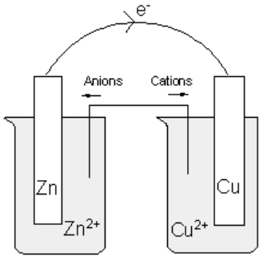

**Hypothesis**: That the voltage values shown on the electrochemical series can be replicated in a school laboratory.

**Procedure**

The student prepares a zinc metal, zinc solution half-cell and connects it in turn to four other half-cells.

Salt bridge: prepared from absorbent paper soaked in Na2SO4 solution.

Solutions: All carefully prepared 0.10 M solutions.

Temperature: 18.4 0C

The voltages obtained and the polarity of each cell are recorded in the table below.

|  |  |  |
| --- | --- | --- |
| Cell combination | Positive electrode | Cell voltage (V) |
| Zn2+,Zn(s)||Cu2+,Cu(s) | copper | 0.82 |
| Zn2+,Zn(s)||Pb2+,Pb(s) | lead | 0.54 |
| Zn2+,Zn(s)||Mg2+,Mg(s) | zinc | 1.10 |
| Zn2+,Zn(s)||Fe2+,Fe(s) | iron | 0.29 |

**Student conclusion**: The laboratory values for an electrochemical series are wrong as they are not consistent with those of the Data book .

**a**. For this experiment, identify the 2 marks

**i**. independent variable _________________________________________

**ii**. dependent variable _________________________________________

**b**. The zinc half-cell is represented in your data book as 3 marks

Zn2+(aq) + 2e ⇌ Zn(s)

The student assigns a value of 0.00 V to this half-equation.

Use the experimental data to add the half-equations for the other four metals tested to

make a simplified electrochemical series below.

Include the voltages obtained by experiment in your table.

Zn2+(aq) + 2e ⇌ Zn(s) 0.00 V

**c**. Comment on the validity of the student’s conclusion. 2 marks

___________________________________________________________________

___________________________________________________________________

___________________________________________________________________

**d**. List three reasons the voltages obtained by the student might not match those of the

electrochemical series in your Data Book. 3 marks

___________________________________________________________________

___________________________________________________________________

___________________________________________________________________

**Question 10** (8 marks)

Proteins are natural polymers formed when many amino acids bond together. The chemical structure of proteins is complex and involves several levels.

**a**. Use the protein segment below to demonstrate your understanding of the structure of

proteins. In your answer: 5 marks

* explain the difference between primary, secondary and tertiary structure
* identify the types of bonding present.

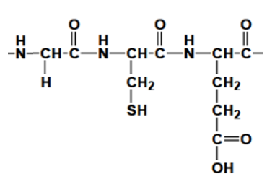

________________________________________________________________________

_________________________________________________________________________

________________________________________________________________________

_________________________________________________________________________

________________________________________________________________________

_________________________________________________________________________

________________________________________________________________________

_________________________________________________________________________

**b**. Proteins can be metabolised in the human body. Explain the likely steps in the digestion

of proteins and the likely uses of the body for the products of protein digestion. 3 marks

________________________________________________________________________

_________________________________________________________________________

________________________________________________________________________

_________________________________________________________________________

________________________________________________________________________

_________________________________________________________________________

**END OF EXAM**