**Chemistry Name: ________________**

**2020 Trial exam**

**120 mark total: 30 + 90**

**SECTION A – Multiple-choice questions**

|  |
| --- |
| **Instructions for Section A**  Answer **all** questions.  Choose the response that is **correct** or **best answers** the question.  A correct answer scores 1, an incorrect answer scores 0.  No mark will be given if more than one answer is completed for any question.  Marks will **not** be deducted for incorrect answers. |

*Use the following information to answer Questions 1 and 2*

The diagram below is a representation of the processes occurring in the production of electrical energy from coal.

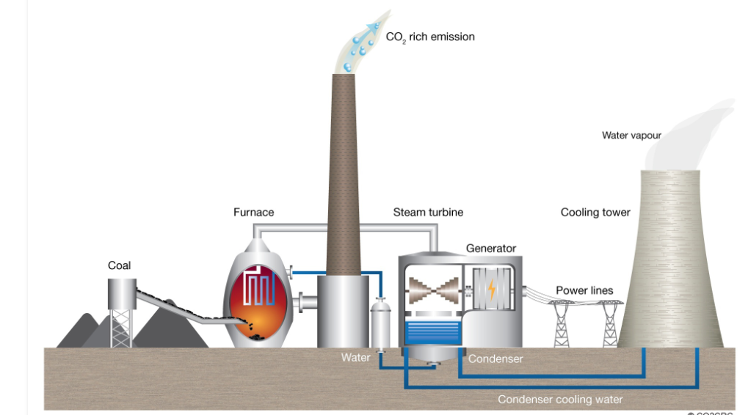

**Question 1**

The main energy producing reaction occurring in this power station is

**A**. CH4(g) + 2O2(g) 🡪 CO2(g) + 2H2O(l)

**B**. 2C(s) + O2(g) 🡪 2CO(g)

**C**. C(g) + O2(g) 🡪 CO2(g)

**D**. C(s) + O2(g) 🡪 CO2(g)

**Question 2**

The main pollutant producing reaction occurring in this power station is

**A**. CH4(g) + 2O4(g) 🡪 CO2(g) + 2H2O(l)

**B**. C(s) + O2(g) 🡪 CO2(g)

**C**. S(s) + O2(g) 🡪 SO2(g)

**D**. N2(g) + O2(g) 🡪 2NO(g)

**Question 3**

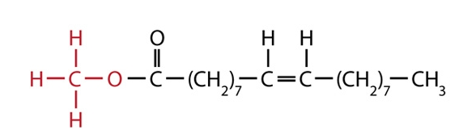

I fatty acid

II biodiesel

III ester

IV triglyceride

The molecule shown can be described as

**A**. I and III only.

**B**. II and IV only.

**C**. I and II only.

**D**. II and III only.

*Use the following information to answer Questions 4 and 5*

In 2019 Australia passed Qatar as the world’s largest exporter of LNG with a total export of 77.5 million tonnes (1 tonnes = 1000 kg). (Assume that LNG is 100% methane for this question)

**Question 4**

The amount of energy that could be produced from the complete combustion of this LNG is, in kJ,

**A**. 7.75×1013

**B**. 4.31×1012

**C**. 4.31×1015

**D**. 4.31×1018

**Question 5**

The volume of CO2 that could be produced at SLC from the complete combustion of this LNG is, in L,

**A**. 4.84×1012

**B**. 1.2 ×1011

**C**. 1.2 ×1014

**D**. 4.31×1015

**Question 6**

Select the alternative that **best** describes why the rate of a reaction increases with temperature.

**A**. A higher temperature means more collisions.

**B**. A higher temperature leads to less space between particles.

**C**. A higher temperature means a higher percentage of collisions are successful.

**D**. A higher temperature gives more collisions and a higher percentage of successful

collisions.

**Question 7**

The diagram below shows an energy profile diagram for a reaction with a two-stage catalyst.

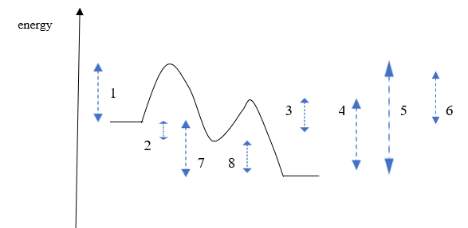

The respective values for the activation energy and enthalpy change for this reaction are

**A**. 1 and 7

**B**. 3 and 8

**C**. 5 and 7

**D**. 1 and 8

*Use the following information to answer Questions 8 and 9*

The diagram below shows a representation of a lithium/ manganese dioxide cell.

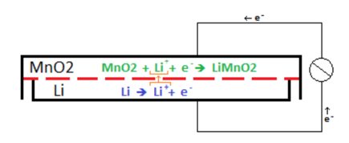

**Question 8**

In this cell,

**A**. electrons will flow from the cathode to the anode.

**B**. the lithium metal is the cathode and has a positive polarity.

**C**. lithium metal is oxidised and manganese ions reduced.

**D**. lithium ions are reduced and manganese ions oxidised.

**Question 9**

The overall reaction (simplified) for this cell will be

**A**. Li(s) + MnO2(s) 🡪 LiMnO2(s) + Li+

**B**. Li(s) + MnO2(s) 🡪 LiMnO2(s)

**C**. Li+ + MnO2(s) + Li(s) 🡪 Li+ + LiMnO2(s)

**D**. Li+ + MnO2(s) 🡪 LiMnO2(s)

**Question 10**

Which of these metals is the least reactive?

**A**. silver

**B**. tin

**C**. copper

**D**. lead

**Question 11**

Which of the following half-equations could be from the cathode of an alkaline fuel cell?

**A**. O2(g) + 2H2O(l) + 4e- 🡪 4OH-(aq)

**B**. CH4(g) + 2H2O(l) + 4e- 🡪 CO2(g) + 4OH-(aq)

**C**. H2(g) 🡪 2H+(aq) + 2e-

**D**. H2(g) + 2OH-(aq)  🡪 2H2O(l) + 2e-

*Use the following information to answer Questions 12 and 13*

Aluminium metal can be recycled by dissolving the aluminium in molten cryolite and electrolysing the liquid. The half equations for the process are shown on the diagram below.

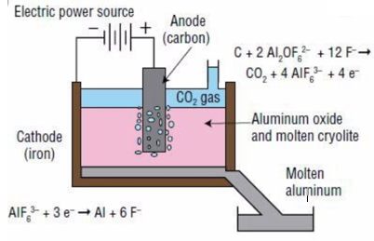

**Question 12**

In this cell

**A**. aluminium metal is formed at the anode and carbon dioxide at the cathode.

**B**. aluminium metal is formed at the cathode and carbon dioxide gas at the anode.

**C**. electrons will flow from the aluminium electrode to the carbon anode.

**D**. the energy released can be used to power other parts of the production process.

**Question 13**

A current of 10 amps runs through this cell for 10000 seconds. The volume of CO2 produced at SLC will be, in litres,

**A**. 0.0064

**B**. 2.0

**C**. 6.4

**D**. 13

**Question 14**

Electrolysis of a liquid produces hydrogen gas at the negative electrode and chlorine gas at the positive electrode. The liquid could be

**A**. a dilute solution of HCl.

**B**. a dilute solution of KCl.

**C**. KCl(l)

**D**. a concentrated solution of KCl.

*Use the following information to answer Questions 15 and 16*

Bromine and chlorine gases can react to form the compound BrCl. The equation for the reaction is

Br2(g) + Cl2(g) ⇌ 2BrCl(g) *K*c = 225 at 200 0C. Δ*H* = -ve

Bromine is dark brown in colour. Chlorine is a very light green and BrCl colourless.

**Question 15**

Given the above information, what is *K*c for the reaction BrCl(g) ⇌ ½ Br2(g) + ½ Cl2(g) at 200 0C?

**A**. 0.0044

**B**. 0.067

**C**. 15

**D**. -225

**Question 16**

A change is made to an equilibrium mixture of the above gases and the brown intensity is seen to increase as equilibrium is re-established. The change could have been

**A**. an increase in volume.

**B**. the addition of further chlorine gas.

**C**. an increase in temperature.

**D**. a decrease in temperature.

**Question 17**

What is the systematic name of this molecule?



**A**. 5-chloropentan-2-ol

**B**. 5-chloropentanol

**C**. 1-chloropentan-2-ol

**D**. 1-chloropentan-4-ol

**Question 18**



The molecule shown could be formed from the reaction between

**A**. propanoic acid and ethanol.

**B**. propan-1-ol and ethanoic acid.

**C**. propan-1-ol and methanoic acid.

**D**. propanoic acid and methanol.

**Question 19**

A HPLC printout for a mixture of sugars is shown below. A non-polar stationary phase has been used. The left most peak is a standard included in all mixtures.

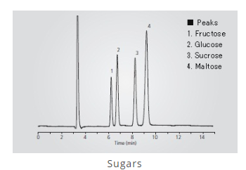

The chromatogram indicates that

**A**. disaccharides are more soluble than monosaccharides in the solvent used.

**B**. maltose is the least adsorbed on the stationary phase.

**C**. the concentrations of all sugars present are relatively similar.

**D**. monosaccharides have lower retention times than disaccharides.

**Question 20**



The molecule shown is tested in both proton-NMR and carbon-NMR. It will have

|  |  |  |
| --- | --- | --- |
|  | Hydrogen environments | Carbon environments |
| **A.** | 2 | 2 |
| **B.** | 3 | 2 |
| **C.** | 2 | 3 |
| **D.** | 3 | 3 |

**Question 21**

Oxalic acid is a diprotic acid. A 15 mL aliquot of oxalic acid is neutralised by 20 mL of 3.0 NaOH. The concentration of the oxalic acid is, in M,

**A**. 1.0

**B**. 1.5

**C**. 2.0

**D**. 4.0

**Question 22**

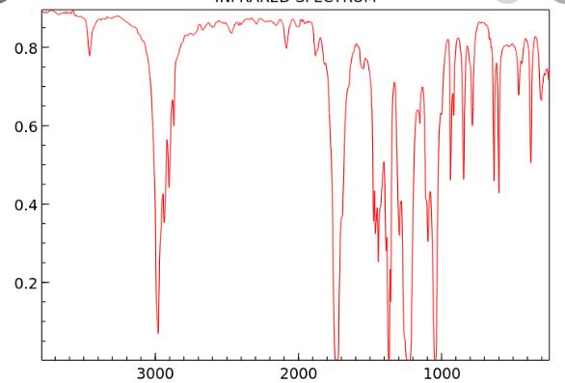

The infrared spectrum of a molecule with molecular formula C4H8O2 is shown above. The molecule is

**A**. butanoic acid.

**B**. ethyl ethanoate.

**C**. butan-1,4-diol (1,4-hydroxybutane).

**D**. butanone.

**Question 23**

A high-resolution proton-NMR is shown below.

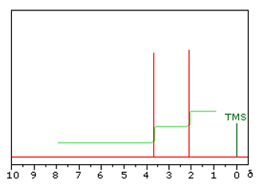

This molecule is likely to be

**A**. ethanol

**B**. propan-1-ol

**C**. methyl propanoate

**D**. methyl ethanoate

**Question 24**

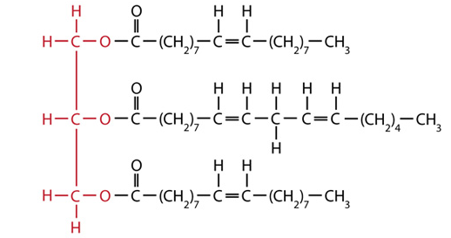

This triglyceride has been made from the reaction between

**A**. glycerol, a saturated fatty acid and an unsaturated fatty acid.

**B**. glycerol and three polyunsaturated fatty acids.

**C**. glycerol, a monounsaturated fatty acid and a polyunsaturated fatty acid.

**D**. glycerol and three different unsaturated fatty acids.

**Question 25**

The presence of the amino acid lysine in a protein is likely to lead to

**A**. dispersion forces in the tertiary structure.

**B**. ionic bonding in the tertiary structure.

**C**. covalent bonds in the tertiary structure.

**D**. dipole bonding in the tertiary structure.

**Question 26**



The molecule shown is

**A**. a dipeptide formed from threonine and serine.

**B**. an ester formed from two molecules of propan-1-ol.

**C**. a dipeptide formed from two molecules of serine.

**D**. a protein formed from threonine and serine.

**Question 27**

The diagram below outlines the stages in the metabolism in humans of triglycerides.

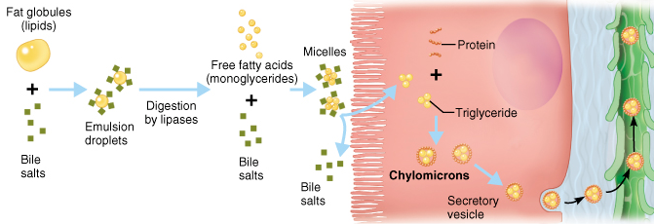

The sequence shown involves

**A**. fat blobs 🡪 emulsified drops 🡪 lipase induced hydrolysis 🡪 new triglycerides.

**B**. fat blobs 🡪 emulsified drops 🡪 glycerol and glycogen 🡪 fatty acids.

**C**. fat blobs 🡪 emulsified drops 🡪 lipase induced hydrolysis 🡪 protein.

**D**. fat blobs 🡪 emulsified drops 🡪 fatty acid 🡪 carbon dioxide and water.

**Question 28**

The molecule 2-amino-3-methylpentanoic acid is also known as

**A**. glycine.

**B**. isoleucine

**C**. leucine.

**D**. valine.

**Question 29**

A 0.64 g sample of almond is burnt under a can containing 60.0 g of water. The temperature of the water rises from 20.2 0C to 28.2 0C. The heat of combustion of the almond is, in kJ g-1,

**A**. 2.01

**B**. 3.14

**C**. 2010

**D**. 3140

**Question 30**

A student conducts a titration, rinsing a pipette with deionised water. She then uses the pipette to transfer a 20.0 mL aliquot of standard base solution to flask to place under a burette. The burette contains ethanoic acid that the is attempting to determine the concentration of. The impact of this poor technique is likely to be a

**A**. higher titre than expected causing the calculated concentration of the acid to be high.

**B**. higher titre than expected causing the calculated concentration of the acid to be low.

**C**. lower titre than expected causing the calculated concentration of the acid to be high.

**D**. lower titre than expected causing the calculated concentration of the acid to be low.

**SECTION B - Short-answer questions**

|  |
| --- |
| **Instructions for Section B**  Questions must be answered in the spaces provided in this book. To obtain full marks for your responses you should   * give simplified answers with an appropriate number of significant figures to all numerical questions; unsimplified answers will not be given full marks. * show all workings in your answers to numerical questions. No credit will be given for an incorrect answer unless it is accompanied by details of the working. * make sure chemical equations are balanced and that the formulas for individual substances include an indication of state; for example, H2(g); NaCl(s) |

**Question 1** (13 marks)

The flowchart below refers to the production of biodiesel. The structure of a triglyceride is also drawn for you. The alcohol used is methanol.

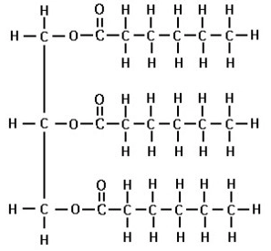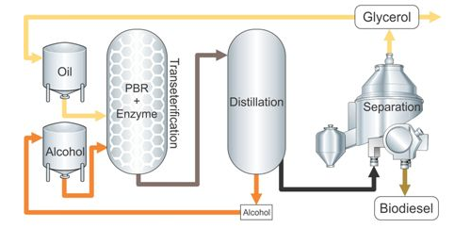

**a. i**. Draw the biodiesel molecule that could be formed from these raw materials. 2 marks

**ii**. This biodiesel molecule is a liquid at room temperature. List the two main factors

that determine the melting point of a biodiesel molecule. 2 marks

_______________________________________________________________________

_______________________________________________________________________

**iii**. The main reaction in this process is labelled ‘transesterification’. Explain what this

term means. 1 mark

_______________________________________________________________________

_______________________________________________________________________

**b**. The products of this process are biodiesel and glycerol. These molecules are both

liquids but they are easy to separate. Why are they easy to separate? 2 marks

_______________________________________________________________________

______________________________________________________________________

**c. i**. Write the molecular formula for the biodiesel formed ________________ 1 mark

**ii**. Write a balanced equation for the complete combustion of this fuel. 2 marks

_______________________________________________________________________

**d**. Complete the table below which is a general comparison between petrodiesel and

biodiesel. 3 marks

|  |  |
| --- | --- |
| **Property** | **Which is higher? Biodiesel or petrodiesel.** |
| Viscosity |  |
| Energy density |  |
| Melting point |  |

**Question 2** (11 marks)

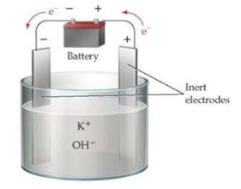British scientist, Sir Humphry Davy, was credited as the first person to isolate the metal potassium in 1807. To do this he electrolysed molten potassium hydroxide, KOH, as shown below.

**a**. Use the template below to write the half-equations, then the overall equation occurring

in this cell. (You may need to refer to your Data Book to answer this question) 3 marks

Anode: _____________________________________

Cathode: _____________________________________

Overall equation: _______________________________________________

**b**. Any attempt to operate a large-scale version of the above process is very dangerous

without modification of the cell design.

Why is this circuit dangerous? Include a chemical equation in your answer. 2 marks

_______________________________________________________________________

_______________________________________________________________________

**c**. Calculate the mass of potassium Davy would have isolated using a current of 0.23 amps

for 20 minutes. 3 marks

_______________________________________________________________________

_______________________________________________________________________

_______________________________________________________________________

**d**. If Davy had used a dilute solution of KOH, the products would not have been the same.

Complete the template for the half-equations and overall equation for the electrolysis of

KOH(aq). 3 marks

Anode: _____________________________________

Cathode: _____________________________________

Overall equation: _______________________________________________

**Question 3** (9 marks)

The molecular formula of a molecule is found to be C4H10O.

**a**. The infrared spectrum of the molecule is shown below.

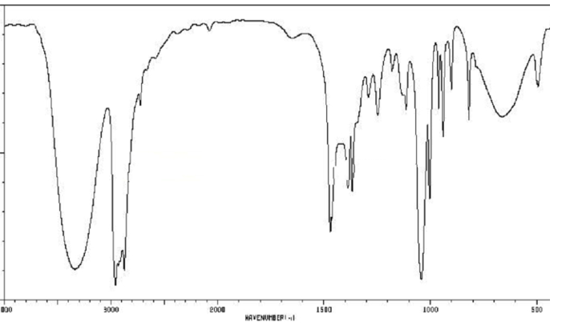

What conclusions can you draw from this spectrum? 2 marks

____________________________________________________________________

____________________________________________________________________

**b**. Draw two possible structures for this molecule. 2 marks

**c**. The carbon-NMR of the molecule is shown below.

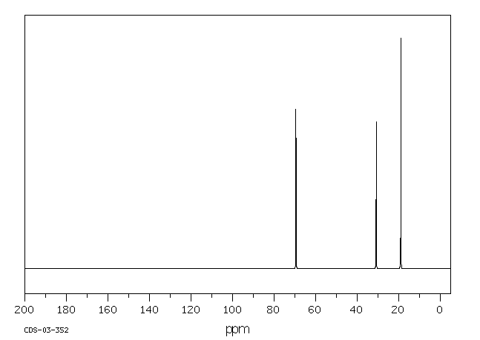

Use this spectrum to name the molecule in question. Explain how the carbon-NMR

structure provided is consistent with your choice. 3 marks

____________________________________________________________________

____________________________________________________________________

____________________________________________________________________

____________________________________________________________________

**d**. The molecule in question is converted to a carboxylic acid.

**i**. Draw the likely carboxylic acid formed. 1 mark

**ii**. List the reagent(s) required for this reaction. _____________ 1 mark

**Question 4** (8 marks)

The cell shown below is a fuel cell using ethanol solution and oxygen gas as reactants. The reaction produces CO2 gas which in turn forms carbonate ions in the solution. The half-equation and voltage for the reaction of the ethanol is

C2H5OH(aq) + 16OH-(aq) 🡪 2CO32-(aq) + 11H2O(l) + 12e-  -0.74 V

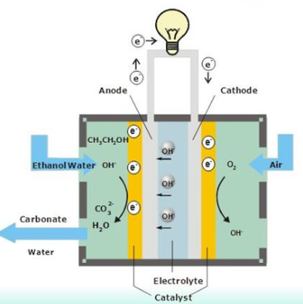

**a**. Use the circles provided to indicate the polarity of the electrodes. 1 mark

**b. i**. Use the template provided to write the oxygen half-equation and the overall equation

for this cell.

Oxygen half-equation: ___________________________________ 1 mark

Overall equation: ____________________________________ 1 mark

**ii**. What will be the cell voltage of this cell? __________________ 1 mark

**iii**. Calculate the energy is released by the reaction of 1 mol of ethanol? 2 marks

______________________________________________________________________

**c**. Energy can also be produced by the direct combustion of ethanol. 2 marks

List two advantages of the use of an ethanol fuel cell over direct combustion of ethanol.

_____________________________________________________________________

_____________________________________________________________________

**Question 5** (9 marks)

**a**. The two molecules shown are structural isomers. They are both colourless liquids.



___________________ _________________

**i**. Use the lines provided to name each molecule. 2 marks

**ii**. Describe a chemical test or reaction that could be used to distinguish between the two

liquids. Explain briefly how your test works. 2 marks

____________________________________________________________________

____________________________________________________________________

**iii**. Which spectrum should easily distinguish the two molecules? 1 mark

____________________________________________________________________

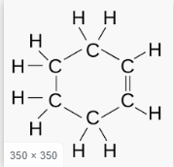**b**. The two molecules shown are both fuels and are both colourless liquids.

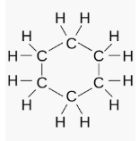

Describe carefully a chemical test that will distinguish the two liquids. Explain briefly

how your test works. 2 marks

____________________________________________________________________

____________________________________________________________________

**c**. The two molecules shown are both colourless liquids



Describe carefully a chemical test that will distinguish the two liquids. Explain briefly

how your test works. 2 marks

____________________________________________________________________

____________________________________________________________________

**Question 6** (8 marks)

Hydrogen and iodine gases react to form hydrogen iodide:

H2(g) + I2(g) ⇌ 2Hl(g) Δ*H* < 0

**a**. The volume of an equilibrium mixture of the above gases is decreased. Explain the

impact of this change on

**i**. the value of the equilibrium constant. 1 mark

_______________________________________________________________________

**ii**. the concentration of HI gas. 2 marks

________________________________________________________________________

________________________________________________________________________

**iii**. the amount of HI gas. 1 mark

________________________________________________________________________

_________________________________________________________________________

**iv**. the rate of the forward reaction 1 mark

________________________________________________________________________

_________________________________________________________________________

**b**. 0.60 mol of HI is added to an empty 2.0 L reactor at 80 0C. At equilibrium the amount of

hydrogen gas is found to be 0.15 mol.

Calculate the value of the equilibrium constant at 80 0C. 3 marks

________________________________________________________________________

_________________________________________________________________________

________________________________________________________________________

_________________________________________________________________________

**Question 7** (8 marks)

The apparatus below is used to determine the heat of combustion of an almond.

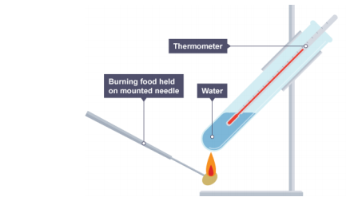

Mass of water: 80 g

Mass of almond: 0.42 g

Initial temperature water: 22 0C

Final temperature water: 48 0C

**a**. Use the data provided to calculate the per gram heat of combustion of the almond.

3 marks

_______________________________________________________________________

_______________________________________________________________________

_______________________________________________________________________

**b**. The experiment shown above usually results in low estimates for heats of combustion.

**i**. If the composition of the almond is assumed to be 70% oil and 30%carbohydrate what

would the theoretical heat of combustion be? 1 mark

_______________________________________________________________________

**ii**. Discuss reasons for the low results. 2 marks

_______________________________________________________________________

_______________________________________________________________________

**c**. Write a balanced equation for the complete combustion of glucose. 2 marks

________________________________________________________________________

**Question 8** (8 marks)

**a**. The metabolism of different animals varies and even the metabolism of different humans

varies.

**i**. Give one example of a biomolecule that some animals can digest but humans cannot.

Include in your answer why humans cannot digest this molecule. 1 mark

______________________________________________________________________

**ii**. Give one example of a biomolecule that some humans can digest easily others cannot.

Include in your answer a reason for the difference. 1 mark

_______________________________________________________________________

**b**. Many biomolecules are large molecules. Complete the template below by

- identifying in the second column the smaller molecule(s) used to form the food.

- listing in the third column an enzyme that plays a role in the metabolism of that

biomolecule. 3 marks

|  |  |  |
| --- | --- | --- |
|  | Building block(s) | Enzyme aiding metabolism |
| Carbohydrate |  |  |
| Protein |  |  |
| Triglyceride |  |  |

**c.** Milk contains significant levels of protein. A student conducts tests on milk and observes

the following two reactions:

1. When acid is added to milk it curdles and blobs of solid separate from a watery liquid.
2. A test for the presence of protein involves adding NaOH and then adding blue copper sulfate solution. If protein is present, the blue colour changes to purple.

One of these processes involves hydrolysis and the other denaturation.

Use these examples to explain the difference between hydrolysis and denaturation and to

identify which process is which. 3 marks

_______________________________________________________________________

_______________________________________________________________________

_______________________________________________________________________

_______________________________________________________________________

**Question 9** (8 marks)

When you cook eggs the egg white, albumin, turns white. The albumin is a protein and the heat used during cooking causes it to denature. The addition of vinegar aids the denaturing process.

A student conducts an investigation into this process. An outline of her experimental procedure is shown in italics below.

***Investigation****: To conduct an experiment where eggs are cooked at different temperatures and the time it takes for the eggs to cook is recorded and studied.*

*Hypothesis: The rate at which an egg cooks will increase with temperature up to a point but then will drop as the protein denatures.*

***Procedure***

*1. Prepare several beakers containing 50 mL of 1.0 M ethanoic acid.*

*2. Heat each beaker to a different temperature.*

*3. Add an egg to each beaker and record the time it takes for the outside of the egg to turn*

*completely white.*

***Results***

|  |  |
| --- | --- |
| ***Temperature 0C*** | ***Time to cook (secs)*** |
| *30* | *Over 10 minutes* |
| *40* | *812* |
| *50* | *420* |
| *60* | *250* |
| *70* | *146* |
| *80* | *88* |
| *90* | *52* |

***Conclusion***

*The denaturing of egg is not typical of normal enzymes – the rate does not slow at high temperatures.*

**a**. For the student’s experiment, state the

**i**. independent variable _____________________________ 1 mark

**ii**. dependent variable ______________________________ 1 mark

**iii**. a controlled variable. _____________________________ 1 mark

**b**. Suggest an important reason why multiple trials will improve the reliability of the results

obtained in this experiment. 1 mark

_______________________________________________________________________

**c**. Use your knowledge of proteins to explain what is happening to the bonding in egg white

as it is heated. 2 marks

_______________________________________________________________________

_______________________________________________________________________

_______________________________________________________________________

**d**. Discuss the student’s conclusion. 2 marks

_______________________________________________________________________

_______________________________________________________________________

**Question 10** (8 marks)

Many nutritionists consider hemp seeds to be a superfood. Hemp seeds come from the *Cannabis sativa* plant but they do not produce a mind-altering effect. They are a small, brown seed, rich in protein, fibre and fatty acids.

**a**. Hemp oil contains high proportions of fatty acids such as linolenic acid.

Draw a structural diagram of linolenic acid and use this diagram to explain

* what a polyunsaturated fatty acid is and
* how the degree of saturation impacts the melting point. 3 marks

___________________________________________________________________

___________________________________________________________________

___________________________________________________________________

___________________________________________________________________

___________________________________________________________________

___________________________________________________________________

**b**. Hemp seeds are one of the few foods considered to be a ‘complete source of protein’.

This means they provide all amino acids.

Use your knowledge of biomolecules to explain the significance of a food being

classified as ‘complete source of protein’. 3 marks

___________________________________________________________________

___________________________________________________________________

___________________________________________________________________

___________________________________________________________________

**c**. Hemp seeds are high in fibre. What is fibre and what happens to fibre when consumed by

humans? 2 marks

___________________________________________________________________

___________________________________________________________________

___________________________________________________________________

**Section A 30 marks ____**

**Total Section B 90 marks ____**

**Total exam 120 marks ____**

**END OF EXAM**