Chemistry SAC Unit 4 Outcome 1: Data analysis task
The whole of this SAC task relates to one molecule. You have to use the data provided to identify this molecule.
Aim: To use the data provided to deduce the formula and structure of a molecule.
Data
A 1.424 g sample of an organic hydrocarbon molecule is found to contain 1.221 g of carbon.
1. Complete the table provided to show the mass of each element present.

Element | mass present (g)
carbon
hydrogen

1 mark
2. Determine the empirical formula of the mystery molecule.

_______________________________________________________________________

_______________________________________________________________________

_______________________________________________________________________

_______________________________________________________________________

2 marks

The mass spectrum of the molecule is shown below
3. a. i. What is the m/e ratio of the parent molecular ion?

_______________________

ii. Suggest an explanation for the small peak with m/e ratio of 57.

________________________________________________________________

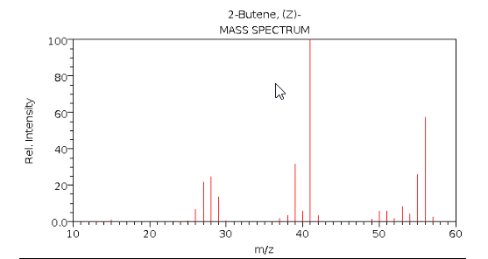

b. i. What fragment has probably been broken from the molecule to produce a peak
with m/e ratio of 41? _______________

ii. What possible fragment might have caused the peak at 28? ____________

c. What is the molecular formula of the mystery molecule?

__________________________________________________________________
2 + 2 + 1 = 5 marks

The infrared spectrum of the mystery molecule is shown below
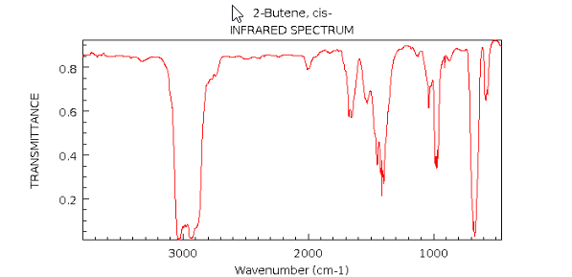

4. a. How can the infrared spectrum be used to confirm the molecule is not an alkanol
molecule?

____________________________________________________________________

b. There is a significant absorption at 3000 cm⁻¹. What type of bond might have caused
this?

____________________________________________________________________

c. The infrared spectrum is a relatively plain one. What conclusion might this lead to?

____________________________________________________________________

d. There is an absorption around 1600 cm⁻¹. What type of bond might have caused this?

_________________________________________________________________________
1 + 1 + 1 + 1 = 4 marks

5. Draw and name two possible isomers with the molecular formula of this mystery
molecule.

Isomer 1: ___________________ Isomer 2: ________________
2 marks

The low resolution ¹H NMR spectrum for the mystery molecule is drawn below

6. a. How many different hydrogen environments does this molecule have? ________

- Given the shift values shown, and the molecular formula, what proton structure has produced the peak at shift
i. 1.6

ii. 5.4
1 + 2 = 3 marks

7. Use the NMR to explain carefully which isomer is the correct one.

_________________________________________________________________________

___________________________________________________________________________

___________________________________________________________________________

___________________________________________________________________________
2 marks

8. a. How many different carbon environments does this molecule have? ________

b. Would you expect this molecule to be polar or non polar. Explain your answer.

_____________________________________________________________________

_____________________________________________________________________
1 + 1 = 2 marks

9. This mystery molecule can be reacted with bromine solution.
a. Describe what change an observer will see.

______________________________________________________________________

b. Draw and name the product formed
________________________
1 + 1 = 2 marks

10. A polymer can be formed from the reaction of this molecule with itself.
Show a segment of the polymer chain that will form.

1 mark

11. A reaction occurs when the mystery molecule is heated with steam.
Draw and name all products formed in this reaction.

1 mark

