Topic test 2: Unit 3 Combustion

SECTION A – Multiple-choice questions

Instructions for Section A
Answer all questions.
Choose the response that is correct or best answers the question.
A correct answer scores 1, an incorrect answer scores 0.
No mark will be given if more than one answer is completed for any question.
Marks will not be deducted for incorrect answers.

Question 1
The specific heat capacity of copper is
A. the energy required to raise the temperature of 1.0 mole of copper by 1.0⁰C.
B. the energy required to raise the temperature of 1.0 g of copper by 1.0⁰C.
C. the energy released by the combustion of 1.0 g of copper.
D. the energy required to raise the temperature of water in a copper vessel by 1.0⁰C.

Use the following molecule to answer Questions 2 and 3
An energy profile diagram is shown below.
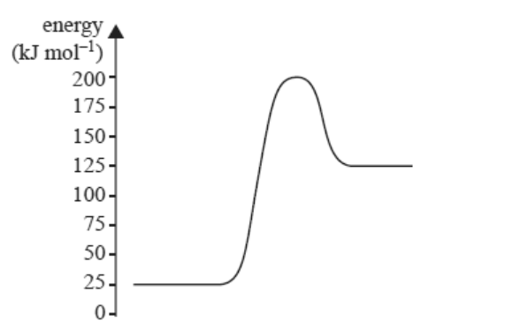

Question 2
The energy profile diagram is for a reaction that
A. will release energy as the chemical potential energy of the products is less than reactants.
B. will require energy as the chemical potential energy of the products is less than reactants.
C. will release energy as the chemical potential energy of the products is greater than reactants.
D. will require energy as the chemical potential energy of the products is greater than reactants.

Question 3
The activation energy of the reverse reaction will be, in kJ mol⁻¹,
A. +75
B. -75
C. +175
D. +200
Question 4
The mass of ethane required to produce the same amount of energy as 10 g of hydrogen gas will be, in g,
A. 3.62
B. 10
C. 20
D. 27.2

Question 5
A 4.0 L sample of ethane undergoes complete combustion. The volume of oxygen gas required at this temperature for an exact reaction is, in L,
A. 4
B. 8
C. 14
D. 16

Question 6
1.20 g of ethanol is burnt under a beaker containing 800 g of water. The temperature change will be, in ⁰C,
A. 0.011
B. 10.6
C. 16.8
D. 43.4

Question 7
Given the thermochemical equation

2C₄H₁₀(g) + 13O₂(g) 8CO₂(g) + 10H₂O(l) ΔH = -5660 kJ mol⁻¹
The energy released from the reaction of 1 mol of oxygen will be, in kJ,
A. 217
B. 435
C. 5660
D. 37000

Question 8
The mass of gas in a sample can be calculated using the formula
A.
B.
C.
D.

Question 9
The following graph is obtained from the investigation of a gas system.

The horizontal and vertical axes are likely to be, respectively,
A. volume and temperature
B. volume and pressure
C. pressure and temperature
D. amount and pressure

Question 10
Select the correct alternative about incomplete combustion.
A. The products of incomplete combustion will always be carbon monoxide and water.
B. The number of mole of carbon monoxide formed will equal the number of mole of fuel.
C. Incomplete combustion is an indicator that the reaction is endothermic.
D. Solid carbon can be formed from incomplete combustion..

SECTION B- Short-answer questions

Instructions for Section B
Questions must be answered in the spaces provided in this book.
To obtain full marks for your responses you should
- Give simplified answers with an appropriate number of significant figures to all numerical questions; unsimplified answers will not be given full marks.
- Show all workings in your answers to numerical questions. No credit will be given for an incorrect answer unless it is accompanied by details of the working.
Make sure chemical equations are balanced and that the formulas for individual substances include an indication of state; for example, H₂(g); NaCl(s)

Question 1 (9 marks)
a. Convert the following to Kelvin: 2 marks

-100 ⁰C __________________ 110 ⁰C _________________

b. Convert these pressures to kPa: 2 marks

2.6 atm __________________ 700 mm Hg ____________________

c. Calculate the volume of 1.0 mole of an ideal gas at 100 ⁰C and 100 kPa pressure. 2 marks

______________________________________________________________________________

______________________________________________________________________________

d. A gas sample has a volume of 48 L at a pressure of 100 kPa. The pressure is increased to 400 kPa.
What will the volume be? (assume the temperature is held constant) 1 mark

______________________________________________________________________________

e. What will the volume be of a 60.0 g sample of nitrogen gas at SLC? 2 marks

_______________________________________________________________________________

_______________________________________________________________________________

Question 2 (7 marks)
The diagram below is an energy profile diagram for an exothermic reaction.
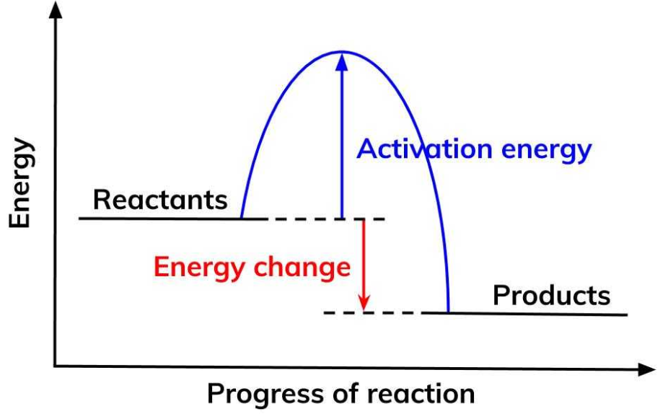

a. For this reaction, 3 marks
i. how will the enthalpy of the products compare to the enthalpy of the reactants?

______________________________________________________________________

ii. how will the temperature of the surroundings to this reaction change?

_______________________________________________________________________

iii. why is the enthalpy value listed as a negative value?

___________________________________________________________________________

b. Diesel is considered a good fuel but a safe fuel to handle. How will this knowledge be evident in the energy
profile diagram? 2 marks

__________________________________________________________________________________

__________________________________________________________________________________

c. The activation energy and enthalpy change for the above reaction are listed below. 2 marks

Activation energy: 356 kJ mol⁻¹ ΔH -220 kJ mol⁻¹

What is the
-magnitude of the activation energy for the reverse reaction? ____________________

-value of H for the reverse reaction? ____________________

Question 3 (10 marks)
A sample of methanol is burnt under a beaker of water. The data recorded during this experiment has been recorded on the diagram below

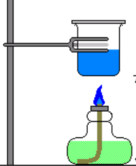
Mass water: 136 g

Initial temp: 18.4 ⁰C
Final temp: 27.9 ⁰C

Initial mass methanol: 34.2 g
Final mass methanol: 33.6 g

a. Calculate 2 marks
i. the change in temperature of the water. ______________________

ii. the mass of methanol reacting. ______________________

b. i. Calculate the amount of energy released. 1 mark

ii. Calculate the molar heat of combustion of methanol. 2 marks

__________________________________________________________________________

__________________________________________________________________________

iii. Calculate the heat of combustion per g of methanol. 1 mark

__________________________________________________________________________

iv. Write a thermochemical equation for the complete combustion of methanol. 2 marks

___________________________________________________________________________

____________________________________________________________________________

c. Give two reasons why the combustion values obtained for methanol from the experiment the experiment
do not match those of the Data book. 2 marks

___________________________________________________________________________

___________________________________________________________________________

Question 4 (8 marks)
The thermochemical equation for the complete combustion of octane is given below.

2C₈H₁₈(g) + 25O₂(g) 16CO₂(g) + 18H₂O(l) ΔH = --10920 kJ mol⁻¹

a. 80.8 g of octane undergoes combustion.
i. Calculate the energy released. 1 mark

___________________________________________________________________________

ii. Calculate the mass of CO₂ released. 3 marks

___________________________________________________________________________

___________________________________________________________________________

___________________________________________________________________________

iii. Calculate the volume of this CO₂ released at 354 ⁰C and 90.0 kPa pressure. 2 marks

___________________________________________________________________________

___________________________________________________________________________

b. Calculate the mass of octane required to produce 1.00 MJ of energy. 2 marks

____________________________________________________________________________

____________________________________________________________________________

Question 5 (6 marks)
The following questions refer to the reaction between ethane and oxygen shown below:

2C₂H₆(g) + 7O₂(g) 4CO₂(g) + 6H₂O(g)

a. 40 L of ethane is reacted with 84 L of oxygen gas. (Conditions are held constant)
i. Calculate the volume of CO₂ formed. 1 mark

_________________________________________________________________________

ii. Calculate the volume of steam formed. 1 mark

_________________________________________________________________________

iii. Calculate the volume of reactant remaining. 1 mark

_________________________________________________________________________

b. Calculate the volume of ethane at SLC needed to react with 0.28 mol of oxygen gas. 2 marks

_________________________________________________________________________

c. Write a balanced equation for the incomplete combustion of ethane to form carbon monoxide and water.
1 mark
__________________________________________________________________________________

