Metabolism Topic Test

Question 1
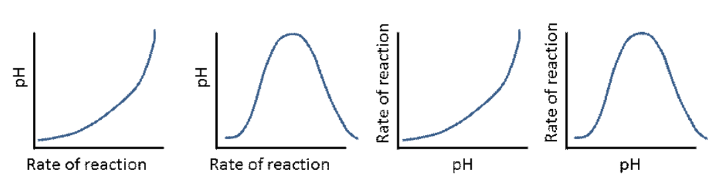
A B C D
Which graph correctly shows the relationship between rate of reaction of an enzyme and pH?
- A
- B
- C
- D

Use the following diagram to answer Questions 2 and 3
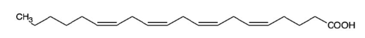

Question 2
How many hydrogen atoms will need to be added to this molecule for it to be saturated?
- 2
- 4
- 6
- 8

Question 3
Select the alternative that best describes how susceptible this molecule will be to oxidation.
- This molecule will be one of the easiest fatty acids to oxidise.
- Oxidation is dependent upon the presence of lipase enzyme.
- This molecule will oxidise but at a slower rate than a saturated fatty acid.
- The lack of polarity of this molecule will ensure that it is unlikely to oxidise.

Question 4
A current of 3.8 amps, a voltage of 5.0 V is passed through a calorimeter for 4.0 minutes. The temperature increases during this time from 16.6 ⁰C to 20.9 ⁰C. The calibration factor for this calorimeter is, in J ⁰C⁻¹,
- 17.7
- 88.3
- 1060
- 2120

Question 5
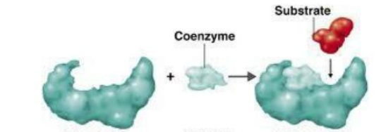
Select the alternative that best describes what this diagram is illustrating.
- An enzyme is often made from the combination of two smaller enzymes.
- A coenzyme’s role is to help the substrate match the active site of the enzyme.
- A coenzyme can render an enzyme inactive by blocking the site.
- A coenzyme is a protein that helps shape an active site to match a substrate.

Question 6
Lactose is
- a disaccharide made from glucose and galactose.
- an enzyme that is important in the digestion of milk.
- a dipeptide found in milk that can be difficult to digest.
- a polysaccharide found in milk.

Question 7
Select the alternative that best describes oxidative rancidity of a fatty acid.
- Rancidity is the oxidation in muscle cells of fatty acids to form carbon dioxide and water.
- Saturated fats are highly susceptible to oxidation as they have no carbon-to-carbon double bonds.
- The products of rancidity are glycerol and fatty acids.
- Carbon atoms adjacent to carbon-to-carbon double bonds are susceptible to oxidative rancidity.

Question 8
A hydrolysis reaction leads to the formation of 100 amino acids.
- 100 protein molecules reacted to form these amino acids.
- 100 enzyme molecules were required for this reaction.
- 100 peptide linkages were broken in this reaction.
- 99 molecules of water would be required for this reaction to have occurred.

Question 9
A polysaccharide molecule is stored in the liver of animals. The molecule is most likely to be
- amylose.
- glycerol.
- glycogen.
- amylopectin.

Question 10
A food bar contains 5.0 g of protein, 5.0 g of starch and 4.0 g of oil. Its energy content will be close to, in kJ,
- 80
- 224
- 313
- 422

SECTION B - Short-answer questions
Question 1 (10 marks)
A simple apparatus for determining the energy content of a food is shown below.

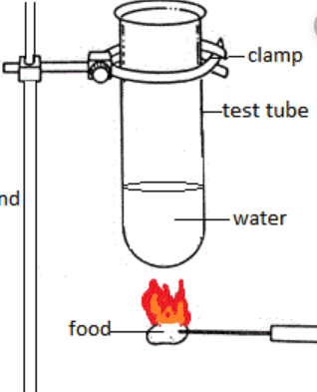
Experimental data

mass of water 28.8 g
initial temperature water 18.4 ⁰C
final temperature of water 39.8 ⁰C
mass of nut burnt 0.22 g

a. i. Explain how this apparatus provides information
about the energy content of a food. 2 marks

_______________________________________________

_____________________________________________________________________________

ii. The results obtained from this apparatus do not match documented values. 2 marks
Will the apparatus provide high or low results? Explain your answer.

_____________________________________________________________________________

_____________________________________________________________________________

b. Calculate the heat of combustion, in kJ g⁻¹, of the nut used. 3 marks

_____________________________________________________________________________

_____________________________________________________________________________

_____________________________________________________________________________

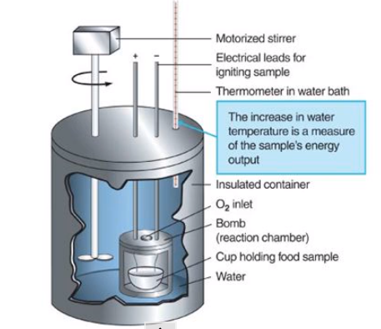
c. Better results are obtained if the food is tested in a
bomb calorimeter.
i. Why is a bomb calorimeter built to handle
high pressure? 1 mark

_________________________________________

_________________________________________

ii. Why is a supply of oxygen required? 1 mark

_________________________________________

_________________________________________

iii. How is the food set alight? 1 mark

_____________________________________________________________________________
Question 2 (7 marks)
The structure of a triglyceride molecule is shown below.
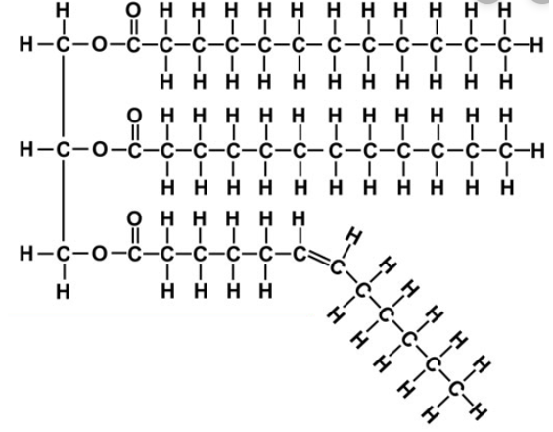
- Draw all of the products of hydrolysis of this triglyceride. 3 marks

b. i. Why does the hydrolysis of this triglyceride not occur in the stomach? 1 mark

________________________________________________________________________________

ii. Where does the body store hydrolysis products? ________________________________ 1 mark

c. Two of the hydrolysis products above can undergo oxidation in muscle cells. 2 marks
Select one of these products and write a balanced equation for its oxidation.

___________________________________________________________________________________

Question 3 (12 marks)
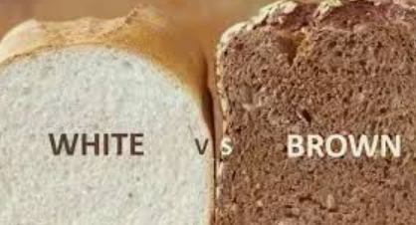
a. A photograph of a slice of white and brown bread
is shown.
i. What substance does the Glycemic Index
refer to? _______________ 1 mark

ii. The graph shown relates to experiments on
the impact on the body of foods of different
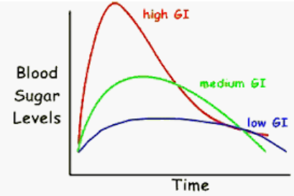
GI levels.
Explain carefully what the graph is showing.
Relate your answer to the bread photo.
4 marks
____________________________________

____________________________________

____________________________________

_____________________________________________________________________________

______________________________________________________________________________

______________________________________________________________________________

iii. Both potatoes and rice are mainly starch but the GI value of rice is considerably lower than that of
potato. Give a reason for this difference. 1 mark

______________________________________________________________________________

- Cellulose is a natural polymer made from glucose. It is a component of all plants.
Explain what happens to cellulose when consumed by 2 + 2 + 2 = 6 marks

i. humans _______________________________________________________________

____________________________________________________________________________

ii. cows ________________________________________________________________

____________________________________________________________________________

iii. elephants ________________________________________________________________

____________________________________________________________________________

Question 4 (6 marks)
The graphs below refer to the action of two enzymes used by the human body to help digest protein.

Question 4

a. i. What does the first graph show about the effect of pH on enzyme activity? 2 marks

_________________________________________________________________________________

ii. Refer to the R group of an amino acid of your choice to offer a reason why pH might affect the
action of an enzyme. 1 mark

_________________________________________________________________________________

iii. Where in the digestion process are the two enzymes above likely to be found? 1 mark

_________________________________________________________________________________

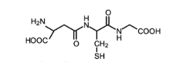
- The molecule shown contains two α-amino acids.
Draw both. 2 marks

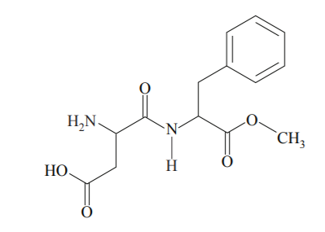
Question 5 (5 marks)
The molecule aspartame is drawn below.

a. What is the role of aspartame in food? ___________________________________ 1 mark

b. A food contains 4.0 g of sucrose. A diet alternative keeps the same ingredients but replaces the sucrose
with 0.4 g of aspartame.
i. How will the sweetness of the two products compare? 1 + 1 = 2 marks

__________________________________________________________________________________

ii. How will the energy content of the two foods compare?

__________________________________________________________________________________

c. During digestion, aspartame is hydrolysed to three products, one of which is phenylalanine.
Draw the other two products of hydrolysis. 2 marks

