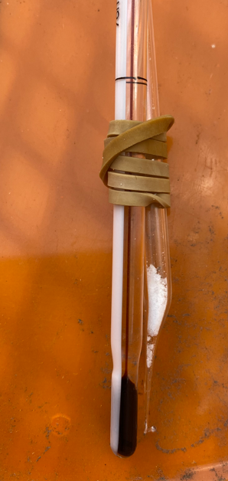
DIY Melting points
Naphthalene: MP listed as 80.5º C.
Thin glass tube prepared by stretching glass tubing
in a hot Bunsen flame.
Naphthalene added to tube – strapped to thermometer.

Heated in water on a hot plate
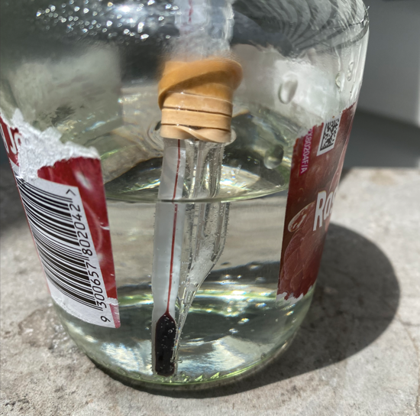
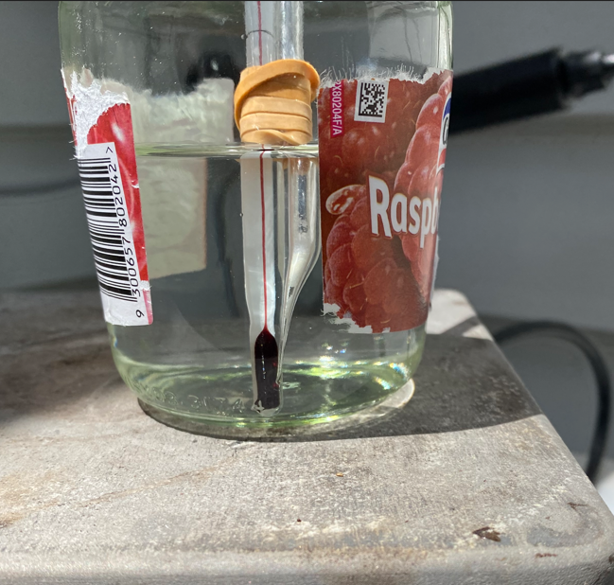

Just starting to melt at 84 ºC.
Could be heated more slowly and stirred.

B: Resorcinol MP 121 ºC (could try benzoic acid)
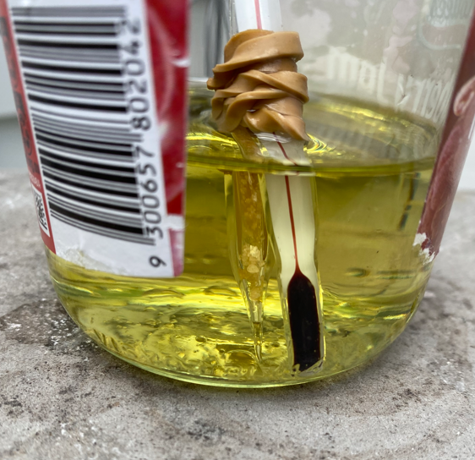
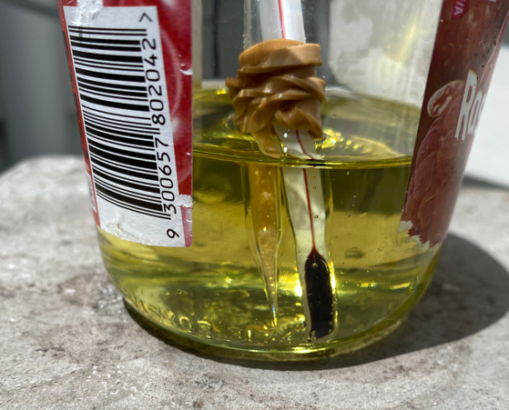
Heated in olive oil: melting on the right at 116 ºC

