**Energy Profile diagrams**

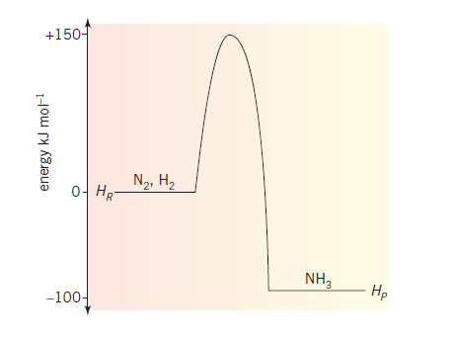The energy profile diagram shown is for the

formation of ammonia, NH3.

*Assume whole number coefficients in the eqn.*

1. Write a balanced thermochemical equation

for this reaction.

_____________________________________

1. What is the magnitude of the activation energy?

___________________________________

1. Calculate the amount of energy released in the

formation of 100 g of ammonia. ________________________________________



1. Use the second graph provided to illustrate the

impact of the addition of a catalyst on the reaction.

1. Explain the impact of the catalyst you have illustrated

in part d.

________________________________________

_

_________________________________________

1. What is the value of Δ*H* for the reaction below?

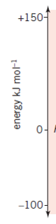2N2(g) + 6H2(g) 🡪 4NH3(g) ___________

1. Use the axes provided to draw an energy profile diagram

for the reverse reaction of the ammonia formation.

**Solutions**

1. N2(g) + 3H2(g) 🡪 2NH3(g) Δ*H*  = -100 kJ mol-1
2. 150 kJ mol-1
3. 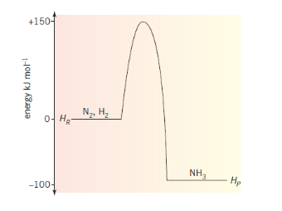 *n*(NH3) =  = 5.88 mol Energy = 5.88 ×  = 294 kJ



d.



**e**. The catalyst provides an alternative reaction pathway with lower activation



**f**. Δ*H*  = -200 kJ mol-1

