Topic test 4: Unit 3 Rates and equilibrium

SECTION A – Multiple-choice questions

Instructions for Section A
Answer all questions.
Choose the response that is correct or best answers the question.
A correct answer scores 1, an incorrect answer scores 0.
No mark will be given if more than one answer is completed for any question.
Marks will not be deducted for incorrect answers.

Question 1
Select the alternative that is a correct statement about a particular reversible reaction.
A. At equilibrium the number of reactant molecules will equal the number of product molecules.
B. The equilibrium constant does not have units because it is a ratio.
C. Reactants will still be present at equilibrium.
D. Equilibrium might not be reached in an open system.

Use the following equation to answer Questions 2 and 3
The equation for the reaction between hydrogen and iodine gases is:

H₂(g) + I₂(g) ⇌ 2HI(g) ΔH = -ve

Question 2
0.20 mol of hydrogen gas and 0.15 mol of iodine are added to an empty reactor. When equilibrium is reached,
A. all iodine will have reacted but not all hydrogen.
B. the amount of HI will be twice the amount of hydrogen gas.
C. the amount of HI will be twice the amount of iodine gas.
D. the amount of H₂ will be 0.05 mol higher than the amount of I₂.

Question 3
A mixture of the three gases is allowed to come to equilibrium. A change in conditions causes the concentration of hydrogen gas in the reactor to fall. The change could have been
A. the addition of a catalyst.
B. an increase in volume.
C. the addition of an inert gas.
D. an increase in temperature.

Question 4
The units for the equilibrium constant of a reaction are M⁻². The reaction could be
A. N₂(g) + 3H₂(g) ⇌ 2NH₃(g)
B. H₂(g) + I₂(g) ⇌ 2HI(g)
C. 2SO₂(g) + O₂(g) ⇌ 2SO₃(g)
D. N₂O₄(g) ⇌ 2NO₂(g)
Use the following equation to answer Questions 5 and 6
The rate vs time graph shown refers to a mixture of gases used to produce ammonia:

N₂(g) + 3H₂(g) ⇌ 2NH₃(g)
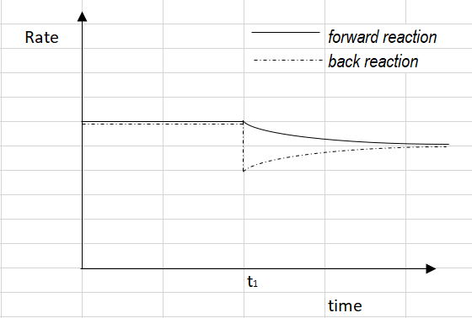

Question 5
Before time t₁,
A. the number of mole of reactants equals the number of mole of products.
B. the concentration of reactants equals the concentration of products.
C. the reactants and products have not been allowed to contact each other.
D. the reaction is at equilibrium.

Question 6
The change occurring at time t₁ could be
A. the addition of some nitrogen.
B. the removal of some ammonia.
C. an increase in temperature.
D. a decrease in volume.

Question 7

N₂O₄(g) ⇌ 2NO₂(g) K_{c} = 64.0 M at 150 ⁰C

Given the above information, what is numerical value of K_{c} the reaction NO₂(g) ⇌ ½ N₂O₄(g) at 150 ⁰C?
A. 0.0156
B. 0.25
C. 0.125
D. 8

Use the following equation to answer Questions 8 and 9
A series of reactions are conducted to compare the reaction rates between calcium carbonate and hydrochloric acid. The time taken for each reaction to produce 80 mL of gas is recorded.
 | HCl concentration | Mass of CaCO₃ added | Time to produce 80 mL
Experiment 1 | 1.0 M | 2 g | 34 sec
Experiment 2 | 2.0 M | 2 g | 22 sec
Experiment 3 | 2.0 M | 4 g | 28 sec

Question 8
Which of the following is unlikely to be a useful method for monitoring the rate of this reaction?
A. Monitoring the colour change occurring during the reaction.
B. Measuring the volume of gas evolved.
C. Monitoring the mass of the flask.
D. Monitoring the pH of the solution.

Question 9
In a comparison of experiment 2 and experiment 3, it is likely that
A. the temperature in experiment 3 was higher than that of experiment 2.
B. the calcium carbonate particle size in experiment 3 is larger than experiment 2.
C. the rate of reaction in experiment 3 was greater due to the increased calcium carbonate mass.
D. the rate of reaction in both reactions should have been the same as the HCl concentration was the same.

Question 10
A Maxwell-Boltzmann diagram is shown below.
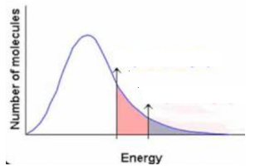
This graph highlights that
A. at a higher temperature, a higher proportion of particles have the activation energy for a reaction.
B. the activation energy of a reaction depends upon the temperature.

C. the addition of a catalyst lowers the activation energy required for a reaction to occur..
D. at a higher temperature, the activation energy for a reaction will be lower.

SECTION B- Short-answer questions

Instructions for Section B
Questions must be answered in the spaces provided in this book.
To obtain full marks for your responses you should
- Give simplified answers with an appropriate number of significant figures to all numerical questions; unsimplified answers will not be given full marks.
- Show all workings in your answers to numerical questions. No credit will be given for an incorrect answer unless it is accompanied by details of the working.
Make sure chemical equations are balanced and that the formulas for individual substances include an indication of state; for example, H₂(g); NaCl(s)

Question 1 (8 marks)
When sodium thiosulfate solution is added to iron (III) nitrate solution a dark brown colour forms. The solution then becomes colourless. The equation for the reaction is

2Fe³⁺(aq) + 2S₂O₃²⁻(aq) 2Fe²⁺(aq) + S₄O₆²⁻(aq)
brown colourless

This reaction is often used to investigate the impact of various factors on reaction rates. The time it takes for the solution to go colourless is recorded as a measure of reaction rate.

a. The results for a set of experiments are shown below.
Experiment | Conditions ⁰C | Time to go colourless (sec)
1 | 20 | 240
2 | 30 | 180
3 | 40 | 110
4 | 50 | 45
5 | 60 | 19

Explain clearly
i. What the data is demonstrating. 2 marks

_________________________________________________________________________________

_________________________________________________________________________________

ii. The reason for this effect. 2 marks

_________________________________________________________________________________

_________________________________________________________________________________

b. Identify in part a. 2 marks

i. the independent variable _______________________________

ii. the dependent variable _______________________________

c. 20 mL of both solutions are mixed at 35 ⁰C and the time taken for the solution to become colourless is
timed at 1 min 25 secs. The experiment is repeated but this time 5 drops of 1.0M CuSO₄ are included. The
time for the reaction is now 19 secs.
Explain clearly what has happened. 2 marks

___________________________________________________________________________________

____________________________________________________________________________________

Question 2 (9 marks)
The graph below shows an equilibrium system and the changes occurring with time.
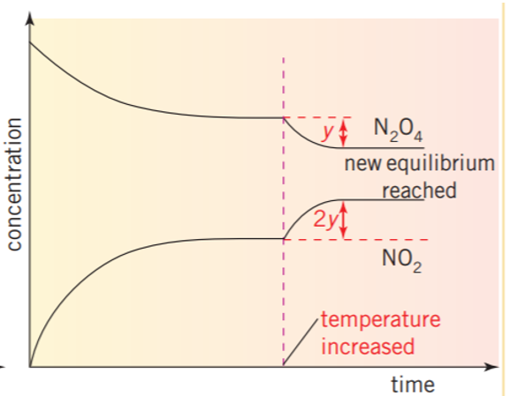
a. i. Write a balanced equation for the reaction occurring. 1 mark

______________________________________________________________________________

ii. Write an expression for the equilibrium constant for this reaction. 1 mark

______________________________________________________________________________

b. Describe what has happened during this experiment – 5 marks
- what are the reactant(s)?
- what is the significance of the ‘y’s’ on the graph?
- what change was made to the system after it reached equilibrium the first time?

______________________________________________________________________________

______________________________________________________________________________

______________________________________________________________________________

______________________________________________________________________________

c. Is this reaction exothermic or endothermic? 2 marks
Explain your answer.

______________________________________________________________________________

______________________________________________________________________________

Question 3 (10 marks)

Sulfur dioxide can react with oxygen gas to form sulfur trioxide:

2SO₂(g) + O₂(g) ⇌ 2SO₃(g) ΔH = -ve

a. 0.46 mol of SO₂ and 0.42 mol of oxygen gas are added to an empty 2.0 L reactor. At equilibrium, 0.18 mol
of SO₃ has formed. Determine the value of K_{c} for this reaction. 4 marks

______________________________________________________________________________

______________________________________________________________________________

______________________________________________________________________________

______________________________________________________________________________

b. What is the value of K_{c} at the same temperature for the reaction 2 marks

SO₃(g) ⇌ SO₂(g) + ½ O₂(g)

_____________________________________________________________________________

c. The volume of an equilibrium mixture of the above gases is doubled. Explain the impact of this change on-
i. the rate of the reaction. 2 marks

______________________________________________________________________________

______________________________________________________________________________

ii. the yield of SO₃. 2 marks

______________________________________________________________________________

______________________________________________________________________________

Question 4 ( 7 marks)
The graph below monitors the concentration of gases in an equilibrium system.

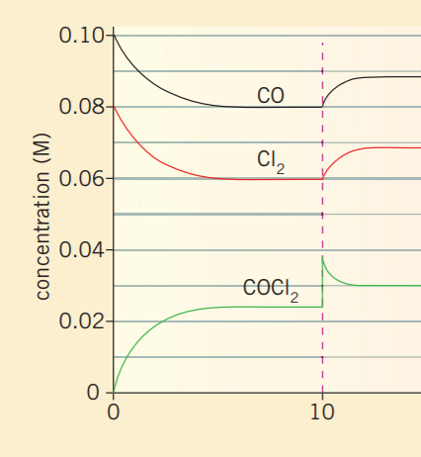
a. Write a balanced equation for the reaction this graph is monitoring. 1 mark

_________________________________________________________________________________

b. i. Determine the value of the equilibrium constant. 3 marks

__________________________________________________________________________________

_________________________________________________________________________________

_________________________________________________________________________________

ii. Will the value of the equilibrium constant change after equilibrium is established after the 10 minute
mark? 1 mark

________________________________________________________________________________

c. Explain the change occurring at the 10 minute mark and the response of the system to this change.
2 marks
_________________________________________________________________________________

__________________________________________________________________________________

Question 5 (6 marks)
The reaction between iron ions and thiocyanate ions is
Fe³⁺(aq) + SCN⁻(aq) ⇌ FeSCN²⁺(aq)
The FeSCN²⁺(aq) is deep red in colour while the reactants are colourless.

a. An equilibrium mixture of the above species is diluted with water. 2 marks
How will this dilution affect the intensity of the red colour?

______________________________________________________________________________

______________________________________________________________________________

b. 10 drops of Fe(NO₃)₃ are added to an equilibrium mixture of the above species.
Explain the impact of this addition on the intensity of the red colour and the concentration of the Fe³⁺.
2 marks
______________________________________________________________________________

______________________________________________________________________________

c. The temperature of an equilibrium mixture is increased and the red intensity drops. Is the reaction
endothermic or exothermic? Explain your answer. 2 marks

______________________________________________________________________________

______________________________________________________________________________

