Equilibrium Experiment
(This sheet accompanies the video experiment)
Aim: To investigate equilibrium systems using Le Chatelier’s Principle.

Background
LCP: A system at equilibrium will oppose any change.

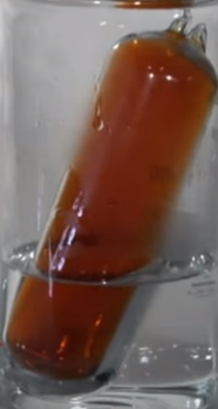
Part A: N₂O₄(g) ⇌ 2NO₂(g)
Temperature
1. Summarise the impact of a temperature change on this system
Temperature up _____________________________________
___________________________________________________
Temperature down ___________________________________
___________________________________________________

2. Explain very carefully if this reaction is endothermic or exothermic.
_____________________________________________________________________________________
_____________________________________________________________________________________
_____________________________________________________________________________________
_____________________________________________________________________________________
Volume
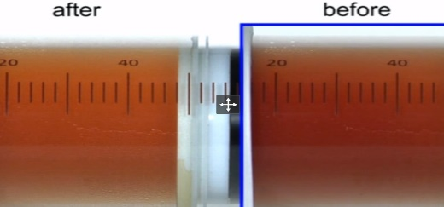
3. a. Why did the brown intensity initially increase?
________________________________________
________________________________________
________________________________________
b. Why did the brown intensity then decrease?
________________________________________________________________________
________________________________________________________________________
_________________________________________________________________________
c. How does the final concentration of NO₂ compare to the initial concentration before the
syringe was pushed in? Be careful to think this through.
_____________________________________________________________________________________
_____________________________________________________________________________________
_____________________________________________________________________________________
Q. 4 Has the value of K changed when the syringe was pushed in?
_____________________________________________________________________________________
_____________________________________________________________________________________
_____________________________________________________________________________________

Part B: Co²⁺(aq) + 4Cl⁻(aq) ⇌ CoCl₄²⁻(aq)
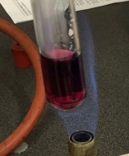
Q. 5 a. Describe what happened when the solution was heated.
________________________________________________
b. Is the reaction exothermic or endothermic?
__________________________________________________
___________________________________________________
____________________________________________________

Q.6 a. Describe what happened when HCl was added to the mixture?
______________________________________________________________________
b. Explain clearly why this happened.
_____________________________________________________________________________________
_____________________________________________________________________________________
_____________________________________________________________________________________

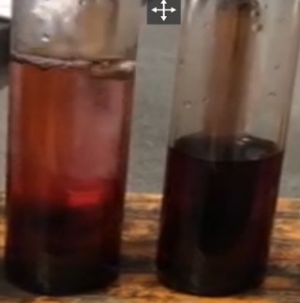
Q.7 a. Describe what happened when water was added to the mixture.
________________________________________________________________
b. Explain why this happened.
_____________________________________________________________________________________
_____________________________________________________________________________________
_____________________________________________________________________________________

