CHEMISTRY SAC: Analysis of Data AOS2
Aim: To analyse a series of equilibrium data scenarios

Case 1: Equilibrium constant expression
Hydrogen and iodine gases can form an equilibrium with hydrogen iodide. The equation is
H₂(g) + I₂(g) ⇌ 2HI(g)
Four different equilibrium mixtures of these gases are formed at 25 ⁰C and the concentration of each species is listed below.
H₂ | I₂ | HI
0.60 | 0.40 | 1.70
0.80 | 0.50 | 2.19
1.00 | 0.50 | 2.45
1.20 | 0.70 | 3.17
1. Write an equilibrium expression for this mixture. 1 mark
___________________________________________________________________________________
2. Use the data provided to prove that this data does in fact produce a constant when substituted into the
equilibrium expression. 3 marks
___________________________________________________________________________________
___________________________________________________________________________________
___________________________________________________________________________________
____________________________________________________________________________________
3. Use the data provided to prove that the expression does not produce a constant. 2 marks
___________________________________________________________________________________
___________________________________________________________________________________

4. A new mixture of the above species is prepared at 25 ⁰C and the concentration of each species is listed below:
[H₂] = 5.0 M [I₂] = 5.0 M [HI] = 5.0 M 3 marks
Is this mixture at equilibrium? If not, in which direction does it need to move? Explain your answer.
___________________________________________________________________________________
___________________________________________________________________________________
___________________________________________________________________________________
___________________________________________________________________________________

Case 2: Equilibrium graphs
Nitrogen oxide and oxygen form an equilibrium with nitrogen dioxide.
2NO(g) + O₂(g) ⇌ 2NO₂(g)
1.1 mole of NO and 1.0 mole of O₂ gases are mixed in an empty 1.0 L reactor.
The graph below shows the concentration of NO₂ over the first 3 minutes.
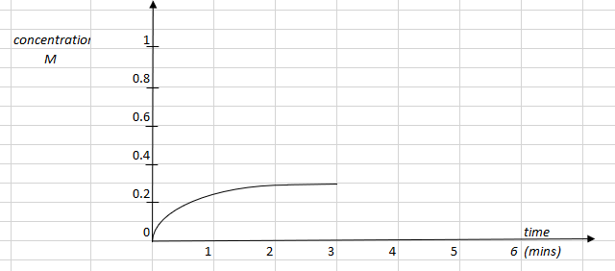
5. Draw in the concentrations of both NO and O₂ that are consistent with the starting amounts and the NO₂graph.
4 marks
6. Calculate the value of K_{c}. 2 marks
___________________________________________________________________________________
___________________________________________________________________________________
7. At the 3 minute mark the volume of the container is doubled.
Use the graph to show this change and to draw in the likely response of the system over the next couple of
minutes. 4 marks

Case 3: Equilibrium and yield
Ethane can be ‘cracked’ to form ethene and hydrogen gases. The equation for the reaction is
C₂H₆(g) ⇌ C₂H₄(g) + H₂(g) ΔH = +94 kJ mol⁻¹
An ethene manufacturer will want to maximise the yield of ethene in this reaction.
8. For each variable, explain in detail how and why it should be manipulated to lead to a maximum yield:
a. Temperature: _______________________________________________________________ 3 marks
___________________________________________________________________________________
___________________________________________________________________________________
b. Pressure: ___________________________________________________________________ 3 marks
___________________________________________________________________________________
___________________________________________________________________________________
c. Catalyst: _________________________________________________________________ 2 marks
____________________________________________________________________________________
Case 4: Colour change
The equilibrium between nitrogen tetroxide and nitrogen dioxide is
N₂O₄ (g) ⇌ NO₂(g)
colourless brown
9. An equilibrium mixture of the above gases is formed. The volume is then halved.
Explain carefully how the brown intensity will change after the volume change. 3 marks
___________________________________________________________________________________
___________________________________________________________________________________
___________________________________________________________________________________
___________________________________________________________________________________

