**Applying Faraday’s Laws**

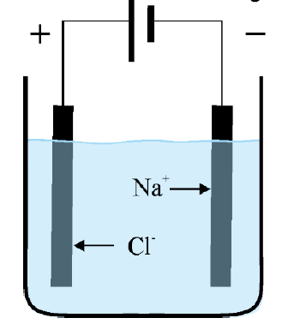 **Question**: A current of 4.50 amps is run for 8 hours and 30 minutes

through a molten solution of aluminium chloride, AlCl3.

1. Calculate the volume of chlorine gas that will be produced if

the temperature is 256 0C and the pressure 150 kPa.

Al3+

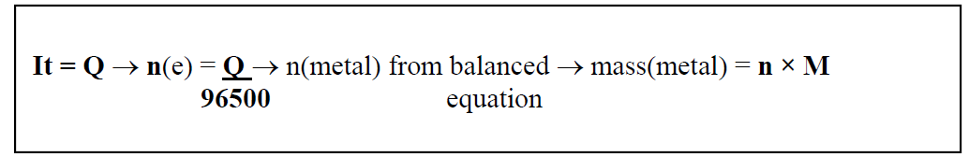

_________________________________________________________________

_________________________________________________________________

_________________________________________________________________

1. Calculate the current required to produce 2.25 kg of

aluminium in 7.50 hours.



_________________________________________________________________

_________________________________________________________________

_________________________________________________________________

**Solution**

1. Al3+(l) + 3e 🡪 Al(l) 2Cl-(l) 🡪 Cl2(g) + 2e

Q= It = 4.5 × 8.5 × 60 × 60 = 1.38 × 105 C

*n*(e) =  = 1.43 mol *n*(Cl) = ½ ne = 0.713 mol

*V =*  20.9 L

1. *n*(Al) =  = 83.3 mol *n*(e) = 3*n*(Al) = 250 mol Q = 96500 × 250 = 2.41× 107

*I* =  = 894 amps