Unit 4 SAC: Response to stimulus material
Title: Protein in milk
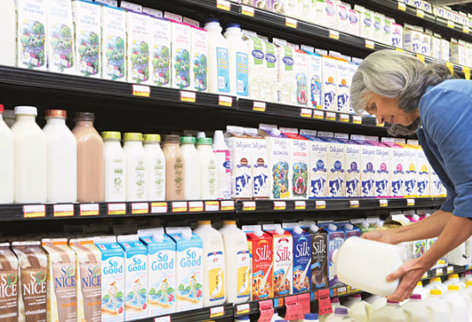
Background

Milk is an amazing food and an amazing liquid (or colloid to be more specific). It contains significant amounts of essential fats, protein, carbohydrates and important minerals such as calcium and phosphorous.
Milk is an example of an oil in water emulsion, with the watery component containing blobs of insoluble nutrients known as micelles. The diagram below shows the watery phase, the whey and then the fat globules and the casein protein micelles.
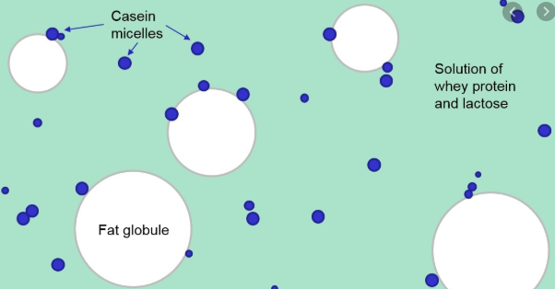

There are two categories of protein in milk, whey proteins which are soluble in water or whey and casein proteins that are insoluble. There are at least 4 types of casein protein and they forms clumps with calcium phosphate. As a clump, the hydrophobic parts of the structure can clump together avoiding the water. The calcium and phosphate are vital for infant development. CP on diagram = calcium phosphate
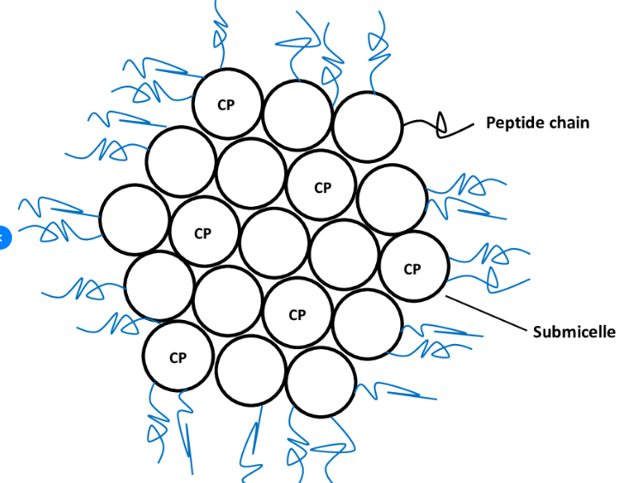
1. Milk contains all 9 essential amino acids.
What does this mean and why is it important?
4 marks

Cow’s milk contains all essential amino acids
but cows cannot synthesise all essential amino
acids. Explain this.

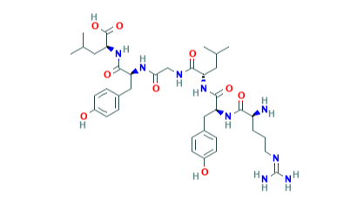
One of the four types of casein protein is α-casein shown below. Its molecular formula is C₃₈H₅₇N₉O₉.

2. a. How many amino acids can you count in this structure? 3 marks
b. Will there be any disulfide links formed in α-casein?
c. Name the amino acid that appears twice in the structure.

3. One of the amino acids in this structure has a IUPAC name of 2-amino-4-methylpentanoic acid.
Draw this molecule and use your data book to name it. 3 marks

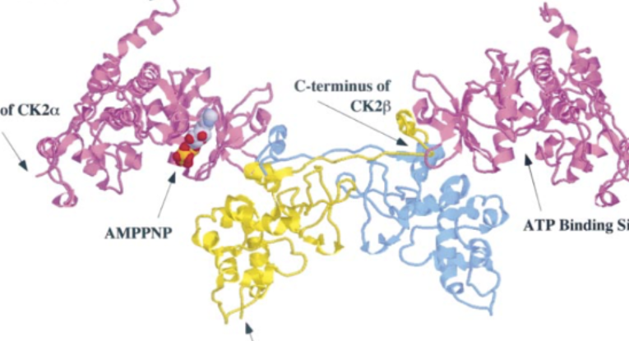
4. a. This protein in not soluble in water. What conclusion can you draw about the amino acids in its structure?
3 marks

b. The nature of the amino acids also causes the structure of casein to be loosely packed as the diagram
above shows. Why is this?
Whey proteins contain a high proportion of amino acids with sulfur. They do not bond to any calcium or phosphate.
5. Whey proteins are far more compact than casein proteins. Give one reason for this difference. 1 mark
6. Which type of protein is more likely to be in skim milk? Explain your answer. 1 mark
Whey proteins are more heat sensitive than casein proteins but casein proteins are more pH sensitive. They denature if the pH drops below 4.6.
7. A junior science project is to add vinegar to milk and white ‘clumps’ form.
a. Explain what is happening when vinegar is added to milk. 5 marks
b. Do you think this process will reduce the nutritional value of the milk? Justify your answer
c. Name an industry that deliberately uses the above change to make a product.

8. If you heat milk, a thin skin eventually forms on the surface. Explain what is happening when this occurs.
2 marks

9. Explain why the digestion of milk involves many different enzymes. 4 marks
What is the role of lactase in milk digestion?

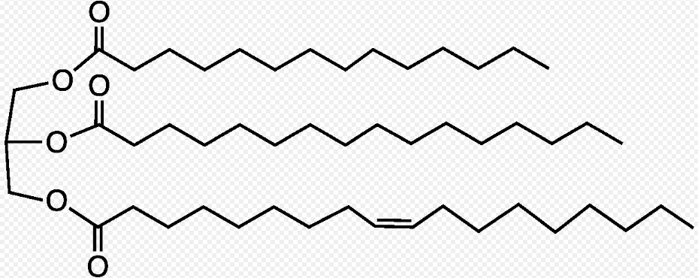

10. The structure of a typical molecule of butterfat is shown above. 4 marks
a. Draw the full structure of the three fatty acids this is made from.
b. Is butterfat a saturated fat? Explain your answer.

