Forces
Name: ____________

Push
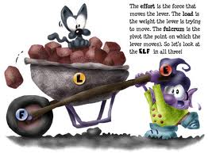

Pull

Gravity

Weight
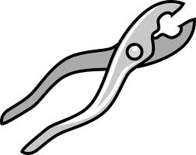
Mass

Focal questions
What is a force?
What types of force are there?
How do you measure forces?
What is gravity? What is friction?
What are levers?
How do machines apply the knowledge we have learnt?

Forces
Do you already have a good idea of what a force is? Write down what you think the word ‘force’ means.
_______________________________________________________________________________
Activity 1
Sit a metal can on its side on the cement sheet used for the Bunsen.
Use the first column of the table to list as many ways as you can think of to make the can move i.e. push it with your finger.
Method | result | push or pull?
push with finger | can rolled easily | push

The can moved when a force was applied to it. Try and write a definition for what a force is.
_________________________________________________________________________________
_________________________________________________________________________________
List 10 examples of forces that you might see in action today i.e. picking up your school bag
_________________________________________________________________________________
_________________________________________________________________________________
_________________________________________________________________________________
_________________________________________________________________________________
Forces can be described as contact or non contact. What do you think this means?
_________________________________________________________________________________
Add a C (for contact) or an N (for non contact) into the third column of the table above to classify the forces you used as contact or non contact.
What can forces do?
When a tennis ball is struck with a racquet, the racquet applies a force to the ball. Slow motion photography shows the ball and racquet are very distorted by this process. The force on the ball causes it to change speed and to change direction.
A number of actions are given in the table below. Perform each action and record its impact in column 2 of the table.
Task | Changes occurring | Reasons for the change
1. Drop a piece of plasticine
or blu-tack onto the floor
2. Drop a tennis ball
i. As you let the ball go
ii. As it falls
iii. When it hits the floor
3. Use a straw to blow on an object rolling on the desk

4. Flick a coin along the bench

5. Stretch an elastic band

From the activity above, list some things that forces can do.
_________________________________________________________________________________
_________________________________________________________________________________
_________________________________________________________________________________
Representing forces. Forces are usually represented as arrows that point in the direction the force is acting. The length of the arrow gives an idea of the strength of the force. The diagram below is a force diagram of a student pushing a ball along the bench.

Some different types of forces.
There are several categories of forces, some of which are demonstrated below
A. Magnetic forces
Sit a magnet on the bench. Hold a second magnet in your hand and bring the two ends labeled N together.
Describe what happens.
_________________________________________________________________________________
Is this a contact force? __________________________________
Make a diagram of this activity showing the force as an arrow.

B. Buoyancy forces
Hold a ping pong ball under water in a beaker. Let it go.
Describe what happens.
_________________________________________________________________________________
Is this a contact force? ________________________________
Make a diagram of this activity showing the force as an arrow.

C. Gravitational forces
Hold a tennis ball in your hand. Let it go.
Describe what happens.
_________________________________________________________________________________
_________________________________________________________________________________
Is this a contact force? ______________________________
Make a diagram of this activity showing the force as an arrow.

D. Electrostatic forces
Tear a few scraps of paper and leave them on the bench.
Rub a plastic ruler on your jumper. Hold the ruler just above the paper.
Describe what happens.
_________________________________________________________________________________
_________________________________________________________________________________
Is this a contact force? _________________________
Make a diagram of this activity showing the force as an arrow.

E. Pushing force
Blow a balloon to about half full. Let it go!
Describe what happens.

_________________________________________________________________________________
_________________________________________________________________________________
Is this a contact force? ______________________
Make a diagram of this activity showing the force as an arrow.

Summarise the types of forces you have investigated above by completing the table below
Name of force | This force is due to | I have seen this force used in
Watch: http://www.youtube.com/watch?v=5qjRWLGYncU
Now watch: http://www.youtube.com/watch?v=rU7iYYpSrlo&NR=1&feature=endscreen
http://www.youtube.com/watch?v=snD1b-om5xw&feature=related
Gravity
Objects fall because they are attracted to the Earth. This is gravity. Gravity also holds the moon in orbit around the Earth and the Earth in orbit around the Sun. The heavier the object, the greater the pull of gravity. An astronaut can jump higher on the moon than they can on Earth because the moon has a lower mass and exerts a lower force of attraction than the Earth.
Is gravity acting on you as you sit in your chair?
_________________________________________________________________________________
_________________________________________________________________________________
How would an astronaut feel different sitting in a chair in space?
_________________________________________________________________________________
_________________________________________________________________________________
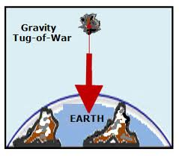
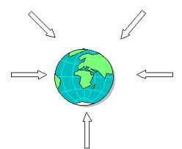
When you sit on a chair, why does gravity not pull you to the floor? Draw a force diagram of this situation.

Use the first diagram above to explain why the gravity of the moon is less.
____________________________________________________________________________
Use the second diagram to explain whether gravity acts the same on a big object as it does on a small one
___________________________________________________________________________
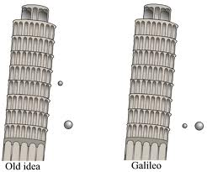
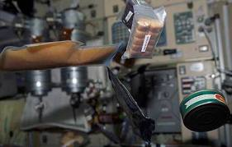
No Gravity

Activity 2: Falling objects
If a student leans over the second floor balcony and holds a marble in her left hand and a piece of apple in her right, and she lets both go at the same time, what will happen?
_________________________________________________________________________________
_________________________________________________________________________________
Why will this happen?
_________________________________________________________________________________
_________________________________________________________________________________
Try this out with the class watching. What happened?
_________________________________________________________________________________
_________________________________________________________________________________
If one of the objects was a feather, what would happen?
_________________________________________________________________________________
_________________________________________________________________________________
What would happen, if
a. you drop a rock and a piece of chalk on the moon?
_________________________________________________________________________________
b. you drop a rock and a piece of chalk in space?
_________________________________________________________________________________
_________________________________________________________________________________
Draw a force diagram of each scenario above.
Research Task: Several science experiments have been conducted on dropping objects under different conditions. Can you find out about any of these?
_________________________________________________________________________________
_________________________________________________________________________________
As objects fall, they experience air resistance. The faster they move, the greater the resistance. The larger the object, the greater the resistance. Draw a force diagram of a parachutist falling to Earth.
Measuring force
One common way, we regularly measure a force is with bathroom scales, or any balance for that matter. When we stand on a balance, the balance measures how much the force of gravity is pushing down upon us. The balance has a spring. The greater our mass, the more the spring is compressed.

Investigation: Properties of an elastic band

Sit an elastic band on the retort stand.

You will add 50 g weights to the elastic band.

ruler reading start: ________

no. of weights | mass, g | ruler reads | extension

Use the table on the right to
record your results. Wherever the elastic
sits with no weights on it will be called zero.
Add the weights one at a time, completing the table.
Once you have completed the table with weights, replace the weighs with some objects like a stapler.
Record the extension.
Graph your results from the table. Your graph will have mass on the horizontal axis and extension on the vertical axis.
What is the mass of the items that you ‘weighed’ like the stapler?
_________________________________________________________________________________
_________________________________________________________________________________
What conclusion can you draw from your graph?
_________________________________________________________________________________
_________________________________________________________________________________
Reflection on: Elastic band experiment
What force is causing the elastic band to stretch?
Make a sketch of the forces present on the diagram.(Fig 2)

Make a sketch of the forces present when the weight is doubled. Fig. 3 fig 4
Show on the third diagram how far the weights caused
the elastic band to stretch. (Fig 3) fig 2 fig 3
Show the expected stretching if 1 weight is put on the strong band in Fig. 4
Force measurer
Science teachers can buy proper force measurers to measure the size of a force being used. Complete the table below using a force measurer.
action | force measurer reading | ranking
move pencil case along bench | 24

Once you have completed columns 1 and 2 in your table, rank the forces required from highest to lowest.
Friction
One of the more interesting forces is friction.
Slide a plastic block along the bench. Why does it slow down?
________________________________________________________________________________
Suggest ways in which you can change the rate the sliding block slows down.
_________________________________________________________________________________
_________________________________________________________________________________
Try these ideas out. What conclusion can you draw?
________________________________________________________________________________
________________________________________________________________________________
Friction is a contact force that opposes motion. It is present when two surfaces move past each other.
Activity: Measuring friction
Your task is to pull a block along the bench with a force measurer and to record the force required.

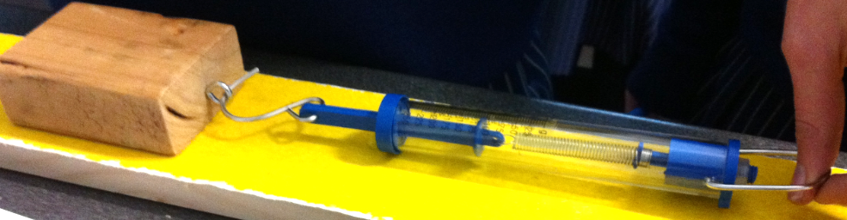

Run each part of the experiment 3 times and average your result. You should try and pull at the same speed each time. Change the surface several times, predicting the likely value before running the experiment. (Use a 250 g blue force measurer)
surface | Prediction | Run 1 | Run 2 | Run 3 | Average
Rank the surfaces (from least amount of friction to greatest)
________________________________________________________________________________
Why make 3 runs for each surface?
________________________________________________________________________________
What conclusions can you draw?
________________________________________________________________________________
________________________________________________________________________________
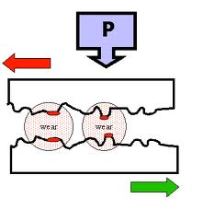
Sandpaper will have high friction. Explain why this will be the case?
__________________________________________________
_________________________________________________
A microscope shows that what looks like a smooth wooden surface is really not very smooth. It is like the diagram shown.
Use this diagram to explain what causes friction.
________________________________________________________________________________
________________________________________________________________________________
Give three instances where low friction is helpful.
________________________________________________________________________________
________________________________________________________________________________
Give three instances where high friction is helpful.
________________________________________________________________________________
________________________________________________________________________________
Try this!
- Set up a plastic dinner set on a smooth cloth. Pull the cloth very, very fast so that the dinner set stays put and the cloth comes out!

- Make a hover craft using a balloon and the lid of a can. balloon

stopper lid
Homework sheet 1
1. Explain what a force can do.
________________________________________________________________________________
________________________________________________________________________________
2. When you stand on the floor, gravity acts down on you. Why don’t you fall through the floor? (Include a force diagram in your answer)

________________________________________________________________________________
3. Give two examples of non contact forces. __________________________________________
4. What will happen if you drop (at the same time);
a. a brick and a peanut ________________________________________________________
b. a brick and a feather _________________________________________________________
c. Explain why the answer should be different to the above two scenarios
________________________________________________________________________________
________________________________________________________________________________
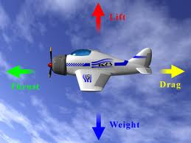
5. The forces on an aeroplane are shown in this diagram. Explain what each force shown is due to

Which force is greater?

6. How does it work when you weigh yourself on bathroom scales?
________________________________________________________________________________
________________________________________________________________________________
7. Do all rubber bands behave the same when you hang weights from them? Explain your answer
________________________________________________________________________________
________________________________________________________________________________
8. List three examples of forces you have used at home before leaving for school i.e. turning a door handle to open the door.
________________________________________________________________________________
________________________________________________________________________________
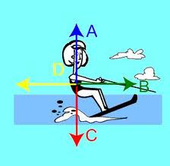
9. Explain each of the forces on the water skier
___________________________________________
___________________________________________
___________________________________________
__________________________________________
10. A tub of margarine slides along a bench.
a. Explain why the margarine will slow down

________________________________________________________________________________
b. Explain what causes friction
________________________________________________________________________________
c. The diagram below is used to help explain fraction.
What does the diagram show?

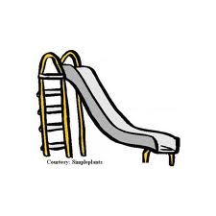
11. For each scenario, explain whether you want friction to be high or low
a. the slide shown ___________________
b. the sole of your shoe ________________
c. a car tyre on a road _________________
d. the handle of a door knob ______________
e. skating rink _________________________

Prangs!
Make a plasticine dummy. Sit the dummy on a toy car or trolley.
You will roll the car down a ramp to hit a barrier. What do you think will happen to the dummy?

____________________________________________________________________________

Try this. What happened?

____________________________________________________________________________
Sit your dummy on a trolley at the base of the ramp. When the first trolley runs down the ramp and hits the trolley with dummy, what will happen to the dummy?

______________________________________________________________________________

Try this. What happened?

______________________________________________________________________________

______________________________________________________________________________

Machines
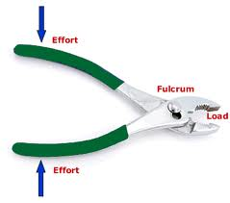
Our daily life is made easy by the use of machines. While a car is a very obvious machine, we also benefit from many simpler machines. A door handle, a pair of scissors and a screw driver are examples of machines. Machines help you to do things more easily. They do this by magnifying the force you are capable of applying or changing the direction of the force. Many of the machines we use are levers.
Levers have a turning point or a fulcrum. The lever applies your effort to a load. See diagram of pliers
Experimenting with levers and machines: Workstations
You are supplied with a series of levers or machines in the class. Rotate around the class and try each lever out.
Keep a running list as you go of ‘things that occur to me’ – minimum of 10 wanted.
Things that occur to me:
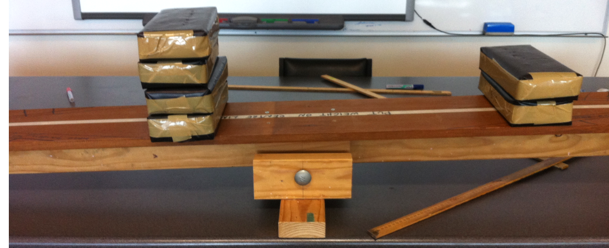

Levers to include
- Taking the lid off a can. Try and do this with your fingers. Try it with a short piece of metal. Try it with a screwdriver.
What conclusion can you draw?
___________________________________________________________________

___________________________________________________________________

- Cracking a walnut. Try this in your hand. Now try it with a nutcracker.
What conclusion can you draw?
___________________________________________________________________

___________________________________________________________________

- Screwing a screw into wood. Try and do this with your fingers. Try with a small screwdriver. Try with a large screwdriver.
What conclusion can you draw?

___________________________________________________________________

___________________________________________________________________

- Turning a nut. Try this with your fingers. Try this with a spanner.
What conclusion can you draw?

_____________________________________________________
___________________________________________________________________

- Removing a nail from wood. Try this with your fingers. Try this with a hammer.
What conclusion can you draw?

___________________________________________________________________

___________________________________________________________________

- Try and bend a piece of wood to break it. Hammer a wedge into the block of wood. What happens?

___________________________________________________________________

___________________________________________________________________

- Use the ruler and pivot to ‘catapult’ a piece of blu-tack. Vary the position of the pivot point. What leads to the best results?

___________________________________________________________________

__________________________________________________________________
Make a sketch of any three of the machines that you used showing the load, effort and fulcrum.
Clickview called Simple Machines

What conclusions can you draw as to how to make it easier to
- use a spanner to screw a nut onto a bolt

___________________________________________________________________
- use a screwdriver to turn a screw into timber
___________________________________________________________________
___________________________________________________________________
- use a ruler to lever up a weight?
___________________________________________________________________

___________________________________________________________________

You can get a measure of how useful a simple machine is by dividing the load by the effort. If you apply 10 kg force to lift a 50 kg rock, the mechanical advantage is 50/10 = 5. In other words, you only have to lift one fifth as much as if no lever was present.
Mechanical advantage with coffee tin lid. The mechanical advantage in this situation will be;
mechanical advantage = $\frac{distance from effort to fulcrum}{distance from load to fulcrum}$
Try a series of levers to open the coffee tin i.e. screwdriver, and calculate the mechanical advantage. Test each. Show your calculations of mechanical advantage below;
lever | Distance effort to fulcrum | Distance load to fulcrum | Mechanical advantage

Screwdriver
Start a screw into a piece of wood with a screwdriver.
Try and turn the screwdriver by gripping the shaft of the screwdriver.
Go back to giving the screw one turn using it as it should be used.
Wrap a cloth around the handle to make it wider. Try turning it now. Is it any different?
_____________________________________________________________________________
In summary then, which is easier – using the screwdriver handle or the shaft?
____________________________________________________________________________
Why is it easier?
____________________________________________________________________________
____________________________________________________________________________
To turn the screw one turn, how far does the handle have to turn? _____________________
How far does the shaft have to turn? _____________________________________________
Notice the price of a mechanical advantage - as it gets easier to move the object, you have to move the handle further.
Explain how this principle applies when you use a short spanner and a long spanner to do up a nut.
________________________________________________________________________________
________________________________________________________________________________
Activity: See-saw
Set up a see-saw as shown in the diagram.

Add a 50 g mass to the left end of the lever. What mass is required to balance it at the other end?
Complete the table below, adding to the 50 g mass.
Load g | Effort g | Mechanical advantage  = load/effort
Conclusion: While the distance from the fulcrum to the effort = the distance to the load, there is no mechanical advantage.
Now move a 100 g mass to the new point shown. Measure the distances from the fulcrum to each hole and complete row one of the table. Increase the mass on the left by 100 and record what mass is needed to balance this. Repeat with further masses, completing columns 1,2 and 3 of the table.

Load g | Effort g | Mechanical advantage  = load/effort | Distance to load | Distance to effort | Dis. Effort/  Dis. Load

Conclusion: ________________________________________________________________
__________________________________________________________________________
Place a 150 g mass on the final position on the right hand side of balance. Balance this mass using the end hole on the left side. Complete row 1 of the table. Now use the second hole to achieve balance. Measure the distances to the fulcrum and complete row 2 of the table. Repeat for all 4 hole.

Load g | Effort g | Mechanical advantage  = load/effort | Distance to load | Distance to effort | Dis. Effort/  Dis. Load

What conclusions can you draw from your experimenting?
_______________________________________________________________________________
_______________________________________________________________________________
_______________________________________________________________________________
Giant See-saw
Sit 1 brick on the end of the giant see-saw. Measure the distance from the fulcrum to the brick. ___
Calculate where you would have to place the following number of bricks for the see-saw to balance;
1 brick ______________________________________
2 bricks ______________________________________
3 bricks ________________________________________
4 bricks ________________________________________
5 bricks ________________________________________
Test your calculations. What did you find?
_______________________________________________________________________________
_______________________________________________________________________________
Pulleys
Stand two students a metre apart each holding a broomstick about a metre in front of them. Tie a rope to one broomstick, then wrap the rope back and forth around both brooms.

Challenge the students to hold the broomsticks apart while you pull on the rope.
What happens?
_____________________________________________________________________________
_____________________________________________________________________________
How do you predict the number of loops will impact upon the force needed to pull on the rope?
________________________________________________________________________________
_______________________________________________________________________________
Test this theory. What happens?
_______________________________________________________________________________
_______________________________________________________________________________
The broomstick above is acting like a pulley. If you set up the two systems below ( A and B), do you think it will require the same amount of effort to lift the weight?
_______________________________________________________________________________
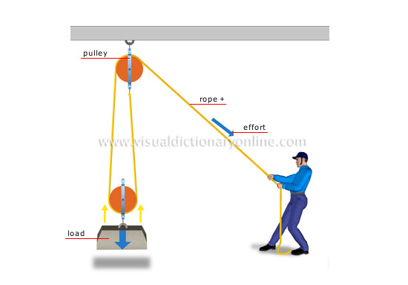
Set up a pulley as in the first diagram below. Attach 150 g to both sides. Do the weights move to balance at the same height? ________________
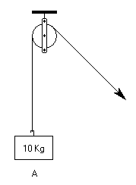 Now set up pulleys to match the diagram on the right above. If you place 200g where the load goes, what mass do you have to attach where the man is pulling to achieve balance? ______________
150g
150g
What was your mechanical advantage? ______ How could you predict this in advance?
Try this. What conclusion do you draw?
______________________________________________________________________________
_______________________________________________________________________________
The answer should have been that the second arrangement was twice as easy as the first. If so, what is the compromise with this set up? _________________________________________________
How can you predict this? The first pulley is fixed – it does not give a mechanical advantage. The second pulley can move so it does give a mechanical advantage. It is supported by two ropes so the mechanical advantage is two. The mechanical advantage is equal to the number of ropes supporting the weight, in this case two. Another way of looking at it is that each moving pulley halves the weight.
Try this one. Which weight requires the least force to move? 3 possible answers given below.

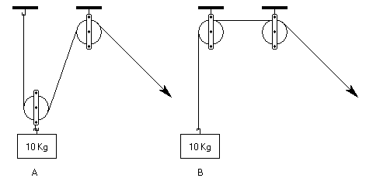
A) A | B) B | C) Both require the same force
Remember – count up the number of pulleys that can move. Each moving pulley, halves the weight.

Answer
A – Weight A requires a force equal to 5 Kg whereas weight B requires a force equal to 10 Kg. Remember to divide the weight by the number of sections of rope supporting it to get the force needed to lift the weight.

Next one. What weight will it feel like that you are lifting? Count the pulleys that can move.

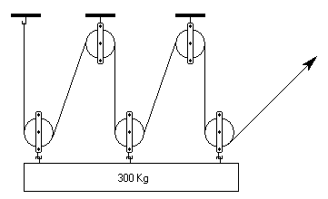

A) 100kg | B) 150kg | C) 50kg | D)60kg

Answer C – The weight is 300 Kg and there are 6 sections of rope supporting it. Divide 300 by 6 to get 50 Kg. In all cases, just divide the weight by the number of sections of rope supporting it to get the force needed to lift the weight.
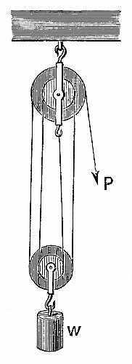
The set-up shown on the right is called a block and tackle.
How many supporting ropes can you count? __________
What will the mechanical advantage be? _________

Other systems: Crane. What is the role of the counterweights?
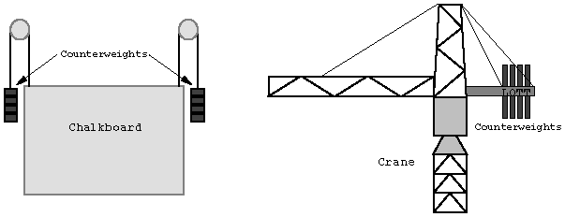
_______________________________________________________________________
_______________________________________________________________________
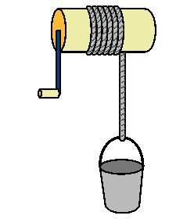
Windlass
The windlass is a means of converting rotary motion to linear motion, usually with some mechanical advantage.
Essentially a class 1 lever, the effort is applied to the handle of the crank, the fulcrum is the centre of the drum, and the load is applied to the rope. The mechanical advantage is approximately the length of the crank divided by the diameter of the drum.

What is the mechanical advantage of the windlass we have in the science room? Measure it! ___________________________________________
___________________________________________________________________________
Try changing the length of the crank or the diameter. Describe what you changed and the impact that it had.
______________________________________________________________________________
______________________________________________________________________________
Conclusion
- What have you leant? Use the diagram below to explain clearly and thoroughly what a lever is and how it works. Include mechanical advantage in your discussion.
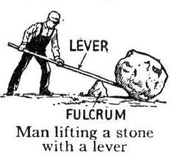
- A block sits on the front bench, as shown below. Show the forces involved in each of the scenarios provided.

- The block is stationary.
- The block is moving to the left at a constant speed

- The block is slowing down after being pushed to the left.

- The block is accelerating to the right

Fill in the blanks 42cm 42 cm

150 g 150 g load
Distance effort = _____ = : Mass load = ________ = Mech. Advantage = _
Distance load Mass effort
_______________________________________________________________________________
Fill in the blanks 42cm 21 cm

150 g 300 g load
Distance effort = _____ = : Mass load = ________ = Mech. Advantage = _
Distance load Mass effort
__________________________________________________________________________________
Fill in the blanks 42cm 14 cm

150 g 450 g load
Distance effort = _____ = : Mass load = ________ = Mech. Advantage = _
Distance load Mass effort

