Drawing a galvanic cell : Using the electrochemical series to predict a reaction

Qn. A galvanic cell can be constructed by connecting an iron half-cell with an iodine half-cell.
Use the snippet of the electrochemical series, and the cell template, provided below to draw the
resulting cell.

Electrochemical series snippet
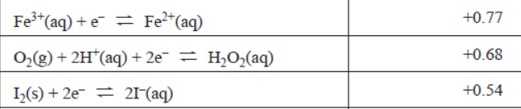

Template
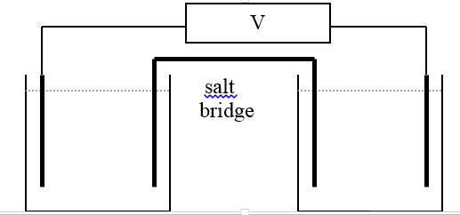

Use the template to show, the
- reactants
- direction of electron flow
- polarity
- ion movement on the salt bridge
- half equations
- overall equation
Solution

+ -

cathode anode

Pt(s) Pt(s)
FeCl₃/FeCl₂ KI

Fe³⁺(aq) + e⁻ Fe²⁺(aq) 2I⁻(aq) I₂(l) + 2e⁻

Overall equation 2Fe³⁺(aq) + 2I⁻(aq) Fe²⁺(aq) + I₂(l) voltage 0.77-0.54 = 0.23 V

Salt bridge: K⁺ moving into Fe half-cell/ NO₃⁻ moving into I half-cell

