Galvanic cell experiment feedback
Group 1: Testing the impact of temperature.
Group set-up a zn/cu cell on a hot plate and monitored the voltage with temperature.
Obtained a linear graph with a gentle rise in temperature. This is consistent with the Nernst equation.
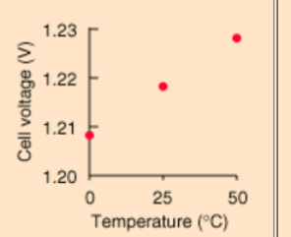
Group 2: Effect of concentration of KNO₃ on the salt bridge
Group set up a zn/cu cell and soaked a salt bridge in 0.1 M KNO₃. Record voltage. Move to a salt bridge of higher concentration and repeat this procedure.
They found a rapid increase in voltage with concentration until the concentration reached around 2.0 M then it started to plateau out. Limit to how low the resistance can go.
Group 3: Solution concentrations
Group set up a zn/cu cell using solutions that were 0.1 M. Increased the concentrations incrementally. Voltage increased a linear fashion with concentration
Group 4: electrode separation
This cannot be done with a salt bridge. Use a beaker with CuSO₄ and dip the zn and cu electrodes in very briefly to this beaker. Adjust the separation each time. Using a voltmeter will give no variation. Using an ammeter will. The separation affects the current but not the voltage.
For 4 and 5, the electrode needs to always be at the same depth in the solution for good results. Same volume of solution should be used each time
Group 5: electrode surface area
Same set up as group 4 but using a range of electrode sizes. Again current increases with surface area but not voltage.

