Title: The electrochemical series
Aim: To construct a simple electrochemical series

Background
In chemistry we make a lot of use of the electrochemical series. In this experiment you will see how this table was prepared.
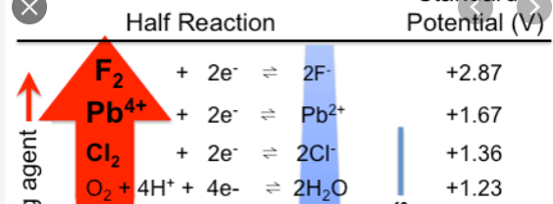

Method
Your group is supplied with a copper/copper ion half cell.
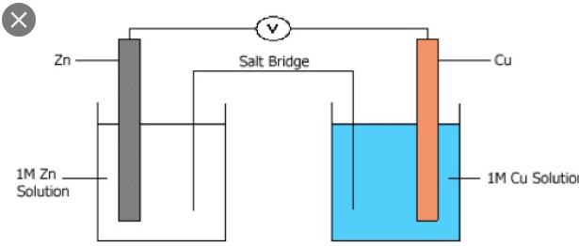
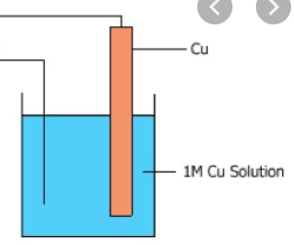
Procedure
- You will attach it to another half-cell and record the voltage and the polarity. Example shown: copper and zinc half-cells attached.
- Replace the zinc half-cell with a lead half-cell and record the voltage and polarity between lead and copper.
- Repeat for other half-cells provided.
Results
Make a table of the cell combination, voltage obtained and the electrode polarity.
Questions
- When copper and zinc half-cells are connected, how can you use the polarity to tell which metal is the least reactive?
- Rank the metals in order of reactivity, from least to most.
- a. Use the data obtained to construct an electrochemical series for the half-cells you tested.
b. What did you choose as a standard?
- Take one galvanic cell, perhaps the copper-lead one and draw it and annotate it with
- the direction of electron flow
- the anode and cathode
- label the oxidant and reductant
- the two half-equations
- the overall equation
- When the electrochemical series in your data book was prepared,
- What standard was used?
- What steps were taken to ensure each experimenter gets the same voltages?
- If a zinc half-cell was connected to a lead half-cell, what would the voltage be and which metal would be the positive electrode – you should be able to use your version of the table to answer this.

