**Carbohydrates**: Energy storage molecules

1. *Write a balanced equation in the box provided for the formation of the molecule below in plants*.

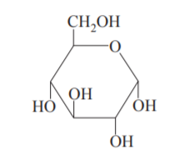

.

1. *Name the above molecule: ________*  3. *Draw the molecule formed from the reaction between 2 of these molecules*



*4. Write a balanced equation in the box above for the formation of the small molecule above from the original molecule.*

*5. Three different polysaccharides can be formed from the original molecule above. Fill in the template*

*below with reference to these polysaccharides.*

|  |  |  |
| --- | --- | --- |
| Polysaccharide | Use | Comment on structure |
| starch | Energy storage in plants |  |
| cellulose | Structural material in plants |  |
| glycogen | Energy storage in animals |  |

**Solutions**

1. Photosynthesis 6CO2(g) + 6H2O(l) 🡪 C6H12O6(aq) + 6O2(g)
2. Glucose 3. Maltose forms

4. fermentation C6H12O6(aq) 🡪 2C2H5OH(aq) + 2CO2(g)

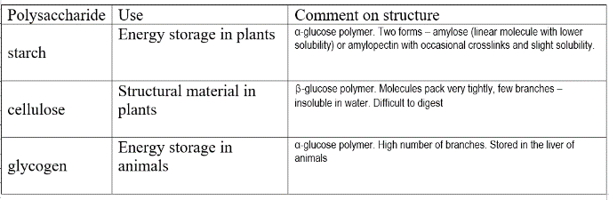5.