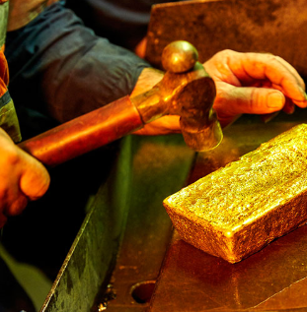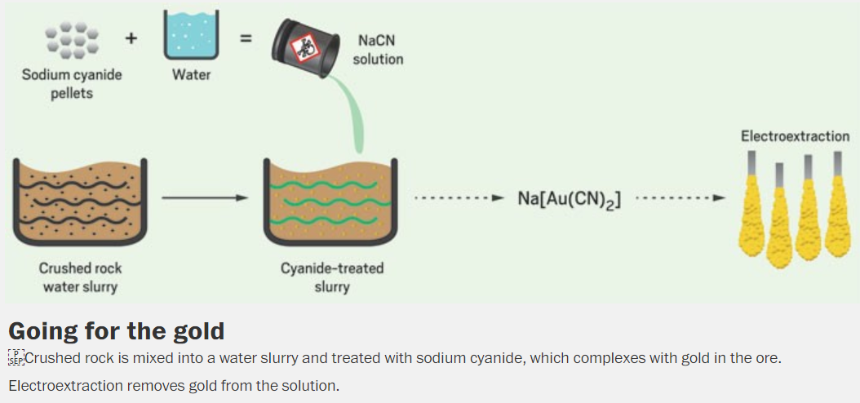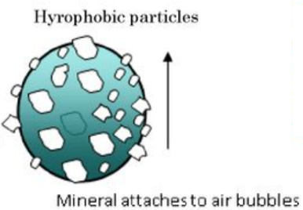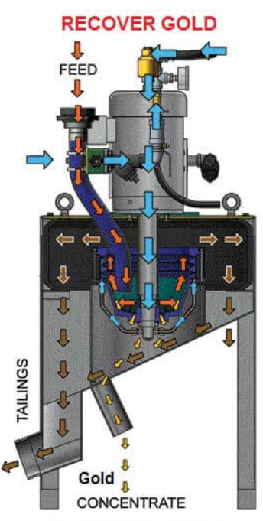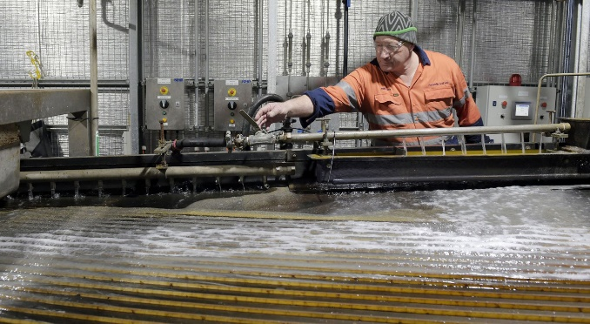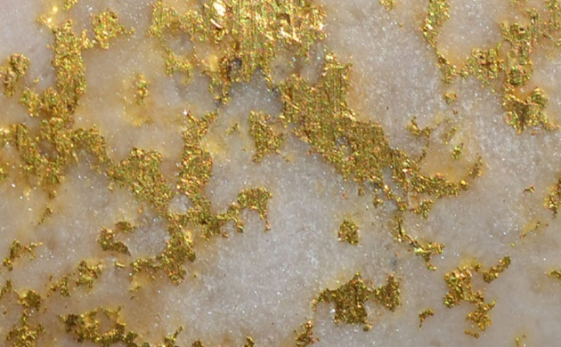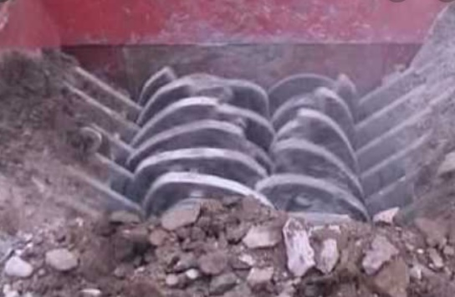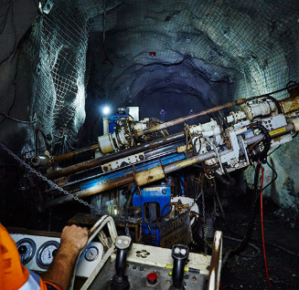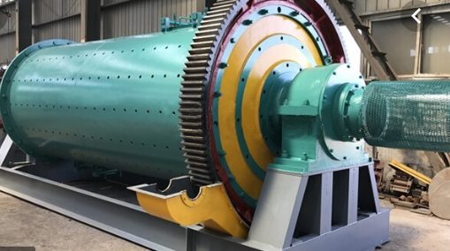

Cyanidation

Flotation

©POShea

After concentration, **cyanide** ions are added to the slurry. **Complex ions** form with the gold that can be collected on activated charcoal and separated from remaining solids

Large gold particles can be collected on **shaking tables** due to the high density of gold

GOLD

Small gold particles are concentrated using **flotation**. Gold particles are attracted to air bubbles that carry them to the surface to be collected.

The ore is brought to the surface and ground to small pieces in **crushers** and **ball mills**. This separates gold ore from quartz.

Gold mining is in a resurgence in Victoria. The most productive mines are Fosterville near Bendigo and Ballarat Gold.