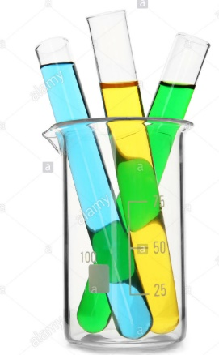**HPLC: High performance liquid chromatography**

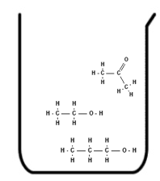

If you have a mixture of liquids, HPLC can be used to –

- **separate** them and to

- work out their **concentrations**.

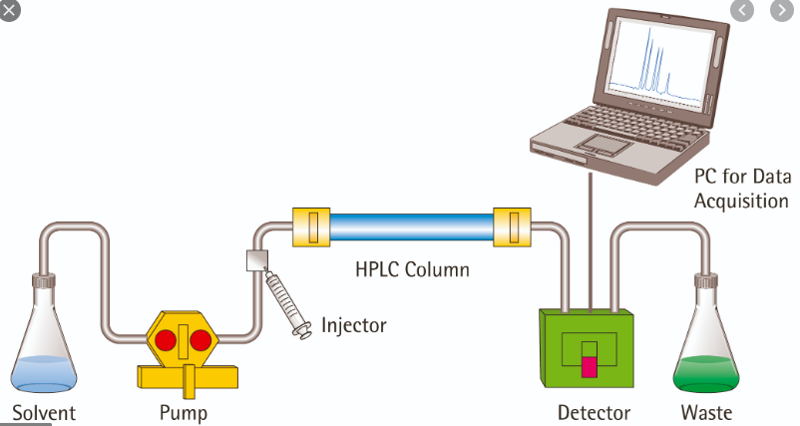

HPLC pumps a solvent through a **narrow column**, using high pressure. The components move at different speeds and arrive at the detector after **different times**.



The column is packed with tightly packed, carefully prepared particles (as shown in grey). This is the **stationary phase**.

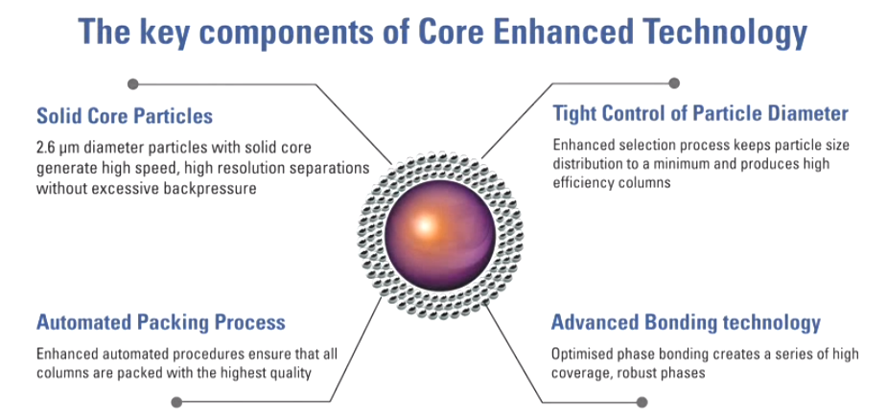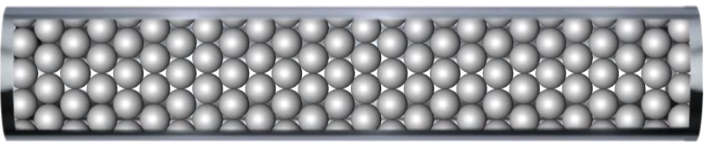

Particles in stationary phase

are coated in chemicals to make

them either **polar or non-polar**.

The **mixture of liquids is injected** into the left end of the column (the coloured spots below). The solvent (**the mobile phase**) carries the liquids through the tightly packed particles.

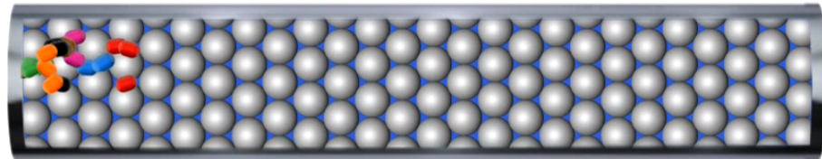

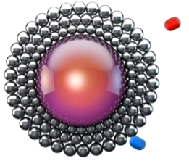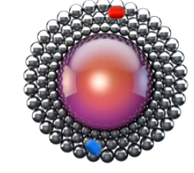

The two liquids contact the stationary phase – the blue particles are **more strongly adsorbed** and take longer to move on.

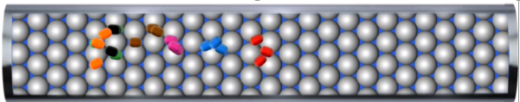

The red particles consistently move on more quickly, so they forge ahead of the blue particles. Notice that each component of the mixture is starting to form bands. Separation increases with time as the diagram below shows.

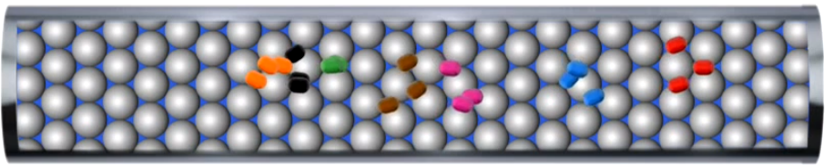

There are several possible **reasons for particles to move at different speeds** –

* their solubility in the mobile phase differs
* their attraction to the stationary phase differs or
* their physical size limits their movement.

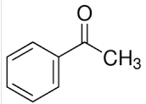

These are the first three components in the mixture above. Speed is related to polarity and size.

Pentan-2-one (red particles) get to the end of the column and the detector records the time it took – the **retention time**.

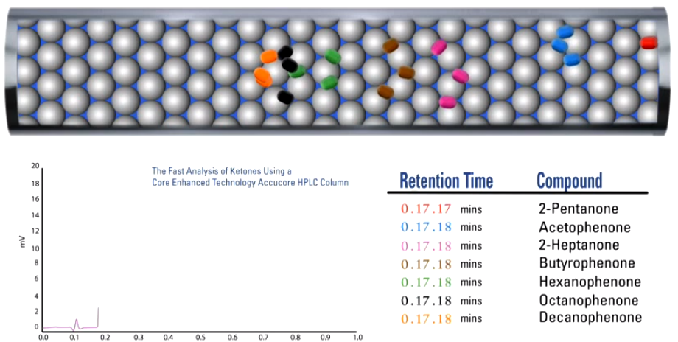

As each subsequent component gets to the end of the column another peak is recorded.

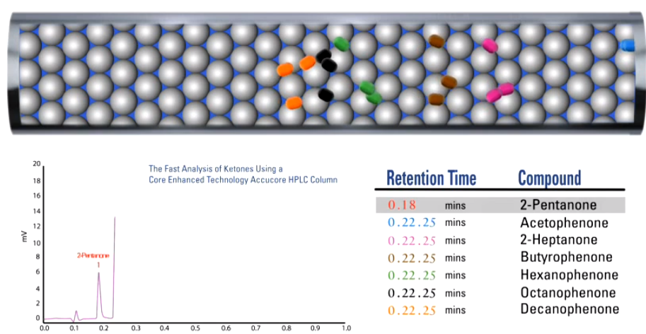

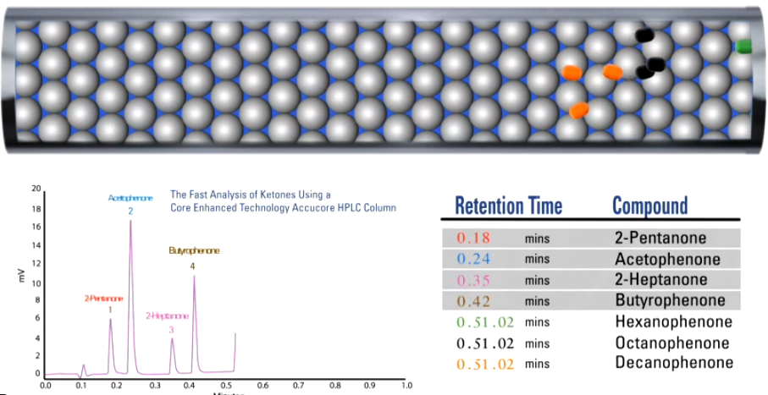

Each component produces a peak.

The final chromatogram produced by this mixture.

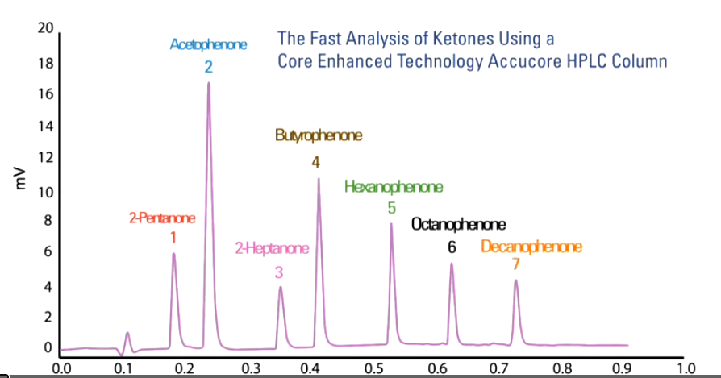

Each peak has a **retention time** and the **area under the peak** is also calculated.

**What is HPLC telling you?**

1. The **identity** of a substance (qualitative) through the retention time.

A mixture might produce the chromatogram below.

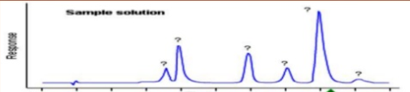

You might suspect the peak labelled with an asterisk is pentan-1-ol. If you then run a sample of pentan-1-ol solution and it provides the peak shown, there is a high likelihood you have identified the substance.

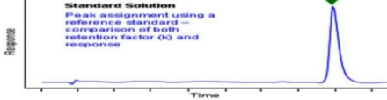

2. **Concentration** of a substance (quantitative) through **peak area**

The higher the concentration of a substance, the greater the area under a peak. The concentration of a solution is determined by comparison to prepared standard solutions.

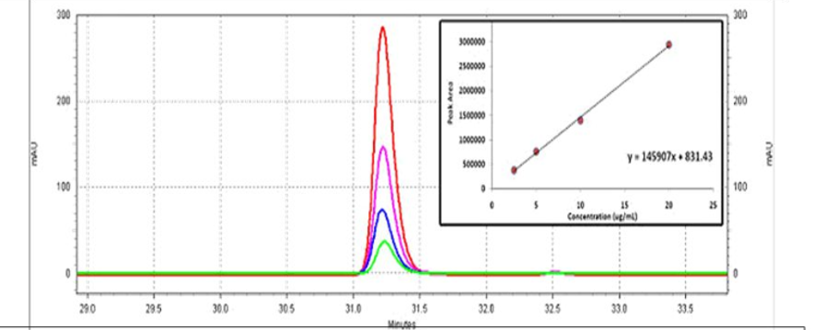

Note that each peak in the above diagram represents an increased concentration. The graph produced shows the **linear relationship between area under the peak and concentration**. Run an unknown solution and plot the area on the vertical axis.

**Normal phase HPLC**: Non polar solvent and polar stationary phase.

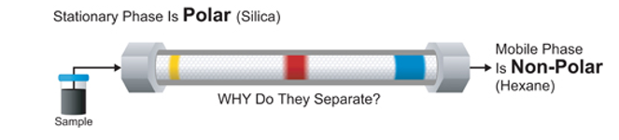

The blue component is non polar, soluble in the solvent and has a short retention time.

The polar yellow component is attracted to the polar stationary phase and moves slowly through the column.

If there are several non-polar components, the molecules will separate according to mass or size.

**Reverse phase HPLC**: Polar solvent and non-polar stationary phase

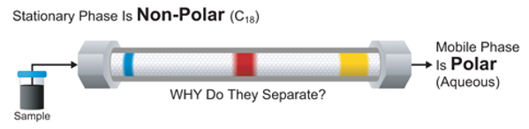

The same mixture added to a reverse phase HPLC come out in the opposite sequence. Reverse phase is the most popular form used.

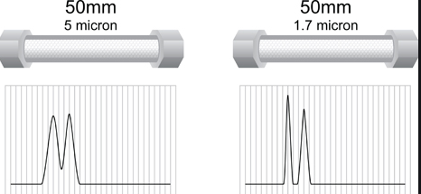Impact of a change in **stationary phase particle size**.