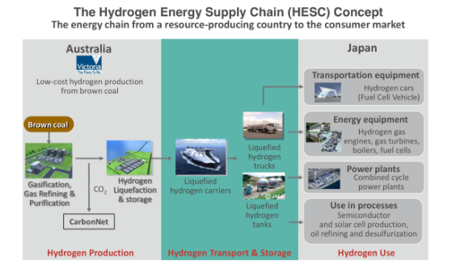
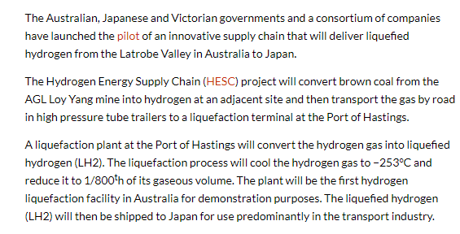
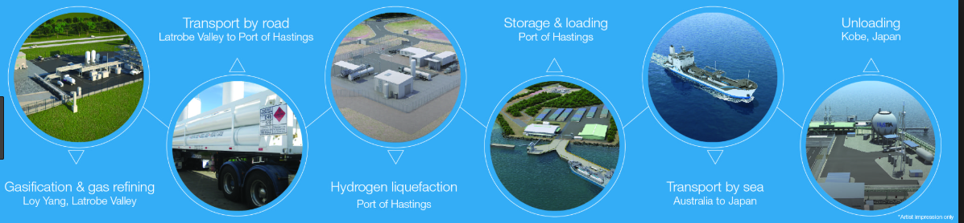
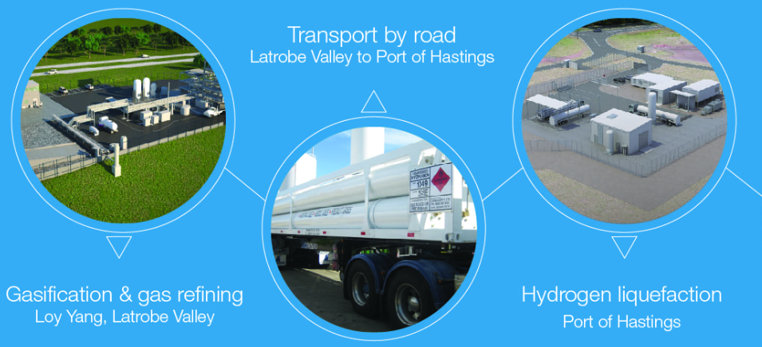
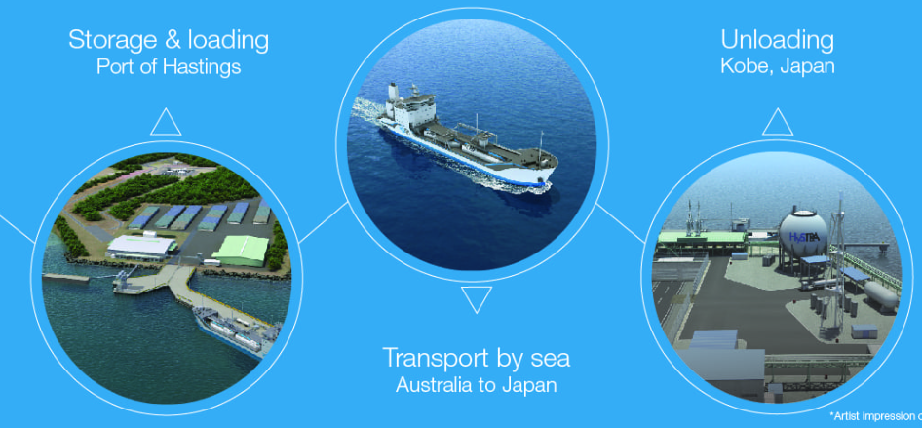
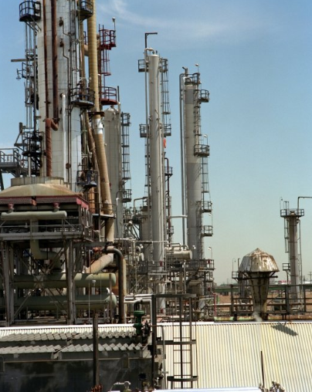
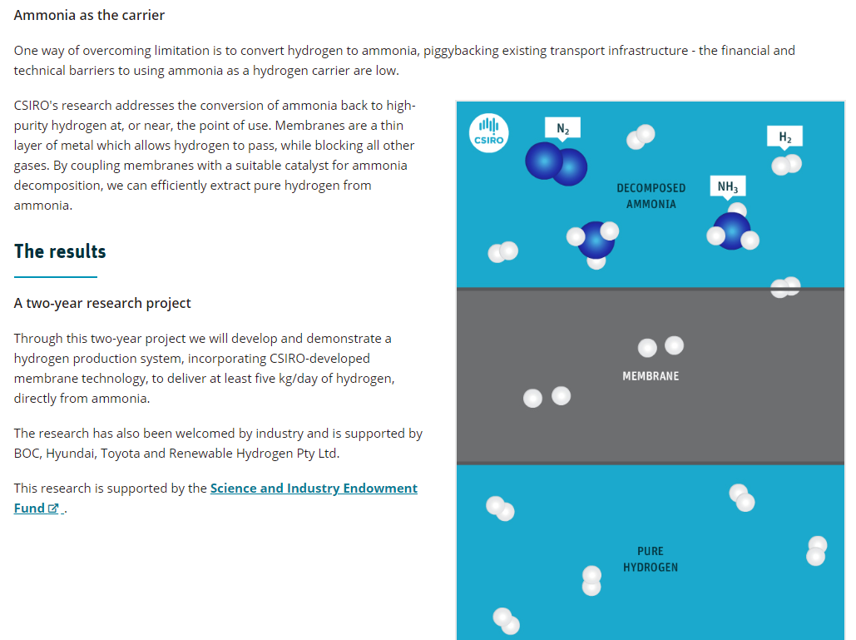
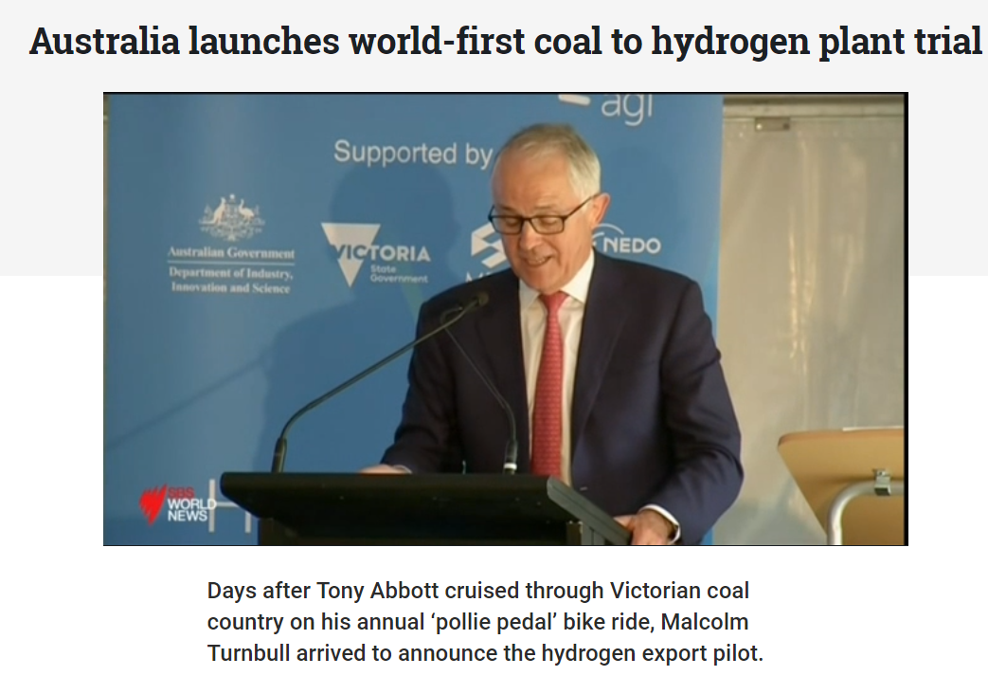
https://www.sbs.com.au/news/australia-launches-world-first-coal-to-hydrogen-plant-trial
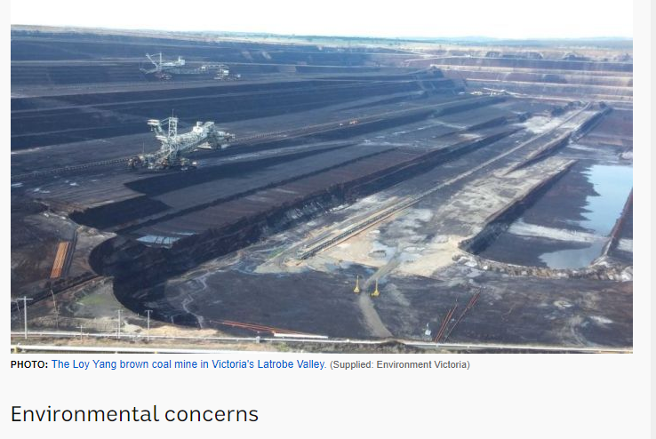
Steam reforming of natural gas is the most common method of producing commercial bulk hydrogen at about 95% of the world production^{[1][2]} of 500 billion m³ in 1998.^{[3]} Hydrogen is used in the industrial synthesis of ammonia and other chemicals.^{[4]} At high temperatures (700 – 1100 °C) and in the presence of a metal-based catalyst (nickel), steam reacts with methane to yield carbon monoxide and hydrogen.
CH₄ + H₂O ⇌ CO + 3 H₂
Catalysts with high surface-area-to-volume ratio are preferred because of diffusion limitations due to high operating temperature. Examples of catalyst shapes used are spoked wheels, gear wheels, and rings with holes. Additionally, these shapes have a low pressure dropwhich is advantageous for this application.^{[5]}
Additional hydrogen can be obtained by reacting the CO with water via the water-gas shift reaction.
CO + H₂O ⇌ CO₂ + H₂
The first reaction is strongly endothermic (consumes heat, ΔH_{r}= 206 kJ/mol), the second reaction is mildly exothermic (produces heat, ΔH_{r}= -41 kJ/mol).
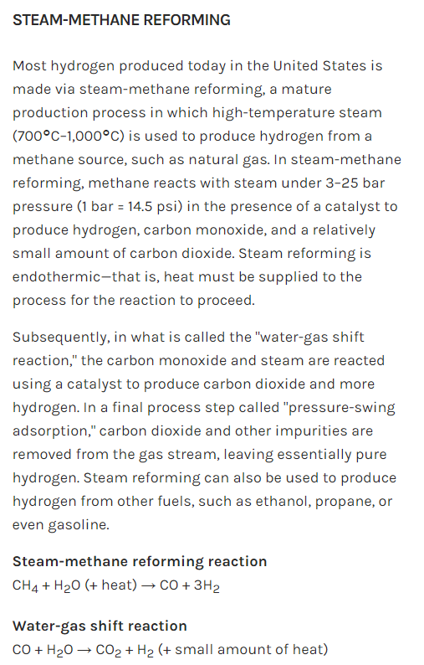

Syngas, or synthesis gas, is a fuel gas mixture consisting primarily of hydrogen, carbon monoxide, and very often some carbon dioxide. The name comes from its use as intermediates in creating synthetic natural gas (SNG)^{[1]} and for producing ammonia or methanol. Syngas is usually a product of gasification and the main application is electricity generation. Syngas is combustible and can be used as a fuel of internal combustion engines.^{[2][3][4]} Historically, syngas has been used as a replacement for gasoline, when gasoline supply has been limited; for example, wood gas was used to power cars in Europe during WWII (in Germany alone half a million cars were built or rebuilt to run on wood gas).^{[5]} Syngas, however, has less than half the energy density of natural gas.^{[1]}
Syngas can be produced from many sources, including natural gas, coal, biomass, or virtually any hydrocarbon feedstock, by reaction with steam (steam reforming), carbon dioxide (dry reforming) or oxygen (partial oxidation). Syngas is a crucial intermediate resource for production of hydrogen, ammonia, methanol, and synthetic hydrocarbon fuels. Syngas is also used as an intermediate in producing synthetic petroleum for use as a fuel or lubricant via the Fischer–Tropsch process and previously the Mobil methanol to gasoline process.

