AOS 1 Unit 4 Chemistry SAC: Instrumentation

Aim: To use the data provided to deduce the formula and structure of a molecule

Data

A 3.400 g sample of an organic molecule is found to contain 2.110 g of carbon and 0.352 g of hydrogen. The remainder is oxygen.

1. Complete the table provided to show the mass of each element present

element | mass present
carbon
hydrogen
oxygen

1 mark

2. Determine the empirical formula of the mystery molecule.

_______________________________________________________________________

_______________________________________________________________________

_______________________________________________________________________

_______________________________________________________________________

2 marks

The mass spectrum of the molecule is shown below

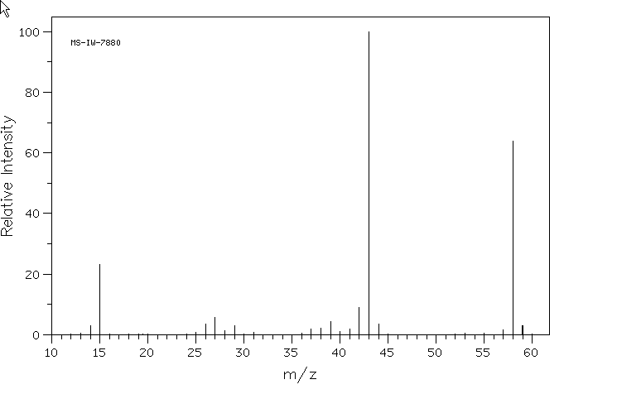

3. a. i. There are two distinct parent molecular ions. What are their masses?

____________________________ ______________________

ii. How do their relative abundances compare?

_________________________________________________________

iii. What is the likely difference between the two parent molecular ion peaks?

____________________________________________________________________

____________________________________________________________________
1 + 1 + 1 = 3 marks

b. i. What fragment has probably been broken from the molecule to produce a peak
at 43? _______________

ii. What fragment has caused the peak at 15? ______________

iii. What might the absence of a significant peak at mass 29 indicate?

__________________________________________________________________
1 + 1 + 1 = 3 marks

c. What is the molecular formula of the mystery molecule? __________
1 mark
The infrared spectrum of the mystery molecule is shown below
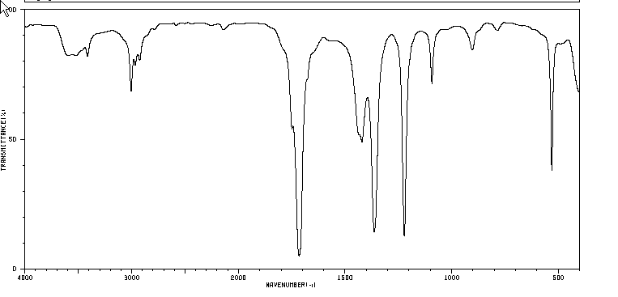
4. a. There is no significant peak over 3000 cm⁻¹. What conclusion might this lead to?

____________________________________________________________________

b. There is a significant peak around 1700 cm⁻¹. What conclusion might this lead to?

____________________________________________________________________

c. The infrared spectrum is a relatively plain one. What conclusion might this lead to?

____________________________________________________________________
1 + 1 + 1 = 3 marks

The ¹H NMR spectrum for the mystery molecule is drawn below
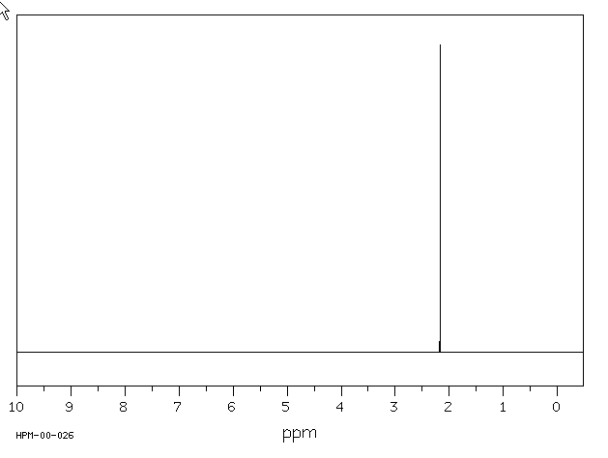

5. a. How many different hydrogen environments does this molecule have? ________

- Why is there no evidence of peak splitting?

____________________________________________________________________
1 + 1 = 2 marks

6. Time to put all of the evidence together.

The molecular formula is ______
The molecule cannot be an alkanol because

_____________________________________________________________________

The molecule cannot be an amine because

______________________________________________________________________

The molecule cannot be a carboxylic acid because ( 2 reasons wanted)

_____________________________________________________________________

The number of different hydrogen environments is _____________
1 + 1 + 1 + 2 + 1 = 6 marks

7. Draw a structural diagram of the molecule. Name the molecule.
1 + 1 = 2 marks

8. a. How many different carbon environments does this molecule have? ________

b. Would you expect this molecule to be polar or non polar. Explain your answer.

_____________________________________________________________________

_____________________________________________________________________
1 + 2 = 3 marks

9. This molecule can be manufactured in a pathway that starts with propene. Outline the
steps and reagents required in this synthesis.

4 marks

Total out of 30 ___

