Media Files/ Case studies
Vanadium flow batteries: Energy storage possibilities
Structure of these – equations – how they work.
Advantages? Sustainability issues
Australian hydrogen industry overview

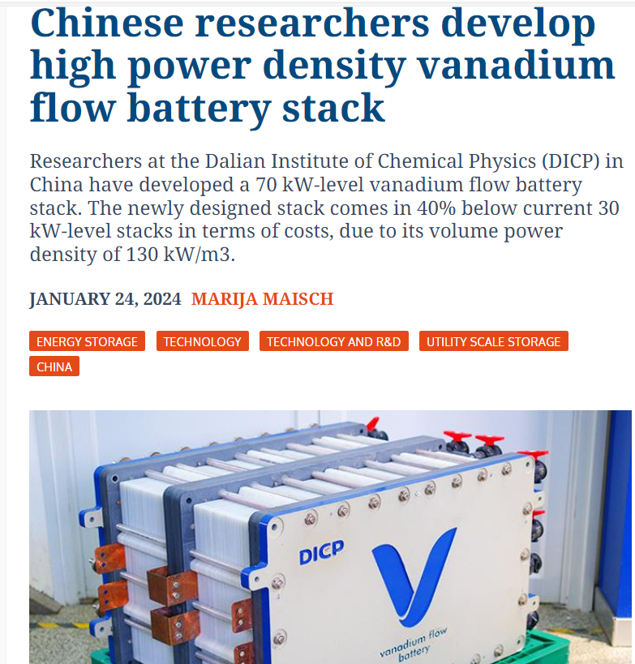
Chinese researchers develop high power density vanadium flow battery stack – pv magazine International (pv-magazine.com)
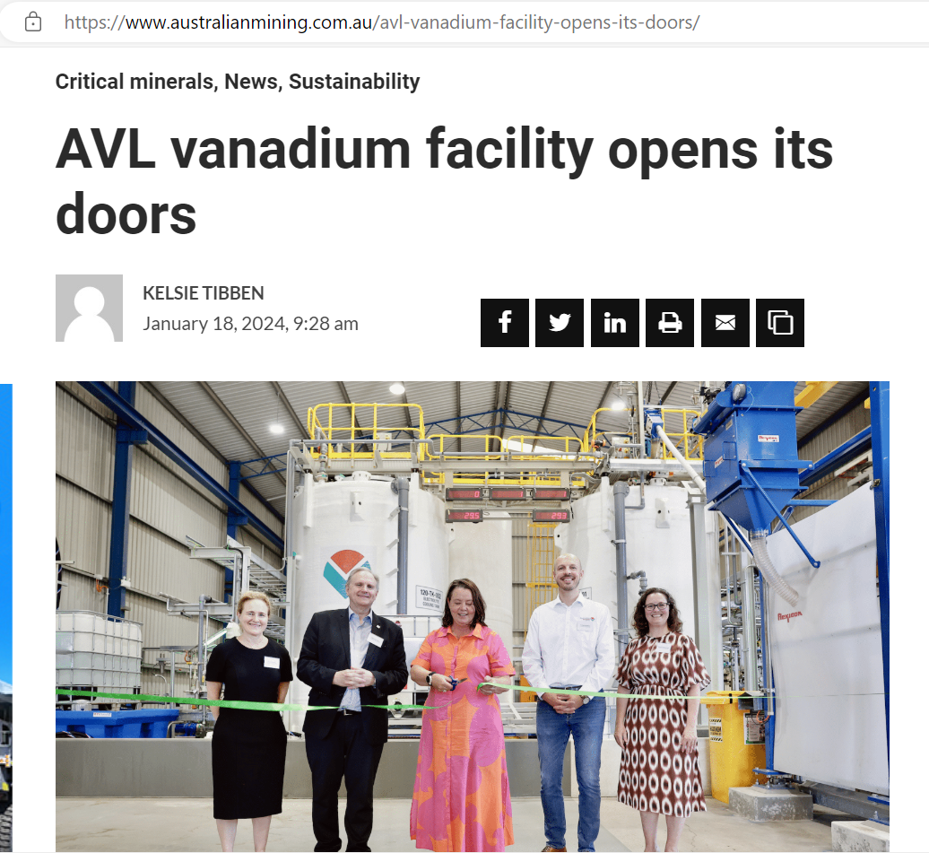
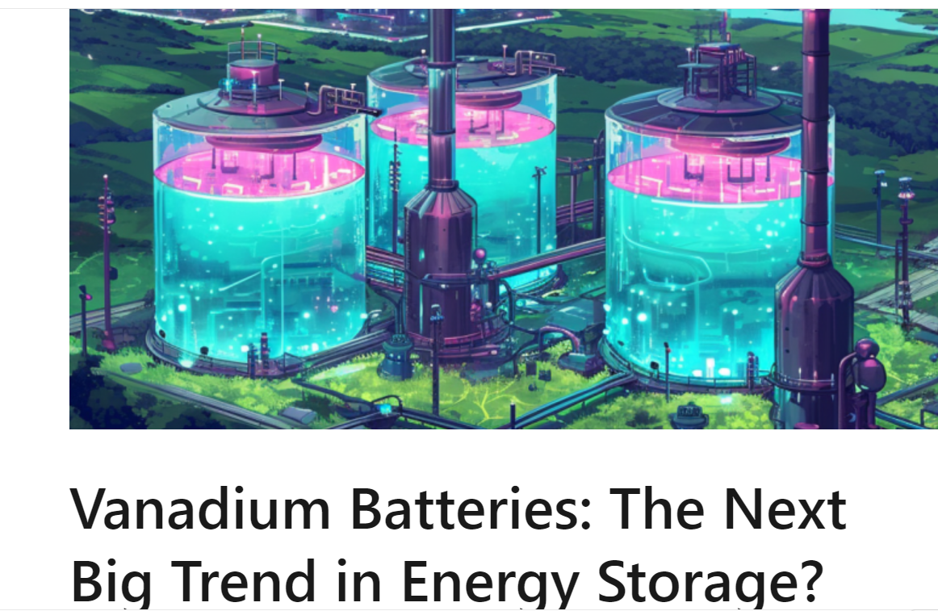
(17) Vanadium Batteries: The Next Big Trend in Energy Storage? | LinkedIn
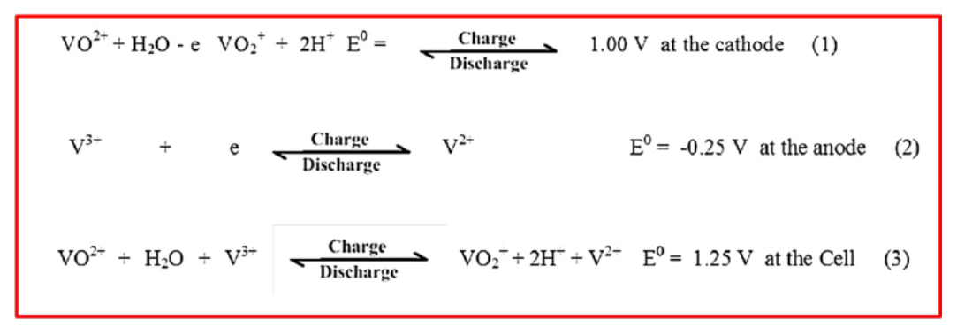
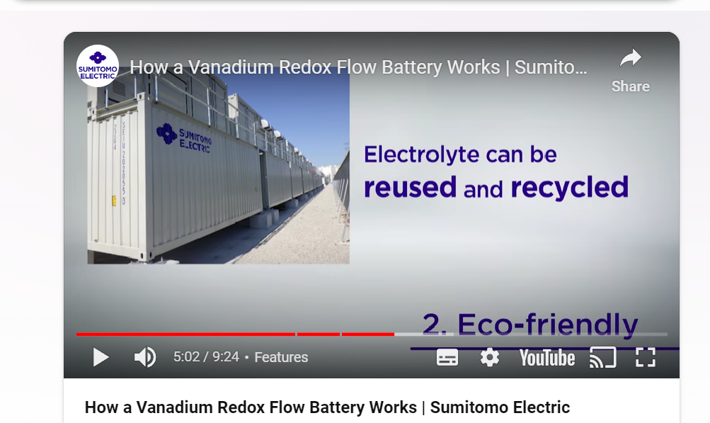
Bing Videos

