Media Files/ Case studies
Australian hydrogen industry: Mainly focused on Whyalla, Kwinana and Gladstone.
This could focus on – why it is green hydrogen? What industries are part of the hub?
What type of electrolysers are being used. Electricity source?
Australian hydrogen industry overview
Hydrogen: The Clean Fuel of the Future | Global Australia
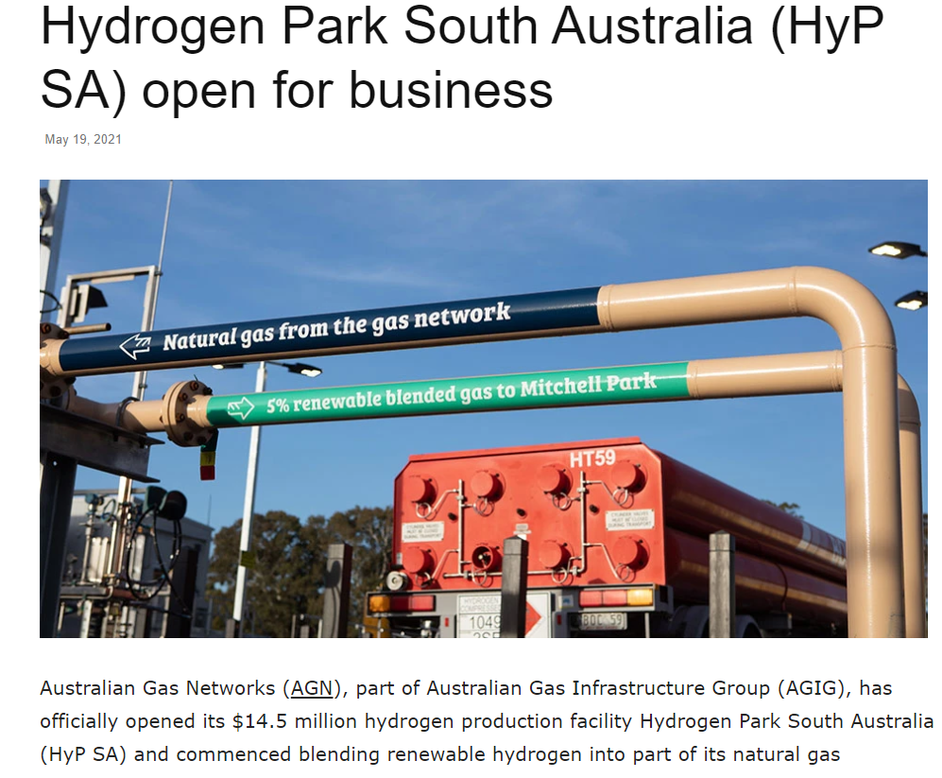
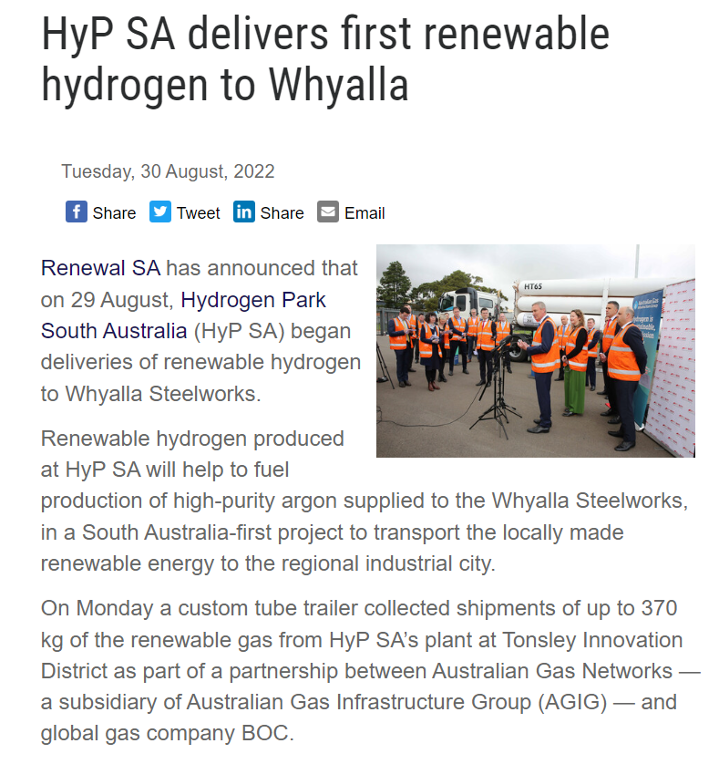
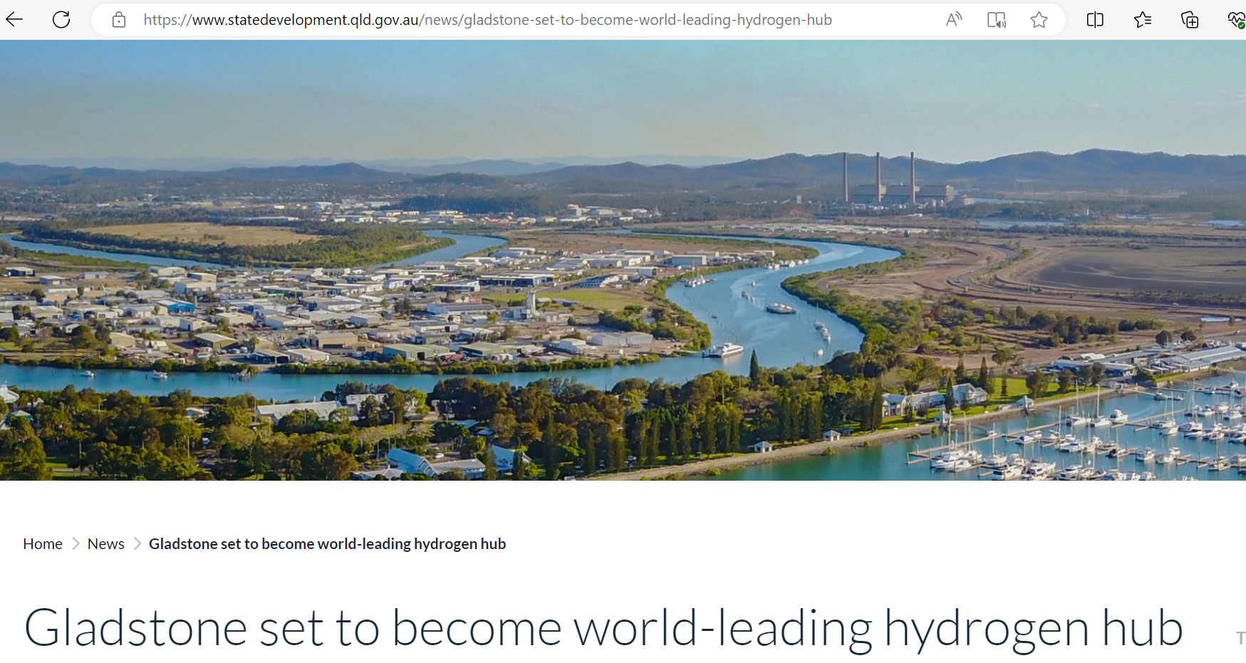
Gladstone set to become world-leading hydrogen hub | State Development and Infrastructure

Microbial
Hydrogen Production: Microbial Biomass Conversion | Department of Energy
Slideshow
PPT - Production of Bio-hydrogen by Microorganism PowerPoint Presentation - ID:2367403 (slideserve.com)

