**Metabolism Topic Test**

**Question 1**

Blood sugar levels refer to the concentration of

1. glucose in urine
2. glucose in blood
3. sucrose in blood
4. glycogen

**Question 2**

Select the list that contains only foods high in natural antioxidants.

1. carrots, oranges, blueberries and kidney beans
2. carrots, pasta, potato and butter
3. oranges, butter, potatoes and rice
4. blueberries, milk, flour and lettuce

**Question 3**

When a triglyceride is hydrolysed the products formed are:

1. 3 fatty acids
2. 1 fatty acid and 1 glycerol molecule
3. 1 fatty acid and 3 glycerol molecules
4. 3 fatty acids and a glycerol molecule

**Question 4**

A particular protein containing 27000 amino acid units is hydrolysed completely. Select the alternative that correctly compares the cumulative mass of the amino acids to the mass of the original protein.

1. mass of amino acids = mass of protein
2. mass of amino acids = mass of protein + mass of 26999 water molecules
3. mass of amino acids = mass of protein - mass of 26999 water molecules
4. mass of amino acids = mass of protein - mass of 27000 water molecules

**Question 5**

The enzymes pepsin and trypsin both have a role to play in the hydrolysis of proteins. The graph below shows their effectiveness at different pH levels.

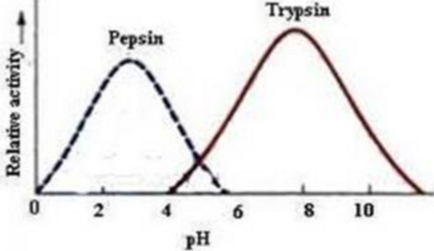

Select the correct alternative about these two enzymes.

1. Pepsin is important if foods are acidic while trypsin is important if foods are non-acidic.
2. The stomach has a pH around 5 to allow both enzymes to function.
3. The stomach is acidic when we start to eat but gradually neutralises during a meal.
4. Pepsin operates in the acidic stomach environment and trypsin in the slightly basic intestine.

**Question 6**

The complete hydrolysis of amylopectin requires the breaking of

1. covalent bonds in the long chains and the breaking of covalent crosslinks between chains
2. covalent bonds in the long chains only
3. hydrogen bonds between long chains only
4. covalent bonds between long molecules only

**Question 7**

Fats can lower a food’s glycaemic response. They do this because

1. fats absorb released glucose
2. fats slow the rate of digestion and the rate at which the stomach empties
3. fats convert glucose to glycerol
4. fats cause condensation reactions to occur

**Question 8**

A representation of one of the processes of digestion is shown below.

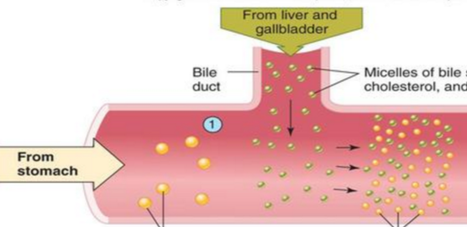

This diagram is a representation of the process of

1. the breakdown of dietary fibre in the large intestine
2. digested food entering the bloodstream to be transported to other parts of the body
3. emulsification and hydrolysis of fats
4. aqueous

*Use the following information to answer Questions 9 and 10*

The mechanism of an enzyme is often referred to a ‘lock and key’ one as shown below.

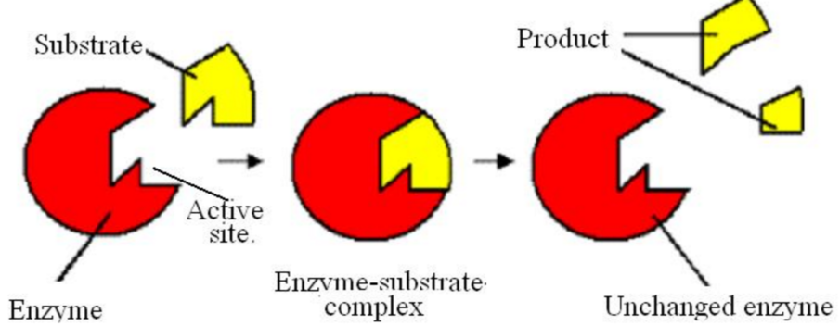

**Question 9**

If the substrate is sucrose, the

1. products will be fructose and galactose and the enzyme sucrase
2. product will be glucose and the enzyme pepsin
3. product will be glucose and the enzyme sucrase
4. products will be fructose and glucose and the enzyme sucrase

**Question 10**

Select the correct alternative about the action of an enzyme.

1. As temperature increases the enzyme will become more and more effective.
2. An enzyme will work for several molecules of similar shape and properties.
3. An enzyme should be able to work repeatedly for the same reaction.
4. The enzyme is denatured after it has been involved in a reaction.

**SECTION B - Short-answer questions**

**Question 1**

During hydrolysis, macronutrients are reduced to their basic building blocks.

**a**. Complete the table below to show what bond needs to be broken for hydrolysis to occur and

to identify the basic building blocks formed.

|  |  |  |  |
| --- | --- | --- | --- |
|  | protein | carbohydrate | triglyceride |
| linkage to be broken  (draw linkage) |  |  |  |
| basic units formed |  |  |  |

6 marks

**b**. There are many important enzymes used by the body during digestion. Outline the role of

each of the following

**i**. amylase ______________________________________________________________

**ii**. lactase ______________________________________________________________

**iii**. cellulase ______________________________________________________________

1 + 1 + 1 = 3 marks

c. Foods containing a high sugar content are usually high GI foods. Explain why this is so.

__________________________________________________________________________

__________________________________________________________________________

2 marks

Total 11 marks

**Question 2**

The structure of a triglyceride molecule is shown below.

H O

| ||

H - C – O – C – C17H35

O

||

H – C – O – C – C17H35

O

||

H – C – O – C – C17H35

**|**

H

1. On the diagram above, circle the functional groups present.

1 mark

1. Chemical digestion of fat does not start until it reaches the small intestine where, with the aid of enzymes, it undergoes hydrolysis.
2. What is the other reactant required for hydrolysis to occur?

________________________________________________________________________

1. Name the products that are formed during hydrolysis.

________________________________________________________________________  
  
________________________________________________________________________

1. Are the fatty acids formed saturated, monounsaturated or polyunsaturated? Explain how you can tell.

________________________________________________________________________

________________________________________________________________________________________________________________________________________________

1. What functional groups are present in the products?

________________________________________________________________________

1 + 2 + 2 + 2 = 7 marks

Total 8 marks

**Question 3**

The structure of vitamin A is shown below.

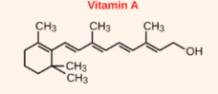

**a. i**. Will vitamin A be water soluble? Explain your answer.

________________________________________________________________________

________________________________________________________________________

**ii**. Will the body store vitamin A for significant periods? Explain your answer.

________________________________________________________________________

**iii**. What do vitamins have in common that leads to them be labelled as ‘vitamins’?

_________________________________________________________________________

2 + 1 + 1 = 4 marks

**b**. Vitamin A can act as a coenzyme. What is a coenzyme?

_________________________________________________________________________

1 mark

Total 5 marks

**Question 4**

The molecule drawn below could be found in living things.



**a. i**. What type of molecule is this? _______________________________

**ii**. Name an enzyme that can hydrolyse this molecule. _____________________

1 + 1 = 2 marks

**b**. Draw and name the smaller molecules that will form from the hydrolysis of this molecule.

3 marks

1. What happens to the small molecules formed from the hydrolysis above?

__________________________________________________________________________

1 mark

Total 6 marks

**Question 5**

A fatty acid molecule is shown below.

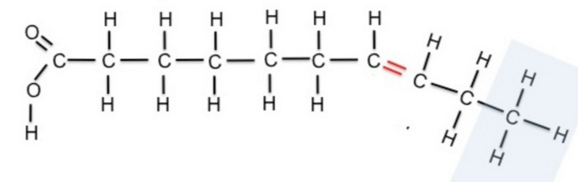

**a. i**. What is the molecular formula of this fatty acid? ___________________

**ii**. This is an example of an omega-3 fatty acid. Use the diagram to explain what this term

means.

______________________________________________________________________

_______________________________________________________________________

1 + 2 = 3 marks

**b. i**. Little digestion of this molecule occurs in the stomach. Refer to its structure to explain

why.

__________________________________________________________________________

**ii**. During digestion, enzymes in the body form fats into emulsions. What is an emulsion and

how does its formation help digestion?

________________________________________________________________________

________________________________________________________________________

1 + 2 = 3 marks

**c.**  Fatty acids like the one shown are prone to rancidity.

**i**. What is rancidity?

__________________________________________________________________________

**ii**. Why is this molecule prone to rancidity?

__________________________________________________________________________

**iii**. Draw a possible free radical this molecule will form.

**iv**. Free radicals can propagate. Explain what this means

__________________________________________________________________________

1 + 1 + 1 + 1 = 4 marks

Total 10 marks