**NMR Splitting**

Neighbouring protons influence a proton-NMR peak – they cause splitting of the peak.

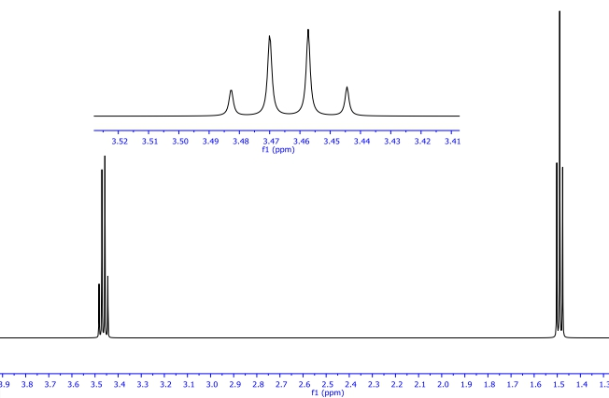‘n+1’ rule: a peak is split into n+1 lines, where n is the number of neighbouring (but not identical) protons.

1. chloroethane

A B

Peak A: split into 4 (quartet as it has 2 neighbouring protons.

Peak B: split into 3 (triplet) as it has 3 neighbouring protons

2. ethane

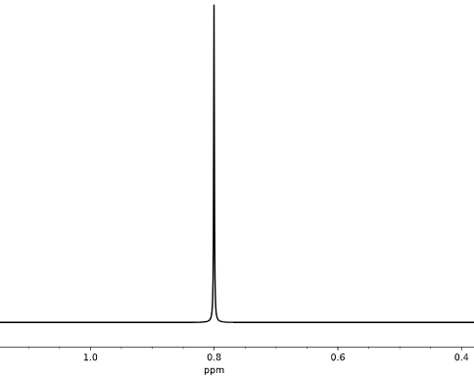

Ethane has no splitting as all protons are identical.

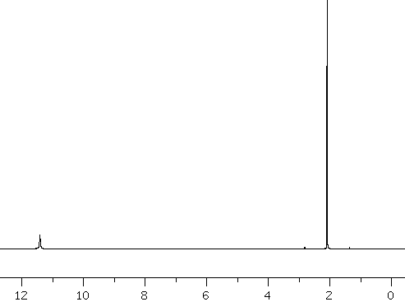

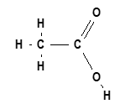3. ethanoic acid

Ethanoic acid has two environments, or 2 peaks. There is no splitting as the second proton is not considered ‘adjacent’. If it is separated by an oxygen atom from the adjacent carbon.

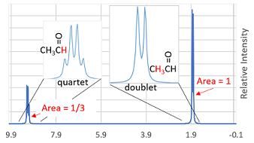

4. ethanal

A B

Ethanal has two peaks.

Peak A is split into a doublet due to the single neighbour.

Peak B is split into a quartet as there are 3 neighbouring protons. The oxygen does not shield the hydrogen this time as it is not between the carbon and the hydrogen.

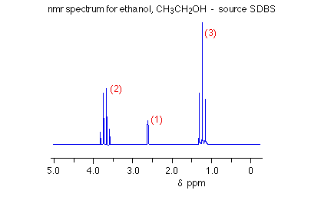5. ethanol



1 2 3

3 hydrogen environments – note no splitting here due to oxygen

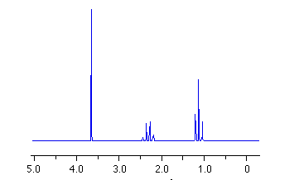6. butanone



A B C

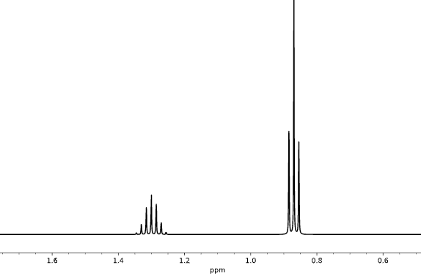Butanone has 3 peaks. Peak A is split into a triplet, B into a quartet and C is a singlet – it is separated by the CO from Peak B.

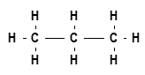7. propane

A B C

Peaks A and C are the one peak as they are

equivalent. They have 2 neighbouring protons

in the middle so they form a triplet. The middle 2 protons have 6 neighbouring protons so they form a septet.

++++++++++++++++++++++++++++++++++++++++++++++++++++++++++++++++++++++++++++++++++++++++

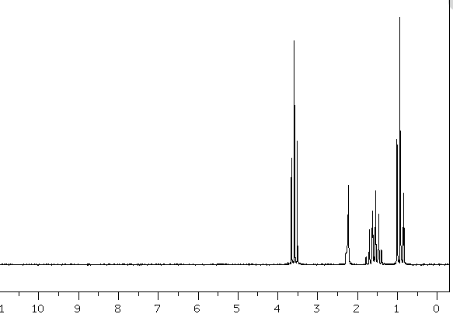**The next few examples have a step up in complexity – they are uni standard examples and will not be asked on a yr 12 paper – they are here to complete the discussion. They refer to example where there are 3 C’s in a row and the two end groups are different**

8. propan-1-ol



A

Consider the middle carbon – the groups either side are

different. You cannot add the protons circled then add 1.

This peak will not be a sextet – there is a multiplying effect making the splitting more complex.

9 ethene.

The middle proton peak will not be a sextet for the same reason

– the groups either side are not identical.

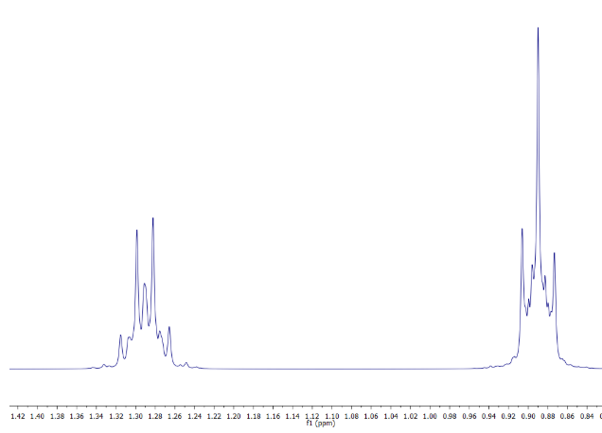

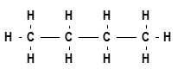10 butane

The 4 protons circled are equivalent but

the number of splits will not be 7 as there

are multiplicity effects – too hard!