(Note for teachers: In 2020, the investigation is not required to be a poster, hence this two stage outline below. I also checked the following with Maria James
- the logbook can be part of the assessment
- the criteria in the study design are a guide – you are allowed to vary these criteria if it helps you design an appropriate task.
- the important aspects of this task are that it makes students think about experimental design.

The 2020 modification is beautifully suited to a 2-part experiment on just about any topic, where part A is on the design used and part B is using that design to answer a question)

Question
Can I obtain viable estimates of heats of combustion of foods in a school laboratory?

Experimental set-up for food calorimetry
The energy content of a food can be determined by burning it under a container of water and measuring the temperature change.
You could hold your food in tongs and burn it under a beaker of water. The internet however will show you a range of possible set-ups. The efficiency of each design will vary.

Part A: Design of your testing
The class will have a packet of Savoy crackers for experimentation.
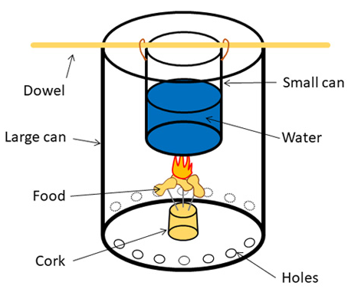

Your brief is to test and refine a design that will allow you to determine the energy content of a food item.
You should detail your original design, the data obtained and the modifications you make to improve the efficiency of your design.

Part B: Investigate the energy content of a food item to answer a question.
In Part A, you investigated the design of a calorimeter. In part B you will use this design to investigate a food energy question.
Examples of questions
Is the energy content of all dry biscuits the same?
In a packet of Arnott’s cream biscuits, what is the ranking of energy content?
Do most forms of nut have the same energy content?

Logbook
Your logbook must be used as a record of your experimentation. All test data needs to be recorded as well as design modifications.

Assessment
Assessment of this task will include the following
- A satisfactory record of experimentation in your logbook. All data needs to be presented in appropriate scientific format. Energy calculations should be in your logbook. 50% of marks

You have to plan how to represent your results scientifically and succinctly, using correct units, appropriate tables and sensible formatting. You logbook needs to be a record of the design you used and the modifications you made. You will be penalised if the logbook is not systematic and if it is verbose.

- A 1 hour period will be allocated for the class to answer under test conditions a series of questions related to the experimentation. (600 word aim) 50% of marks

Example of questions for this task.
Part A
1. Summarise the design aspects you tested and the results you found.

Part B
2. a. What was the question you posed in part B?
b. What conclusion can you now draw about that question?

3. Despite your modifications, your energy content values are likely to be well below documented values. Give
reasons why this might be.

4. Explain why different foods will have different energy contents?

5. Explain the impact of your food item absorbing moisture if left out the day before your testing.

6. A group is given a thermometer that reads 2 °C higher than it should all the time.
What type of error is this and what is its likely impact?

7. A group conducts their experiments with 90 mL of water in their container when they thought they were using 80
mL. What is the likely impact of this mistake?

8. A particular group wishes to ensure there are few heat losses from their apparatus, so they construct an
aluminium foil shield all around the combustion experiment. When they test this set-up out they find their results
are low and the bottom of their water container has a heavy layer of black powder. Explain what has happened.

+++++++++++++++++++++++++++++++++++++++++++++++++++++++++++++++++++++++++++++++++++++++++++++

The same approach of
- an initial experiment to investigate a design then
- the application of the design to test a question
could be applied to many other topics.

Examples
Reaction rates
Part A: How to determine the rate of a marble chip/acid reaction
Part B: Apply the design to a particular question on temperature or concentration or surface area.

Galvanic cell
Part A: Set-up of a particular cell
Part B: Apply the design to test a question such as impact of temperature or salt bridge concentration

Electrolysis
Part A: Set-up to measure mass changes
Part B: Apply design to investigate a question such as mass vs time or mole vs electrovalence

