Reaction Rate Experiment
(This sheet accompanies the video experiment)
Aim: To investigate the factors that affect the rate of a reaction.

Background
When bananas go brown in a fruit salad it is due to a chemical reaction. The rate of this reaction is fairly slow, but it can be changed. In this experiment we will consider factors that affect the rate of a chemical reaction.

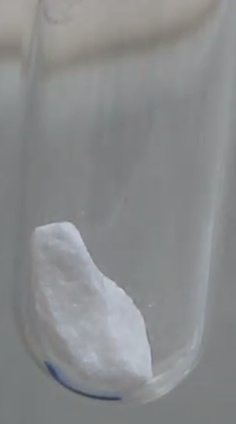
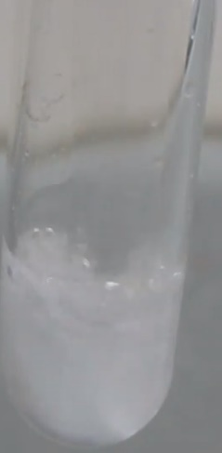
Part A: Reaction rate

The video will show you that when
HCl is added to a test-tube containing
a marble chip, a reaction occurs.

1. Write a balanced equation for the reaction occurring.
_______________________________________________________________________

2. How can you ‘observe’ the rate of this reaction?
_______________________________________________________________________

3. Suggest three ways you could modify this experiment to monitor the rate of this reaction.
_______________________________________________________________________

5. Why does this reaction stop?
_______________________________________________________________________

6. a. Why does the pH change during this reaction?

_______________________________________________________________________
b. What is the final pH in the test-tube likely to be?
________________________________________________________________________

Part B: Rate and Temperature
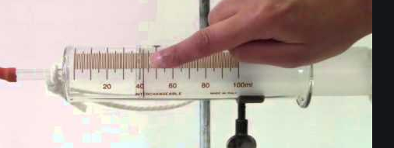
Aim: To investigate the impact of temperature upon the rate of the reaction.

A gas syringe is used to monitor the progress of the reaction.
Results
Volume of gas evolved at the three temperatures used.
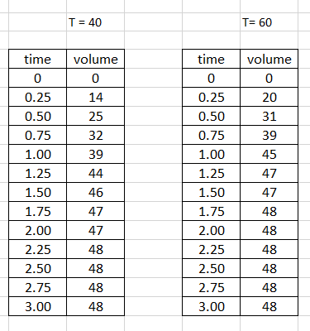
20 ⁰C 40 ⁰C 60 ⁰C
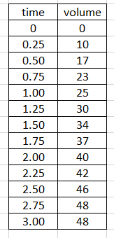

7. Explain how the progress of the reaction is being monitored?
________________________________________________________________________________
8. Draw a graph of your results. All three reactions can be plotted onto the one graph.

9. What conclusion can you draw from your graph?
_______________________________________________________________________
_______________________________________________________________________
_______________________________________________________________________
10. Explain why the rate varies with temperature.
_______________________________________________________________________
_______________________________________________________________________
_______________________________________________________________________
11. Explain why all graphs plateau out at the same volume.
_______________________________________________________________________
_______________________________________________________________________
_______________________________________________________________________
12. Give three examples from society where temperature is used to change a reaction rate.
_______________________________________________________________________
_______________________________________________________________________
_______________________________________________________________________

