Topic test 3: Unit 3 Redox and galvanic cells

SECTION A – Multiple-choice questions

Instructions for Section A
Answer all questions.
Choose the response that is correct or best answers the question.
A correct answer scores 1, an incorrect answer scores 0.
No mark will be given if more than one answer is completed for any question.
Marks will not be deducted for incorrect answers.

Question 1
The oxidation number of bromine in the bromate ion, BrO₃⁻, is
A. -1
B. +1
C. +5
D. +7

Use the following equation to answer Questions 2 and 3

2NaI(aq) + 3H₂SO₄(aq) 2NaHSO₄(aq) + 2H₂O(l) + I₂(l) + SO₂(g)

Question 2
In this equation
A. I₂ is reduced to I⁻ ions.
B. sulfur is reduced from +6 to +4.
C. sulfur is oxidised from +2 to +4.
D. I⁻ ions are reduced to I₂

Question 3
The half-equation occurring at the cathode is
A. 2I⁻ I₂ + 2e⁻
B. 3H₂SO₄ 2HSO₄⁻ + 2H₂O + SO₂ + 2e⁻
C. 2HSO₄⁻ + 2H₂O + SO₂ + 2e⁻ 3H₂SO₄
D. 3H₂SO₄ + 2e⁻ 2HSO₄⁻ + 2H₂O + SO₂

Question 4
Methane can be burnt in a coal-fired power station to generate electricity or it can be reacted in a fuel cell to generate electricity. When the two methods are compared, a fuel cell
A. is likely to produce electricity on a much larger scale.
B. will lead to each mole of methane releasing more energy than in a gas-fired power station.
C. will produce less carbon dioxide from each mole of methane reacting.
D. will produce more electrical energy from each mole of methane consumed.

Question 5
In the half-equation
NO₃⁻(aq) + 4H⁺(aq) + 3e⁻ NO(g) + 2H₂O(l)
the nitrogen atoms are
A. reduced from +4 to 0
B. reduced from +5 to +2
C. reduced from +7 to +2
D. oxidised from -3 to +2

Question 6
When a chlorine half cell is connected to an aluminium half-cell
A. no spontaneous reaction will occur.
B. chloride ions will be oxidised and aluminium ions reduced.
C. chloride ions are reduced and aluminium metal oxidised.
D. electrons will flow from the aluminium electrode to the chlorine half-cell.

Question 7
A student makes the following observations:

Gallium reacts spontaneously in CdSO₄ solution.
Gallium does not react in RbCl solution.

The order of oxidising strength, from weakest to strongest, is
A. Cd, Ga, Rb
B. Cd²⁺, Ga³⁺, Rb+
C. Rb⁺, Ga³⁺, Cd²⁺
D. Rb, Ga, Cd

Use the following equation to answer Questions 8 and 9
The diagram shows the structure of a zinc, silver oxide button battery.
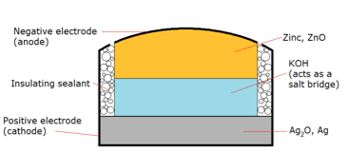

Question 8
In this cell,
A. zinc metal will be the reducing agent and silver oxide the oxidising agent.
B. zinc metal will be the oxidising agent and silver oxide the reducing agent.
C. zinc ions are oxidised and silver atoms reduced.
D. zinc ions are reduced and silver atoms oxidised.

Question 9
The overall equation is likely to be
A. Ag₂O(s) + Zn(s) + H₂O(l) Zn(OH)₂(s) + 2Ag(s)
B. 2AgOH(s) + Zn(s) + H₂O(l) Zn(OH)₂(s) + 2Ag(s)
C. ZnO(s) + 2Ag(s) Zn(OH)₂(s) + Ag₂O(s) + H₂O(l)
D. Ag₂O(s) + Zn(s) Zn(OH)₂(s) + 2Ag(s)

Question 10
If ethane is used in an acidic fuel cell, the anode reaction will be
A. 2C₂H₆(g) + 8H⁺(aq) 4CO₂(g) + 7H₂O(l) + 8e⁻
B. 2C₂H₆(g) + 8H₂O(l) 4CO₂(g) + 28H⁺(aq) + 28e⁻
C. 2H₂O(l) O₂(g) + 4H⁺(aq) + 4e⁻
D. O₂(g) + 4H⁺(aq) + 4e⁻ 2H₂O(l)

SECTION B- Short-answer questions

Instructions for Section B
Questions must be answered in the spaces provided in this book.
To obtain full marks for your responses you should
- Give simplified answers with an appropriate number of significant figures to all numerical questions; unsimplified answers will not be given full marks.
- Show all workings in your answers to numerical questions. No credit will be given for an incorrect answer unless it is accompanied by details of the working.
Make sure chemical equations are balanced and that the formulas for individual substances include an indication of state; for example, H₂(g); NaCl(s)

Question 1 (7 marks)
a. Determine the oxidation number of the underlined species below: 3 marks

i. C₂O₄²⁻ _____ ii. NH₄⁺ _______ iii. NO₂⁻ ______

b. Complete and balance the following half equations: 2 marks

i. O₂ O²⁻

ii. Sn²⁺ Sn⁴⁺

c. Complete and balance the following half-equations: 2 marks

i. SO₃²⁻(aq) SO₄²⁻(aq)

ii. IO₃⁻(aq) I₂(aq)

Question 2 (6 marks)
For each of the equations below,
- Write the relevant half-equations.
- Identify the oxidizing agent and the reducing agent

a. 2FeCl₂(aq) + Cl₂(g) 2FeCl₃(aq) 3 marks

_________________________________________________________________________

__________________________________________________________________________

__________________________________________________________________________

b. 3K(s) + Al(NO₃)₃(aq) Al(s) + 3KNO₃(aq) 3 marks

_________________________________________________________________________

__________________________________________________________________________

__________________________________________________________________________

Question 3 (8 marks)
A galvanic cell can be formed when a chlorine half cell is connected to a magnesium half-cell.
Use the template below to show-
- suitable solutions and electrodes for this cell
- the polarity of the electrodes
- the relevant half-equations
- the overall equation
- the direction of electron flow
- the theoretical cell voltage

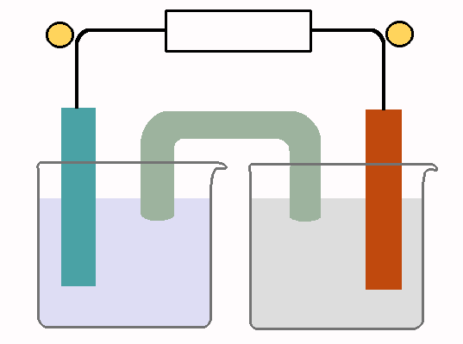

½ equations _______________ ___________________

Question 4 (6 marks)
One of the following reactions will occur spontaneously:

FeCl₃(aq) + Ni(s)

FeCl₂(aq) + Ni(s)

a. Which reaction occurs? ________________________ 1 mark

b. Write balanced half-equations and an overall equation for the reaction that occurs. 3 marks

_________________________________________________________________________

_________________________________________________________________________

__________________________________________________________________________

c. Identify the oxidizing agent in this reaction. _______________________ 1 mark

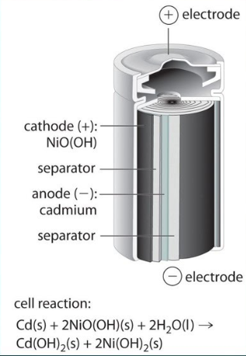
Question 5 (6 marks)
The diagram shown is of a nickel-cadmium rechargeable battery.
The overall equation of this cell is provided.

a. This is an example of a secondary cell. 2 marks

i. What is a secondary cell?

__________________________________________________

__________________________________________________

ii. Give one difference between a secondary cell
and a fuel cell.

_______________________________________________________________________________

b. Write the half-equations occurring in this cell. 2 marks

Anode: __________________________________________________________________

Cathode: _________________________________________________________________

c. i. Write a balanced equation for the overall reaction in this cell when it is being recharged.
2 marks
____________________________________________________________________________

ii. Which metal will be the positive electrode during recharging? __________________

Question 6 (7 marks)
A fuel cell that operates on methane is shown in the diagram. The cell operates in acidic conditions.
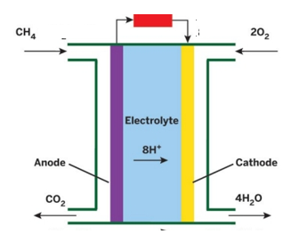

a. Use the headings below to write the half-equations and overall equation for the reactions occurring in this
cell. 3 marks

anode: __________________________________________________________________

cathode: ___________________________________________________________________

overall equation: ___________________________________________________________________

b. i. Use the two circles on the diagram to indicate the polarity of each electrode. 1 mark

ii. What is the oxidation number change of carbon during this reaction? 1 mark

__________________________________________________________________________________

c. Is this an example of the use of a renewable fuel? Discuss. 2 marks

_________________________________________________________________________________

_________________________________________________________________________________

__________________________________________________________________________________

