Investigation: Salinity
Hypothesis
Accurate salinity levels can be determined by electrical conductivity testing.
Aim: To use electrical conductivity to determine the salinity levels of water samples.

Introduction
Connect two graphite electrodes to a power supply.
Include an ammeter in the circuit.
Prepare a salt solution.
As a teacher demonstration, turn the power supply on and demonstrate to the class that the solution conducts. Move the electrodes around – as you do so the current fluctuates. This demonstrates that testing will need to be better controlled if useful results are to be obtained.
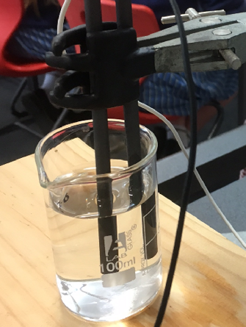

Ask students to select one variable to test. The students need to
- hypothesise as to the likely impact of that variable.
- design an experiment to test that variable.
Possible variables:
- separation distance of electrodes
- temperature of solution
- depth of electrodes
- concentration range
- AC vs DC current **you might need to purchase AC ammeter)
- size of beaker

Students will conduct an experiment to test their hypothesis.
They should find that
- the current does vary slightly with temperature
- the depth of the electrode in the solution matters
- the electrode separation matters
- AC current with AC ammeter gives better results.
- The same beaker type and size should be used each time.
Putting this together.
Prepare a set of solutions from 50 to 250 mg L⁻¹.
Test these with apparatus like shown below
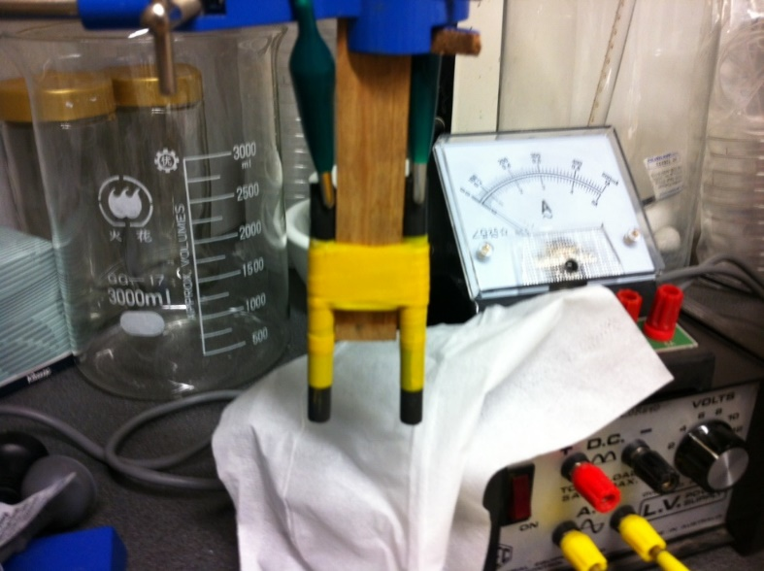
Maintain all solutions at the same temperature. Fix the electrodes in a retort stand with a piece of wood between them to maintain the separation. Tape the top of the electrodes to maintain surface area. Use AC current.
Test these solutions and some solutions of unknown concentration.
Use the data from the standards to prepare a calibration curve.
Plot the unknown solutions on the calibration curve.

