Aboriginal and Torres Strait Island Chemistry

The World’s first scientists.

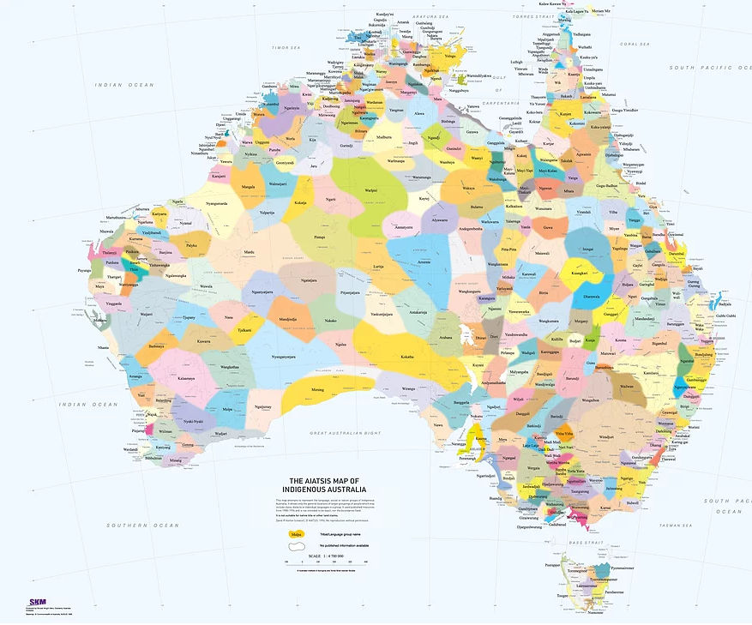

Archaelogical evidence from digs such as Cuddie Springs in Western NSW show clear evidence that Indigenous Australians were regularly grinding the seeds from native grasses to make flour, then bread, over 30000 years ago, thousands of years before flour milling is recorded any where else on the planet.
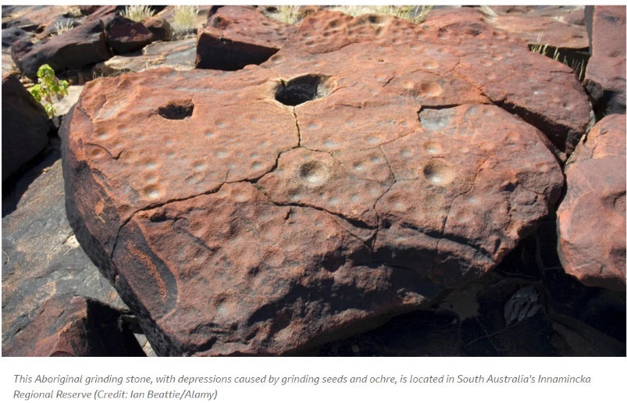
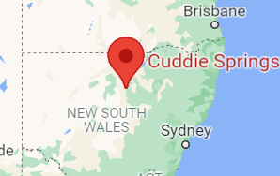
Cuddie Springs Grinding Stone cut and moved to the grass site.

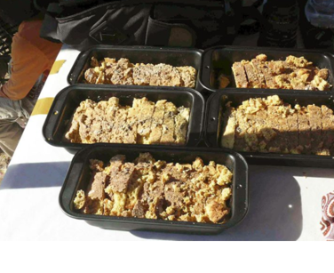
The seeds from various native grasses and acacia trees are nutritional but cannot be digested while whole. They need to be milled to break open the shell, forming a form of flour.
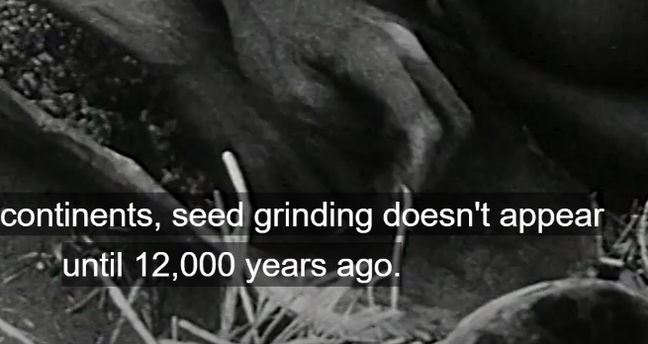
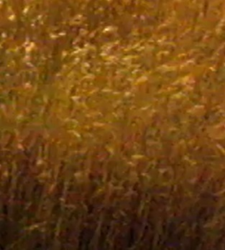

Native grass Seed grinding Lake Mungo bread
https://www.abc.net.au/education/aboriginal-ingenuity-ch-4-worlds-first-bakers/13500210

Many native seeds are small and hard, grinding is a slow and arduous task, as is the collecting of the seeds. There is ample evidence that the Aboriginal peoples cultivated, planted, stored and traded seeds and various vegetables. The grinding stones used were often sourced a long way from the grass crops and were considered important tools.
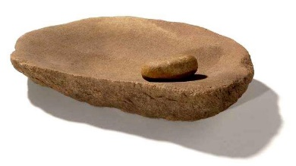
Flour milling is just one example of the long existent science understanding of Aboriginal and Torres Strait Islander peoples. Weapons, paints, medicines, fibres, aquaculture and glues are other examples.
The bread was a bush bread, like a form of damper. The seeds
from a wide variety of plants were used.

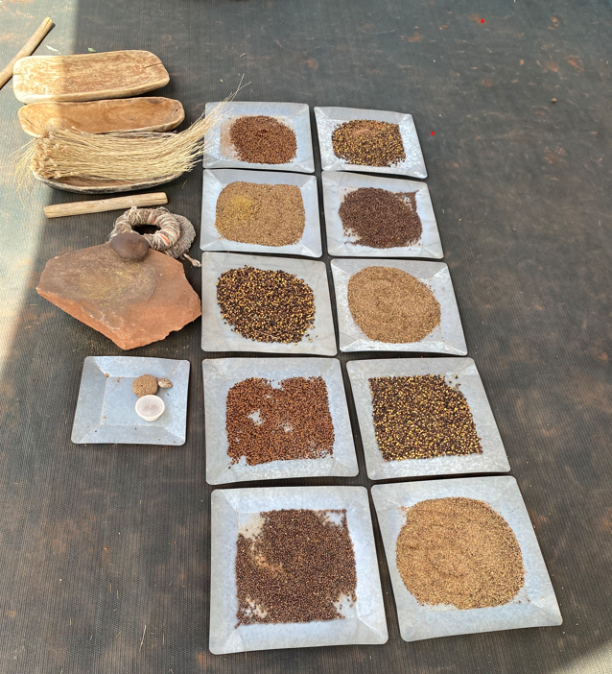

Photo: A range of seeds from native grasses are pictured above, with a grinding stone.
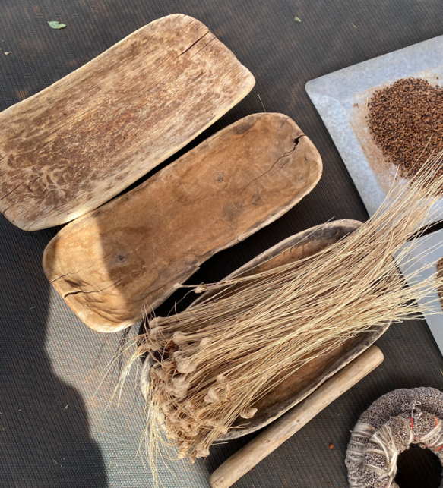
Photo: courtesy Karrke

The photo also shows a tuft of native grass.
Each person has their own grinding stone,
and the seeds are rarely mixed. The seeds are very hard.

Resources
Without the equivalent of BHP, Orica, Pfizer and other chemical manufacturers, First Peoples turned to the natural resources around them, the plants, animals and rocks. Given how many thousands of years they have been in Australia, the accumulated knowledge of these resources is extraordinary.
An example of each category of resource that indigenous Australians used is given below. Each example shows that over thousands of years First Peoples built up a ‘library’ of uses for all parts of the natural tools in their environment.
Plants
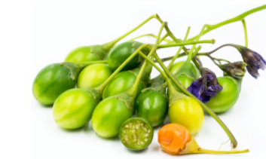
There is an estimated 395000 species of vascular plants on this planet. Of those, there are over 50000 flowering plants that have been used for medicine somewhere in the world. Many plants are food sources and others are sources of shelter or fibres.

Example: kangaroo apple: solanum laciniatum
The small berries on the kangaroo apple are toxic before ripening
but they are a valuable food source once ripe. They can be eaten raw
or cooked. They are a source of vitamin C and beta-carotene. Kangaroo
apples also contain phenol antioxidants. They are now cultivated
overseas where the steroids they contain are used in
the manufacture of cortisone and contraceptives.
Indigenous Australians used kangaroo apples in poultices to reduce inflammation.

Animal: Witchetty grub
Witchetty grubs are an ideal survival food, being rich in protein (15%) and fat (20%). They are a source of vitamin B1 and minerals such as potassium, magnesium and zinc.
A paste was made from witchetty grub to treat burns and scalds.
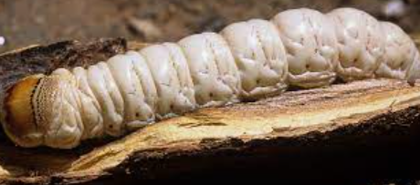

Rock: Basalt
The hard basalt deposits across Australia provided
an ideal source of sharp cutting tools and axe heads.
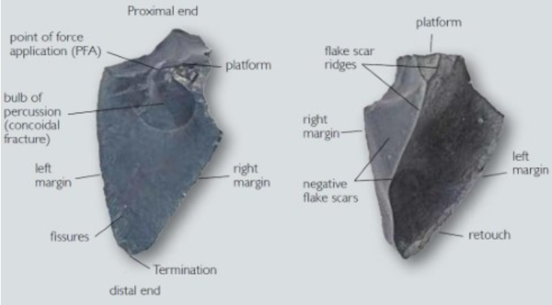

Extracting and analysing active ingredients
To identify the active ingredients, they need to be extracted and separated from each other. This is a fairly standard process of extracting the liquids, separating them and then trying to identify each one.

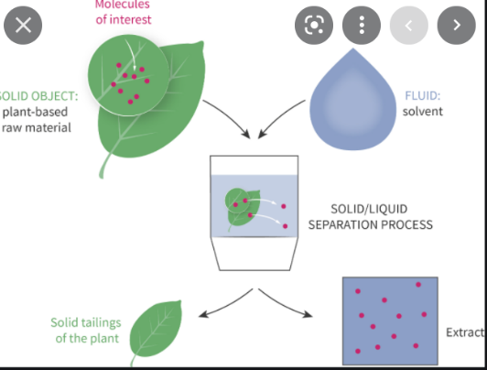
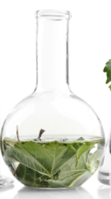
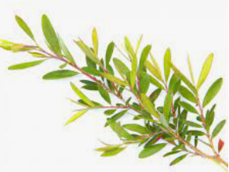
Leaves added to a solvent.

Active ingredients now mixed together in solvent
Tea-tree leaves. The active ingredients need to be ‘extracted’ from the solid leaves.

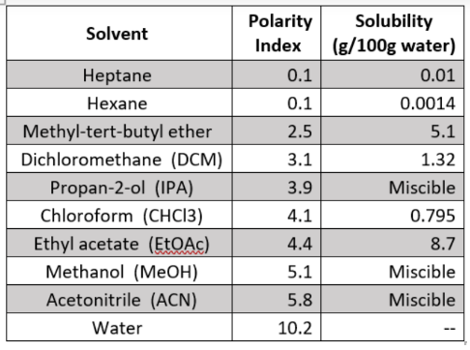
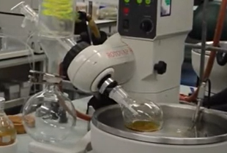
Extraction concentrated.

Solvent choice: solvent polarity should match polarity of active ingredient. Heptane and hexane are considered the least polar of all practical solvents.

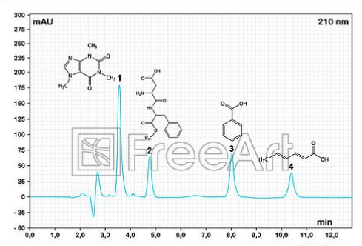
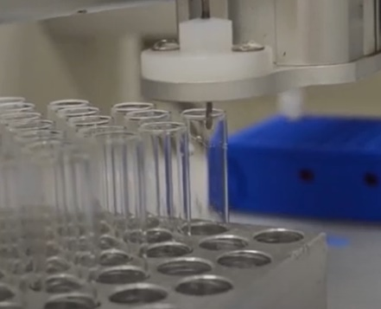
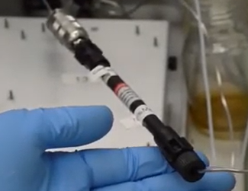

Each component of the mixture produces a peak. The retention time of the peak can help identify the component.
Each component goes into a different tube as it emerges from the column.
HPLC column. The components from the plant will separate in this column as they travel at different speeds.

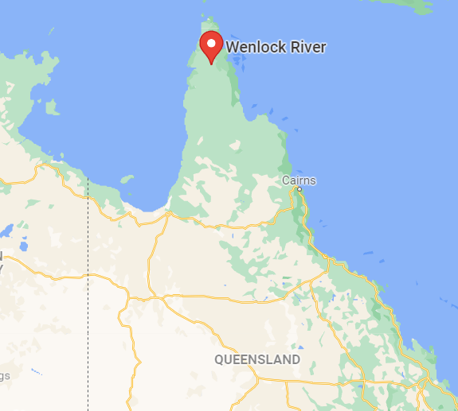
Uncha leaves: anti-inflammatory

The homelands of the Kuuku l’yu peoples lie in Australia’s
far north in the Cape York peninsula. This region is also
home to the uncha plant (Dodonaea polyandra). The Kuuku l’yu
people have long known that a toothache can be soothed by
applying the leaf and stem of this plant on the gums.

In a unique partnership a research team from the University
of South Australia, led by Dr Susan Semple, has been partnering
with the Chuulangun Aboriginal Corporation and the Traditional
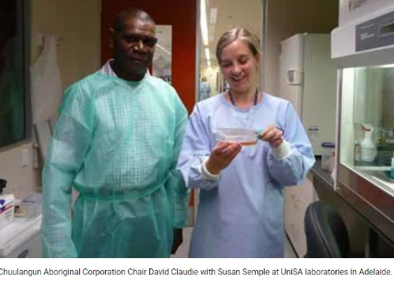
Custodians of the region to investigate the efficacy of the active agents of the uncha plant. University-based researchers learnt from Kuuku I’yu Traditional Custodians about the way the plant was used to relieve pain and inflammation in the mouth, as well as how and where to harvest the plant material. The University team investigated the chemistry of the plant to identify the active ingredients.

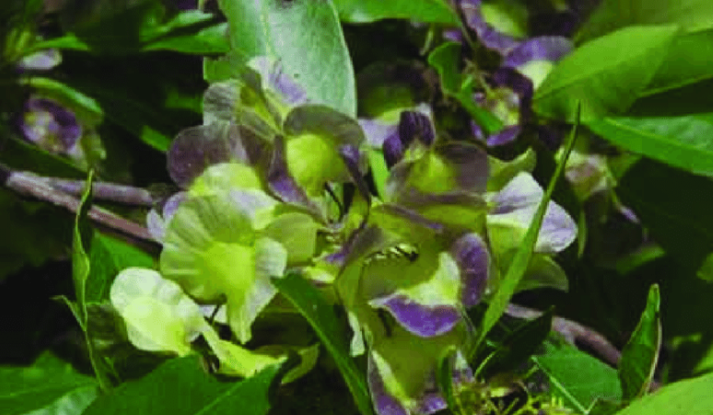

Uncha: Dodonaea polyandra David Claudie and Dr Susan Semple

The investigation over several years has involved extracting the active ingredients, using a polar ethanol/water blend as a solvent. Using various forms of chromatography, the University team has been able to isolate two types of active ingredients:

1. Clerodanes: Four clerodanes have been isolated from the plant, two of these clearly having
anti-inflammatory activity. The structure of each diterpenoid is complex and required a full
array of infrared spectroscopy, mass spectroscopy and NMR to determine the functional groups
present and their arrangement. The structure of the most common one is shown below and it
was given the name polyandric acid A. Terpenoids are common in plants but they are rarely
found to be anti-inflammatories, so the isolation of this molecule has significant medical
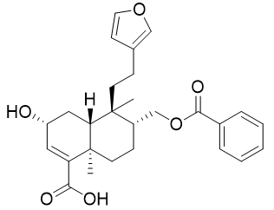
potential.

Experiments with mice have shown the
effectiveness of polyandric acid A on reducing
inflammation in the ear of the mouse.
Researchers have trialled administering the acid
as an emulsive cream. The cream has been shown to
be effective on psoriasis and dermatitis.

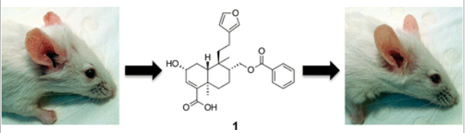
The quoted results of the emulsion tests are copied below:

Results: The prototype resin cream was a chartreuse-coloured homogenous semisolid preparation that was readily spreadable upon contact with skin with no sensation of tackiness, residual greasiness, or irritation. The optimized cream showed no phase separation after 30 min centrifugation at 825 g. In the TPA-induced inflammation model, the resin formulation significantly reduced ear thickness and interleukin-1 beta levels in mouse ear tissue. The 5% w/w resin cream formulation showed no irritancy in a 3D human skin model.

2. Several flavonoids including a kaempferol derivative (pictured) which had previously been
isolated from some other plant species and shown to have anti-inflammatory effects.
Kaempferol is a natural flavour found in a wide variety of plants and vegetables such as tea, kale, spinach and beans. It is a yellow, crystalline solid with a melting point around 280 C. It can be extracted from plants with hot ethanol. Its flavour is bitter.

For a skin lotion, the researchers have not chosen to separate the active ingredients. It has been found that the efficacy of the cream is more effective if all active ingredients from the plant are retained. This makes the prospect of producing a commercial product far more viable.

Cycads
The nuts of the cycad tree (sago palm) shown below are a rich source of carbohydrates. They are also quite toxic. Latrobe University researchers have been investigating how Indigenous peoples from the Atherton Tablelands have been able to safely consume these nuts whereas they have made other people violently ill.
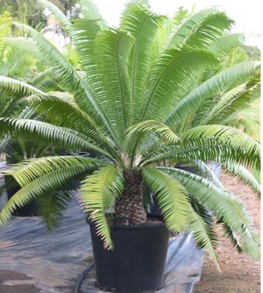
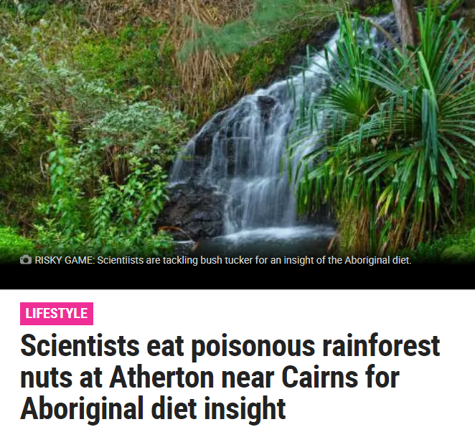

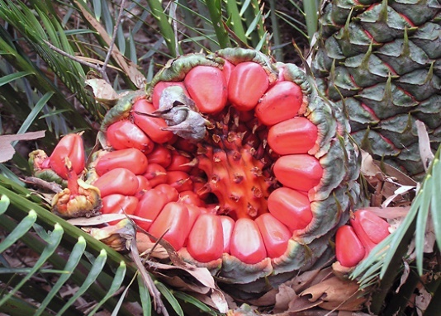
Above: cycad tree. Below: cycad nut

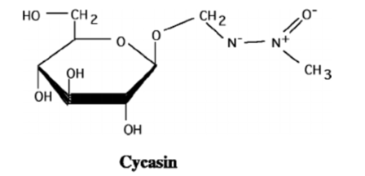

Cycad nuts contain a poison, cycasin, the structure of which is shown below. It is easy to see how plants can synthesise this molecule as the left side of the structure is a glucose molecule. It is thought that cycasin is a plant defence against herbivores, the unpleasant taste deterring animals from wanting to consume the nuts. The cycasin is spread throughout the plant but the highest concentrations are in the seeds. The tree also contains several other toxic substances.
Early symptoms of cycasin poisoning are vomiting, nausea, abdominal pain and diarrhea. Cattle eating the raw nuts develop a neurological syndrome known as zamia staggers. This leads to a gradual deterioration of muscle and balance control. The disease is fatal.
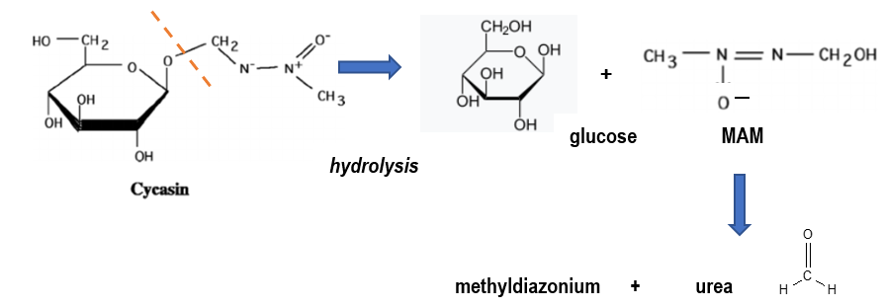It is not the cycasin itself that causes the problems, it is the products of its hydrolysis in the stomach. The initial reaction forms glucose and methylazoxymethanol (MAM) and it is the MAM and its reactions that produce toxins. It decomposes readily to methyldiazonium and formaldehye. Formaldehyde is carcinogenic and the methyldiazonium causes many unwanted reactions.
formaldehyde
So, how is it that Aboriginal peoples from North Queensland were able to consume these nuts? They hydrolysed the cycasin before consuming it. They ground the nuts to a powder that was placed in a dilly bag and the dillybag left soaking in the creek. The grinding increased the surface area of the starch powder, increasing the rate of hydrolysis. The arm temperatures of North Queensland water supplies also increased the reaction rate. Most of the toxic products are soluble whereas starch is only slightly soluble so the toxins were leached from the starch.
Bayoo fruit: Macrozamia
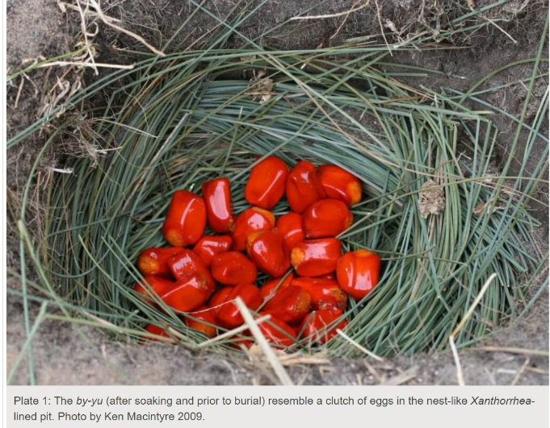
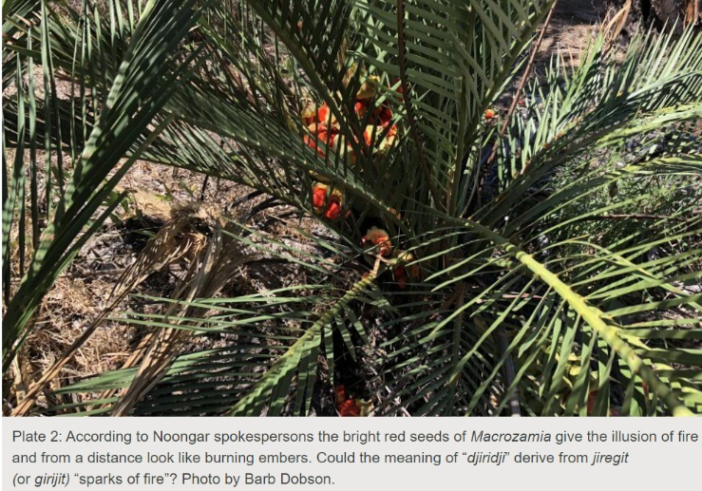
While in Eastern Australia indigenous peoples were eating the nuts of the cycad palm, in the South Western corner of the country the Noongar people were eating the fatty flesh (known as the sarcotesta) from around the seed of a similar nut from the Macrozamia tree. The name for this fleshy, oily coating was bayou (several local variations to the spelling and pronunciations.)

Early white settlers gave mixed feedback as to the after-effects of this food, as the passages below show!
https://anthropologyfromtheshed.com/project/the-ancient-practice-of-macrozamia-pit-processing-in-southwestern-australia/
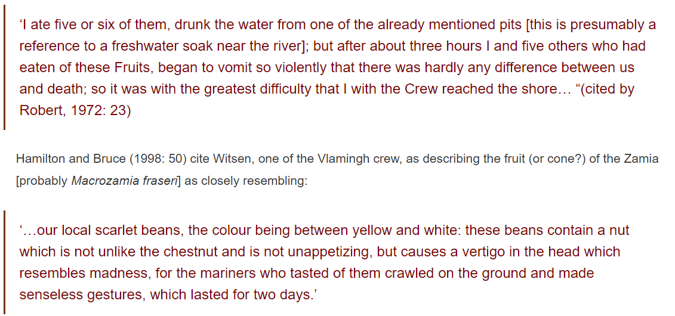
There is still conjecture as to whether it was the toxins from the seed, rather than the bayoo that caused the illness, or whether it was just a reaction to large quantities of the very oily flesh. This flesh contained high levels of fat-soluble vitamins such as Vitamin A and D. The Noongar people probably had developed specialised stomach adaptations in their gut biomes to help them digest such foods.

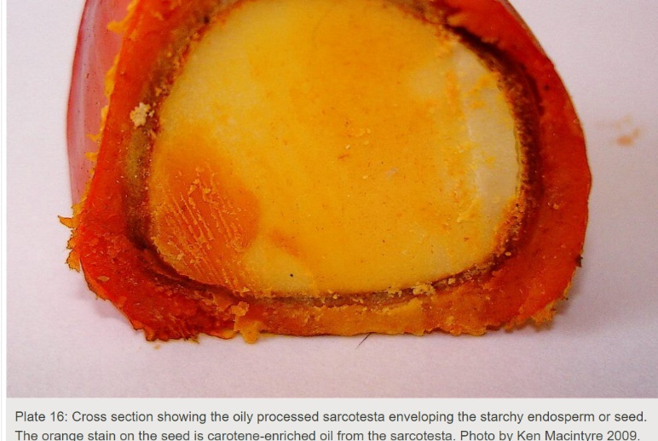

Archaeological evidence shows the Noongar people evolved a form of anaerobic fermentation as long as 13000 years ago, some of the earliest recorded examples of food fermentation – the process is described below
The native women collect the nuts from the palms [Macrozamia] in the month of March, and having placed them in some shallow pool of water, they leave them to soak for several days. When they have ascertained that the by-yu has been immersed in water for a sufficient time, they dig, in a dry sandy place, holes which they call mor-dak; these holes are about the depth that a person’s arms can reach, and one foot in diameter; they line them with rushes, and fill them up with the nuts, over which they sprinkle a little sand, and then cover the holes nicely over with the tops of the grass-tree; in about a fortnight the pulp which encases the nut becomes quite dry, and it is then fit to eat, but if eaten before that it produces the effects already described. The natives eat this pulp both raw [that is, processed but not roasted] and roasted; in the latter state they taste quite as well as a chestnut.’ (Grey 1841, Vol 2: 296)

Indigenous fishing poisons
There are many recorded examples of Australian and Torres Strait Island peoples using chemicals from plants to poison fish. Two quite different examples are provided below:
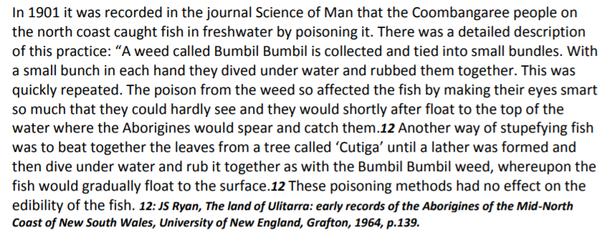
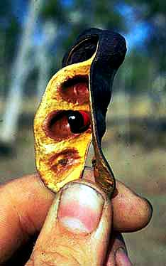
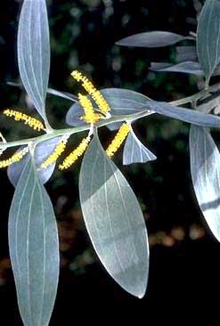
Poison sources
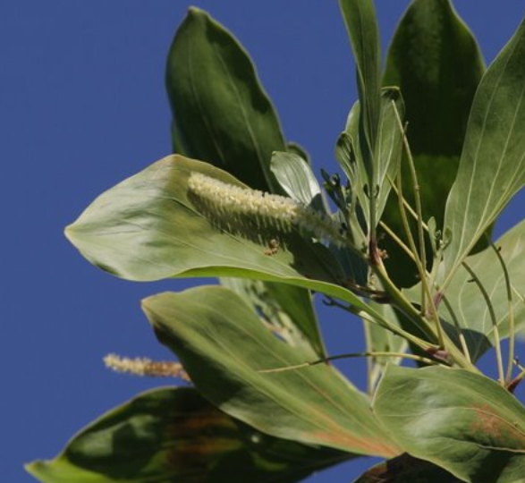
Velvet wattle Fish Poison Wattle Fish Poison Tree seedpod
(Acacia holosericea) (Acacia ditricha)
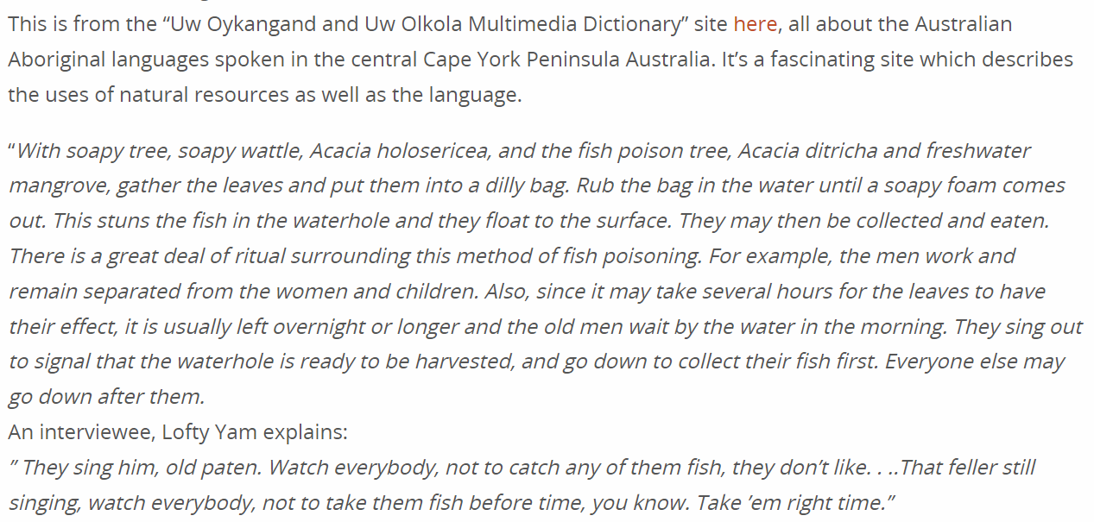

There are two mechanisms for this successful fishing practice.
1. Saponins (soaps). Plants that have an ability to make a soapy lather when crushed. They contain natural detergents that destroy the cells in gill membranes. Fish are very sensitive to soaps and detergents, these plants are just a good source of natural soaps. Saponins act on the respiratory organs of the fish without affecting their edibility. Saponins normally break down in the digestive system and must enter the bloodstream to be toxic, but fish take in saponins directly into their bloodstream through their gills. The toxin acts on the respiratory organs of the fish without affecting their edibility. Saponins also cause the breakdown of red blood cells that help the toxin to spread quickly. Even though the effects of the poison are powerful, they are not usually fatal. Fish that are washed away into untainted water revive, and can return to their pre-toxic condition. Because of this, the fishermen would have to gather the stunned fish quickly as they floated to the surface.
Saponins have been used in modern times in the manufacture of fire extinguisher foam, toothpaste, shampoos, liquid soaps, and cosmetics and to increase the foaming of beer and soft drinks.
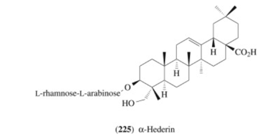
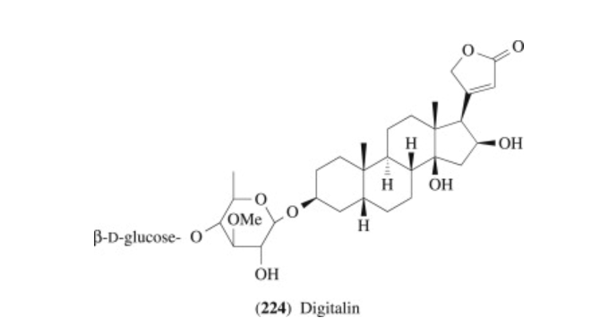

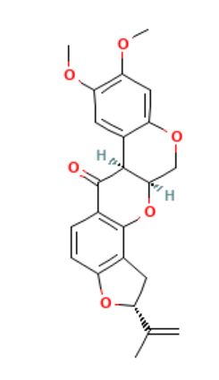
2. Rotenones. Fish are very sensitive to rotenones – they interfere with the ability of the fish to use oxygen. Rotenones are flavonoids and are only toxic to
cold-blooded creatures. Rotenones are used today in insecticides.

Fishing advice! Mash the appropriate part of the plant, sometimes
a seed and other times roots or leaves. Add to a water pool or slow
moving creek. Gathering of the stunned fish can be done by hand.

Trial and error over many centuries meant most poisons used were
non-toxic to humans, just fish.

file:///G:/My%20Drive/Indigenous/book/fish.pdf
https://www.youtube.com/watch?v=YnHteM5cMmY

Nardoo: Marsilea drummondii.
In 1860 Robert Burke, William Wills and John King were starving to death on their return from the Gulf of Carpentaria. While they starved, the local Yandruwandha people were thriving and gave the explorers cakes – made from the crushed seed pods of a clover-like fern called nardoo.
Nardoo plants shoot whenever significant rains come to the inland. Sixty species of the genus Marsilea occur worldwide, with eight found in Australia.
Burke eventually had a falling out with the locals and drove them away. They tried to make the same cakes as the locals but only got sicker and sicker and both Burke and Wills died about a month later.
On Wednesday, June 12, 1861 Wills wrote... "King out collecting nardoo. Mr Bourke and I at home, pounding and cleaning. I still feel myself, if anything, weaker in the legs, although the nardoo appears to be more thoroughly digested."
Another case of indigenous peoples knowing how to prepare a native food that was harmful to other people eating it without appropriate preparation. Had Burke and Wills roasted the nardoo, they would probably have survived.
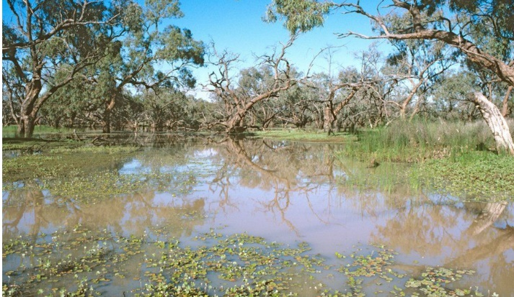
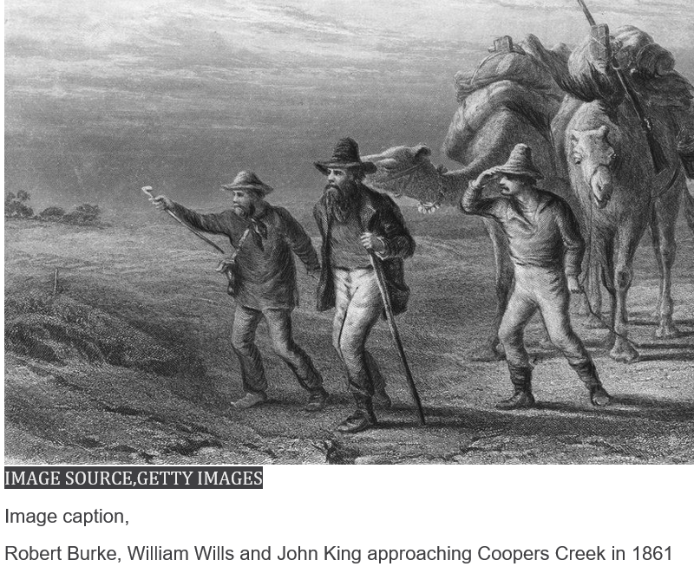 Nardoo – floating on the pond – type of fern
Nardoo contains a high concentration of an enzyme named thiaminase, which is toxic to the human body. Thiaminase breaks down the Vitamin B1 in the body. The body cannot break down carbohydrates without Vitamin B1, so Burke and Wills had carbohydrate in their body but their bodies could not process it. Thiamine is needed to produce ATP, a complex molecule that provides the energy required for cells to work. The Yandruwandha practice of roasting the seeds, then grinding the flour with water and ash was breaking down or leaching the thiaminase from the nardoo. This sequence of steps was a learned practice, not a stroke of luck.
Nardoo was an important food source for Aboriginal people and there is evidence that it was processed in large volumes with so-called ‘Nardoo Mills’.

Nardoo grows like a fern, its leaves unfurling as it grows. When it matures, it produces hard, nut-like objects up to 10 mm long, called sporocarp. The sporocarp contain spores in a starchy packing. The sporocarp can become trapped in dry mud and lie dormant for up to 30 years. When it rains, the starch soaks up water and the nut bursts, releasing the spores.
Japanese study of the African silkworm
Some of the chemistry behind the digestion of nardoo was provided by a team of Japanese scientists, studying another food that presented the same issue, the African silkworm. The silkworms are a potential source of valuable protein. The team studied the high levels of thiaminase in the silkworms that was making them a problem in the diet of some locals and not others. The researchers knew of the issue with nardoo, so they focused on heat treatment of the thiaminase.
The first graph below shows the impact of temperature on thiaminase activity. You can see that thiaminase is unusually heat resistant, having an optimum operating temperature significantly above that of most enzymes, explaining why roasting was so important.
The second graph shows two lines – the lower line shows how quickly thiamine levels drop at the optimum temperature. If, however, a thiamine ester substrate is added, the thiaminase is rendered inactive and the thiamine levels hardly drop at all (top line)
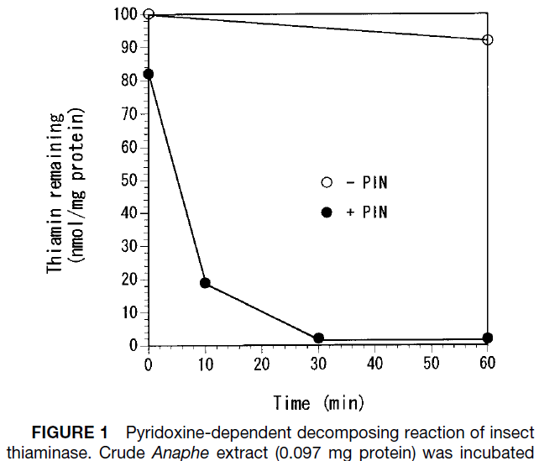
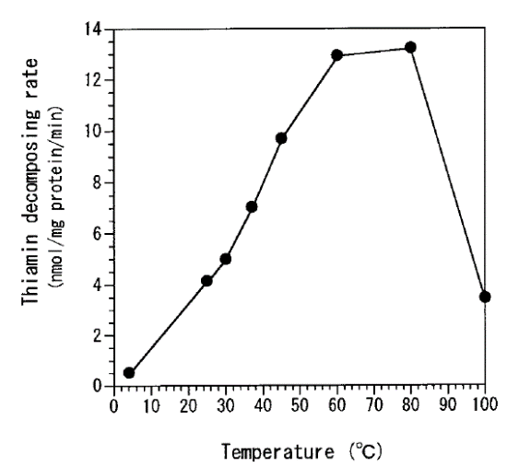

Conclusion: If you eat African silkworms, make sure they are cooked at high temperatures!
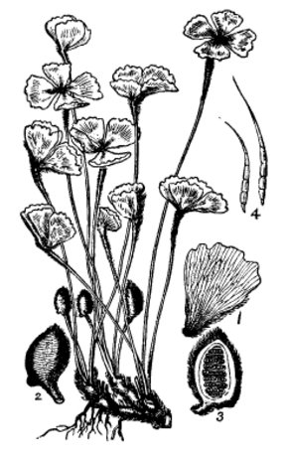
https://www.abc.net.au/science/articles/2007/03/08/2041341.htm
https://www.bbc.com/news/business-48859333

nardoo and sporocarps

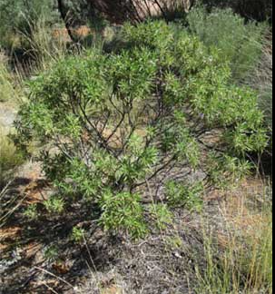
Rock fuchsia eremophila freelingii

Rock fuchsia has long been used around Central
Australia for its healing properties.
The smoke is used to relieve stress and the leaves
are ground into a paste that heals and relieves
skin complaints.

Rock fuchsia is one of several plants that is
collected and packaged for sale at the
Akeyulerre healing centre in Alice Springs (also
Referred to as Purple House).

The centre works on many levels, preparing medicines, providing a safe place for indigenous people to practice and enjoy cultural life and as a centre of learning for local communities.
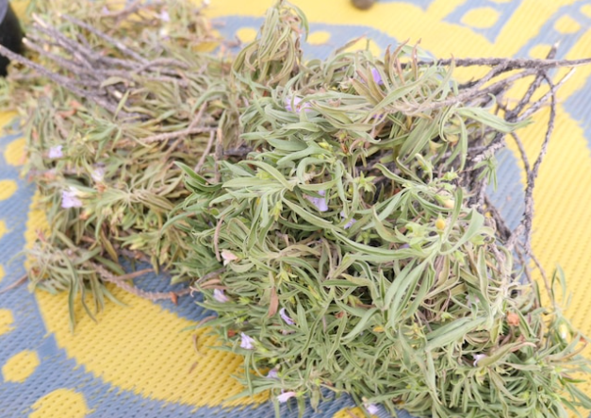
The Akeyulerre healing centre in Alice Springs was established by Arrernte elders as a place to practice and enjoy their cultural life on a daily basis.
Rock fuchsia collected for medicine.
Grinding
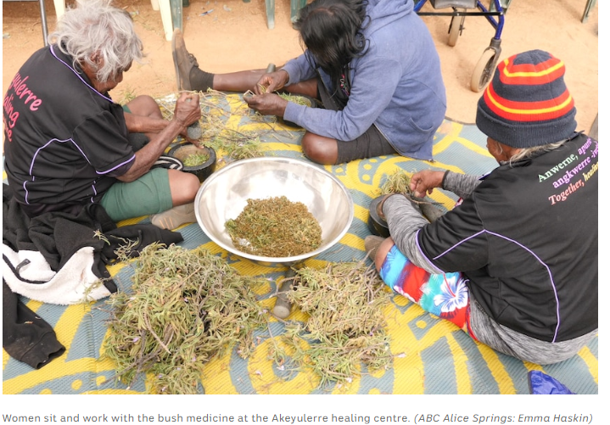

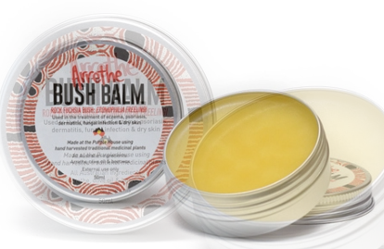
Commercial end result.

https://www.abc.net.au/news/2019-09-28/bush-medicine-keeping-womens-culture-alive-and-well/11545810
https://www.abc.net.au/news/2019-09-28/bush-medicine-keeping-womens-culture-alive-and-well/11545810?utm_campaign=abc_news_web&utm_content=link&utm_medium=content_shared&utm_source=abc_news_web
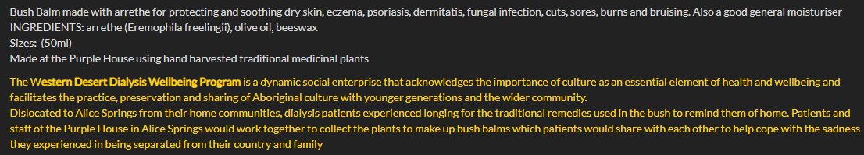
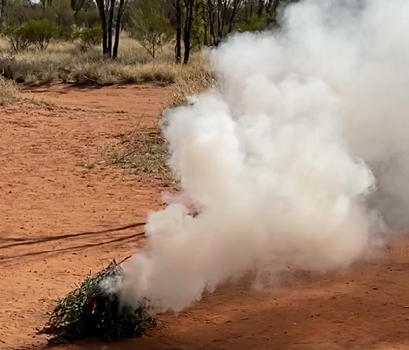

Rock fuchsia smoke used as a calming, soothing agent.

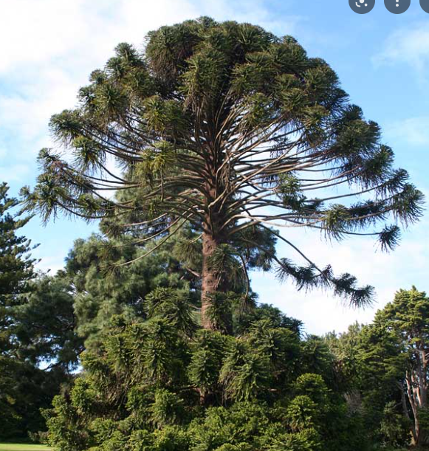
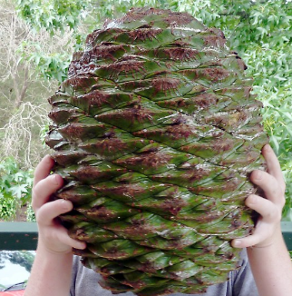
Bunya Pine araucaria bidwillii

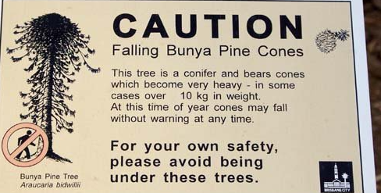

The sign on the right is common in Queensland near the distinctive bunya pines. The massive pine cones shown is going to do some damage if it lands on your head. The nuts from the tree however, have long been sought after as a food by Australia’s First Peoples.
The photo below shows the pine comb being dissaembled and the resultant nuts obtained.
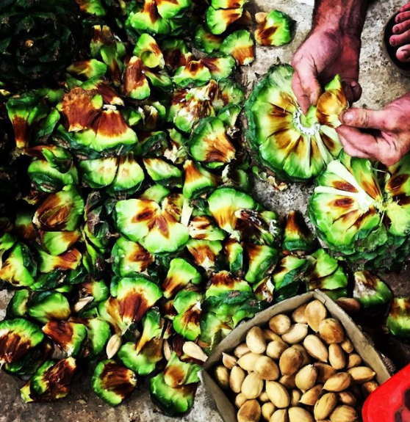
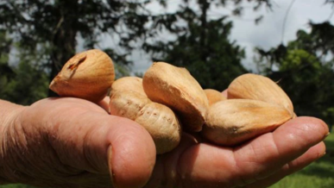

Bunya nuts are usually cooked or roasted like chestnuts. They have a high starch content and a low oil content. A paste made from bunya nuts is used as a preservative in other foods as it can kill some forms of bacteria.
Boiling bunya nuts made them softer and more moist while roasting made them drier. Flour, beer, cakes, bread, curries, snacks and stir fries are all potential uses. Frozen, they last at least two years.
https://youtu.be/G0f6XNMDb64
How football-sized bunya nuts could be the next big thing in bush food business - ABC News
Aboriginal rituals and dinosaur food: why bunya nuts matter | SBS Food
Alcohol
Throughout the course of human history, most societies found some method of fermenting sugars to form alcohol. Indigenous Australians were no exception in this area of expertise. There are several documented examples of First Peoples having developed a method of producing alcohol that reflected the available resources of their particular region:
1. Mangaitch, made from the flowering cone of Banksia trees in Western Australia. Local people filled a tea-tree bark container with Banksia cones and left it in a trench near a swamp. A sugar-rich solution would form that would ferment over the next fortnight.
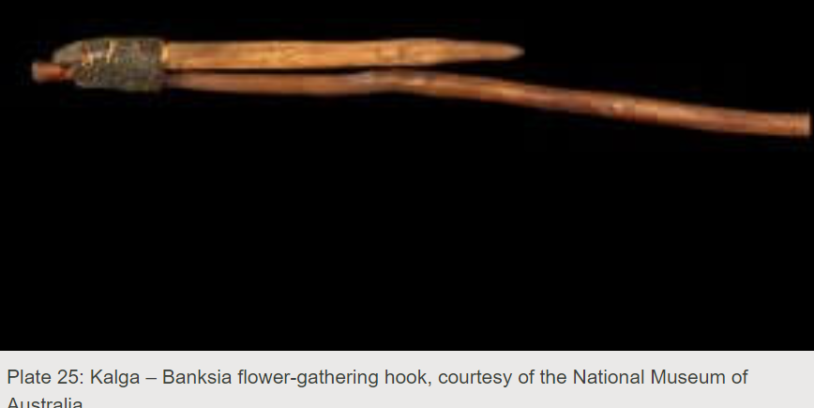
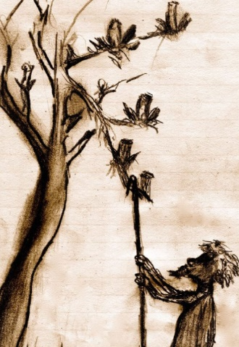
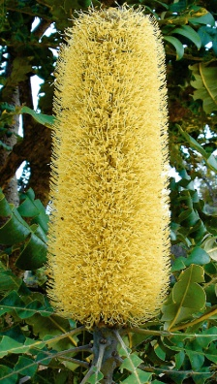

‘ripe’ banksia kalga – cone collecting tool
As the banksia cones flower, they develop a sweet nectar or crude honey. The high sugar content combined with natural yeasts led to this fermenting naturally. It was taboo to eat the cone before it ripened as the high phosphorous and nitrogen content led to stomach aches in the same way green apples might.
Some descriptions of early white settlers are provided below:
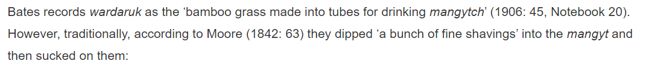
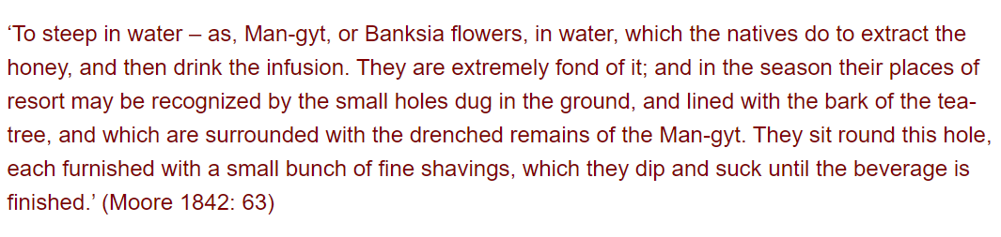
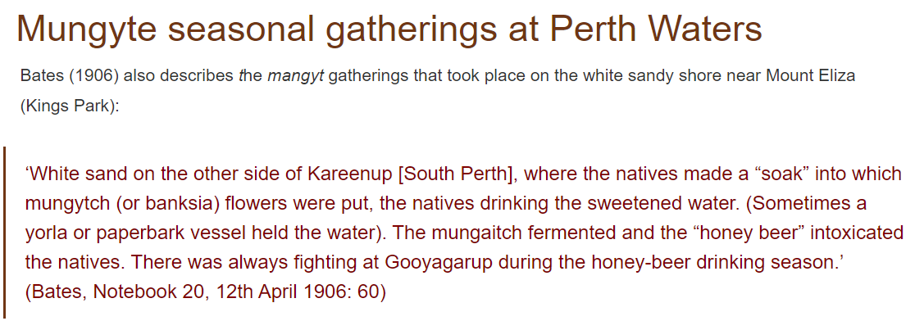
2. Kambuda, made from crushed nuts of the Pandanus tree in the Borroloola region of the Northern Territory. The ripe nuts from the tree were crushed, roasted then left to soak and ferment in water.
3. Tuba, made from coconut palm buds (shown below) by Torres Strait Islanders. Tuba was made from the syrup that seeps from a cut in unopened buds of the tree. Visiting sailors from Pacific countries had passed this practice on. Bamboo reeds were used to provide a crude distillation of tuba to make a far more potent liquor.
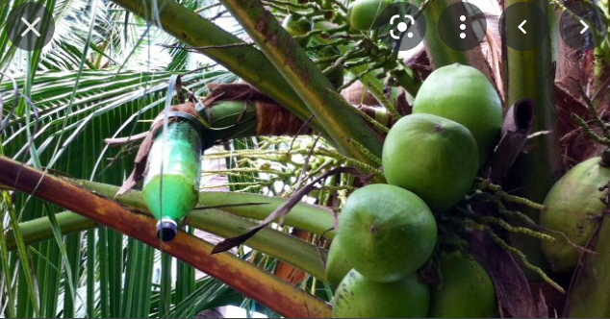
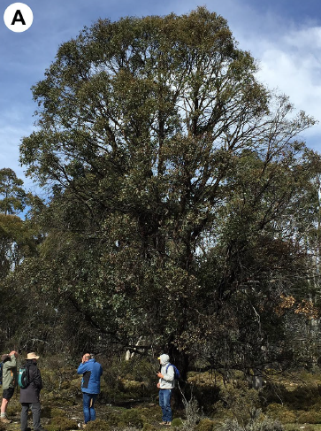
4. Way-a-linah made from eucalyptus tree sap from the Tasmanian cider gum (eucalyptus gunii) shown below. This fermentation process has been studied by scientists as the cold conditions of central Tasmania would limit the functioning of traditional yeast such as . Stone tools were used to bore a hole in the trunk of the tree to release the sap to accumulate in a container or in the base of the tree.
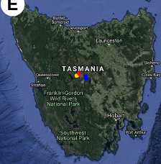

HPLC testing showed the sap contained a higher level of maltose than most sugars used in fermentation. The yeast organisms that triggered fermentation were not the common saccharomyces known to our wine industry, rather they were yeast and fungi organisms found in local soil, sap and bark. These organisms were able to function effectively at much lower temperatures than normal yeasts. In fact, the higher temperatures of recent years are threatening the survival of the trees themselves.
https://anthropologyfromtheshed.com/project/the-consumption-of-banksia-nectar-in-traditional-noongar-society/#
https://theconversation.com/alcohol-brewed-from-trees-and-other-fermented-drinks-in-australias-indigenous-history-96127
Kakadu Plums: Terminalia ferdinandiana: Also known as gubinge, billygoat plum, green plum, mador
Native plum from Northern Australia

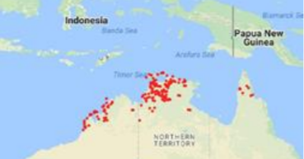
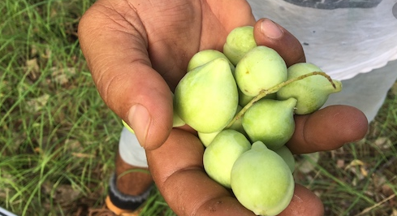

Kakadu plums have been an important form of bush tucker for First Peoples for a long time. They have also been known for their medicinal properties. Modern research is suggesting they are a superfood and there is emerging science to back this claim up. Nor is vitamin C the only point of discussion.

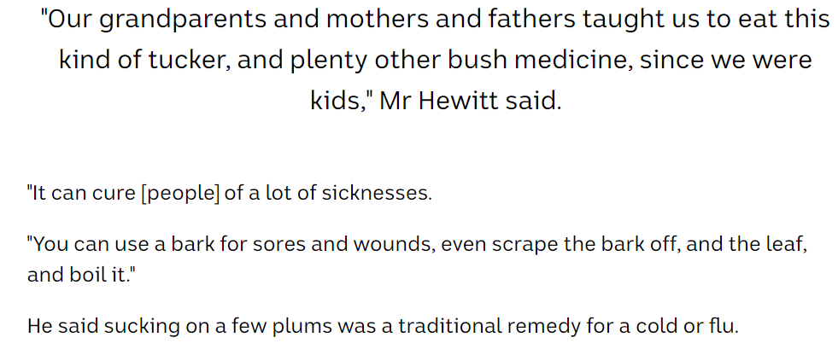
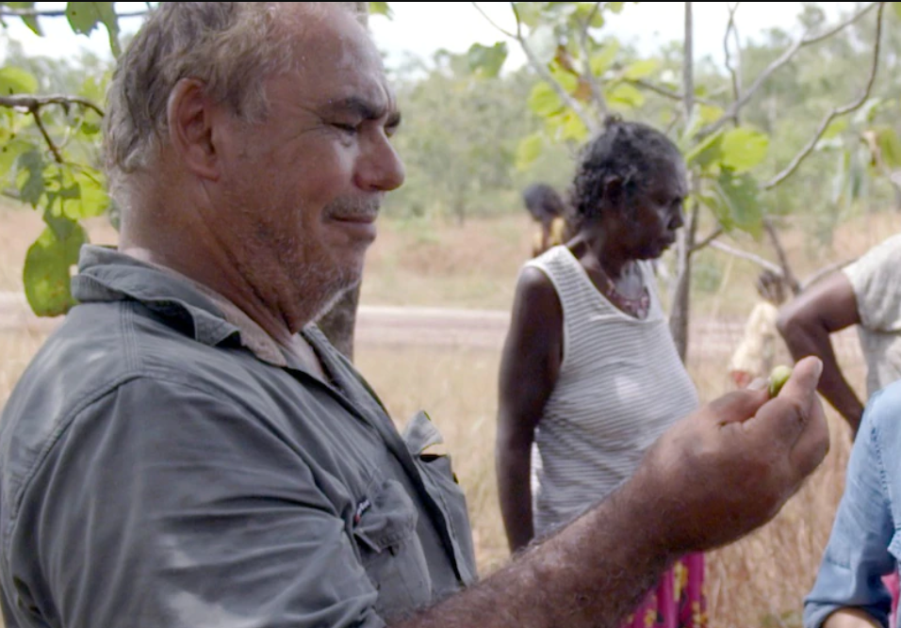

Vitamin C
Vitamin C levels are extraordinary – almost 100 times that of oranges, the graphs below speaking for themselves.

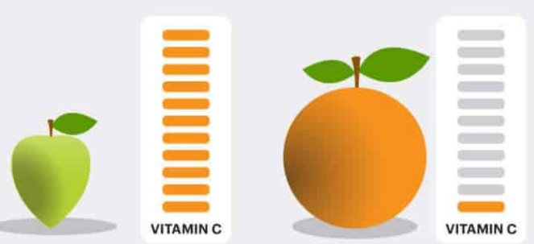
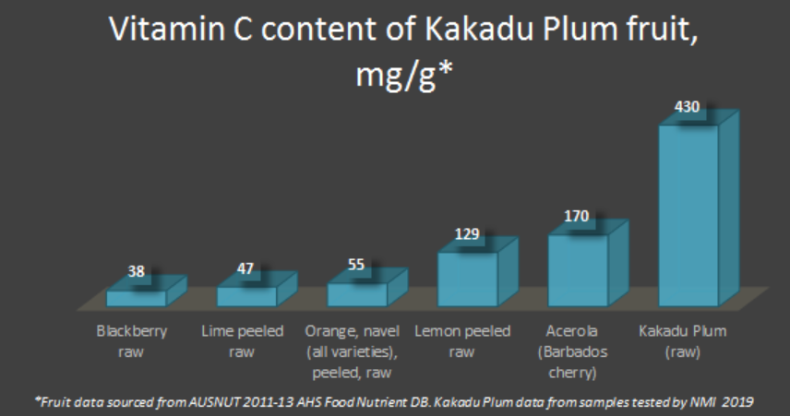

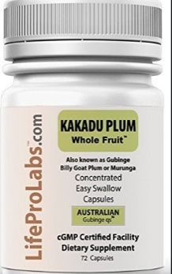
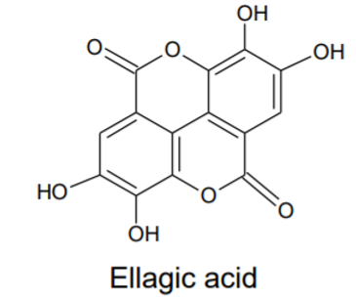
Other acids
The HPLC chromatograms below show that, like all plants, Kakadu
plums contain many other substances including other acids, ellagic
acid, gallic acid and oxalic acid in particular. While two of these are
most welcome the third, oxalic acid, is not.

Regular consumption of high oxalate foods poses a variety of health
risks to humans in the form of kidney stones and urinary issues.

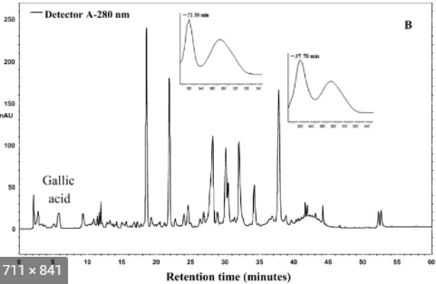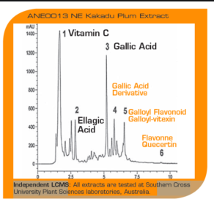

HPLC chromatograms for plum extract.

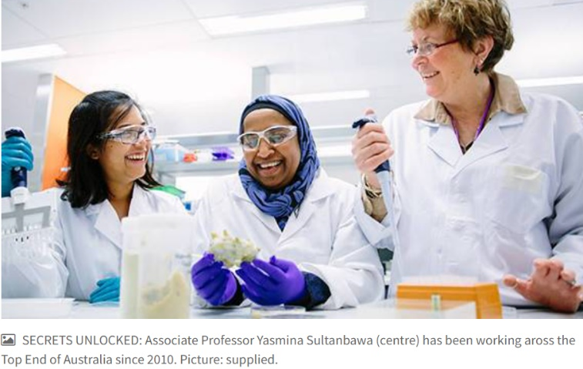
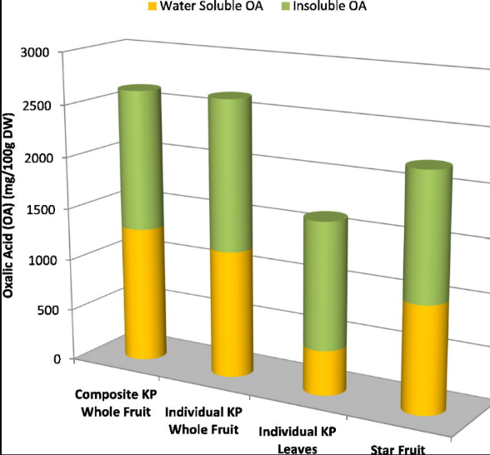

Oxalic acid levels

Gallic acid and ellagic acid on the other hand are powerful antioxidants and the level of both of these
is over 6 times greater in Kakadu plums than in the much spruiked blueberries. Both acids are examples
of phytochemicals, their antioxidant properties a result of the high number of hydroxyl groups on the structure.

An interesting niche use for Kakadu plum juice has been to extend the shelf life of prawns. The antioxidant properties of the juice have been shown to increase the cold storage of prawns from 14 days to 21 days.
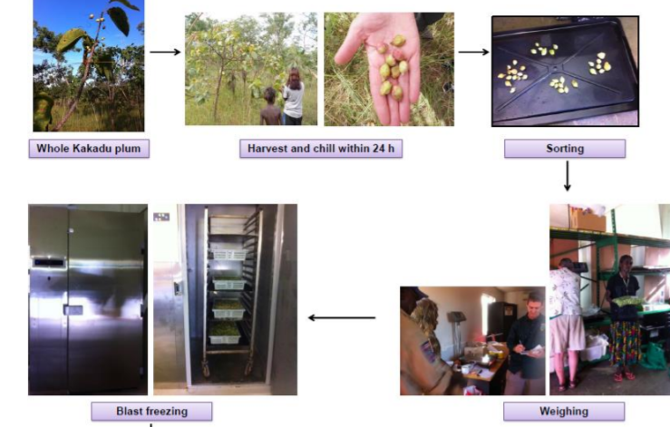

Kakadu Plum seeds
Once you suck the flesh from the plum it might be a good idea to also consider eating the seed. Research from the University of Queensland suggests the range of unsaturated fats, minerals and proteins in the seeds are also highly nutritional.

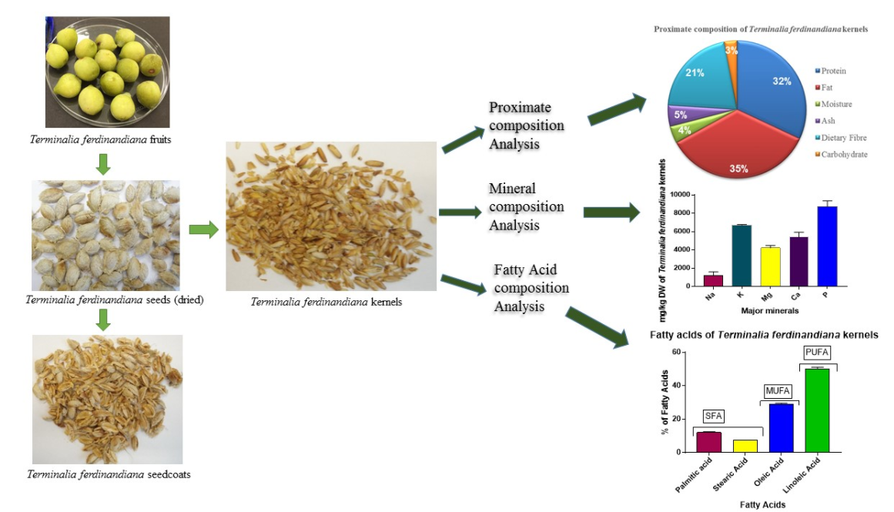
Analysing the seeds of the Kakadu plum
https://www.ncbi.nlm.nih.gov/pmc/articles/PMC5920425/
https://www.agrifutures.com.au/wp-content/uploads/2018/12/18-024.pdf
As the data below shows, Kakadu plums have a high level of unsaturated fats compared to mose equivalent foods.
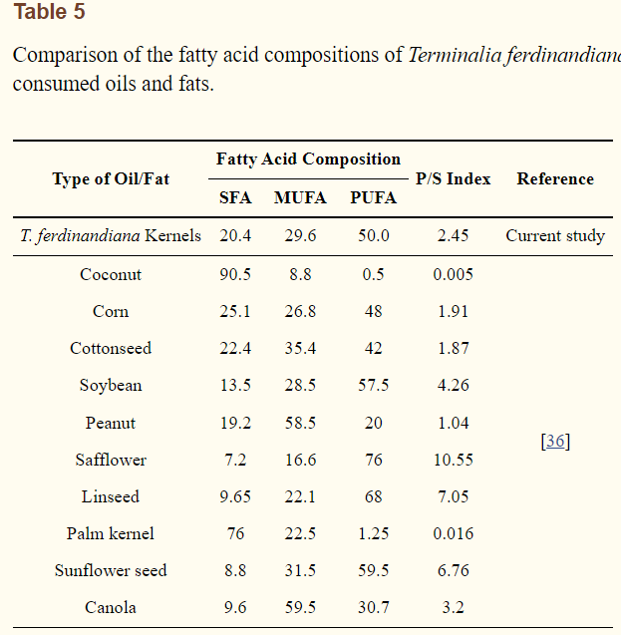
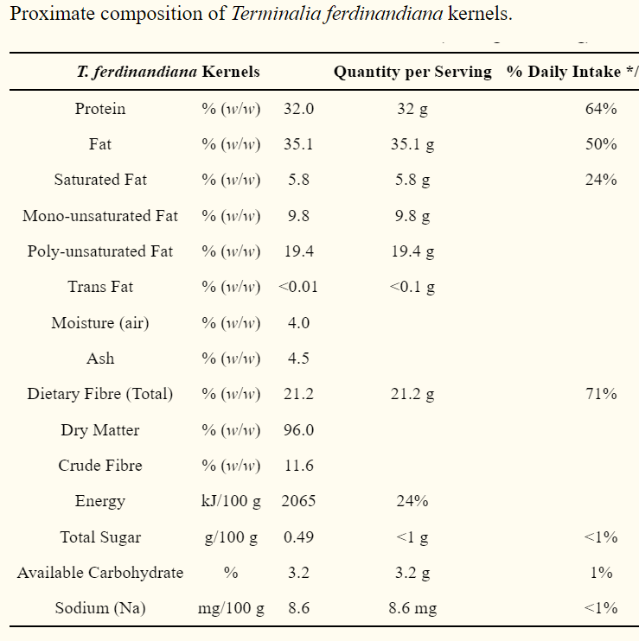

.

Bush Tucker

Bush tucker
The photo below shows a range of bush tucker at Wanmarra station near Watarrka, (Kings Canyon)
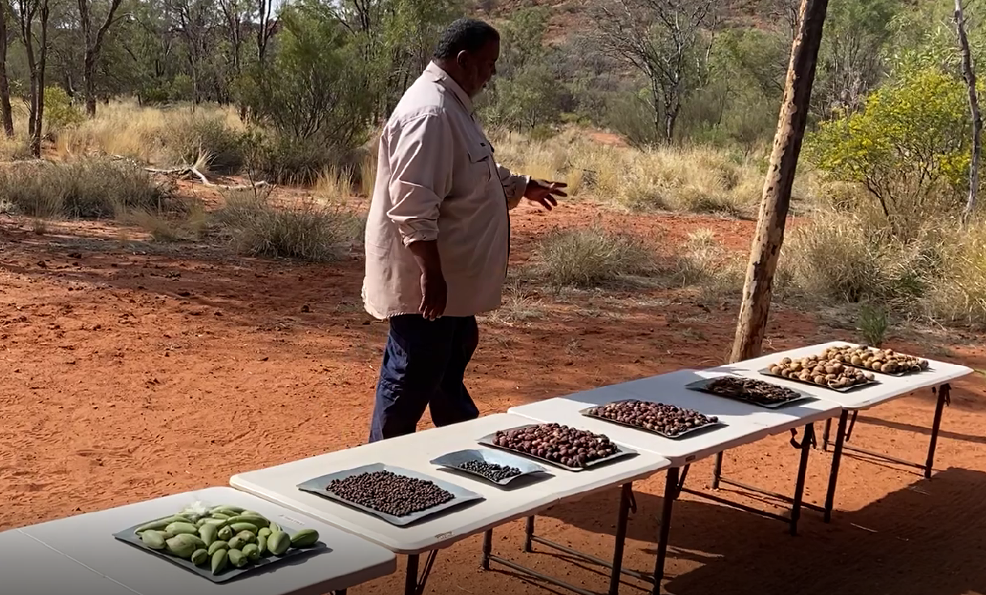
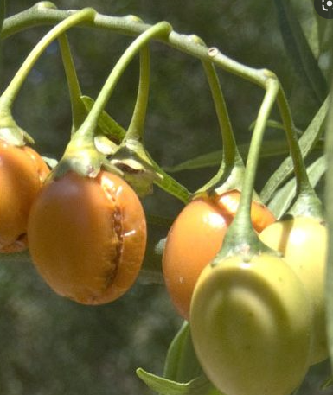
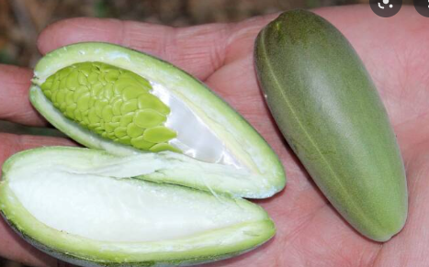
bush banana (left most) bush tomato (2ndfrom left) wild orange (far right)
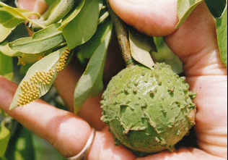

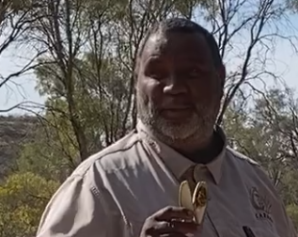
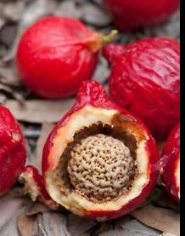
quandong

Wild banana – totally edible, not related to western bananas

Bogong moths: Agrotis infusa

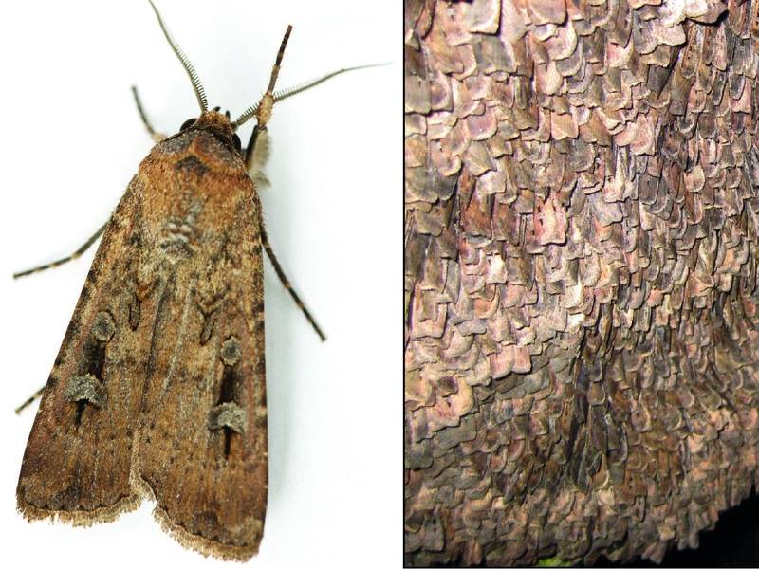
Bogong moth once part of Indigenous diet
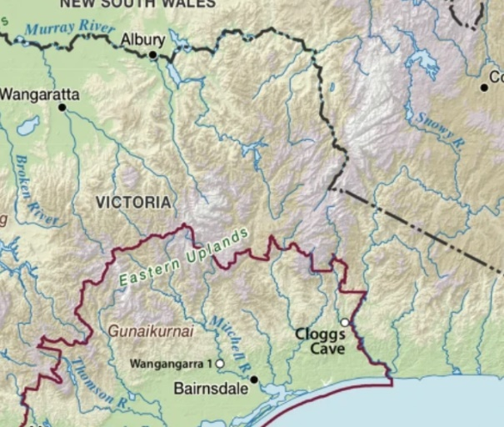

Bogong moth Moth hordes on alpine rocks Cloggs cave in eastern Victoria
Bogong moths are native to Australia and are named after the Bogong High Plains region of Victoria where the moths congregate in huge numbers over the summer months. The larvae of Bong moths (black cutworms) feed on seedlings of wide-leafed plants in inland regions of Australia. During spring, they fly south to high altitude regions where they remain inactive over the summer months.
The Bogong moth was considered a source of fat and nutrients for thousands of years by Indigenous Australians. It was abundant, easy to collect and palatable to eat. A festival was held each year when the moths were collected and eaten. Collection involved stupifying the mots with smoke so they fell from the rocks. They could be cooked on the ashes of a fire or ground to make a cake that would last for several weeks.
Analysis of the ground moths shows they were high in fat, protein and fibre: (They are a source of energy but not particularly high in nutrition)
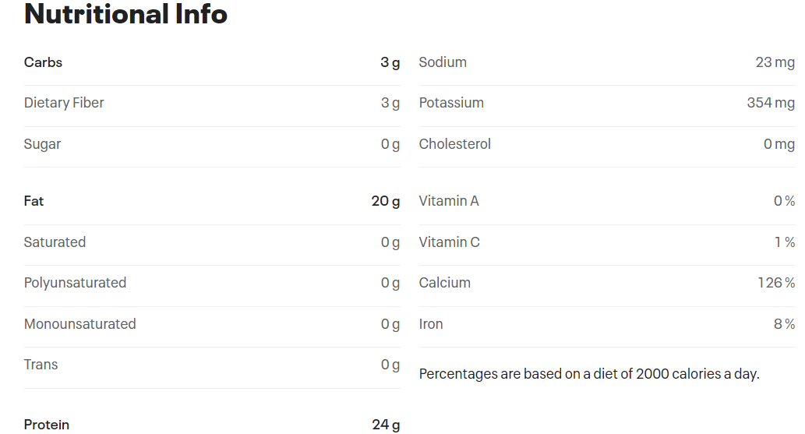

An archaeological team from Monsah University has worked with elders of the Gunaikurnai Land to research this practice. The team has been very excited to find old grinding stones and moth remains dating back at least 2000 years in Cloggs cave near Buchan. The significance of the find is that it is the first recorded evidence of humans regularly dining on insects. Elder Russell Mullet’s comment are provided below:
Below are pictures of the grind stone found and some of the insect segments pulled from the grindstone.
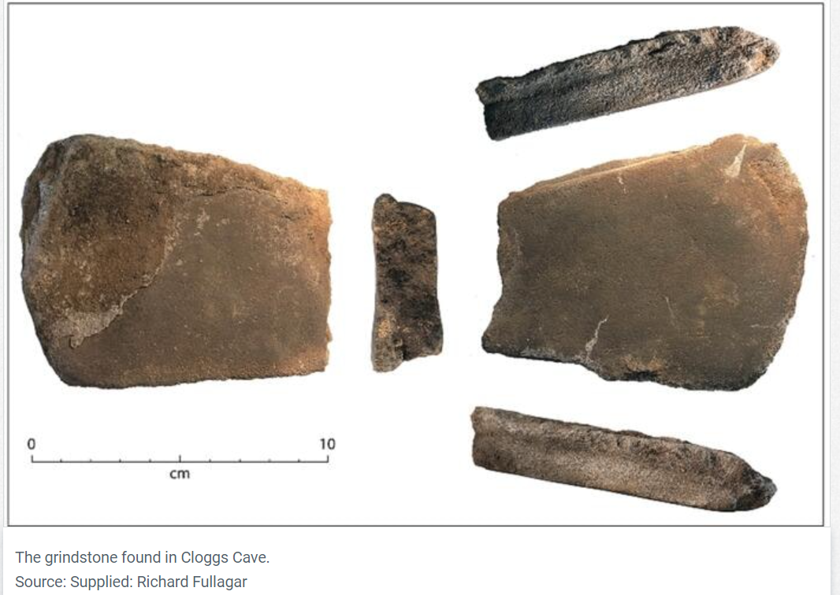
The repeated action of grinding forced the residues below into the voids of the stone. These samples were then preserved under a layer of dirt.
https://www.sbs.com.au/nitv/article/2021/02/05/bogong-moth-remains-provide-window-ancient-food-sources
https://www.nature.com/articles/s41598-020-79307-w

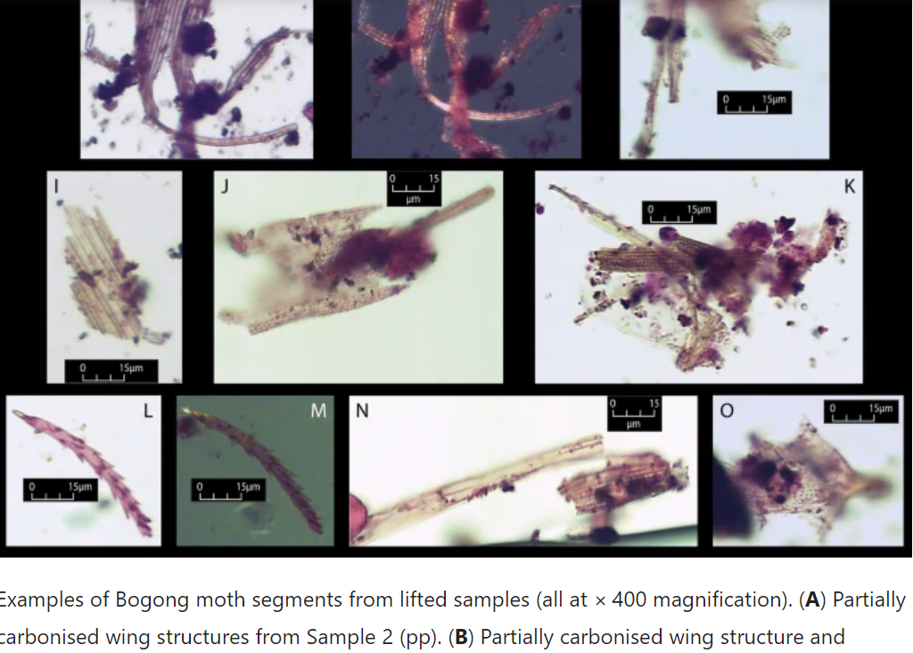

Recent years has seen two new concerns with Bogong moths. The first is their low numbers, causing them to be listed as an endangered species. The second is the level of arsenic around the areas where they were harvested as the arsenic accumulated in their bodies.

Plant resins and gums (adhesives)
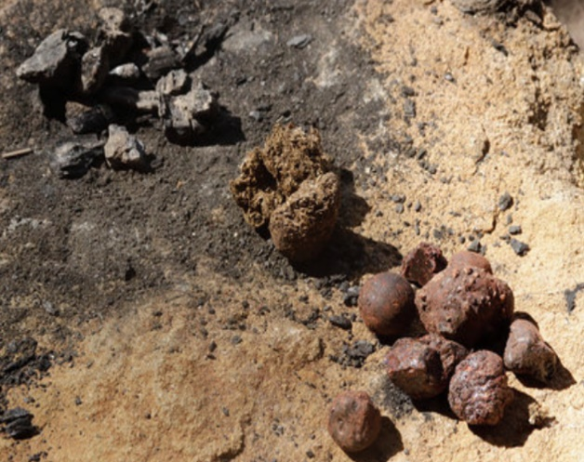
A common mixture used to produce an adhesive was formed from charcoal, kangaroo scats and tree resin, all three ingredients shown below.

The resin is heated in a fire to melt it and then crushed
charcoal and kangaroo dung is worked into it,
keeping it soft by working it on hot stones around the fire.
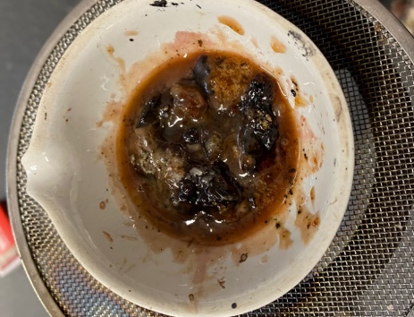

molten resin left to right: charcoal, kangaroo poo, resin
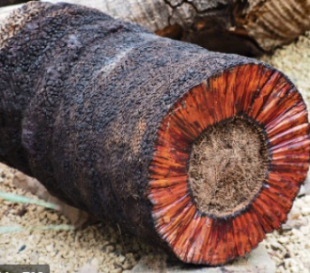
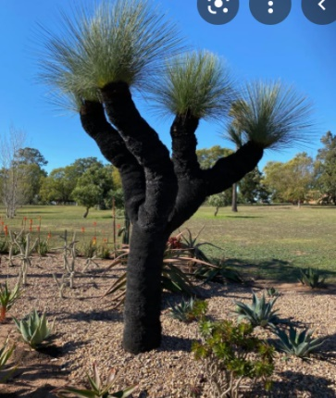
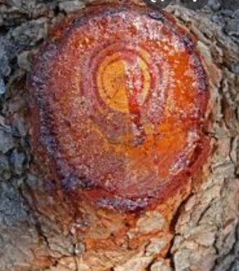
Tree resin and tree gum are similar to look at, and both play an important role in healing trees, but their composition
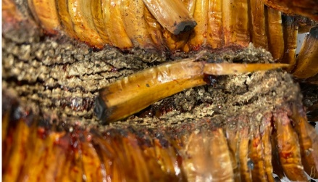

is completely different.
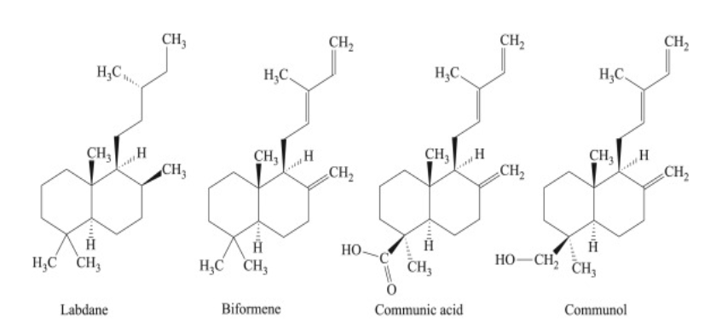
Resin from pine tree cut grass tree grass tree cross-section close-up
Chemical structures of some of the components of resins. While fresh they are liquids due to the aromatic oils they contain. Once the oils evaporate a hard, brittle solid remains. It is thermoplastic.
The charcoal acts as a hardening agent and the dung is a binder – similar to glass fibre in fibre glass resins.

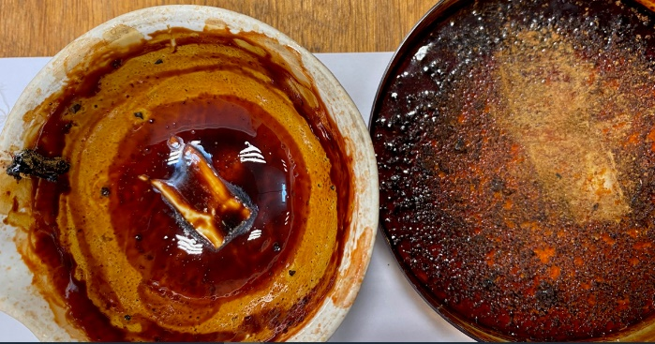
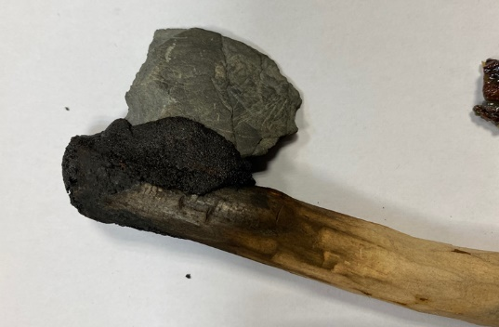

To get the resin from the grass tree I soaked the leaves Axehead we were able to attach at school using this recipe
in metho, then allowed the metho to evaporate.

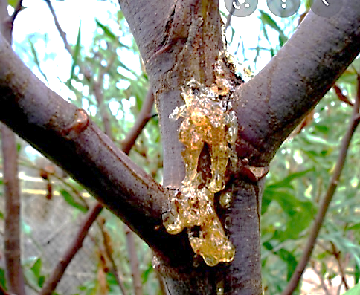
Gums: as seen in the acacia tree shown.

Gums are thermoset and are generally polysaccharides.
There are many types of gums such as xanthan and agar.

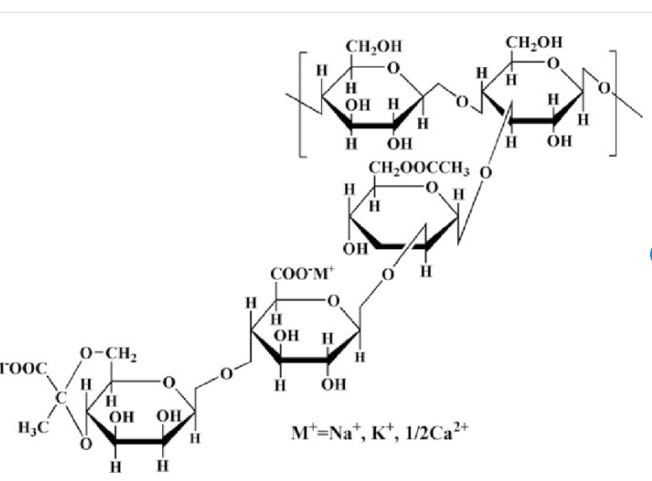

Xanthan gum – polymer of glucose and mannose
Used as a food thickener

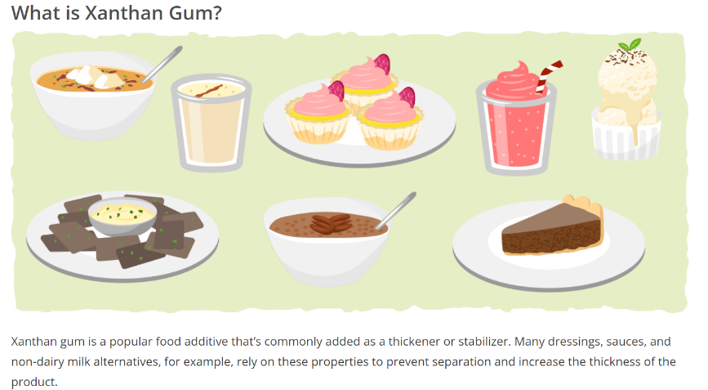

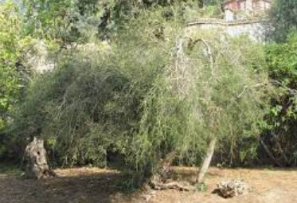
Tea-tree: Melaleuca Alternifolia

Hopefully we can get a small version of a tea-tree.

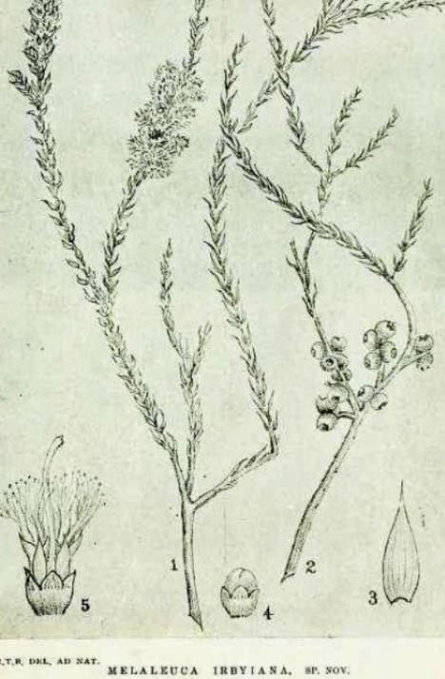
When Captain Cook sailed into Botany Bay
in 1770, his crew noticed how the Indigenous
people used the local bushes as medicine.

The diagram shown was drawn by Cook’s
famous botanist, Joseph Banks. As the leaves
made a very fragrant tea, Banks called the
shrubby tree, Tea-tree.

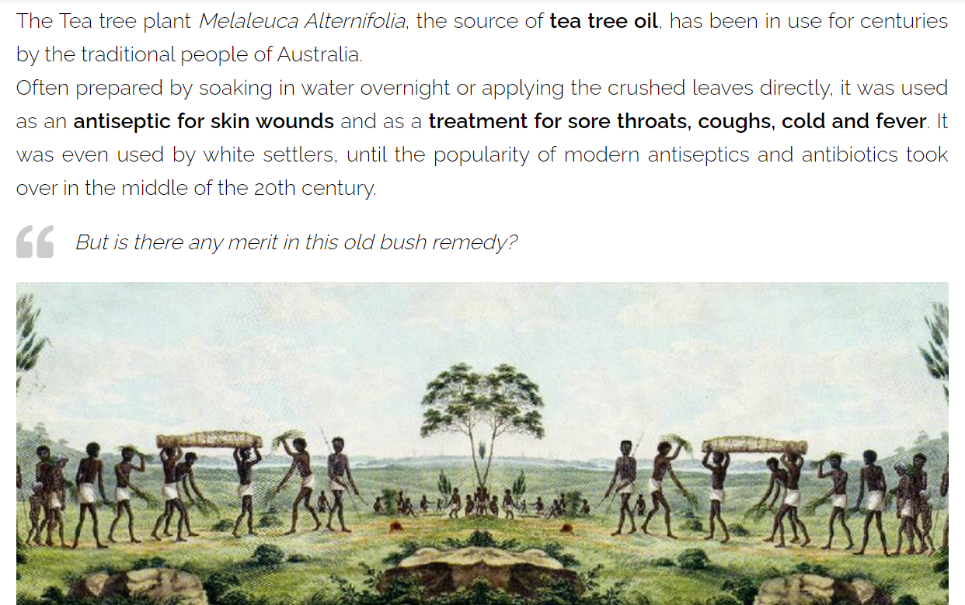

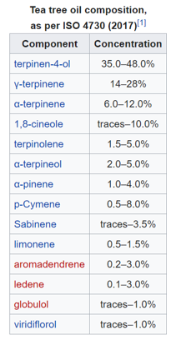
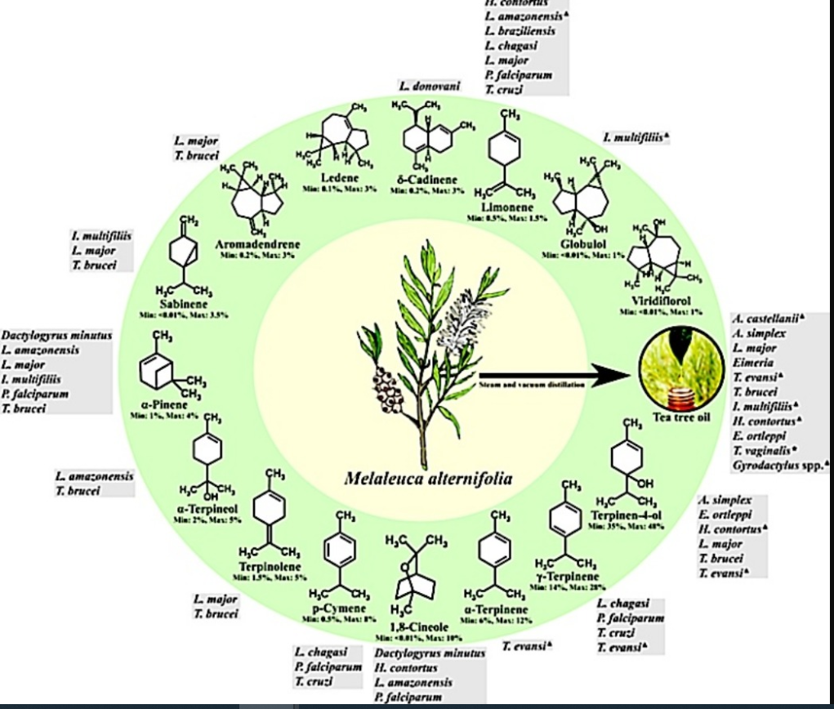
Active ingredients in tea-tree oil

