Topic test 3: Metals and ionic compounds Name: _____________

SECTION A – Multiple-choice questions

Instructions for Section A
Answer all questions.
Choose the response that is correct or best answers the question.
A correct answer scores 1, an incorrect answer scores 0.
No mark will be given if more than one answer is completed for any question.
Marks will not be deducted for incorrect answers.

Question 1
A particular element has two electrons in its valence shell. This element will form
A. a metallic lattice when pure and covalently bonded molecules when combining with chlorine.
B. an ionic lattice when pure and a covalent lattice when bonding to chlorine.
C. an ionic lattice when pure and covalently bonded molecules when combining with chlorine.
D. a metallic lattice when pure and an ionic lattice when combining with chlorine.

Question 2
Select the property that is common to both metals and to ionic compounds.
A. Electrical conductor as a solid
B. Ductile
C. Electrical conductor as a liquid
D. Hard and brittle

Question 3
Select the correct alternative relating to the abundance of copper.
A. World reserves of copper are high and extraction of pure copper is relatively simple.
B. The abundance of copper is low but, its low reactivity, means demand for it is low.
C. Copper is considered an endangered element as its abundance is very low.
D. Copper is considered endangered despite its relative abundance due to the high demand for it.

Question 4
The differences in properties between metals and ionic substances mainly relate to the
A. much greater strength of ionic bonds over metallic bonds.
B. presence of delocalised electrons in the metal structure but not in ionic solids.
C. metal atoms retaining outer shell electrons while the ionic compounds exchange electrons.
D. much greater strength of metallic bonds over ionic bonds.

Question 5
Metal Q forms a compound QF₃. If Q reacts with carbonate ions the formula of the compound formed will be;
A. QCO₃
B. Q₂CO₃
C. Q₂(CO₃)₃
D. Q(CO₃)₂

Question 6
When barium forms a compound with fluorine, each atom of barium will
A. donate two electrons to two different fluorine atoms.
B. donate two electrons to a fluorine atom.
C. donate one electron to a fluorine atom.
D. accept one electron from each atom of fluorine.

Question 7
The following reactions of metals A, B and C are known to be spontaneous:

A(s) + BCl₂(aq) ACl₂(aq) + B(s)
C(s) + ACl₂(aq) CCl₂(aq) + A(s)

The order of reactivity of the three metals is, from lowest to highest,
A. A, B, C
B. B, A, C
C. C, B, A
D. C, A, B

Question 8
Metal A can be determined to be more reactive than metal B if
A. atoms of metal A can replace ions of metal B in solution.
B. atoms of metal B can replace ions of metal A in solution.
C. metal A contains less electrons in its outer shell than metal B.
D. metal A has more electron shells than metal B.

Question 9
The correct names for the following compounds are, respectively,

CaS CaSO₃ CaSO₄

A. calcium sulfide, calcium sulfite, calcium sulfate
B. calcium sulfur, calcium sulfide, calcium sulfate
C. calcium sulfide, calcium sulfate, calcium sulfoxide
D. calcium sulfide, calcium sulfite, calcium sulfuroxide

Question 10
Which of the following pairs will not exhibit ionic bonding between the atoms?
A. calcium and sulfur
B. nitrogen and hydrogen
C. aluminium and chlorine
D. gold and oxygen

SECTION B- Short-answer questions

Instructions for Section B
Questions must be answered in the spaces provided in this book. To obtain full marks for your responses you should
- Give simplified answers with an appropriate number of significant figures to all numerical questions; unsimplified answers will not be given full marks.
- Show all workings in your answers to numerical questions. No credit will be given for an incorrect answer unless it is accompanied by details of the working.
Make sure chemical equations are balanced and that the formulas for individual substances include an indication of state; for example, H2(g); NaCl(s)

Question 1 (7 marks)
The diagram below shows the arrangement of ions and electrons in a metal.
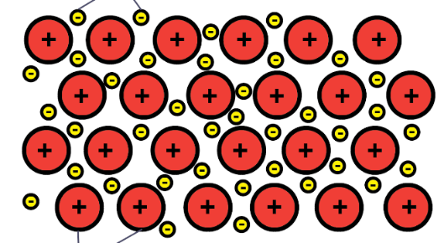

- If the diagram is showing the arrangement in a piece of magnesium ribbon ;
i. identify the positive ions that are present. 1 mark

_______________________________________________________________________________

ii. What will the ratio of metal ions to delocalised electrons be? Justify your answer. 2 marks

________________________________________________________________________
________________________________________________________________________

- Electrodes are now placed over the piece of magnesium. Explain the impact on this structure of it being included in an electric circuit. 2 marks
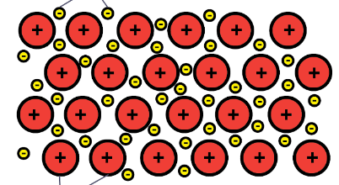
+ -

________________________________________________________________________
________________________________________________________________________

- Magnesium metal can react with a range of non-metals. When magnesium reacts, how will the particles shown in the diagrams above change? 2 marks

________________________________________________________________________
________________________________________________________________________

Question 2 (6 marks)
Samples of the following metals are made available to a student to observe and test;

zinc sodium calcium

a. Rank the three metals in order of reactivity, lowest to highest. Explain your ranking. 2 marks

_________________________________________________________________________

_________________________________________________________________________

b. When a metal reacts with an acid, a salt and a gas are formed. 2 marks
Write a balanced equation for the reaction between hydrochloric acid, HCl and strontium.

____________________________________________________________________________________________________________________________________________________________________

c. One of the reactions below will occur spontaneously while the other will not react at all.
Write a balanced equation for the reaction that will occur. 2 marks

K(s) + ZnCl₂(aq)

or

Zn(s) + KCl(aq)

Question 3 (12 marks)
Magnesium and fluorine atoms can react to form magnesium fluoride. Both atoms achieve a complete outer shell as a result of the reaction.
a. Fill in the template below to show the electron movement in this reaction.
 | magnesium | fluorine
Electron configuration before reaction
Lose or gain electrons to complete outer shell?
Number of electrons to change to gain a complete outer shell
Electron configuration of ion
Formula of ion
Chemical formula of magnesium fluoride
6 marks
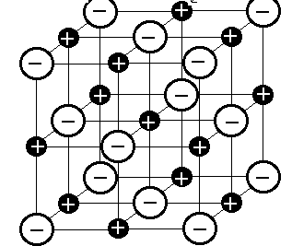
b. The structure of an ionic lattice is shown below.

Use the structure shown to
i. explain the electrical conductivity of ionic compounds. 2 marks

________________________________________________________________________
________________________________________________________________________
ii. explain the hard and brittle nature of ionic solids. 2 marks

________________________________________________________________________
________________________________________________________________________
iii. explain the forces present in this lattice. 2 marks

______________________________________________________________________________

_______________________________________________________________________________
Question 4 (10 marks)
a. The chemical formula of aluminium sulfate is Al₂(SO₄)₃.
i. What is the electrovalence of an aluminium ion in aluminium sulfate? ___________ 1 mark

ii. What is the electrovalence of the sulfate ion? ____________________ 1 mark

iii. What would the chemical formula of aluminium sulfide be? _______________ 1 mark

iv. List three likely properties of aluminium sulfate. 1 mark

________________________________________________________________________

b. Write the correct chemical formula of each of the following; 3 marks

i. ammonium sulfate _________________________
ii. barium chloride _________________________
iii. magnesium phosphate _________________________

- Name the ionic compounds below: 3 marks

i. LiOH _________________________
ii. Na₂CO₃ _________________________
iii. Cu(NO₃)₂ _________________________

Question 5 (5 marks)
When the following solutions are mixed a precipitate forms.
For each combination, write a balanced equation and identify the precipitate formed.

a. LiCl(aq) + AgNO₃(aq) __________________________ 1 mark

b. Ba(NO₃)₂(aq) + K₂SO₄(s) __________________________ 2 marks

c. copper(II) nitrate + sodium carbonate

___________________________________________________________________________ 2 marks

END OF KEY TOPIC TEST

