**Unit 1 Chemistry Name: ________________**

**2023 Trial exam: 90 mins**

**SECTION A – Multiple-choice questions**

|  |
| --- |
| **Instructions for Section A**  Answer **all** questions.  Choose the response that is **correct** or **best answers** the question.  A correct answer scores 1, an incorrect answer scores 0.  No mark will be given if more than one answer is completed for any question.  Marks will **not** be deducted for incorrect answers. |

**Question 1**

Which of the following processes is likely to have the least impact upon the environment?

**A**. Using car tyres in place of coal in the manufacture of steel.

**B**. Manufacture of a compostable polymer from fruit waste.

**C**. Manufacture of polyethene from bioethanol.

**D**. Manufacture of a compostable plastic from crude oil.

**Question 2**

The electron configuration of an ion is 1s22s22p63s23p6. The ion could be

**A**. F-

**B**. K+

**C**. Cl

**D**. Ar

**Question 3**

Which of the following metals is the most reactive?

**A**. nickel

**B**. calcium

**C**. lithium

**D**. potassium

**Question 4**

I am an element.

I am in Group 14.

I am a non-metal.

I am used as a standard on a relative scale.

I am most likely to be

**A**. silicon.

**B**. lead.

**C**. hydrogen.

**D**. carbon.

**Question 5**

A sample of calcium will conduct electricity because

**A**. each atom contributes a delocalised electron to the structure.

**B**. the electrons in each atom are free to move throughout the structure.

**C**. the calcium ions are free to move through the structure.

**D**. two outer shell electrons from each atom are delocalised in the structure.

**Question 6**

An ionic compound has the formula X2(CO3)3. The electrovalence of element X is likely to be

**A**. X-

**B**. X2+

**C**. X3+

**D**. X4+

**Question 7**

Hydrogen and oxygen can react to form a compound other than water. The compound is hydrogen peroxide, H2O2. The electrovalences in this compound will be

**A**. H+ and O-

**B**. H- and O-

**C**. H2+ and O2-

**D**. H+ and O2-

*Use the following diagram to answer Questions 8 and 9*

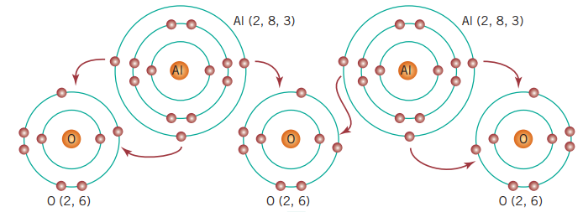

**Question 8**

When aluminium and oxygen react to form a compound

**A**. 3 electrons from each aluminium atom move to oxygen atoms.

**B**. 3 electrons from each aluminium atom move to each oxygen atom.

**C**. 2 aluminium atoms share 6 electrons with 3 oxygen atoms.

**D**. each aluminium atom shares 3 electrons with each oxygen atom.

**Question 9**

Given that oxygen exists as O2 gas, a balanced equation for the reaction between aluminium and oxygen is

**A**. Al + O2 🡪 AlO2

**B**. 2Al + 3O 🡪 Al2O3

**C**. 2Al + 3O2 🡪 Al2O3

**D**. 4Al + 3O2 🡪 2Al2O3

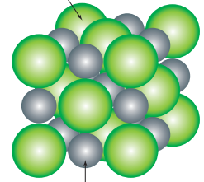**Question 10**

The structure of potassium chloride is modelled in the

diagram shown.

Select the correct statement about the electrical conductivity of potassium chloride.

**A**. KCl will not conduct in any form.

**B**. KCl will not conduct as a solid but will conduct as a liquid or as a solution.

**C**. KCl will not conduct as a solid or as a liquid but it will as a solution.

**D**. KCl will conduct as a solid or a liquid.

**Question 11**

Which of the following represents the greatest mass?

**A**. 0.1 mol of Pb

**B**. 5.0 mol of H2 gas

**C**. 6.02 x 1023 molecules of H2 gas

**D**. 1.0 mol of C

**Question 12**

The number of atoms in 3.0 mol of AlCl3 will be

**A**. 3

**B**. 3 x 6.02 x 1023

**C**. 3 x 3 x 6.02 x 1023

**D**. 3 x 4 x 6.02 x 1023

**Question 13**

A molecule has an empirical formula of CH2O and a molar mass of 60 g mol-1. The molecule could be

**A**. ethanol.

**B**. ethanoic acid.

**C**. propanol.

**D**. propanoic acid.

**Question 14**

An alkane is found to be 80 % carbon by mass. The alkane is

**A**. methane.

**B**. ethane.

**C**. propane.

**D**. butane.

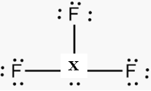**Question 15**

Element X shown in the Lewis diagram above is most likely to be

**A**. oxygen.

**B**. carbon.

**C**. chlorine.

**D**. phosphorous.

**Question 16**

Which two molecules have same empirical formula?

**A**. ethane and butane

**B**. ethene and butene

**C**. pentane and pentene

**D**. ethane and ethene

**Question 17**

Which of the following liquids will form hydrogen bonds?

**A**. ethanol

**B**. chloroethane

**C**. ethane

**D**. 1,2-dichloroethane

**Question 18**

A condensation polymer can be formed when

**A**. the monomer used contains a carbon-to-carbon double bond.

**B**. the monomer used has a functional group on each end.

**C**. the monomer used contains a functional group on at least one end.

**D**. a compound such as ethanol reacts with a compound such as ethanoic acid..

**Question 19**



The systematic name for this molecule is

**A**. 2-ethylhexane

**B**. 2-ethylheptane

**C**. 3-methylheptane

**D**. 3-methylhexane

**Question 20**

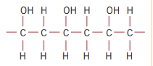

The monomer used to produce the polymer segment shown is

**A**. CHCHOH

**B**. CH2CH2OH

**C**. CH2CHOH

**D**. CH3CHOH

**Section A 20 marks ____**

**Total Section B 66 marks ____**

**Total exam 86 marks ____**

**SECTION B – Short-answer questions**

|  |
| --- |
| **Instructions for Section B**  Questions must be answered in the spaces provided in this book. To obtain full marks for your responses you should   * give simplified answers with an appropriate number of significant figures to all numerical questions; unsimplified answers will not be given full marks. * show all workings in your answers to numerical questions. No credit will be given for an incorrect answer unless it is accompanied by details of the working. * make sure chemical equations are balanced and that the formulas for individual substances include an indication of state; for example, H2(g); NaCl(s) |

**Question 1** (6 marks)

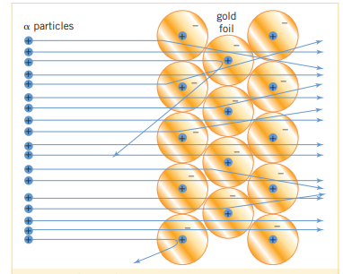New Zealand physicist Ernest Rutherford is famous for his gold foil experiment. An outline of the experiment is shown below, where he directed fast moving, positively charged α-particles at a thin layer of gold foil.

1. Use the template provided to state

two conclusions Rutherford was able

to draw from this experiment.

4 marks

Conclusion 1: ____________________________________________________________

Observation that led to this conclusion.

_____________________________________________________________________

Conclusion 2: ___________________________________________________________

Observation that led to this conclusion:

_______________________________________________________________________

**b**. Write the electron configuration of 35Br: _____________________________ 1 mark

**c**. Use atomic notation to represent an atom of uranium that has 92 protons and 146

neutrons.

__________________________ 1 mark

**Question 2** (8 marks)

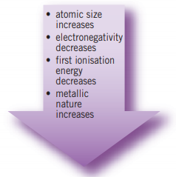The Periodic Table can be used to predict the properties of

elements that you might not be familiar with.

The arrow shown on the right is an example of a guide for

predicting properties.

**a. i**. What is ‘first ionisation energy’? 1 mark

_______________________________________________

_______________________________________________

**ii**. Why does it drop as you move down a group? 2 marks

____________________________________________________________________

____________________________________________________________________

**b.** The graph shown refers to one of the above properties.

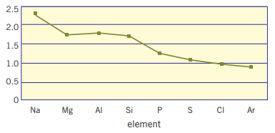

Which property is it, and explain why the trend is as shown? 2 marks

____________________________________________________________________

____________________________________________________________________

**c.** The Transition Metals are in the middle of the Periodic Table.

**i**. Explain why there are ten elements in each row of the Periodic Table. 1 mark

_____________________________________________________________________

**ii**. Why are there several rows of Transition metals? 1 mark

_____________________________________________________________________

_____________________________________________________________________

**d**. Name the element in period 4 and group 16. _________________ 1 mark

**Question 3** (10 marks)

A student sets up the experiment ahown to determine the empirical formula of the oxide that forms between magnesium and oxygen. She sits a piece of magnesium ribbon in the crucible and heats it until it starts to burn. The oxide formed is trapped in the crucible. The student’s data is recorded below.

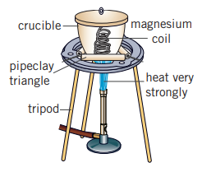

mass of crucible: 42.00 g

mass of crucible and magnesium: 42.90 g

mass of crucible and oxide: 43.41 g

**a**. Use the data provided to

**i**. determine the mass of magnesium _________________________ 1 mark

**ii**. determine the mass of oxygen in the oxide _____________________ 1 mark

**iii**. determine the emprical formula of magnesium oxide 2 marks

____________________________________________________________________

____________________________________________________________________

____________________________________________________________________

**iv**. You may have found the last step of the previous question on the empirical formula

difficult. Explain why. 1 mark

_____________________________________________________________________

**b**. Use your knowledge of electron configurations to suggest what the empirical formula of

magnesium oxide should be. Justify your answer. 2 marks

____________________________________________________________________

____________________________________________________________________

**c**. List three properties of magnesium oxide. 3 marks

_________________________________________________________________________

**Question 4** (8 marks)

**a**. Give the correct name for each of the following ionic compounds

**i**. Ba(OH)2 _____________________ **ii**. AgBrO4 ______________________

**iii**. NH4Cl ______________________ **iv**. Na2CO3 ______________________

**b**. Write a chemical formula for each of the following.

**i**. sodium oxide ____________ **ii**. sodium hydroxide _______________

iii. aluminium carbonate ________ **iv**. calcium iodide _________________

**Question 5** (11 marks)

The table below has been produced from the mass spectrum of magnesium.

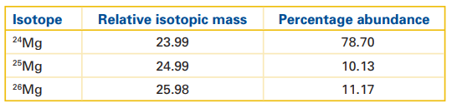

**a**. Use the axes provided to draw the mass spectrum. 2 marks

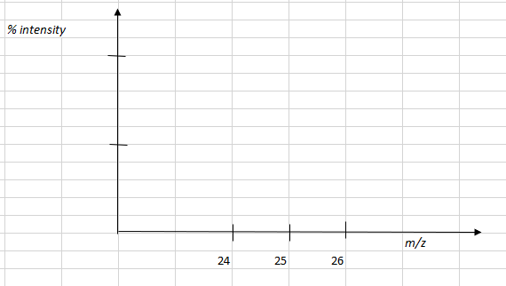

**b**. Calculate the relative atomic mass of magnesium from the data provided. 2 marks

___________________________________________________________________

___________________________________________________________________

____________________________________________________________________

**c**. Use a diagram to explain the structure in a strip of magnesium. 3 marks

**d**. Given a 80 g sample of Mg(OH)2, calculate

**i**. the amount, in mol, of Mg(OH)2 2 marks

_______________________________________________________________________

**ii**. the amount, in mol, of oxygen atoms 1 mark

________________________________________________________________________

**iii**. the number of hydrogen atoms. 1 mark

________________________________________________________________________

**Question 6** (8 marks)

Four categories of molecule shapes are shown below.

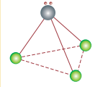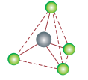

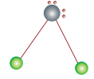



**V-shape tetrahedral linear pyramidal**

Use the following molecules to answer this question:

carbon tetrachloride CCl4 water H2O ammonia NH3 carbon dioxide CO2

Each of the above molecules belongs to a different category in the table. Select the correct molecule for each category and draw an electron dot diagram to support your answer.

|  |  |  |
| --- | --- | --- |
| Category | molecule | Electron dot diagram |
| V-shape |  |  |
| Tetrahedral |  |  |
| Linear |  |  |
| Pyramidal |  |  |

**Question 7** (9 marks)

**a. i**. Draw an ethene molecule. 1 mark

**ii**. What is its empirical formula? _________________ 1 mark

**iii**. Use ethene to explain what a homologous series is. 2 marks

__________________________________________________________________

__________________________________________________________________

__________________________________________________________________

**b**. Ethene can form a polymer.

**i**. Draw a segment of a polyethene molecule to show what the repeating structure is.

1 mark

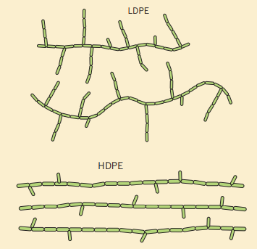 **ii**. Use the diagram below to discuss the

structure and properties of the two

common forms of polyethene.

4 marks

______________________________________

_______________________________________

_______________________________________

________________________________________________________________________

**Question 8** (6 marks)

Diamond and graphite are allotropes of carbon. A model of each is shown below.

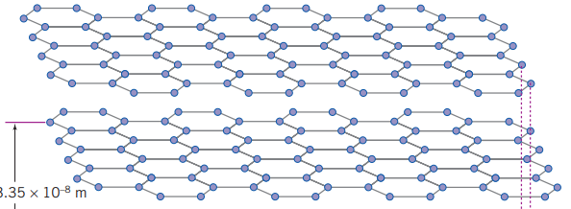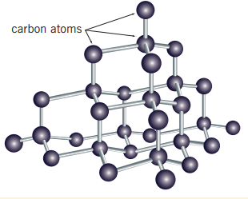

graphite diamond

**a**. List the type(s) of forces present in

**i**. graphite ____________________________________________ 1 mark

**ii**. diamond ____________________________________________ 1 mark

**b**. Explain why graphite conducts electricity but diamond does not. 2 marks

______________________________________________________________________

______________________________________________________________________

**c**. Diamond is one of the hardest substances known yet it is brittle. Explain why. 1 mark

_____________________________________________________________________

**d**. Graphite can be used as a lubricant, an unusual property for a solid. Explain how

graphite acts as a lubricant. 1 mark

_______________________________________________________________________

**END OF EXAM**